Fibrenamics Green: an opportunity to a sustainable innovation

João Bessa¹, Luís Nobre² Fernando Cunha² and Raul Fangueiro³

¹CVR – Centro para Valorização de Resíduos, Rua de Francos nº350, 4800-058 Guimarães, Portugal
Email: joaobessa@fibrenamics.com, Web Page: https://www.web.fibrenamics.com/en/
²CVR – Centro para Valorização de Resíduos, Rua de Francos nº350, 4800-058 Guimarães, Portugal
Email: luisnobre@fibrenamics.com, Web Page: https://www.web.fibrenamics.com/en/
³2C2T – Centro de Ciência e Tecnologia Têxtil, University of Minho, 4800-058 Guimarães, Portugal
⁴University of Minho, Department of Mechanical Engineering, Campus de Azurém, 480-058 Guimarães, Portugal

Keywords: circular economy, waste, recycling, composite materials

Abstract
This work presents potential applications of use the several types of waste into new value added products. Actually, a high volume of different types of waste, coming of several industries was generated, without any type of recycling and recovery. Moreover, the high population growth verified in the last century has jeopardized the renewable character of certain natural resources, fundamental for the sustainability of the planet. Then, the need of reuse and recycling waste at the end of life cycle is emerging. It was in this context that the Fibrenamics Green platform was born, with the objective to develop innovative products based on waste from several industries, such as automotive, textile, footwear, furniture, construction, among others. In this context, in this work were presented 6 examples of new products from 4 different types of waste, namely wood dust, fibrous waste, mineral dust and polymeric compounds of electrical and electronic equipments, using a polypropypele (PP), maleic anhydride polypropylene (MAPP) and bio-epoxy resin as auxiliary materials. This products includes a bank (Facet Stool), cookware (Dress Your Pans), shelf (Junta), footwear (Zouri), lamp (Matteo Lamp) and a modular floor (Kort).

1. Introduction

The recent world population growth has been one of the main factors for the technological development and innovation. In fact, exponential growth has taken place in the world population, being expected to reach 9 billion in 2042, compared to 3 billion in 1960 [1]. However, this technological development has led to an overuse of resources, from natural to synthetic ones, which affects the earth sustainability. In this sense, several studies and measures to avoid the negative effects of this context it has been promoted on the use of recyclable and environmentally friendly materials, capable contribute to a more sustainable and eco-friendly world.
This has led to the use and development of new materials and products, which can respond to these increasing needs and trends. Consequently, an increase in composite materials’ use has been noticed for several applications, replacing conventional materials. In addition to the costs and weight reduction of components, these materials also allow us to increase some mechanical properties and corrosion resistance. On the other hand, in the present state of art, the product design concepts have increasingly assumed as an opportunity for differentiation in more competitive markets.
It was in this context that the Fibrenamics Green platform was born, promoted by the University of Minho, in Portugal, as a sustainable innovation initiative, which aims to transfer scientific and technical knowledge for companies, in order to develop innovative products based on waste from several industries, such as automotive, textile, footwear, furniture, construction, among others. Then, this platform intends to contribute to a multisectorial partnership between the scientific and technological development centres and the manufacturing industries, offering a valued solution to the waste from several industries to create value for the development of innovative products by incorporating design, engineering and creativity.
Currently, some of the main wastes generated in Portugal includes the wood dust, fibrous waste from the textile and garment industries, mineral dust and polymeric waste of electrical and electronic equipments. So, in this paper, there are presented some practical applications of the reuse and recycle these types of waste into a new value added products.

2. Materials and Methods

2.1. Used Materials

2.1.1. Waste Materials

In the present work, it were used four different types of waste, namely wood, non-woven fabrics, mineral and plastic ones, all illustrated in Figure 1.
The wood dust is mainly from carpentry and furniture industries, which generates huge volumes of waste. The dust waste used is coming of mahogany tree, Swietenia macrophylla, which presents a density between 0.85 – 0.95 g cm⁻³.
The fibrous waste from the textile and garment industries, which is higher than 80 000 tons per year, can be recovered into non-woven, which are a flexible and porous structures. In this case, non-woven fabrics are provided by Pastofo, Portugal, with a weight of 1800 g cm⁻² and 20 mm of thickness. These non-woven fabrics are composed by several types of fibrous wastes from textile and clothing industries, namely: 28% of polypropylene (PP), 40% of polyester, 20% of cotton and 12% of another fibres.
Mineral dust is mainly from extraction and quarries industries, of which is about 85% come from the cutting and treatment processes of stone processing industries. It is estimated that by processing each ton of mineral based products, about 30 tonnes of waste is generated, thus causing a high environmental impact [2]. The mineral waste used is come from basalt rock, which is a metamorphic rock composed essentially by silicate and clay elements. This waste is essentially generated from the extraction and sanding processes. This type of rock has a density of 2.7 g cm⁻³, a flexural strength of 42.5 MPa and a moisture absorption capacity of 0.46%.
The plastic waste comes from of the recovery of waste electrical and electronic equipment (WEEE), since they have been assuming special focus due to the purpose of the European Directive 2012/19/EU to prevent the generation of this waste by the reuse, recycling and other forms to recover it [3]. Besides that, according to this Directive, it is expected that from 2019, the minimum collection rate to be achieved annually shall be 65 % of the average weight of electrical and electronic equipment (EEE) placed on the market in the three preceding years in the Member State concerned, or alternatively 85 % of WEEE generated on the territory of that Member State [3]. This type of waste is mainly composed by two types of materials:
- A metallic conductor elements, in the interior part, which allows the conduction of electric current, like as cooper or aluminium [4];
- A polymeric insulating elements of the exterior part, such as polyvynil chloride (PVC), polyethylene (PE), among other polymers [4].
In this sense, both elements are obtained after the mechanical or chemical separation processes of exterior polymeric insulating elements and interior metallic conductor elements. Chemical processes have significant potential benefits, compared with mechanical ones. Although mechanical recycling processes dominate the industry due of lower operating costs, chemical recycling allows neutralize dangerous additives such as heavy metal stabilizers [5].

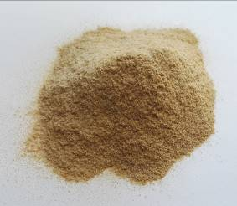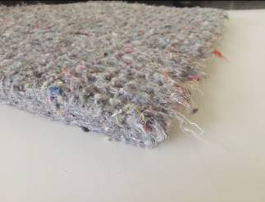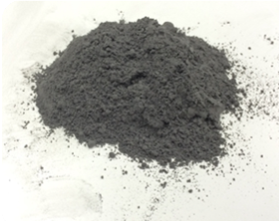

Figure 1. Waste materials: wood, non-woven, mineral and plastic, respectively.

2.1.2. Auxiliary Materials

In order to enhance the reuse of the referred waste, some auxiliary materials were used, mainly some polymeric materials, such as polypropylene (PP), maleic anhydride polypropylene (MAPP) and a bio-epoxy resin.
Polypropylene, which is a thermoplastic polymer, it was purchased from Resinex, Portugal. In fact, two types of this material were used, a RXP 2101 and RX 725 as a commercial references. RXP 2101 has a melt flow index (MFI) of 100 g/10 min, a density of 0.9 g cm⁻³, a Vicat softening temperature of 152°C and a flexural modulus of 1.58 GPa. RX 725, a black pigmented poplypropylene, has a melt flow index (MFI) of 14 g/10 min, a density of 0.9 g cm⁻³, a Vicat softening temperature of 122°C and a flexural modulus of 1.01 GPa.
The MAPP was supplied by BYK Additives & Instruments, with the commercial reference Scona TPPP 8112 FA. This polypropylene highly functionalized with maleic anhydride, in dust form, has a MFI higher than 80 g/10 min and a maleic anhydride content of 1.4% approximately.
Bio-epoxy resin, a thermosetting polymer, was supplied by Sika, reference SR GreenPoxy 56, with up to 56% of its molecular structure coming from plant origin, becoming this polymer an ecological and environmentally friendly resin. This percentage is a function of the carbon origin contained in the epoxy molecule. This resin is out coming from the latest innovations in bio-based chemistry. SR GreenPoxy 56 has a density of 1.198 g cm⁻³ and a viscosity of 800 mPa s at 25°C.

2.2. Materials Processing

2.2.1. Waste Processing

The referred materials were processed by a compression moulding, using a specific and previously dimensioned moulds, as illustrated in Figure 2. Firstly, the raw-materials were manually mixed and put in the mould were the processing occurs. Then, the process was performed at a specific conditions of temperature, pressure and cycle time, according to the used materials. After this heating step, the samples were cooled down in the same equipment, using cold water circulation to hot plates, at the same pressure of the previous step, until it reaches room temperature. Finally, the final processed materials were extracted after the pressure withdrawal.
However, depending on the waste used and the respective application purpose, the formulations and processing conditions were different, as explained in Table 1.

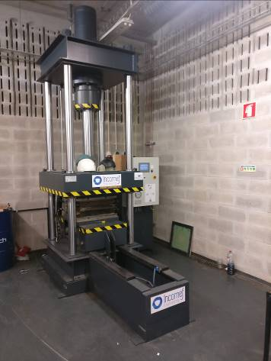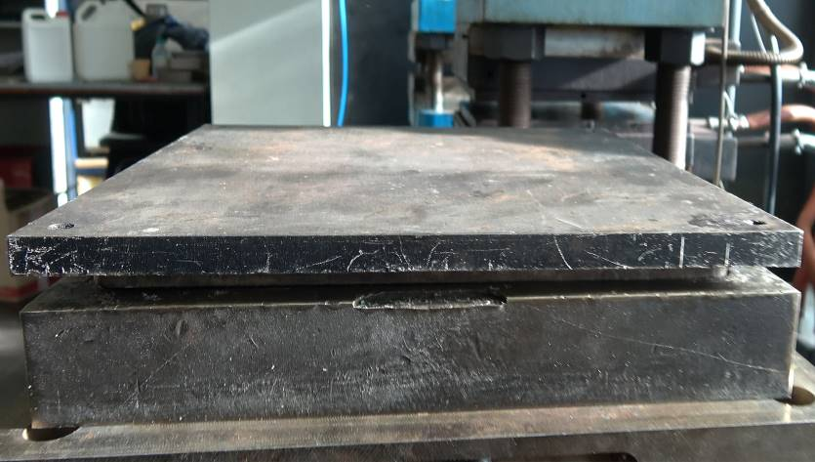

Figure 2. Compression moulding equipment and exemple of mould used.

Table 1. Data and processing conditions for each type of waste.

Waste Material | Auxiliary Materials (Reference) | % of each component (waste: auxiliar) | Processing Conditions
Wood | PP (RX 725), MAPP | 30:70 | 185°C, 100 bar, 20 min
Non-woven fabric | - | 100:0 | 195°C, 2 – 20 bar, 5 min
Mineral | Epoxy resin | 50:50 | 80°C, 1 bar, 15 min
Polymeric | - | 100:0 | 240°C, 50 bar, 15 min

After the processing of the different composite materials, and depending on the desired application, they can be machined using CNC technology, in order to obtain the respective products, which are presented in the next chapter. So, through this type of technology, the produced material sheets can be cut in several components, with the desired design and shapes.

3. Applications

3.1. Facet Stool

Facet Stool project, Figure 3, obtained from the use of wood waste, is a piece of furniture, a bank, which can be used to sit someone. Its facets create effects of light and shadow that give it three-dimensionality, making it a unique sculptural piece. Designed to be produced from a single Wood Polymer Composite board, the Facet Stool rejects the use of complex moulds, making it an even more eco-friendly and sustainable piece even in production.

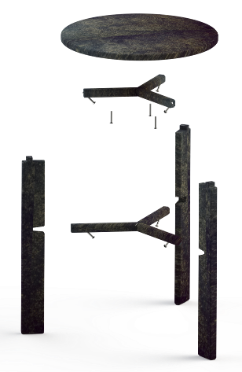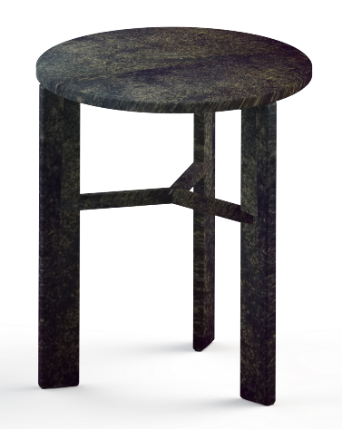

Figure 3. Facet Stool project.

3.2 Dress Your Pans

From the use of non-woven fabric, Dress Your Pans, Figure 4, was born, which consists in a set of protectors for metal cookware that protects, decorates and ennobles the cookware when placed in contact with the user. As a versatile and functional household product, Dress Your Pans protect from burns, and keeps food warm, due of its thermal insulation capacity, keeping it ready to be eaten for longer.

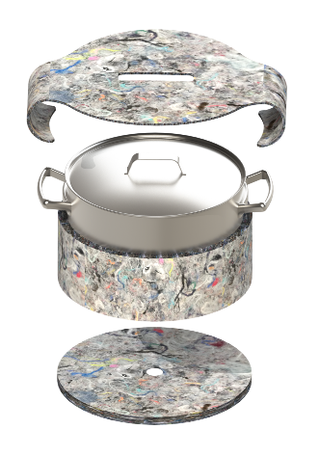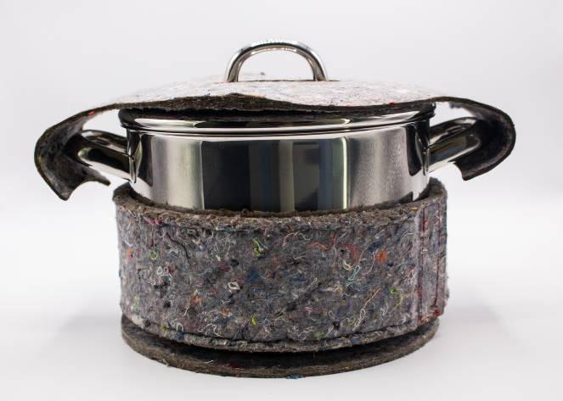

Figure 4. Dress your pans project.

3.3. Junta

Junta, Figure 5, which is obtained from the mineral dust, is a versatile product that allows several applications and several sizes. An industrial and cosmopolitan style is ideal for those who care about the environmental impact of the furniture at home. High strength, durability and ease of use make this a useful piece, as a new solution to interior design for anyone looking for something discrete and elegant. Moreover, if it necessary this material can be upgraded to have an antimicrobial finish, which can be particularly useful in special environments, like as hospitals.

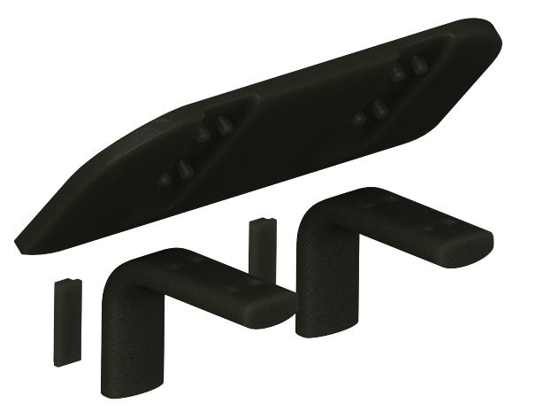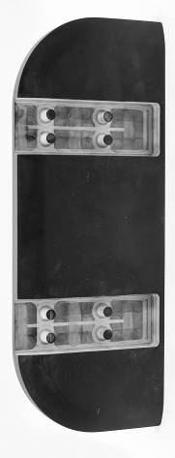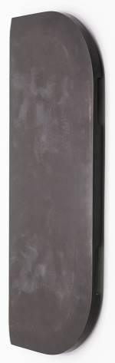

Figure 5. Junta project.

3.4. Zouri

Zouri is an eco-friendly footwear line, obtained with a polymeric waste and residues of ethyl vinyl acetate (EVA) and cork too, which takes advantage of plastic waste as well as other natural materials to give you all the comfort you need. Its unique anatomical shape combined with an insole that follows the physionomy of the foot ensures greater comfort when walking. Ideal for sea and mountain sports, or just to go to the beach, Zouri, Figure 6, is a good bet for those who like to combine design with the environment.

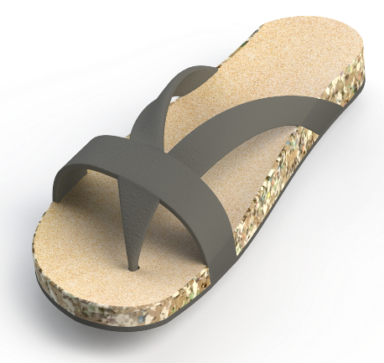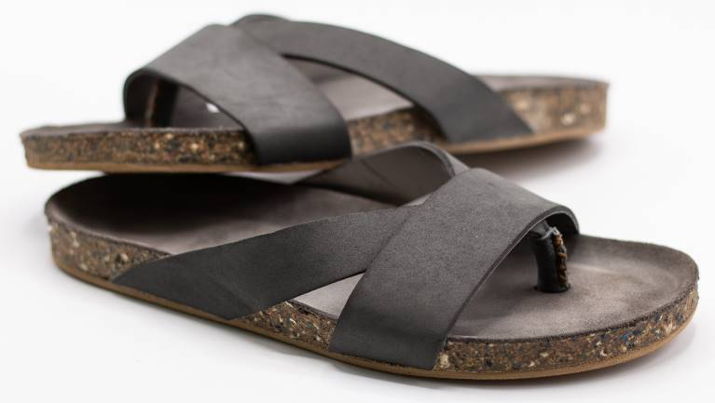

Figure 6. Zouri project.

3.5. Mateo Lamp

Matteo Lamp, Figure 7, is a result of the use of the materials processed with wood and polymeric waste. It consists in a unique lighting solution that excels in its ecological aspect by incorporating in its construction a mixture of plastic and wood waste and by the signature design. It is different from the standard of table lamps currently existing in the market. It is a piece that, in addition to being functional, is decorative and appeals to simplicity. This is the perfect symbiosis for those who appreciate a sustainable and innovative lifestyle.

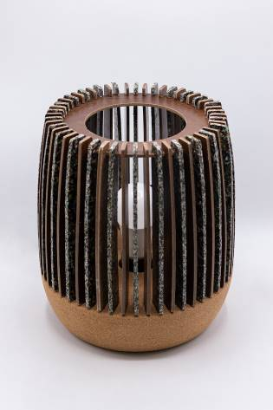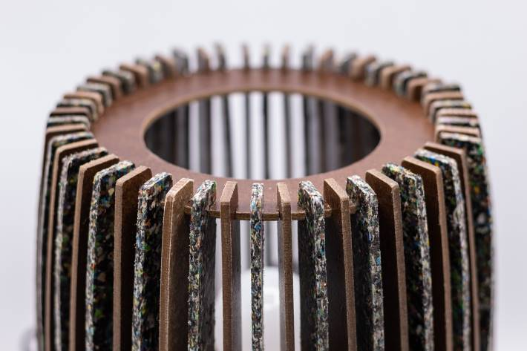

Figure 1. Matteo Lamp project.

3.6. Kort

On one side polymeric waste and on the other non-woven fabric, Kort is the ideal product to create areas where children can play, learn and sleep safely. In addition to working as a modular product that allows you to increase or decrease your area by joining or removing parts, Kort's two faces allow us to create comfortable rest areas that absorb any impact and areas for handwork easily washable.

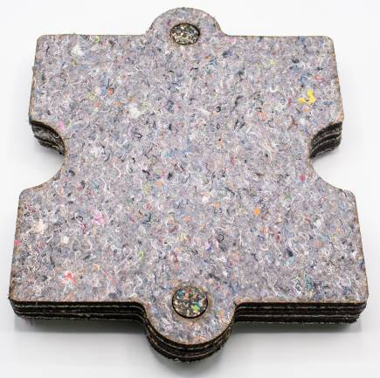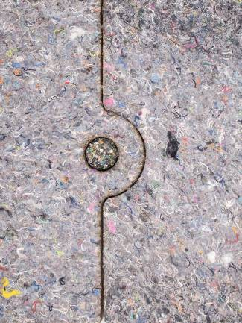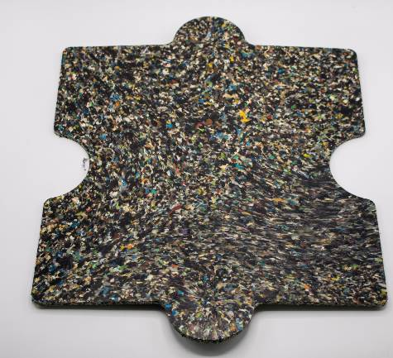

Figure 1. Kort project.

3. Conclusions

Nowadays, the recovery of materials at the end of life cycle in several sectors is a crucial trend in the development of innovation. The concerns related to sustainability of resources and life cycle of the materials has been the main factors for this trend’s evolution. In fact, the recycling and reuse of the materials plays an important role in protecting the environment, since millions of tons of waste are daily generated. Because of that, the quality of life is also affected with this trends, due to the permanent destruction of large green areas, which are responsible for oxygen production, and the caused inherently pollution. So, in the present context of society’s development, concepts such as circular economy are emerging, in order to make our world more sustainable for all.
Thus, the application of measures and/or the creation of entities and platforms that ensures the achievement of eco-friendly products and services are becoming more important. And it was in this context that the Fibrenamics Green platform was born, promoted by the University of Minho, in Portugal, as a sustainable innovation initiative, which aims to transfer scientific and technical knowledge for companies, in order to develop innovative products based on waste from several industries, such as automotive, textile, footwear, furniture, construction, among others. In this study, it were demonstrated 6 examples of useful products for distinctive applications, combining engineering and design, obtained from 4 different types of residues, namely wood, fibrous, mineral and polymeric ones. This products includes a bank (Facet Stool), cookware (Dress Your Pans), shelf (Junta), footwear (Zouri), lamp (Matteo Lamp) and a modular floor (Kort).

Acknowledgments

The authors gratefully acknowledge to project “Fibrenamics Green - Platform for the development of innovative waste-based products”, code NORTE-01-0246-FEDER-000008, which is co-financed by the European Union, through the European Regional Development Fund (ERDF) under the NORTE 2020 - North Portugal Regional Operational Program 2014–2020.
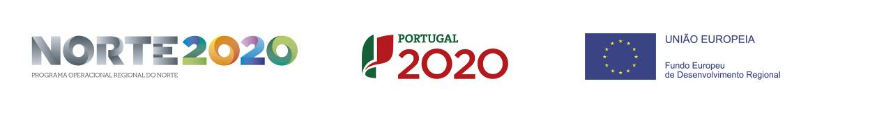

References
[1] | “World Population Clock,” 09 Maio 2018. [Online]. Available: http://www.worldometers.info/world-population/.
[2] | A. Carbonell-Verdú, D. García-García, A. Jordá, M. Samper e R. Balart, “ Development of slate fiber reinforced high density polyethylene composites for injection molding,” Composites: Part B, pp. 460-466, 2015.
[3] | P. European, “Directive 2012/19/EU of the european parliament and of the council on wast electrical and electronic equipment (WEEE),” Official Journal of the European Union, 2012.
[4] | J. N. d. Santos, “Condutores e Cabos de Energia,” Faculdade de Engenharia da Universidade do Porto, 2005.
[5] | N. H. Building, “Post-Consumer Polyvinyl Chloride in Building Products,” 2015.

