EuroSun2026
TECHNICAL AND ECONOMIC FEASIBILITY FOR INTEGRATING SOLAR THERMAL TECHNOLOGY TO AN ABATTOIR: A WALK-THROUGH AUDIT
Wame Moroba, Tshegofatso Bianca Lebotse, Kevin Nnanye Nwaigwe*
Clean Energy Research Centre, Faculty of Engineering and The Built Environment, University of Botswana
*Corresponding author: nwaigwek@ub.ac.bw
Summary
This study evaluates the technical and economic feasibility of integrating solar thermal systems at Goodwill Chickens abattoir in Botswana. Walk‑through audit and Sankey diagram analyses revealed significant heating loads, accounting for 24% of total energy use at Goodwill Chickens. These findings underscore the potential for solar thermal technologies to address substantial thermal demand. T*SOL simulations indicate robust system performance, with annual solar fractions of 66%. The projected impacts include annual savings of 4,373 liters of diesel and 9,248 kg of CO₂ emissions avoided at Goodwill chickens. Despite considerable initial investment, the installation achieves payback period of 5 years during its operational lifespan of 20 years. This study concludes that solar thermal integration offers a practical and cost‑effective pathway for reducing energy use, lowering emissions, and enhancing energy security in Botswana’s climate. A tailored system design is recommended to support industrial decarbonization and long‑term operational savings.
Keywords: Solar thermal, energy audit, heating load, poultry processing, Botswana
Field of application for the findings: Industrial process heating
Addressed audience: engineers, researchers, industrial energy managers
- Introduction
This study investigates the technical and economic feasibility of integrating solar thermal technology at Goodwill Chickens, a high-volume poultry processing facility in Botswana, to mitigate the impact of rising energy tariffs and grid instability (Statistics Botswana, 2022). By leveraging Botswana’s high solar irradiance (Rabasoma, 2022), the research employs a systematic energy audit (ISO, 2025) to establish a consumption baseline and identify critical thermal loads within the slaughter and sanitization processes. The audit serves as the foundational diagnostic tool to optimize the sizing and temperature-matching of solar thermal system, ensuring that solar-derived heat effectively displaces expensive grid electricity and fossil fuels. Ultimately, this integration aims to reduce operational costs while aligning industrial practices with national energy security and sustainability goals.
- Methodology
A Level 1 "walk-through" energy audit was conducted to establish a baseline of energy consumption patterns. Data was collected through utility bill analysis and a survey of major equipment, including boilers and scalding tanks. Sankey diagrams were developed to visualize energy flows and isolate the specific thermal demand. Finally, the T*SOL software tool was employed to simulate the performance and economic viability of a proposed solar thermal system.
- Results and Discussion
3.1 Energy demand profile
The energy profile established through the audit reveals that Goodwill Chickens operates with a substantial monthly baseline demand. As shown in Table 1, the facility consumes an average of 114,998.07 kWh per month. While refrigeration represents the largest single energy sink at 6,945 kWh, as shown in Figure 2, the audit identifies a critical 24% thermal fraction. This heating demand is non-negotiable for industrial hygiene and processing, currently satisfied by a combination of electricity and diesel fuel.
Table 1: Energy Consumption Summary for Goodwill Chickens
Average monthly use | Average daily consumption | Heating fraction | Fuel type
114 998.07 kWh | 3 739.68 kWh | 24% | Electricity and Diesel

Equipment‑level energy‑consumption estimates were converted into proportional load distributions. Heating represented 2,100 kWh out of 8,745 kWh modeled equipment load, equal to 24% of total energy use.

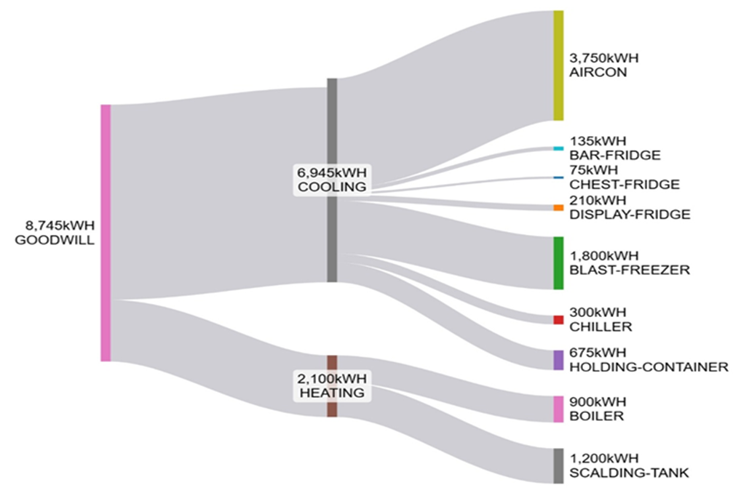

Figure 2: Goodwill Chickens Sankey Diagram
3.2 Performance simulation and Environmental impact
T*SOL was used to evaluate solar‑thermal system performance using daily hot‑water consumption based on the processing needs of the abattoir. Table 2 shows total savings, system performance and environmental benefit of adopting a proposed solar thermal system at Goodwill Chickens.
Table 2: T*Sol solar thermal performance for Goodwill Chickens
Savings Diesel fuel | CO₂ emissions avoided | DHW solar fraction | Efficiency | E Solar - DHW
4,373 [L] | 9,248 [kg] | 66 [%] | 46 [%] | 32,808 [kWh]

The simulation curve in Figure 3 shows cumulative financial benefits within the system`s lifespan, with positive net savings observed from year 5 from reduced diesel consumption. The abattoir will have free hot water for 15 years.
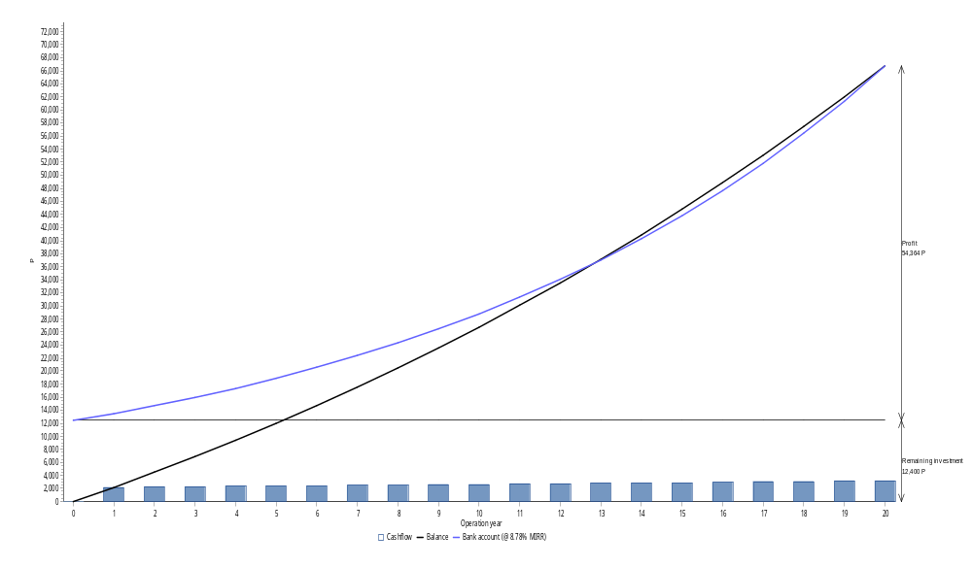
Figure 3: Financial analysis for Goodwill chickens
- Conclusion
The study confirms that solar thermal integration is technically and economically feasible for Goodwill Chickens. By satisfying 24% of the annual hot-water demand through solar energy, the facility can significantly reduce fuel costs and environmental impact. These findings serve as a benchmark for the industrial-poultry sector in Botswana to adopt similar sustainable energy practices.

- Acknowledgement
Authors are grateful to the SOLTRAIN+ project for supporting the audit, through the Clean Energy Research Centre, University of Botswana.
- References

ISO. (2025). ISO50002:2025. Retrieved from ISO-International Organisation for Standardisation: www.iso.org/standard/60088.html
Rabasoma, K. (2022). Solar thermal technology in the Botswana enrrgy mix-Issues and prospects. Gaborone: Clean Energy Research Center.
Statistics Botswana. (2022). Botswana national energy use survey. Gaborone: Statistics Botswana. Retrieved from Statistics Botswana: https://www.statsbots.org.bw/

