EuroSun2026
STUDY OF A THERMAL ENERGY STORAGE SYSTEM USING XYLITOL
Miguel Navarro (corresponding author), Ana Lázaro, Mónica Delgado
Affiliation: Aragon Institute for Engineering Research (I3A), Thermal Engineering and Energy Systems Group, University of Zaragoza, Agustín de Betancourt Building, C/María de Luna 3, 50018, Zaragoza, Spain
Email(s): miguel.navarro@unizar.es
Summary
Due to the great importance of renewable energies, energy storage is becoming an increasingly relevant technology. Latent heat thermal energy storage (LHTES) is the technology on which this work focuses, and more specifically on xylitol as a phase change material (PCM). Xylitol is a sugar alcohol with promising thermophysical properties, such as high energy density (100kWh/m³), but it suffers from stable supercooling and low crystallization speed. To overcome these problems, a stirred tank has been used to activate the phase change in xylitol using the seeding and shearing technique. In this work, an experimental campaign has been carried out on this energy storage system to find the optimal operating conditions for xylitol. In addition, an empirical model has been developed to obtain the power curve of the system.
Keywords: Xylitol, latent heat, thermal energy storage system, model, crystallization
Field of application for the findings: Thermal Energy Storage
Addressed audience: Academia
- Introduction
On the path to decarbonizing society, energy storage is positioned as a necessary tool for the implementation of renewable energies. Among the various storage technologies, this work focuses on thermal energy storage using latent heat (LHTES), which stores and releases thermal energy through the phase change enthalpy of materials. Although less mature than other storage technologies, commercial LHTES systems are already available, particularly for domestic hot water and heating applications. These systems commonly use phase change materials such as sodium acetate-based formulations, reflecting the increasing interest in latent thermal storage. This storage technology uses the latent heat of materials to store heat, using phase change materials (PCMs). There are numerous types of materials that can act as PCMs, such as paraffins or molten salts. However, this work focuses on sugar alcohols, and more specifically on xylitol. Xylitol is a sugar alcohol that melts at around 92°C and has a high energy density (100 kWh/m³ (Del Barrio et al. 2017)). Furthermore, xylitol is neither corrosive nor toxic, and is a cheap material. However, xylitol shows a strong supercooling, followed by a low crystallization rate, which difficult its use as PCM.
Several studies have demonstrated the potential of xylitol as a PCM for thermal energy storage. (Piquard et al. 2022a) showed that crystallization can be induced by combining seeding with bubbling or stirring, despite xylitol’s strong supercooling tendency. In a subsequent shell-and-tube study, (Piquard et al. 2022b applied bubbling and seeding to analyze temperature and stored-energy evolution during crystallization. (Duquesne et al. 2019) likewise showed that bubbling and shear can trigger crystallization in supercooled xylitol. Overall, these studies confirm xylitol as a viable PCM when suitable activation methods are used to initiate crystallization and accelerate latent heat release.
This work will use a storage system consisting of a stirred tank with a coil, very similar to the prototypes already used by the literature (Anish et al. 2021; Navarro et al. 2023), as this system allows for easy implementation of the seeding and shearing technique, which activates and accelerates the crystallization of xylitol in the system (Delgado et al. 2021; Navarro et al. 2025). This work analyses the thermal behaviour of the system by studying the influence of the operating conditions on the thermal power curves, as well as on the maximum power time and discharge time, the characteristic times of the system.
- Methodology
2.1. Prototype characteristics
In this study, xylitol with a purity of 99 %, supplied by Thermo Scientific, was used as the PCM. Xylitol is a sugar alcohol with a phase transition temperature of 92°C, latent heat of 240 J/g (Shao et al. 2023; Zhang et al. 2017), and energy density of 97 kWh/m³.
The experimental system (a cylindrical tank), previously described by the authors (Navarro et al. 2026), has an internal diameter and height of 150 and 230 mm, respectively, and external dimensions, including insulation, of 245 mm in diameter and 290 mm in height, corresponding to a total volume of 13.6 l. The system contained 2.5 kg of xylitol, representing a volume of 1.78 l. Xylitol seeds (300–400 µm) were introduced through an opening in the lid to initiate crystallization.
The internal coil consists of 11 turns, with a coil diameter of 110 mm. The tube has an outer diameter of 10 mm and a wall thickness of 1 mm. An IKA 60 control mechanical stirrer was used to apply shear to the xylitol. Combined seeding and shearing has previously been used to promote xylitol crystallization in a rheometer (Delgado et al. 2021), a glass beaker (Piquard et al. 2022a; Duquesne et al. 2019), and jacketed tanks (Navarro et al. 2023), showing that shear can initiate and accelerate crystallization while enabling control of thermal output. The prototype is not fully optimized (Navarro et al. 2026), as the PCM does not occupy the entire internal volume and the jacket adds unused volume. An optimized design could reduce the total volume to 8.91 l and accommodate more than twice the PCM mass.
Temperature was controlled using a Julabo Corio CP 1001F thermostatic bath with Julabo H10 thermal oil. Four Pt100 probes (uncertainty: 0.21 °C) measured the xylitol and coil inlet/outlet temperatures, while ambient temperature was measured with a type-T thermocouple (uncertainty: 0.5 °C). Flow rate was measured using a Trigear TC008A2212100 positive-displacement oval-gear flowmeter (precision: ±0.5%). Figure 1 shows a simplified schematic of the main system components and sensors.
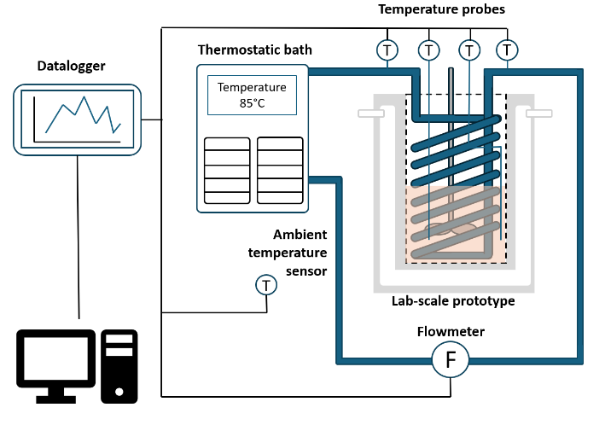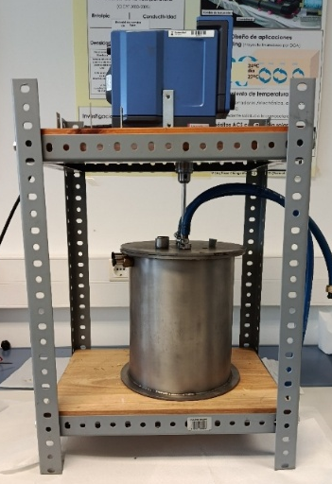
Fig. 1 System configuration. Left: Scheme of the installation. Right: Photo of the tank body without insulation and stirrer configuration.
2.2. Discharge experiments
The discharge tests were executed as follows: first, the xylitol was melted at 105°C. It is then cooled until a stable test temperature (90, 85, or 80°C) was reached, remaining in a glassy state without changing phase (Puupponen and Seppälä 2018). When a stable temperature was achieved, 12.5 mg of seed mass was added, and stirring begins (100, 500 or 1000 rpm). For the thermal power calculation, an energy balance was performed. In steady state, the thermal losses were obtained, and used for the evaluation of the heat exchanged between the PCM and the heat transfer fluid.
The experimental design considered three operating variables: temperature, stirring speed, and seed mass. Temperature was considered the most influential parameter because of its effect on crystallization, recalescence, thermal losses, and power output. Three levels were selected: 80, 85, and 90 °C. Among them, 85 °C was expected to provide a suitable compromise between rapid crystallization and limited energy losses (Delgado et al. 2021).
Three stirring speeds were evaluated: 100, 500, and 1000 rpm. Previous tests at 0 rpm showed a high stability of the supercooled state without mechanical agitation, and the selected conditions were used to evaluate the effect of stirring on crystallization induction and thermal power. Seed masses of 12.5, and 125 mg were tested, following (Delgado et al. 2021). These operating conditions are summarized in Table 1.
Table 1. Operating conditions of the crystallization tests
Temperature [°C] | Stirring velocity [rpm] | Seed mass [mg]
80 | 100 | 0
85 | 500 | 12.5
90 | 1000 | 125
Temperature was expected to have the greatest effect on crystallization time and instantaneous thermal power. Its influence on crystallization time is well established (Lebon et al. 2022; Mura and Zaccone 2016; Richard and Speck 2015); and previous work by the authors (Delgado et al. 2021; Navarro et al. 2025) reported shorter induction times at 80 °C than at 90 °C. Although flow rate could also affect system performance, it was kept constant at the maximum permitted by the hydraulic system (1.62 l/min).
Higher degrees of supercooling were expected to increase peak thermal power because recalescence raises the xylitol temperature toward its crystallization temperature (92 °C), increasing the temperature difference between the PCM and inlet heat transfer fluid. However, part of the stored energy was absorbed by reheating the PCM during recalescence, potentially reducing the energy effectively transferred to the heat transfer fluid.
- Results
3.1. Instantaneous thermal power and discharged energy
Fig. 2, Fig. 3 and Fig. 4 show the thermal power curves obtained from tests performed according to the previous section. The tests are represented as a function of relative time, following the approach reported in literature (Mehling and Cabeza 2008; König-Haagen et al. 2023).
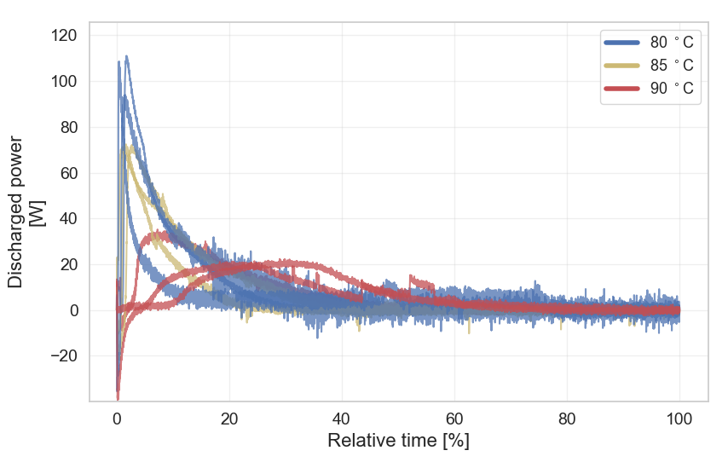
Fig. 2. Discharged thermal power over time at different initial temperatures at 500 rpm and with 12.5 mg of seed
Fig. 2 shows three repetitions of tests performed at different initial temperatures, with stirring speed and seed mass fixed at 500 rpm and 12.5 mg, respectively. In all cases, thermal power initially decreases to negative values, then rises sharply to a maximum before gradually approaching steady-state conditions.
The initial negative values are mainly attributed to a poor representation of heat losses in the energy balance and to the decrease in outlet temperature when stirring begins, as temperature in the xylitol is not homogeneous. Subsequently, recalescence increases the xylitol and thermal oil outlet temperatures, producing a sharp rise in thermal power. The magnitude of this peak is mainly governed by the degree of supercooling and stirring speed. Both the initial negative power and its subsequent increase were observed in all experiments.
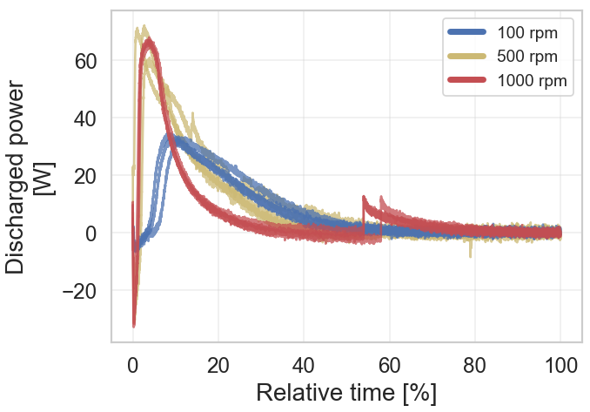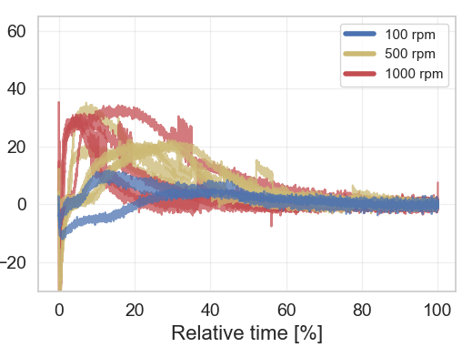
Fig. 3. Discharged thermal power using 12.5mg of seed mass, at different stirring conditions. Left: Experiments at 85°C. Right: Experiments at 90°C
Fig. 3 compares the thermal performance at different stirring speeds for fixed initial temperature and seed mass. Tests at 0 rpm, used to assess the metastability of supercooled xylitol without mechanical agitation, are not shown. The left panel presents three repetitions at 85 °C and 12.5 mg of seeds, whereas the right panel shows tests at 90 °C with the same seed mass. The lowest thermal power was found at 90 °C, where the temperature difference between the heat transfer fluid and xylitol was smallest.
At 90 °C, the effect of shear reached a maximum at 500 rpm, with no further increase at 1000 rpm. A similar trend was observed at 85 °C, whereas at 80 °C the maximum thermal power occurs at 1000 rpm. High stirring speeds also hindered complete crystallization, requiring stirring to be stopped to complete the discharge. This appeared as a jump near the end of the power curves, although it is mainly a mathematical artifact caused by setting the stirring term in the energy balance to zero. In the outlet temperature profiles, the same effect appeared instead as a change in slope. At 90 °C, 12.5 mg of seeds, and 0 rpm, no increase in heat transfer fluid outlet temperature was observed, consistent with the reported metastability and slow crystal growth of supercooled xylitol (Diarce et al. 2015; Delgado et al. 2021; Navarro et al. 2025).
Fig. 4 shows the effect of seed mass on the power curves at 85 °C and 1000 rpm, with three repetitions per condition. No clear influence of seed mass on the thermal power profile was observed. Its effect is therefore assessed through the system characteristic times. Although the power curves of no seed were not shown in Fig. 4, its effect on characteristic times is shown in section 3.3.1 and 3.3.2.
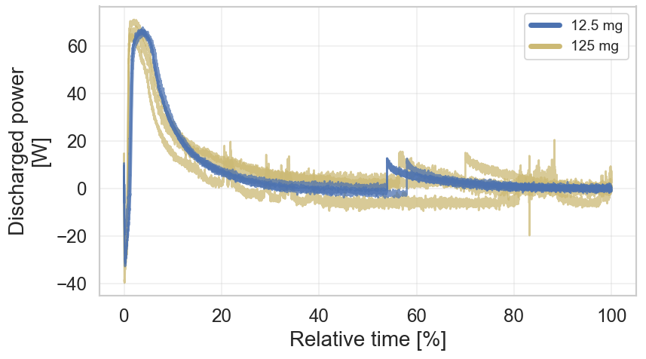
Fig. 4. Discharged power over time of the tests at 85°C, 1000 rpm and different seed masses

Representative tests used in this study are found in Table 2, showing the operating conditions, the thermal power, discharged energy and error between discharged energy and theoretical discharged energy. The results showed that the minimum thermal power was reached at 90°C. It was observed that the stirring speed directly influences the thermal power; although the difference between 1000 rpm and 500 rpm was minimal, the stirring at 100 rpm showed a significant reduction. The decrease in stored energy, shown with an asterisk, was attributed to the thermal degradation of xylitol, whose enthalpy of fusion was reduced from 240 kJ/kg to 200 kJ/kg according to DSC tests. When this factor was taken into account, the experimental values agree with the theoretical ones.

Table 2. Maximum thermal power, discharged energy and theoretical error 5 different tests.
Temperature [ºC] | Stirring velocity [rpm] | Seed mass [mg] | Maximum thermal power [W] | Discharged energy [kJ] | Error [%]
85 | 500 | 12.5 | 71.26 | 668.19 | 7.54
90 | 100 | 12.5 | 11.80 | 426.93* | 24.70
85 | 1000 | 125 | 81.29 | 516.75 | 7.01
80 | 1000 | 12.5 | 124.16 | 491.44 | 11.24
85 | 500 | 12.5 | 72.11 | 545.75 | 3.39

3.2. Temperature evolution
All experiments showed a similar temperature evolution. Fig. 5 presents a representative test at an initial supercooled temperature of 85 °C. The inlet temperature remained constant due to cryostat control, whereas the average xylitol temperature exhibited a more complex evolution governed by crystallization and thermal homogenization. Through recalescence, xylitol temperature increased during crystallization toward the melting temperature, although it does not reach 90 °C. Unlike ideal recalescence, however, the xylitol temperature initially decreased before increasing. This decrease was attributed to stirring-induced homogenization of the initially non-uniform temperature field, and temperature differences of up to 10 °C were measured between the two internal sensors at the beginning of some tests.
The thermal-oil outlet temperature followed a similar but smoother trend than the average xylitol temperature. After a slight initial decrease, it raised with the xylitol temperature, although both peaks occurred at different times. Subsequently, the outlet temperature decreased while the xylitol temperature remained nearly constant. This behaviour was attributed to progressive solid formation during crystallization, which creates a layer around the coil and increases thermal resistance. Consequently, the outlet temperature evolution directly determined the system’s thermal power.
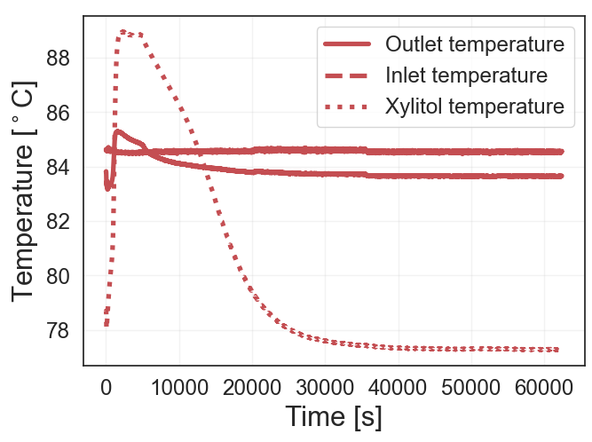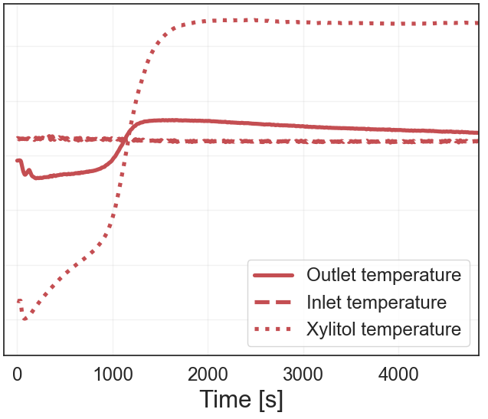
Fig. 5. Temperature evolution of the system. Right: Zoom of the start of the experiment.
3.3. System characteristic times
As the LHTES prototype was characterized primarily from an energy perspective, the system kinetics were studied by the maximum power time and the discharge time. Table 4 summarizes the maximum power time and the time required to reach the discharge of the test for five representative tests from the experimental campaign.
Table 4. Maximum power time and discharge time of 5 different tests.
Temperature [ºC] | Stirring speed [rpm] | Seed mass [mg] | Maximum power time [s] | Discharge time [s]
80 | 500 | 0 | 627.430 | 1171.169
90 | 100 | 12.5 | 15432 | 38988
85 | 500 | 12.5 | 1791.91 | 19049.8
80 | 1000 | 12.5 | 625.60 | 14374.55
90 | 500 | 125 | 103.140 | 6792.012
Assessing the influence of operating variables on crystallization generally requires a large number of experiments, and the effect of the different operating conditions on the system characteristic times were studied through the main effect plots.
3.3.1 Maximum power time
Fig. 6 a shows that the time to maximum power is longer at 90 °C than at 80 and 85 °C, which exhibit similar values. Stirring speed (Fig. 6 b) also has a clear influence, with longer times observed at lower speeds. This differs from the rheometer results shown in literature (Navarro et al. 2025), where temperature was the dominant factor and shear had only a limited effect on crystallization. The discrepancy may be related to the narrower shear-rate range investigated in the rheometer, whereas the broader agitation range used in the prototype reveals a stronger stirring effect, consistent with previous studies (Mura and Zaccone 2016; Lebon et al. 2022). The longest times are observed at 90 °C and 100 rpm.
Seed mass (Fig. 6 c) showed high variability in the time to maximum power, preventing clear conclusions regarding its influence.
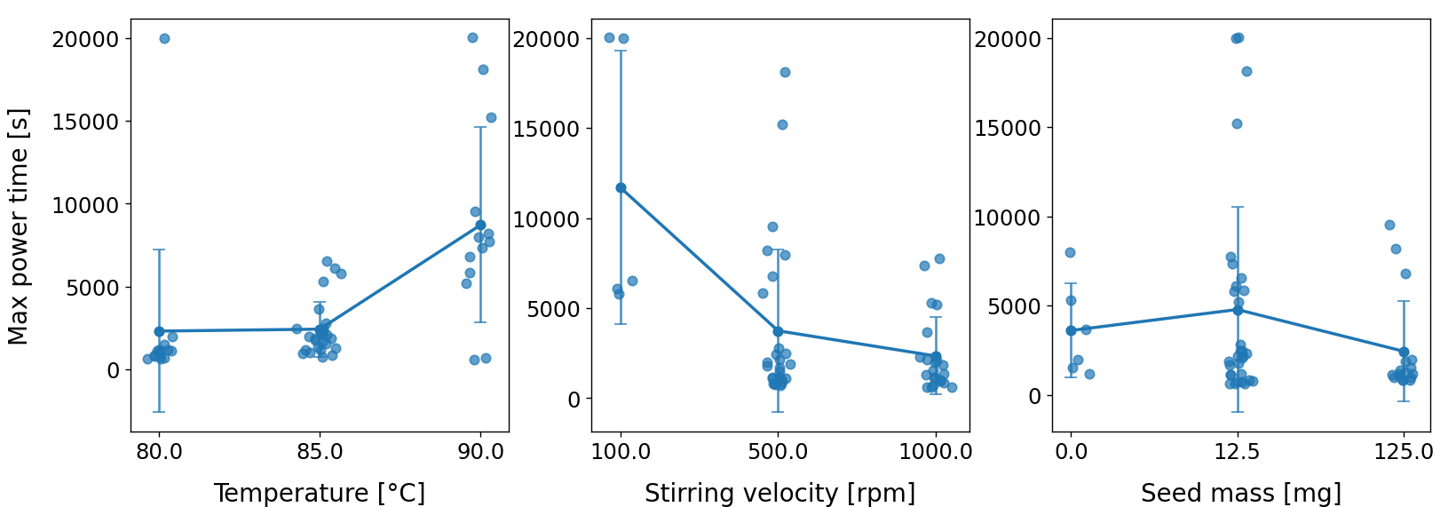
c
b
a
Fig. 6. Main effects of the time for maximum power.
3.3.2 Discharge time
Fig. 7 shows the effects of temperature, stirring speed, and seed mass on discharge time. Tests at 90 °C generally exhibited the longest discharge times, consistent with the rheometer results and the lower degree of supercooling at this temperature. However, the high experimental variability prevented firm conclusions regarding either temperature or seed mass.
In contrast, stirring speed showed a clear effect. Tests at 500 rpm had shorter discharge times than those at 100 and 1000 rpm. At 100 rpm, weaker agitation likely reduced secondary nucleation, slowing crystallization and delaying energy release, in agreement with the literature (Agrawal y Paterson 2015; Bosetti et al. 2020). The increase in discharge time at 1000 rpm indicated an optimum around 500 rpm and suggested that excessive agitation may hinder complete crystallization.
During the experiments at 1000 rpm, xylitol remained partially crystallized in a paste-like state around the stirrer and did not fully release its stored energy until stirring was stopped. This behaviour, also reflected in the power curves in Fig. 3, may have resulted from crystal-cluster breakup that inhibits agglomeration and growth, or from viscous dissipation locally increasing the xylitol temperature and hindering solidification. After stirring stopped, the remaining energy was released slowly because of the low crystallization rate without shear. Overall, an intermediate stirring speed of approximately 500 rpm appeared to provide the best balance between promoting crystallization and allowing complete solidification.
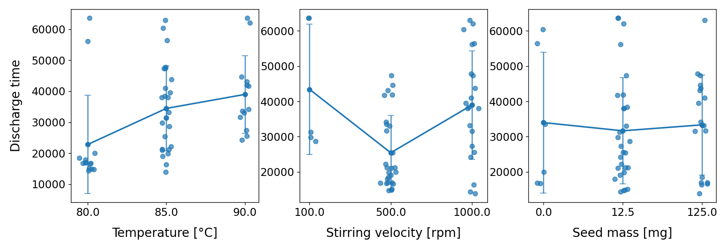
Fig. 7. Main effects of temperature, stirring velocity and seed mass on discharging times
3.3. System modelling
An empirical modelling approach based on the experimental thermal power curves is adopted in this work. From the experimental campaign carried out with the stirred tank, a thermal power curve was obtained for each test. Each curve was therefore associated with a specific combination of initial temperature, stirring speed, and seed mass. Based on this information, it was possible to fit a function capable of representing the thermal power evolution of the system as a function of these operating parameters.

For power curve modelling, the curve_fit function from the Scipy library of the Python programming language was used. Fig. 8 shows the three power curves at 85°C, 500 rpm, and 12.5 mg, together with the fitted function. This function corresponded to a lognormal function, with the different parameters A, µ and σ in the text box in the figure. These parameters have been calculated as the average of the individual curve fits. Similarly, the R² shown is the average of the R² values of the individual fits. Table 5 shows some of the characteristic parameters, as well as the model’s R². Overall, there is good agreement between the model and the data.

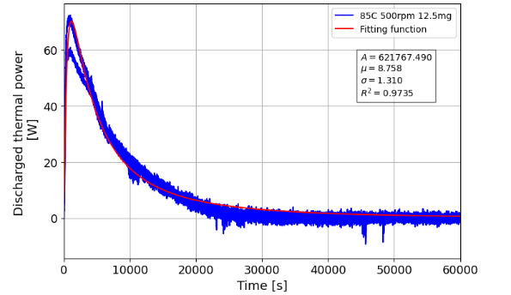
Fig. 8. Discharging thermal power and log normal fitting function

Table 5. Fitting of the lognormal parameters
Temperature [ºC] | Stirring velocity [rpm] | Seed mass [mg] | log(A) | µ | σ | R²
85 | 500 | 12.5 | 13.617 | 9.081 | 1.382 | 0.967
90 | 500 | 12.5 | 13.280 | 9.414 | 0.747 | 0.970
80 | 500 | 25 | 13.379 | 8.578 | 1.561 | 0.987
90 | 500 | 0 | 13.276 | 9.525 | 0.659 | 0.979
85 | 500 | 12.5 | 13.315 | 8.719 | 0.971 | 0.974

- Conclusions
This study investigated the thermal performance of a thermal energy storage system using xylitol as a PCM. It was demonstrated that the seeding and shearing technique is affecting in controlling the thermal behaviour of the xylitol during solidification. It was determined that the temperature difference between xylitol and the heat transfer fluid is the most influential parameter, as a higher degree of supercooling accelerates the attainment of maximum power. The maximum power is also highly influenced by the temperature, as the lower temperature tests show higher maximum thermal power. Furthermore, an optimum stirring speed of approximately 500 rpm was identified, as lower speeds (100 rpm) significantly reduce the thermal power, whilst excessive speeds (1000 rpm) hinder the complete crystallization of the material by keeping it in a pasty state. However, it has been observed that the temperature difference between the system and the heat transfer fluid inlet greatly influences the thermal power. From the analysis of all the experimental data, an empirical model was obtained to predict the instantaneous thermal power as a function of the initial temperature, the stirring velocity, and the seed mass used to trigger crystallization. Regarding the model, the power has been adjusted to a log-normal function, and a good fit has been observed.

- Acknowledgements
This work has been partially financed by the State Research Agency (SRA) and European Regional Development Fund (ERDF). Research Project: PID2023-148958OB-C21 and Grant PRE2021-097131 funded by MICIU/AEI/ 10.13039/501100011033 and, as appropriate, by “ERDF A way of making Europe”, by “ERDF/EU”, by the “European Union” or by the “European Union Next Generation EU/PRTR” with the additional support of the government of Aragon (Spain) (Reference group T55_23 R). Mónica Delgado thanks grant RYC2023-044207-I funded by MICIU/AEI/10.13039/501100011033 and the European Social Fund Plus. The authors would like to acknowledge the use of the Servicio General de Apoyo a la Investigación- SAI, Universidad de Zaragoza.
- References
Agrawal, Shailesh, and Paterson, A.H.J. 2015. «Secondary Nucleation: Mechanisms and Models». Chemical Engineering Communications 202 (5): 698-706. https://doi.org/10.1080/00986445.2014.969369.
Anish, R., Mariappan, V., Suresh, S., Joybari, M.M., and Abdulateef, A.M., 2021. «Experimental Investigation on the Energy Storage/Discharge Performance of Xylitol in a Compact Spiral Coil Heat Exchanger». International Journal of Thermal Sciences 159: 106633. https://doi.org/10.1016/j.ijthermalsci.2020.106633.
Barrio, E. P., Godin, A., Duquesne, M. 2017. «Characterization of different sugar alcohols as phase change materials for thermal energy storage applications». Solar Energy Materials and Solar Cells 159: 560-69. https://doi.org/10.1016/j.solmat.2016.10.009.
Bosetti, L., Mazzotti, M., 2020. «Population Balance Modeling of Growth and Secondary Nucleation by Attrition and Ripening». Crystal Growth & Design 20 (1): 307-19. https://doi.org/10.1021/acs.cgd.9b01240.
Delgado, M., Navarro, M., Lázaro, A., Boyer, S.A.E., Peuvrel-Disdier, E. 2021. «Triggering and acceleration of xylitol crystallization by seeding and shearing: Rheo-optical and rheological investigation». Solar Energy Materials and Solar Cells 220: 110840. https://doi.org/10.1016/j.solmat.2020.110840.
Diarce, G., Gandarias, I., Campos-Celador, A., García-Romero, A., Griesser, U.J. 2015. «Eutectic Mixtures of Sugar Alcohols for Thermal Energy Storage in the 50–90°C Temperature Range». Solar Energy Materials and Solar Cells 134 (marzo): 215-26. https://doi.org/10.1016/j.solmat.2014.11.050.
Duquesne, M., Barrio, E.P., Godin, A. 2019. «Nucleation Triggering of Highly Undercooled Xylitol Using an Air Lift Reactor for Seasonal Thermal Energy Storage». Applied Sciences 9 (2): 267. https://doi.org/10.3390/app9020267.
Lebon, G.S.B., Patel, J.B., Fan, Z. 2022. «Numerical Studies of Batch and Inline High Shear Melt Conditioning Technology Using Different Rotors». Crystals 12 (9): 1299-1299. https://doi.org/10.3390/cryst12091299.
König-Haagen, A., Höhlein, S., Lázaro, A. 2023. «Analysis of the Discharging Process of Latent Heat Thermal Energy Storage Units by Means of Normalized Power Parameters». Journal of Energy Storage 72: 108428. https://doi.org/10.1016/j.est.2023.108428.
Piquard, L., Gagnière, E., Largiller, G., Mangin, D., Bentivoglio, F. 2022a. «Triggering Xylitol crystallization in a 42 kWh shell and tubes latent heat thermal energy storage system». Applied Thermal Engineering, advance online publication. https://doi.org/10.1016/j.applthermaleng.2022.119802.
Piquard, L., Gagnière, E., Largiller, G., Mangin, D., Bentivoglio, F. 2022b. «Xylitol used as phase change material: Nucleation mechanisms of the supercooling rupture by stirring». Journal of energy storage 48 (abril): 103922-103922. https://doi.org/10.1016/j.est.2021.103922.
Mehling, H., Cabeza, L.F. 2008. Heat and Cold Storage with PCM: An up to Date Introduction into Basics and Applications. Heat and Mass Transfer. Springer Berlin Heidelberg. https://doi.org/10.1007/978-3-540-68557-9.
Mura, F., Zaccone, A. 2016. «Effects of Shear Flow on Phase Nucleation and Crystallization». Physical Review E 93 (4): 042803. https://doi.org/10.1103/PhysRevE.93.042803.
Navarro, M., Diarce, G., Lázaro, A., Rojo, A., Delgado, M. 2023. «Comparative Study on Bubbling and Shearing Techniques for the Crystallization of Xylitol in TES Systems». Results in Engineering 17: 100909. https://doi.org/10.1016/j.rineng.2023.100909.
Navarro, M., Gracia, Z., Asín, J., Lázaro, A., Martí, M., Delgado, M. 2025. «Rheological Study on Xylitol Crystallization for Its Use as Phase Change Material: Analytical and Statistical Analysis». Solar Energy Materials and Solar Cells 292: 113803. https://doi.org/10.1016/j.solmat.2025.113803.
Navarro, M., Lázaro, A., Delgado, M. 2026. «Evaluation of Thermal Energy Storage for Medium-Low Temperature Applications: Comparison of Commercial Solutions with a Xylitol-Based Prototype». Energy 356: 141149. https://doi.org/10.1016/j.energy.2026.141149.
Puupponen, S., Seppälä, A. 2018. «Cold-crystallization of polyelectrolyte absorbed polyol for long-term thermal energy storage». Solar Energy Materials and Solar Cells 180: 59-66. https://doi.org/10.1016/j.solmat.2018.02.013.
Richard, D., Speck, T. 2015. «The Role of Shear in Crystallization Kinetics: From Suppression to Enhancement». Scientific Reports 5 (1): 14610. https://doi.org/10.1038/srep14610.
Xuefeng, S., Yang, S., Fan, L., Yuan, Y. 2023. «Sugar Alcohol Phase Change Materials for Low-to-Medium Temperature Thermal Energy Storage: A Comprehensive Review». Journal of Energy Storage 68: 107848. https://doi.org/10.1016/j.est.2023.107848.
Zhang, H. H., Duquesne, M., Godin, A. 2017. «Experimental and in silico characterization of xylitol as seasonal heat storage material». Fluid Phase Equilibria 436: 55-68. https://doi.org/10.1016/j.fluid.2016.12.020.

