EuroSun2026
AN EVIDENCE-BOUND WORKFLOW FOR FLOATING PHOTOVOLTAIC SCREENING ONLAKES: APPLICATION TO LAC DU BOURGET, FRANCE

Hosam Mahmod¹ (corresponding author), Christophe Ménézo¹ 2, Martin Thebault¹ 3, Ahmed Elagami² 4
Affiliations: ¹ Solar Academy, Université Savoie Mont Blanc, Le Bourget-du-Lac, France
² Faculty of Informatics, Eötvös Loránd University, Budapest, Hungary
Corresponding author’s Email: hosam.mahmod@etu.univ-smb.fr
Summary
Floating photovoltaic (FPV) systems are expanding as a way to increase renewable electricity production without using additional land. However, evaluating FPV on lakes requires more than estimating photovoltaic yield. Changes in surface radiation and near-surface wind may affect lake temperature, vertical mixing, stratification, evaporation, and water quality. These effects are difficult to assess because they depend on lake characteristics, FPV coverage, system design, and the quality of the available local evidence. This paper presents an evidence-bound research software workflow for integrating lake observations, hydrometeorological data, lake-temperature modelling, FPV sensitivity scenarios, and photovoltaic energy calculations. The workflow was tested using Lac du Bourget, France, which has long-term observations of water temperature, oxygen, chemistry, phytoplankton, chlorophyll, transparency, and primary production, together with hydrological and meteorological records. The General Lake Model was evaluated at Point B using withheld observations and a separate no-refit 2015–2017 run. The later evaluation produced a pooled temperature RMSE of 0.534 °C, while the upper 0–5 m had an RMSE of 1.429 °C. FPV scenarios from 1% to 30% coverage were then simulated using transferred shading and wind-reduction parameters. At 30% central coverage, the model produced approximately −1.50 °C surface-temperature change, −0.82 °C volume-weighted change, and 27 fewer stratified days. PVGIS and PySAM annual energy estimates differed by 0.046%, confirming calculation consistency rather than independent yield accuracy. The results demonstrate the value of the workflow for reproducible FPV screening. The analysis also identifies the limits of model-based prediction, including the absence of local FPV measurements, validated evaporation suppression, causal ecological and methane assessments, and construction-grade engineering data.Keywords: Floating photovoltaic, Lac du Bourget, lake thermal modelling, General Lake Model, FPV sensitivity analysis, lake stratification, evaporation, reproducible screening.
Field of application for the findings: Floating photovoltaic planning, renewable-energy assessment, and environmental screening of inland lakes using thermal, hydrological, and ecological evidence.
Addressed audience: Researchers in solar energy and limnology, FPV developers, lake and water-resource managers, environmental authorities, and engineers conducting early-stage FPV feasibility studies.
- Introduction
Floating photovoltaic (FPV) systems are expanding as a way to increase renewable electricity generation while using water surfaces instead of additional land. Their potential benefits include electricity production, possible reductions in evaporation, and, in some cases, reduced exposure of water bodies to climate-induced warming. However, the environmental response of an FPV system depends strongly on the characteristics of the host water body and on the design and coverage of the installation (Exley et al., 2025).
A lake is not simply a platform for photovoltaic modules. FPV structures can reduce incoming solar radiation and near-surface wind, changing the surface energy balance and the physical exchange between the atmosphere and the water. These changes may affect surface temperature, vertical mixing, thermocline depth, stratification duration, and evaporation (Ilgen et al., 2023). The consequences may also extend to water quality and ecology. For example, recent field observations in a shallow reservoir associated FPV coverage with changes in benthic algae and cyanobacteria, showing that ecological responses cannot be inferred from energy production alone (Sandrini et al., 2025).
Previous studies have used numerical lake models to examine the effects of FPV coverage on temperature, stratification, evaporation, and water quality. Ilgen et al. (2023) combined field observations and the General Lake Model (GLM) to investigate FPV-related changes in lake temperature and stratification. The study measured reductions in irradiance and near-surface wind beneath and around the FPV system, then represented these effects in model scenarios. Other modelling work has shown that the response to FPV coverage can vary with season, climate conditions, and the amount of surface covered (Exley et al., 2025). Evaporation studies have also shown that coverage ratio is important, while the effects of layout, orientation, wind, and plant geometry remain dependent on the modelling assumptions and require further validation (Berlioux et al., 2025).
These studies demonstrate the value of modelling, but they also reveal an important methodological problem. The field does not lack individual models. GLM can simulate lake thermal and hydrological behaviour, while other tools can estimate photovoltaic production or calculate physical lake diagnostics. The practical gap is the lack of an integrated, evidence-bound workflow that connects local observations, data-quality control, lake-model evaluation, transferred FPV parameters, energy calculations, and explicit limits on the claims that can be made. This gap is especially important when results from one lake are transferred to another lake without local FPV measurements.
Lac du Bourget provides a suitable case study for addressing this problem. It is supported by long-term observations of temperature, oxygen, chemistry, phytoplankton, chlorophyll, transparency, and primary production, together with lake-level, tributary-flow, meteorological, and published thermal-model evidence. These data allow FPV scenarios to be evaluated against an existing observational record rather than against a generic or completely unmeasured lake.
This paper presents and tests a reproducible research software workflow for evidence-bound FPV screening at Lac du Bourget. The workflow integrates public and supplied observations, quality control, the GLM open-water temperature model, transferred FPV shading and wind-reduction scenarios, a retained but unpromoted evaporation diagnostic, and photovoltaic energy calculations. The study evaluates the performance of the open-water thermal model and examines the simulated response to different FPV coverage levels. It does not attempt to define a universal optimum or present transferred scenario results as measured Bourget impacts. Instead, it identifies which conclusions are supported by the available evidence and which require local environmental measurements or engineering investigations.
- Aim and scope
This case study aims to develop a software model that can acquire evidence from real public, supplied observations and observed-data inventory for Lac du Bourget to be normalized and replayed with source level provenance, then analyse, classify and calibrate those data into findings, then finally evaluate and run bounded screening scenarios to stand on those findings quality, missing gaps and needed data packages to close those gaps; to be given to the user as an initial FPV screening aid. It does not mean that the proposed FPV project is environmentally approved, technically designed, financeable, or authorized.
This paper introduces the FPV software workflow and its first conformance lake together, because neither is meaningful alone. A claim-limiting architecture that has never been run against real observations is untested, and a single-lake model result without a stated evidence boundary is not transferable. The workflow spans eleven scientific domains; geometry, morphology, thermal physics, photovoltaic energy, evaporation, water quality, ecology, carbon and methane, metocean loading, mooring and geotechnics, and economics of which only a subset can be supported by the evidence currently available for Lac du Bourget. Which domains return results and which return refusals is itself reported as a result in Section 4.6.
- Methodology
3.1. Workflow architecture
The workflow is organised as four planes bound by a single evidence contract. Source plugins acquire observations from public and supplied providers and preserve the original response bytes. Lake packs bind site-specific knowledge: canonical identity and aliases, shoreline geometry, gauge and tributary identifiers, provider mappings, coordinate and datum transformations, accepted parameter sets, and validation datasets. Topic plugins hold scientific methods that remain independently replaceable, so that a missing dataset in one domain does not block an unrelated domain. Mature external engines perform the numerical work wherever a maintained implementation exists.
The execution boundary between languages is explicit: typed orchestration, schemas and resource policy in TypeScript produce an immutable request with content-addressed inputs; a pinned Python or compiled numerical core executes it; the returned artefact is verified against its schema and digest; and only then does it become a claim-bounded result. A research agent may discover sources, explain gaps, stage captures and propose adapters, but it cannot manufacture observations, bypass validation, or promote a candidate plugin. Deterministic gates make that decision.
The current registry contains the plugins, of which performing data acquiring and simulations execution. The scientific register contains the active methods and pinned upstream interfaces, selected from a research inventory of candidate equations and coefficients from research sources. Figure [1] shows the resulting evidence lineage: literature or search discovery never enters a model directly; the original response is captured and hashed, normalised under explicit quality rules, executed by a pinned method, and exported with its claim level attached.
3.2. Evidence model and the claim ceiling
Every value entering the workflow carries exactly one evidence class: Observed, Derived, Estimated, Transferred, User-supplied, or Unknown. Every result carries one of seven ordered claim levels: inventory, descriptive, screening, temporally validated, transferred scenario, site validated, and engineering ready.
The two are joined by a single deterministic rule. For a result computed by a method of ceiling Lmethod from n inputs of levels Linput,i, and a missing required input produces a refused result rather than a default value. A result can therefore never be stronger than its weakest input, and no choice of wording can raise it. Equation (1) is the methodological core of the workflow: it is what prevents a qualified engine from lending its own credibility to unqualified data.
Validation is treated as a seven-level hierarchy rather than a binary state: (L0) unit, dimensional, property and regression tests; (L1) parity against published results or a second mature implementation; (L2) calibration and withheld-profile evaluation within one lake; (L3) expanded temporal evaluation without refitting; (L4) independent-lake validation against measured covered and control FPV observations; and (L5) engineering verification with specialist review. The present study reaches level (L3).
3.3. Acquisition, provenance and quality control
The accepted acquisition run captured 82 hash-bound artefacts. For each, the request, the raw response bytes, the source URL, the provider metadata, the SHA-256 digest, the normalised file and a completion matrix are retained. Five supplied observational archives were preserved byte-for-byte and normalised into seven analytical views; normalisation records encoding, delimiter, column names, units, platform identity, date range, row count, missingness, duplicates and repairs. Only the normalised research artefact is committed, and the report manifest binds it to its canonical run identifier.
Quality gates are deterministic and are recorded whether or not they fire. In the Lac du Bourget intake they quarantined 6 336 corrected-oxygen rows exhibiting a field anomaly and 8 raw oxygen rows, flagged 14 negative chlorophyll values and 3 negative photosynthetically active radiation values, and applied 2 structural parser repairs to archived bytes that were themselves left unchanged. No temperature value fell outside (0 – 40 °C) and no depth outside (0 – 200 m). Access credentials for authenticated providers are read from environment variables and are never written into logs, commands, receipts or reports.
The clean run downloaded all raw captures rather than satisfying requests from an offline fixture as shown in Table [1]. Public hydrology comes from HydroPortail and Hub’Eau; hourly forcing comes from Météo-France. The PoC also captures the official 2022 lake surveillance report, BRGM geoservice evidence, and persistent identifiers or authoritative pages for the research datasets.
3.4. Scientific modules and imported open-source software
The workflow deliberately reuses maintained scientific software wherever one exists, and implements locally only what is specific to the evidence contract. Table 2 lists every module, whether its numerics are implemented locally or delegated to a pinned upstream engine, and the claim ceiling the module can reach at Lac du Bourget with currently available evidence.
Lake physics, reference evapotranspiration, mooring, photovoltaic performance, numerical finance and multi objective optimisation all reuse qualified upstream implementations. Geometry, evidence governance, scenario assembly and result contracts are implemented locally. This division is deliberate: it limits the volume of unverified custom numerical code, and it makes every scientific result attributable to a citable, versioned method.
3.5. Lake thermal model configuration
Lake physics is executed by the official General Lake Model, version 3.3.3, through the glm-py 0.5.0 interface. GLM is a one-dimensional layered model of surface heat exchange, vertical mixing, hydrology and lake dynamics. It is not reimplemented; the compiled binary is pinned by digest.
Model inputs are assembled from the captured observational temperature profiles, hourly meteorological observations, radiation joined from a global reanalysis product, three tributary discharge series, and a volume conserving screening hypsography of the form equation (2), where A(z) is the horizontal area at depth z, A₀ the surface area, z_{max} the maximum depth and V the lake volume. With the published values A₀ = 44.5 km², z_{max} = 147 m and V = 3.6km³, Eq. (2) gives p = 0.817083 and a mean depth of 80.899 m. The curve integrates to the published volume by construction, but it contains no local lakebed geometry, slope or obstruction information, and it is therefore recorded as Estimated rather than Observed. Section 4.7 quantifies the consequence.
Two boundary conditions require explicit statement. No observed exchange through the lake’s navigable canal exists within the 2010 – 2013 model window, so outflow is balanced against observed tributary inflow and declared a model boundary rather than an observation; the model cannot validate canal dynamics. Tributary inflow temperature is derived from a seven-day air-temperature proxy and is labelled Estimated.
3.6. Representation of FPV coverage
FPV coverage is represented as a modification of two surface forcing terms. For a coverage fraction f, an irradiance reduction r_{SW} and a wind reduction r_{u} measured beneath an existing FPV array, where SW and u are the open-water short wave irradiance and wind speed, and k_{SW} and k_{u} are the calibrated forcing factors. Table 3 lists every coefficient with its evidence class (eq. 3, 4).
The central transfer uses a 73% reduction in broad band global horizontal irradiance over 0.3 – 2.8 µm and a 23% reduction in near-surface wind, measured beneath and around the Lake Maiwald FPV system by Ilgen et al. (2023). The irradiance coefficient is a broad band quantity and is not a photo synthetically active radiation coefficient. The 2026 author correction to that paper changes the printed form of two equations while confirming that the published results were computed with the corrected form (Ilgen et al., 2026). The transfer remains a transfer: Lac du Bourget has no equivalent covered and control measurement.
Equations (3) and (4) modify two terms of the surface energy balance. Table 4 states which terms respond to coverage in this experiment and which do not.
A matched 30% run confirms that the wind pathway is active: adding the transferred wind reduction changes the shading-only surface response. Horizontal patchiness and sky-view geometry are likewise not represented. The resulting temperatures therefore cannot be interpreted as a complete FPV surface energy balance.
3.7. Evaluation design and metrics
For modelled values Mi and observed values Oi on a common date and depth grid, with errors e_{i} = M_{i} − O_{i} over n comparisons, (eq. 5). Errors are additionally reported over disjoint half-open depth strata ([0, 20], [20, 40], [40, 100] and [100,∞]) m. For strata of size nj and error RMSE_{j}, (eq. 6) which provides an arithmetic check that the strata partition the comparison set exactly and reproduce the pooled error. Temperature differences are reported in °C; for differences this is numerically identical to K.
The evaluation protocol was fixed before calibration. The simulation is initialised from an observed profile on 2010-08-04. Three parameters — wind factor, shortwave factor and light extinction — are calibrated by deterministic differential evolution against two profiles, on 2011-08-10 and 2012-08-08. A profile on 2013-08 06 is withheld from the optimiser and used as the first evaluation. A further 96 profile dates inside the same continuous simulation, none seen by the optimiser, are then compared without any refitting. Finally, a separate reinitialised run covering 2015-06-10 to 2017-12-12 is evaluated on 56 further dates, again without refitting. All comparisons use a 1 m depth grid.
Acceptance thresholds were declared in advance: RMSE ≤ 2.5 °C, r ≥ 0.85, NSE ≥ 0.70 and |bias| ≤ 1.5 °C. These are internal screening thresholds for the present decision, not a universal definition of model validity.
3.8. Photovoltaic energy and scenario differencing
Scenario effects are reported as differences against the corresponding open-water run, (eq. 7) so that every reported FPV quantity is a difference between two runs of the same configuration rather than an absolute prediction.
Photovoltaic yield is calculated for a declared horizontal-plane crystalline-silicon reference system using the PVGIS 5 non-interactive service (Huld et al., 2012), and independently recomputed with PySAM using the PVWatts v5 model (Dobos, 2014) on the same input, with a 10% gross-error ceiling. No FPV cooling uplift is applied to the yield. The coupling from modelled water surface temperature to module operating temperature and hence to conversion efficiency is not implemented in the present register, so this energy module reports an open-water screening yield.
- Results
Lac du Bourget is a deep, warm monomictic peri-alpine lake in Savoie, France. The observational core of this study is the long-term monitoring station Point B (5.86◦E, 45.75583◦N).
4.1. Photovoltaic energy and scenario differencing
Table 1 lists the datasets used and the role each plays. Observations from the lake observatory are used under their published terms of use (Rimet et al., 2020); no restricted raw data are reproduced here. The regional export contributes 312 net-new temperature observations at Point B for 2024–2025, spanning 0.1 to 142.1 m; a 52-row profile republished from the observatory archive was identified and counted once.
4.2. Thermal model evaluation
Table 5 reports the four evaluation stages in the order they were executed. Over the 96-date set the model gives MAE 0.337 °C, bias −0.171 ◦C, r = 0.984 and NSE 0.965, with a date-weighted RMSE of 0.647 °C. All four predeclared thresholds are cleared, the tightest being bias at approximately 11% of its allowance. The calibration row establishes nothing on its own; the evidence lies in the two stages where no parameter was re-adjusted. Figure 2 shows modelled against observed temperature and the distribution of whole-profile error against the acceptance threshold.
An independent, model-free reference was also computed. Pairing four 2024 profiles with four 2025 profiles by meteorological season, and interpolating only within observed reference-depth support, gives 142 comparisons with a pooled RMSE of 1.143 °C, MAE 0.603 °C, bias −0.055 °C, r = 0.975, and a 0–5 m RMSE of 1.591 °C. A deterministic whole-profile boots trap over 4096 resamples gives a descriptive pooled-RMSE interval of 0.483–1.561 °C. This is a seasonal profile-persistence baseline, not a validation of GLM; its value is that it independently places the observational surface variability at Point B on the same order as the modelled surface error.
4.3. Depth-resolved error
Table 6 decomposes the 96-date evaluation by depth. The pooled error is dominated by deep water, which is thermally quiescent throughout the year and correspondingly easy to reproduce. Only about 4% of the comparisons lie in the upper 5 m — the only layer on which an FPV array acts — and there the error is approximately twelve times larger than below 100 m. Reporting a single pooled RMSE would therefore substantially overstate the model’s skill for the question this study asks. This decomposition is in expensive to compute and, in the authors’ view, should accompany any lake-model result that is used to support a surface-forcing conclusion.
4.4. FPV coverage scenarios
Low, central and high shielding bands were run for every integer coverage from 1% to 30%, producing 90 GLM simulations. Table 7 gives the central results at selected coverages and Figure 3 shows the full bands. The 30% endpoint corresponds to13.35 km² of whole-lake surface. It is a model stress test and not a proposed, permitted or buildable footprint; no exclusion analysis has been performed. The response is nonlinear across the range, so the bands should not be interpolated to coverages outside those simulated.
4.5. Photovoltaic energy
For the declared horizontal-plane reference system, PVGIS gives a specific yield of 1088.471 kWh kWp⁻¹ yr⁻¹ and PySAM 1088.967 kWh kWp⁻¹yr⁻¹, an annual relative difference of 0.046% against the 10% acceptance ceiling, with a maximum monthly difference of 7.902%. Both engines consume the same irradiance input, so this agreement demonstrates consistency of units, time handling and implementation between two independent codebases. It is not an independent validation of yield accuracy, and it contains no FPV-specific gain (Fig. 4).
4.6. Module outcomes
The workflow executes every registered module for every lake. A module that cannot be supported by compatible local evidence returns a refusal naming the missing role, rather than a number derived from defaults. Table 8 reports the outcome for each domain.
Six of the twelve domains return refusals. That is the claim ceiling of Eq. (1) operating as designed. The value of the refusal is that it is specific: in each case the missing dataset, its owner class and its acceptance criteria are named, so the cost of removing the limitation can be estimated rather than guessed.
4.7. Morphology reconciliation
The measured 145-row depth–area table for the lake was obtained after the simulations reported above were completed. It was reconciled against the analytical curve of Eq. (2) in Table 9 without merging the two, because the survey provenance, horizontal and vertical datum and reference water level are not yet documented, and an undocumented table cannot be promoted above Estimated.
The volumes agree to within 1.4%, confirming that the volume-conserving construction achieved its stated purpose. The shape does not agree as well. The analytical curve overestimates horizontal area by up to approximately 9% between 5 and 20 m depth, and underestimates it below 60 m. Because a thicker, larger modelled surface layer has greater heat capacity, the surface response to a given change in surface forcing is expected to be damped; the FPV sensitivities in Table 7 are therefore likely to be conservative. Re-running the evaluation and the scenario set with the measured curve and frozen parameters is a structural sensitivity test requiring no new data, and it is the first item of further work.
- Discussion and limitations
5.1. The modelled signal is smaller than the error of the model producing it
Section 4.3 established that the relevant error scale for an FPV question is the upper-water error, 1.699 °C over the 96-date evaluation, and not the pooled error of 0.635 °C. Comparing the central modelled surface responses in Table 7 against that scale gives ratios of 0.279 at 10% coverage and 0.882 at 30% coverage. At every coverage simulated, the modelled effect is smaller than the model’s own error in the layer where the effect occurs.
The FPV outputs of this study are therefore bounded model diagnostics, not detected effects at Lac du Bourget. They rank coverage scenarios consistently and monotonically, which is the purpose of a screening study, but they do not constitute a predictive magnitude for this or any other lake.
We suggest this comparison should be reported routinely. It is inexpensive, it requires only results the study has already computed, and it distinguishes a screening ranking from a physical prediction. A pooled error statistic cannot support that distinction, because in a deep lake it is dominated by depths at which no FPV mechanism operates.
5.2. Transferred coefficients
The central coefficients r_{SW} = 0.73 and r_{u} = 0.23 were measured at a single small German lake (Ilgen et al., 2023). Array geometry, module height above water, fetch, and atmospheric stability all influence them, and none of those conditions is reproduced at Lac du Bourget. The low and high bands exist precisely because a single transferred value would misrepresent the state of knowledge.
Normalising by nominal coverage, the central Bourget diagnostic is approximately 5.62 times stronger than the annual mean surface change reported at Lake Maiwald. We do not resolve this discrepancy here. The responses are nonlinear in coverage, and the two lakes differ by more than two orders of magnitude in area and by an order of magnitude in depth, so a per-percent normalisation is not expected to be conserved. It is reported because it is the only quantitative comparison against field evidence that the present configuration permits.
5.3. Comparison with published one-dimensional work
Applied GLM to the same lake and reported epilimnion RMSE values of 4.02 °C over a ten-year window and 4.59 °C over a thirty-seven-year window, against full-profile values of 1.74 and 1.67 °C.
This is not a parity test and not a ranking. The evaluation periods, observation sets, forcing datasets, calibration objectives and the depth definition of “surface” all differ, and the smaller errors reported here reflect a different and much shorter protocol rather than a better model. The transferable observation is the pattern common to both studies and to operational one-dimensional implementations of this lake: upper-water error greatly exceeds pooled error. That pattern is structural. A single vertical column cannot represent wind set-up, internal wave activity, or contrast between basins, and these are precisely the processes that govern the surface layer of a long, narrow, deep lake.
5.4. Structural limitations
Five limitations bound every result reported above. First, morphology is an analytical curve preserving published volume, with no local lakebed geometry; Section 4.7 now quantifies the resulting area error. Second, no observed canal exchange exists in the model window, so outflow is balanced against tributary inflow and declared a boundary; the canal reverses direction — in the 2025 record, flow was directed toward the lake on 46 days and away on 317 — so a boundary that cannot reverse omits a real physical process. Third, the calibration is not identifiable: three parameters were fitted on two dates, wind, shortwave and extinction compensate for one another, and the accepted values lie near the search bounds, which is why objective envelopes rather than confidence intervals are published. Fourth, tributary inflow temperature is an air-temperature proxy. Fifth, four surface-flux terms are absent, as declared in Table 4.
5.5. Missing field evidence, and what can be done instead
No covered and control measurement exists at Lac du Bourget, and none can be obtained retrospectively: the lake has never carried a floating photovoltaic array. This is a permanent constraint on any study of this site, not a temporary gap in acquisition.
Two substitutions are available and neither has yet been performed. The first is to validate the transfer function rather than the lake, by applying Eqs. (3) and (4) unchanged to lakes for which paired covered and control thermal measurements have been published and reporting the resulting transferability error. Care is required, since the lake supplying the central coefficients cannot also serve as their validation. The second is a small instrumented raft with paired thermistor strings beneath and away from the cover, which would not resolve a lake-scale response but would directly constrain the four absent surface-flux terms that currently bound the result.
5.6. Refusals as a reported result
Six of twelve domains in Table 8 return refusals. We report them deliberately. An FPV pre-feasibility study that returns twelve numbers, of which seven rest on undocumented defaults, is less useful to a developer, a regulator or a lake manager than one that returns five bounded numbers and seven named data requirements. The refusals also make the cost of proceeding estimable: each names a dataset, an owner class and an acceptance criterion.
- Conclusion
This paper has presented a reproducible, evidence-bound workflow for floating photovoltaic screening on lakes, and its first end-to-end application. Three elements are transferable beyond the case study. The claim ceiling of Eq. (1) prevents a qualified engine from lending credibility to unqualified inputs and converts missing data into an explicit refusal. The surface-flux contract of Table 4 publishes the mechanisms a coverage experiment does not represent, alongside those it does. The depth-resolved comparison of Section 5.1 tests whether a modelled FPV signal exceeds the error of the model producing it, at the depth where the effect occurs.
For Lac du Bourget, the open-water thermal model reached level (L3) of the six-level validation hierarchy, passing four predeclared thresholds across two evaluation stages in which no parameter was re-adjusted. The FPV coverage scenarios rank consistently but do not exceed the model’s own upper-water error, and are reported as bounded diagnostics. Six of twelve scientific domains returned refusals with named missing evidence.
Three next steps follow directly. Re-running the evaluation with the measured depth–area table and frozen parameters is a structural sensitivity test that requires no new data. Validating the transfer function against lakes with published covered and control measurements would place an external error bound on the FPV response. Beyond both, level (L5) of the hierarchy — a paired covered and control field campaign — remains the only route to a measured FPV effect at any specific lake.
- Acknowledgement
I would like to thank my supervisors Dr. Christophe Ménézo, Head of the LOCIE laboratory, and Dr. Martin Thebault, Research Scientist at CNRS and LOCIE, for supervising and guiding my work throughout the year and in particular during my internship at LOCIE; and Eng. Ahmed Elagami, software engineer, for his substantial help in building the code. This work was done within the framework of Solar Academy Graduate School, grant ANR-18-EURE-0016. Observational data for Lac du Bourget were made available by the Observatory on LAkes (OLA) information system, INRAE, under its published terms of use, and I am grateful to the OLA team for their help in providing them. Lastly, for all the researchers behind the open-sourced codes and data, thank you sincerely.
- Tables, figures, equations, and lists
8.1. Tables
Tab. 1: Observational evidence used in this study, with source and records dates.
Evidence | Original measurement or  source representation | Records
Lake level | HydroPortail hourly gauge series. | 66977 hourly lake levels from 2019.
Tributary discharge | Official daily mean discharge (Q_{mnJ}) for Leysse, Sierroz, and Tillet, preserving station revisions and m³ s⁻¹. | 8377 daily Sierroz, Leysse, and Tillet observations for 2010–2017.
Canal exchange | Signed daily Canal de Savières discharge. | 363 daily observations 2025 series.
Meteorology | Météo-France hourly station observations with native provider quality fields. | 145832 hourly Météo-France observations from 2010 onward.
Radiation | NASA POWER; shortwave forcing | Joined series.
Sonde profiles | OLA initial, calibration and withheld profiles | 215147 / 1071 dates
Public temperature profiles | OLA deposited depth/temperature rows with dataset identifier and upstream checksum. | 20936 public full-depth temperature observations.
Surface temperature | OLA deposited time series. | 687 surface-temperature observations.
Chemistry and zooplankton | Original OLA workbook fields and units. | 2139 public chemistry observations and 11268 zooplankton observations.
Regional geology | BRGM geoservice features. | 729 regional BRGM features.
Hydroacoustics | Downloadable file inventory with identifiers, sizes, and source links. | 102 downloadable hydroacoustic files.
Regional water-quality export | Naïades tributary profiles. | 527718→ 99280 of 2024–2025 profiles.
Hypsography metadata | FEMC documents exactly 145 depth/area rows and their units. | 145-row FEMC depth/area dataset.
Tab. 2: Scientific modules, implementation status, and pinned upstream software at Lac du Bourget. “Delegated” means the numerical work is performed by the named external engine at the stated version pin.
Module | Implementation | Upstream engine and version pin
Lake geometry | local | JPL spherical-polygon algorithm
Coverage and layout | local | —
Photovoltaic energy | delegated | PVGIS 5 non-interactive service; PySAM / PVWatts v5
Evaporation | delegated + local | pyet v1.3.1, FAO-56 method
Lake thermal physics | delegated | GLM 3.3.3 via glm-py 0.5.0
FPV thermal forcing | local | coefficients transferred from (Ilgen et al., 2023)
Validation metrics | local | Nash–Sutcliffe efficiency
Water quality, ecology, methane | interface pinned, not executed here | GLM-AED
Mooring | interface pinned, single line only | MoorPy
Economics and decision | local + delegated | numpy-financial 1.0.0; pymoo 0.6.1.5
Evidence governance | local | weakest-dependency rule, Eq. (1)
Tab. 3: Coefficients used in the Lac du Bourget analysis, with evidence class and origin. Bold values are the central case; the outer values define the low and high screening bands.
Symbol and meaning | Value | Evidence class | Origin
k_{u}, Wind factor | 0.721817 | Derived (calibrated) | This study
k_{SW}, Shortwave factor | 0.770660 | Derived (calibrated) | This study
Light extinction | 0.131947 m⁻¹ | Derived (calibrated) | This study
r_{SW} Irradiance reduction | 0.50 / 0.73 / 0.90 | Transferred
r_{u}, Wind reduction | 0.00 / 0.23 / 0.50 | Transferred
f, Coverage fraction | 0.01 – 0.30 | User-supplied | Scenario control
p, Hypsographic exponent | 0.817083 | Estimated | Eq. (2)
Tab. 4: Surface-flux contract for the FPV experiment. “Absent” means the experiment does not represent that mechanism; it is not silently assumed to be negligible.
Surface term | Coverage effect | Implemented boundary
Shortwave | direct | Eq. (3)
Wind | direct | Eq. (4)
Latent heat | indirect, through GLM wind | Not directly scaled
Sensible heat | indirect, through GLM wind | Not directly scaled
Longwave down | absent | Input forcing unchanged
Longwave up | absent | No explicit panel or sky-view boundary
Panel heat exchange | absent | No panel thermal boundary
Tab. 5: Four-stage evaluation of the open-water thermal model. Only the first stage used the calibration objective; no parameter was re-adjusted for any later stage.
Stage | n | RMSE (°C) | 0–5 m RMSE (°C)
Calibration, two dates | 219 | 0.544 | —
Withheld profile, 2013-08-06 | 139 | 0.687 | 2.271
96 dates, no refit, same run | 10560 | 0.635 | 1.699
2015–2017,no refit, separaterun | 3589 | 0.534 | 1.429
Tab. 6: Error by disjoint depth stratum for the 96-dateno-refit evaluation. Stratum counts sum to the pooled count and reproduce the pooled mean squared error through Eq.(6).
Depth stratum | n | RMSE (°C)
0–20 m | 1640 | 1.481
20–40 m | 1632 | 0.452
40–100 m | 4517 | 0.245
≥100 m | 2771 | 0.143
Pooled | 10560 | 0.635
Of which 0–5 m | 437 | 1.699
Tab. 7: Central modelled response to FPV coverage, expressed as differences against the corresponding open-water run through Eq. (7). The evaporation column is a signed model diagnostic.
Coverage (%) | Surface ∆T (°C) | Volume ∆T (°C) | Stratified ∆ (d) | Evaporation ∆ (10⁶ m³)
1 | − 0.040 | −0.050 | −1 | 0.133
5 | −0.224 | −0.146 | −5 | 0.726
10 | −0.474 | −0.261 | −9 | 1.470
20 | −0.983 | −0.532 | −16 | 2.907
30 | −1.499 | −0.822 | −27 | 4.252
Tab. 8: Module outcomes at Lac du Bourget. A refusal is a reportable result: it names the specific evidence that would lift it.
Module | Result obtained | Evidence blocking a stronger claim
Lake geometry | shoreline area and perimeter | project polygon and legal exclusions
Morphology | volume-conserving curve; measured table reconciled but not merged | survey provenance, datum, reference level
Thermal physics | four-stage evaluation and 90 FPV scenarios | canal exchange; absent surface-flux terms
Photovoltaic energy | specific yield and cross-engine consistency | measured FPV production; thermal–energy coupling
Evaporation | retained but unpromoted evaporation diagnostic | site open-water evaporation; validated suppression factor
Water quality | descriptive inventory only | daily nutrient loads; site parameters; withheld targets
Ecology | descriptive inventory only | registered before–after, control–impact design
Carbon and methane | refused | seasonal paired covered and control flux campaign
Waves and currents | refused | site joint extremes, fetch, water levels
Mooring | refused | coupled loads; line, anchor and soil evidence
Geotechnics | refused | cone penetration tests, cores, strength and pull-out tests
Economics | refused | binding commercial, tax, debt and revenue terms
Tab. 9: Reconciliation of the analytical screening hypsography used in the simulations against the measured depth–area table. The two are retained as distinct evidence objects.
Quantity | Analytical (used) | Measured (candidate) | Difference
Surface area | 44.500 km² | 42.575 km² | −4.33%
Volume | 3.600 km³ | 3.492 km³ | −3.00%
Mean depth | 80.899 m | 82.020 m | +1.39%
Maximum depth | 147 m | 144 m | —

8.2. Figures
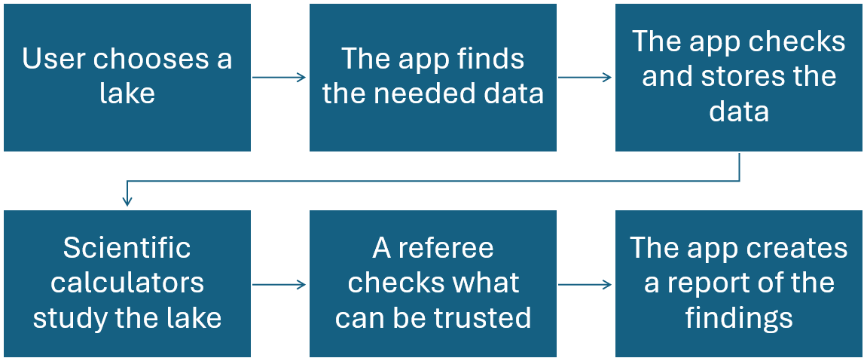
Fig. 1: Resulting evidence lineage: the original response is captured and hashed, normalized with explicit quality rules, executed by a pinned method, and exported with its claim level.
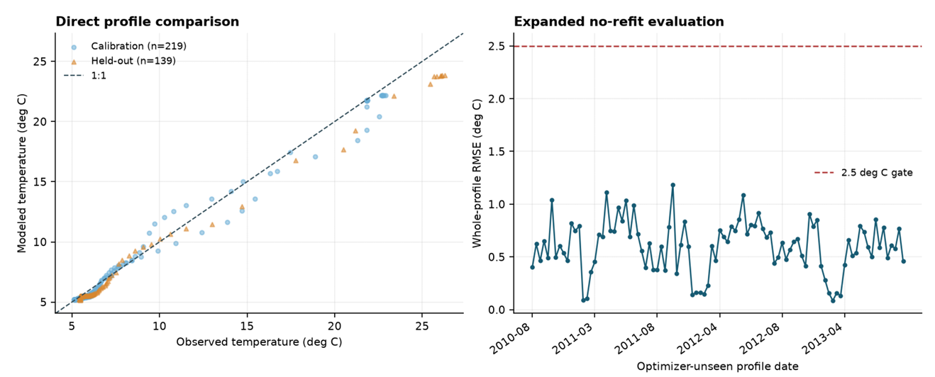
Fig. 2: Left: modeled versus observed temperatures for calibration and the predeclared held-out profile. Right: whole-profile RMSE for 96 additional optimizer-unseen dates with the acceptance ceiling shown explicitly.
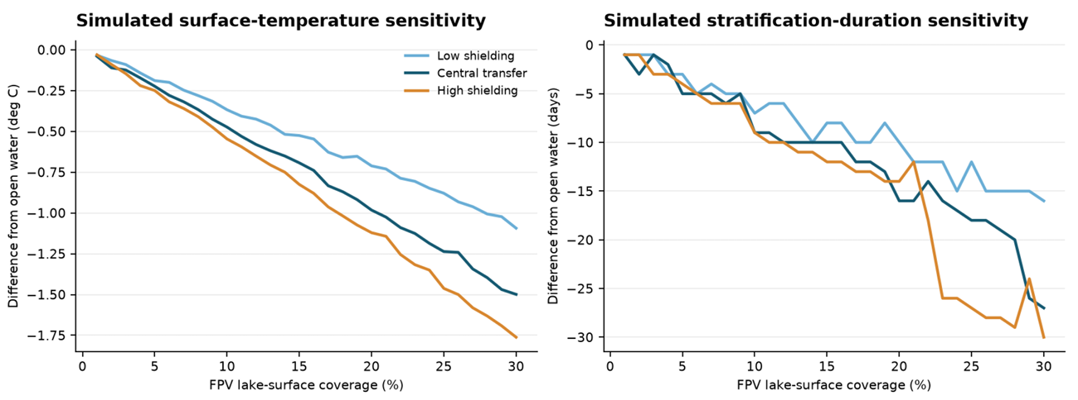
Fig. 3: Low, central, and high transferred shielding scenarios. Nonlinearity and band divergence show why a single universal FPV coefficient is not defensible.
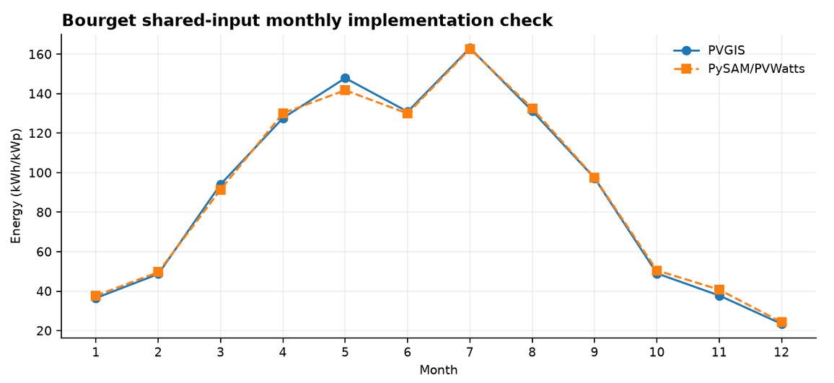
Fig. 4: Monthly PVGIS and PySAM/PVWatts outputs under the same horizontal-plane re source. The profile is more informative than an annual scalar but remains a shared-input implementation check.
8.3 Equations
$L_{result}=min⁡(L_{method}, L_{input,1},…L_{input,n})$ (eq. 1)
$A\left(z\right)=A_{0}{\left(1-\frac{z}{z_{max}}\right)}^{p} , p= \frac{A_{0} z_{max}}{V}-1$ (eq. 2)
${SW}_{eff}=SW∙k_{SW}∙(1-f∙r_{SW})$ (eq. 3)
$u_{eff}=u∙ k_{u}∙(1-f∙ r_{u})$ (eq. 4)
$e_{i}= M_{i}-O_{i}$ , $RMSE= \sqrt{\frac{1}{n}\sum_{i}{e_{i}^{2}}}$ , $MAE= \frac{1}{n}\sum_{i}{\left|e_{i}\right|}$ , $bias= \frac{1}{n}\sum_{i}{e_{i}}$ , $NSE=1- \frac{\sum_{i}{e_{i}^{2}}}{\sum_{i}{{(O_{i}-\overline{O})}^{2}}}$ (eq. 5)
$n= \sum_{j}{n_{j}}$ , $MSE= \frac{1}{n}\sum_{j}{n_{j}{ RMSE}_{j}^{2}}$ (eq. 6)
$ΔX= X_{coverage}- X_{open-water}$ , $d= \frac{\left|E_{pySAM}-E_{PVGIS}\right|}{E_{PVGIS}}$ (eq. 7)

- References
- Exley, G., Page, T., Olsson, F., Thackeray, S. J., Chipps, M. J., Armstrong, A., & Folkard, A. M. (2025). Modelling of the potential of floating photovoltaics for mitigating climate change impacts on reservoirs. Knowledge & Management of Aquatic Ecosystems, (426), 26. https://doi.org/10.1051/kmae/2025021
- Ilgen, K., Schindler, D., Wieland, S., & Lange, J. (2023). The impact of floating photovoltaic power plants on lake water temperature and stratification. Scientific Reports, 13(1), 7932. https://doi.org/10.1038/s41598-023-34751-2
- Sandrini, G., Wagenvoort, A., van Asperen, R., Hofs, B., Mathijssen, D., & van der Wal, A. (2025). Illuminating the Impact of a Floating Photovoltaic System on a Shallow Drinking Water Reservoir: The Emergence of Benthic Cyanobacteria. Water, 17(8), 1178. https://doi.org/10.3390/w17081178
- Berlioux, B., Amiot, B., Ferrand, M., Berre, R. L., Rhazi, O.-L., Vidal, J., Pabiou, H., & Knikker, R. (2025). Numerical analysis of evaporation reduction in floating photovoltaic power plants: Influence of design parameters. EPJ Photovoltaics, 16, 4. https://doi.org/10.1051/epjpv/2024047
- Ilgen, K., Schindler, D., Wieland, S., & Lange, J. (2026). Correction: The impact of floating photovoltaic power plants on lake water temperature and stratification. Scientific Reports, 16(1), 5009. https://doi.org/10.1038/s41598-026-37857-5
- Ministère de la Transition écologique. Hydroportail: Station v133001001, lac du bourget, 2026. URL https://www.hydro.eaufrance.fr/stationhydro/V13300 1001/series.
- Office français de la biodiversité. Hub’eau hydrométrie api, 2026. URL https: //hubeau.eaufrance.fr/api/v2/hydrometrie/api-docs.
- Météo-France. Données climatologiques de base horaires, 2026. URL https: //www.data.gouv.fr/fr/datasets/donnees-climatologiques-de-base-hor aires/.
- Agence de l’eau Rhône Méditerranée Corse. Lac du bourget: suivi de la qualité des eaux 2022. Technical report, Agence de l’eau Rhône Méditerranée Corse, 2022. URL https://www.rhone-mediterranee.eaufrance.fr/sites/sierm/f iles/lake_waterbody/43068/2022/rapport_bourget_2022.pdf.
- Bureau de recherches géologiques et minières. Infoterre ogc geoservices, 2026. URL https://infoterre.brgm.fr/page/geoservices-ogc.
- Frédéric Rimet, Orlane Anneville, Denis Barbet, Cécile Chardon, Laura Crépin, Isabelle Domaizon, Jean-Marcel Dorioz, Laurent Espinat, Victor Frossard, Jean Guillard, Chloé Goulon, Valérie Hamelet, Jean-Christophe Hustache, Stéphan Jacquet, Leslie Lainé, Bernard Montuelle, Pascal Perney, Philippe Quetin, Ser ena Rasconi, Antoine Schellenberger, Viet Tran-Khac, and Ghislaine Monet. The observatory on LAkes (OLA) database: Sixty years of environmental data accessible to the public. Journal of Limnology, 79(2):164–178, 2020. doi: 10.4081/jlimnol.2020.1944.
- Duquette, W. H., & Chamberlain, R. G. (2007). Some algorithms for polygons on a sphere. https://ntrs.nasa.gov/citations/20210005701
- Huld, T., Müller, R., & Gambardella, A. (2012). A new solar radiation database for estimating PV performance in Europe and Africa. Solar Energy, 86(6), 1803–1815. https://doi.org/10.1016/j.solener.2012.03.006
- Dobos, A. (2014). PVWatts Version 5 Manual (NREL/TP-6A20-62641, 1158421; p. NREL/TP-6A20-62641, 1158421). https://doi.org/10.2172/1158421
- Vremec, M., Collenteur, R. A., & Birk, S. (2024). PyEt v1.3.1: A Python package for the estimation of potential evapotranspiration. Geoscientific Model Development, 17(18), 7083–7103. https://doi.org/10.5194/gmd-17-7083-2024
- Hipsey, M. R., Bruce, L. C., Boon, C., Busch, B., Carey, C. C., Hamilton, D. P., Hanson, P. C., Read, J. S., de Sousa, E., Weber, M., & Winslow, L. A. (2019). A General Lake Model (GLM 3.0) for linking with high-frequency sensor data from the Global Lake Ecological Observatory Network (GLEON). Geoscientific Model Development, 12(1), 473–523. https://doi.org/10.5194/gmd-12-473-2019
- Nash, J. E., & Sutcliffe, J. V. (1970). River flow forecasting through conceptual models part I — A discussion of principles. Journal of Hydrology, 10(3), 282–290. https://doi.org/10.1016/0022-1694(70)90255-6
- Hipsey, M. R., Boon, C., Bruce, L. C., Thomas, Q., Weber, M., Winslow, L., Read, J. S., & Hamilton, D. P. (2022). AquaticEcoDynamics/glm-aed: V3.3.0. https://doi.org/10.5281/zenodo.7047527
- Hall, M. (2024). Generalized Quasi-Static Mooring System Modeling with Analytic Jacobians. Energies, 17(13), 3155. https://doi.org/10.3390/en17133155
- Blank, J., & Deb, K. (2020). Pymoo: Multi-Objective Optimization in Python. IEEE Access, 8, 89497–89509. https://doi.org/10.1109/ACCESS.2020.2990567
- Johansson, H., Brolin, A. A., & Håkanson, L. (2007). New Approaches to the Modelling of Lake Basin Morphometry. Environmental Modeling & Assessment, 12(3), 213–228. https://doi.org/10.1007/s10666-006-9069-z
- D. N. Moriasi, J. G. Arnold, M. W. Van Liew, R. L. Bingner, R. D. Harmel, & T. L. Veith. (2007). Model Evaluation Guidelines for Systematic Quantification of Accuracy in Watershed Simulations. Transactions of the ASABE, 50(3), 885–900. https://doi.org/10.13031/2013.23153

