EuroSun2026
ANALYTICAL AND EXPERIMENTAL MASS TRANSFER ANALYSES ON REGENERATION OF LIQUID DESICCANTS USING A SOLAR THERMAL COLLECTOR

Gezahegn Habtamu Tafesse^{*1} (corresponding author)
¹Indian Institute of Technology Delhi, Department of Mechanical Engineering, New Delhi, 110016, India
gezisha@yahoo.com
Summary
This paper analyses diurnal evaporation of water during solar regeneration of LiCl and CaCl₂ solutions using an analytical equation, convective mass transfer principle and conservation of energy and conservation of desiccant mass and found out that there is good agreement to each other. The optical, and heat transfer constants of the regenerator and mass transfer coefficient and vapor pressure constant required for the analytical and conservation relation were also determined for LiCl and CaCl₂ solutions. The optical efficiency of unglazed, single glazed and double glazed solar regenerator were found to be 94.9%, 77% and 62.5%, respectively. The average overall collector heat loss, coefficient was found to be 13.7 W/m^{2o}C for hot and 12.2 W/m^{2o}C for moderate weather conditions, respectively. The convective heat loss coefficient and mass transfer coefficient during regeneration of lithium chloride solution film were found to be of 7.5 W/m^{2o}C and 0.007 m/s (and 0.006 m/s for CaCl₂ solution), respectively for solution temperature in the range of 49-63ºC.

Keyword: Solar Liquid desiccant regenerator, Calcium & Lithium chlorides, Optical efficiency of solar thermal collectors, heat and mass transfer coefficients of solar collectors, Sorption air-conditioning technology.
Field of application for the findings: Solar air conditioning and refrigeration
Addressed audience: Journal
1. Introduction
Energy consumption within residential and industrial sectors is globally escalating fossil fuel demand and has placed a huge strain on electrical grids and the environment (IEA, 2026). Vapor compression air conditioning (VCAC) systems are contributing to the escalation through consuming massive amounts of electricity and exacerbating environmental degradation through the leakage of fluorinated refrigerants (Cian et al., 2025). In response to these pressing challenges, liquid desiccant air conditioning systems (LDACS) have surfaced as an energy-efficient and eco-friendly alternative to VCAC (Gurubalan and Simonson, 2021 ;). These systems are widely used both in residential and industrial air-conditioning systems and several simulation and experimental research works have been carried out on them. By decoupling the control of sensible and latent loads, LDACS can effectively condition outdoor air to comfort levels without sub-cooling it below the dew point. LDACS can also be seamlessly integrated with renewable resources like solar thermal collectors to curb grid peak loads and emissions. To maintain continuous operation, the solution must be re-concentrated after dehumidifying air through a regeneration mass transfer process that demands a significant input of thermal energy (Zhang et al., 2026). While advanced method like electrodialysis(ED) regenerator (Cheng et al., 2017) and solar electricity, thermo-mechanical & solar thermal technologies (Kim & Ferreira, 2008) have been explored to effectively regenerate the desiccant. Several experimental performance studies of a solar-regenerated liquid desiccant system were experimentally investigated for lithium chloride solution (Katejanekarn et al., 2009; Zhang et al., 2025). However, Kim & Ferreira (2008) recommended that future R & D on solar refrigeration should focus on low temperature sorption systems. One such low temperature solar regenerator which operates at ambient pressure is an open type corrugated or flat plate solar collector-cum-regenerator (Mullick & Gupta, 1974; Collier, 1979). The heat and mass transfer performance of various solar collector regenerator systems have been evaluated both experimentally and theoretically. Diurnal experimental regeneration performance of a solar regenerator have been reported for parallel flow (Alizadeh & Saman, 2002), counter flow (Elsarrag, 2008), and cross flow & free convection (Kabeel, 2005) cases. While forced convection enhances mass transfer via vapor shearing, it faces challenges like uneven air distribution and desiccant carryover. There are considerable theoretical studies on this system. Collier (1979) conducted analytical evaporation study whereas non-dimensional correlations have been developed to estimate heat and mass transport coefficients for estimating the evaporation rate (Hiam et al., 1992). Significant parameter gaps remain for both the experimental and theoretical studies. The evaporation performance is highly dependent on whether the system is unglazed, single-glazed, or double-glazed (Yang & Wang, 2001).To ensure uniform desiccant solution distribution over the absorber, researchers have used black cloth lining or nozzle sprays (Hawlader et al., 1993; Kabeel, 2005). A wetting factor was applied to account for dry absorber zones (Fagbenle & Karayiannis, 1998). For simplicity, simulation models of both regenerators and air dehumidifiers commonly use a linear vapor pressure correlation equation as a function of solution temperature and desiccant concentration. However, the exact values of these vapor pressure coefficients for lithium chloride and calcium chloride solutions are not specifically known across the operating temperature and concentration ranges required for dehumidification and regeneration. Theoretical performance models rely heavily on assumed values for vapor pressure relations, heat loss factors, and optical constants, yielding only approximate results. Hawlader et al. (1993) states that simplified assumptions fail to capture real-world complexity, leading to limited analytical success. Consequently, empirical values for these constants, crucial for evaluating actual solar energy conversion capacity and efficiency, remain largely unreported. This paper aims to determine the unknown optical, heat, and mass transfer coefficients for an open-type solar thermal regenerator during the experimental regeneration of LiCl and CaCl₂ solutions, while also identifying the constants for a linear vapor pressure correlation commonly used to simulate the mass transfer performance of the regeneration and dehumidification processes in desiccant cooling systems. Finally, it seeks to estimate the water evaporation rate during solar regeneration using an existing analytical equation and compares those results with values estimated by the conservation of energy, species of water, and desiccant mass.

2. Experimental setup
The solar regenerator setup was composed of absorber area 2.2 m x 1.84 m inclined at 14⁰, 3.2 mm. window glass, 57 cm x 57 cm x 33 cm solution tank connected with a 10 lpm pump and a concentric pipe solution distributor that wets the absorber entirely (Fig.1a). The absorber plate was painted with iron oxide and then blackboard paint. The details of the regeneration experimentation procedure can be look from (Gezahegn et al., 2014; Tafesse et al., 2023). The plate absorptance was measured using two Pyranometers: one facing the absorber and the other exposed to the sun for measuring reflected and incident irradiance, respectively (Fig.1b). The transmittance of single and double glasses were measured by placing two Pyranometers: one under single and another under double glass to measure transmitted lights and another exposed to the sun to measure incident light simultaneously (Fig1c). The collector heat transfer coefficients were calculated using the thermal resistance network diagram after measuring collector surface and air (Fig. 1d). Glass, absorber, solution, air WBT and DBT temperatures were measured using T-type thermocouple and RTDs every ten second using a Data logger and also solar flux using Pyranometers. A solution Densitometer was to recode density every half an hour manual from the solution tank. The uncertainty of Pyranometer, Densitometer thermocouples/RTDs, Tape rule and graduated jar were $± 3 \%$ of Pyranometer reading,$± 0.001g/cm^{3},± {0.5}^{o}C$, $± 1 mm$ and$± 20 ml$, respectively. The propagation of the measurement error into a calculated result parameter is obtained using general uncertainty analysis given by Dunn (2005):
${U^{2}}_{R}=\sum_{i}^{n}{{\left(\frac{∂R}{∂x,i}U_{x,i}\right)}^{2}}$ (1)
3. Data reduction
3.1 Analytical estimation of evaporation
The analytical differential energy balance equation used by Collier (1979) to simulate the evaporation rate of water per unit of collector was:
$η_{opt}I -U_{L}.\left(T_{sol}-T_{∞}\right)-G_{o}C_{p}\frac{dT_{sol}}{dx} -h_{fg}\frac{d{m'}_{v}}{dx}=0$ (2)
As seen, this equation is dependent on two unknown parameters: the solution temperature ($T_{sol}$) and evaporation rate (${m'}_{v}$). This equation was reduced to dependent on a single evaporation rate variable by replacing for the solution temperature and its first derivative with respect to flow length in terms of evaporation rate after applying the appropriate boundary conditions. The final analytical relation developed by Collier (1979) for simulating the rate of evaporation of water per unit width ($w$) of the solar regenerator absorber was
${m'}_{v}=\frac{G_{o}\left[\frac{A_{3}}{A_{2}} k_{2}+β\left(P_{sol,o}-P_{air,o}\right)\right]}{k_{1}-k_{2}} \exp{(k_{1}.\frac{x}{G_{o}})}- \frac{G_{o}\left[\frac{A_{3}}{A_{2}} k_{1}+β\left(P_{sol,o}-P_{air,o}\right)\right]}{k_{1}-k_{2}}\exp{(k_{2}.\frac{x}{G_{o}})}+\frac{A_{3}}{A_{2}}G_{o}$ (3)
The total mass of water evaporated from the solar collector surface can be found by multiplying Eq. (3) by the
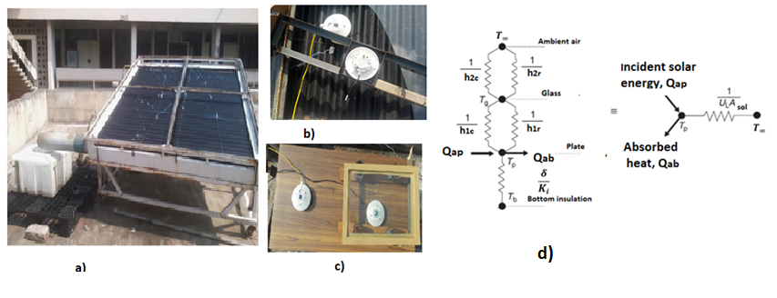
Fig. 1: Experimental setup: a) Solar regenerator; b, c & d) optical & heat transfer coefficients test rigs
width and the desired regeneration interval of time or time step ($∆t$) as
$m_{v,Δt,Collier}={m'}_{v}.w.∆t$ (4)

Where:
$A_{1}=b\frac{β}{ξ_{o}}+aβ\frac{h_{fg}}{C_{p,sol}}+\frac{{U^{'}}_{L}}{C_{p,sol}}$ ; $A_{2}=\frac{b β {U^{'}}_{L}}{ξ_{o}.C_{p,sol}}$ ; $A_{3}=\frac{β}{{Cp}_{sol}}\left[a\left(η_{opt}.I+{U'}_{L}T_{∞}\right)+{U'}_{L}\left(\frac{b}{ξ_{o}}+c-p_{v,air}\right)\right]$
$k_{1}=\frac{{-A}_{1}+\sqrt{{A_{1}}^{2}-4A_{2}}}{2}$ and $k_{2}=\frac{{-A}_{1}-\sqrt{{A_{1}}^{2}-4A_{2}}}{2}$ .
Where a, b, and c are constants in the linear vapor pressure correlation defines by Collier (1979) as:
$P_{v,sol}=a T_{sol}+\frac{b}{ξ}+c$ (5)
Collier’s (1979) mass transfer coefficient $β$, which uses vapor pressure as the driving potential, can be approximated using Arora’s (2010) humidity ration difference -driven mass transport potential. For locations like Delhi, the vapor pressures of the solution (2–7 kPa) and water (2–4 kPa) are negligible compared to the$P_{∞}=$ 99 kPa free-stream pressure. This simplification yields the relationship:
$\frac{d{m'}_{v}}{dx}=β\left(P_{v,sol}-P_{v,air}\right)=\frac{k_{ω}}{ρ}\left(ω_{eq}-ω_{v,air}\right)$=$\frac{{0.622k}_{ω}}{ρ}\left(\frac{P_{v,sol}}{P_{∞}-P_{v,sol}}-\frac{P_{v,air}}{P_{∞}-P_{v,air}}\right)→β=0.622\frac{k_{ω}}{ρ{.P}_{∞}}=0.622 \frac{h_{m}}{P_{∞} } (6)$

3.2 Estimation of rate of evaporation based on species conservation
The evaporation flux of water from solar regenerator can also be independently estimated by using species transfer relation using density as mass transfer driving potential (Incropera et al., 2011):
$m_{v}^{''}=h_{m}\left(ρ_{v,sol}-ρ_{v,air}\right)=h_{m}(\frac{P_{v,sol}}{R_{v}T_{sol}}- \frac{P_{v,air}}{R_{v}T_{air}} )$ (7)
Then total mass of water vapor evaporated from solution spreading over the absorber over a given regeneration time step interval:
$m_{v,∆t}=m_{v}^{''}A_{ab} ∆t$ (8)
The ideal gas constant,$R_{v}$ value for water was taken as 461.5 J/kg K... The equilibrium pressure of saturated water vapor above aqueous solution of LiCl and CaCl₂ , respectively are expressed as (Conde, 2004):
$$P_{v,sol}=P_{v, pw}\left(T_{sol}\right)\left\{1-{\left[1+{\left(\frac{ξ}{0.362}\right)}^{-4.75}\right]}^{-0.4}-0.03\exp^{-\frac{{\left(ξ-0.1\right)}^{2}}{0.005}}\right\}*$$
$\left\{\left(2-{\left[1+{\left(\frac{ξ}{0.28}\right)}^{4.3}\right]}^{0.6}\right)+\left({\left[1+{\left(\frac{ξ}{0.21}\right)}^{5.1}\right]}^{0.49}-1\right)θ\right\}$ (9)
$$P_{v,sol}=P_{v, pw}\left(T_{sol}\right)\left\{1-{\left[1+{\left(\frac{ξ}{0.478}\right)}^{-5.2}\right]}^{-0.4}-0.018\exp^{-\frac{{\left(ξ-0.1\right)}^{2}}{0.005}}\right\}*$$
$\left\{\left(2-{\left[1+{\left(\frac{ξ}{0.31}\right)}^{3.698}\right]}^{0.6}\right)+\left({\left[1+{\left(\frac{ξ}{0.231}\right)}^{4.584}\right]}^{0.49}-1\right)θ\right\}$ (10)

Where $\frac{P_{v, pw}\left(T_{sol}\right)}{22210}=exp\left(\frac{-7.85823τ+1.839991τ^{1.5}-11.7811τ^{3}+22.6705τ^{3.5}-15.9393τ^{4}+1.77516τ^{7.5}}{1-τ}\right)$ (11)
$τ=1- θ=1-\frac{T_{sol}+273.15}{647}$ (12)
The partial pressure of water vapor in air, humidity ratio of air and humidity ratio of air at the saturation pressure can be estimated by Eq.(13), (14) and (15), respectively (ASHRAE, 2009)
$P_{v,air}=\frac{P_{∞}*W}{0.621945+W}$ (13)
$W=\frac{\left(2501-2.326t^{*}\right){W^{*}}_{s}-1.006\left(t-t^{*}\right)}{2501+1.86t-4.186t^{*}}$ (14)
${W^{*}}_{s}=0.621945\frac{{P^{*}}_{v,air}}{P_{∞}-{P^{*}}_{v,air}}$ (15)
${P^{*}}_{v,air}=exp⁡\left(\begin{aligned}-\frac{5800.2206}{t^{*}}+1.3914993-0.048640239t^{*}-0.000041764768{t^{*}}^{2} \\ -0.000000014452093{t^{*}}^{3}+6.5459673ln\left({ t}^{*}\right)\end{aligned}\right)$ (16)

3.3. Estimation of evaporation rate based on desiccant mass conservation
The evaporation rate from the solar regenerator can be accurately estimated using an equation derived based on conservation of desiccant mass in the solution tank ($m_{d}$) with experimentally measured solution volume, temperature and density in a tank before experimentation and after a desired time step (Gezahegn et al., 2014):
$m_{v,Δt}=m_{d}\left[\frac{1}{ξ_{t_{o}+\left(n-1\right)*∆t}}-\frac{1}{ξ_{t_{o}+n*Δt}}\right],where n=1,2,…$ (17)
3.4 Evaporation rate estimating relations based on energy conservation
The rate of evaporation can also be estimated using an algebraic equation found on the basis of conservation of energy equation that take into account the optical & thermal performance parameters of the solar regenerator and solution thermodynamic properties (Tafesse et al., 2023):

$m_{v,Δt}= \frac{ η_{opt}IA_{ab}Δt-{{U^{'}}_{L} A_{ab} \left(T_{P}-T_{∞}\right) ∆t+M}_{sol,t} \left(C_{P_{sol},t+Δt}T_{sol,t+Δt}-C_{P_{sol },t}T_{sol,t}\right)}{h_{fg,av}-C_{P_{sol },t+Δt }T_{sol,t+Δt}}$ (18)
The mass of solution in the tank $M_{sol,t}$ is calculated initially using the density and volume of the desiccant solution in the tank. Then the amount of total mass of water evaporated will be subtracted from this initial value to get the mass of solution for the next time step. The optical efficiency of a glazed solar collector is defined as the product of glass transmittance and plate absorptance:
$η_{opt}=τ_{g}.α$ (19)
The solar absorptance of the plate was measured by using energy conservation of incident, reflected and absorbed irradiances Eq.(20) whereas as the optical transmittance of the glass cover was estimated by taking the ratio of transmitted irradiance through glass, $I_{tra,g}$ and incident on the glass, $I_{inc,g}$ Eq.(21)
$I=I_{ref,p}+I_{ab,p}→$ $α=\frac{I_{ab,p}}{I}=1-\frac{I_{ref,p}}{I}$ (20)
$τ_{g}=\frac{I_{tra,g}}{I_{inc,g}}$ (21)
The effective collector heat loss factor (ECHLF) that accounts for top, side and bottom surface collector heat losses all losses (Fig.1d) can be easily estimated by applying energy balance to dry plate under steady state condition as expressed by
${\dot{Q}}_{ab}={\dot{Q}}_{LOST}→η_{opt}.I.A_{ab}={U^{'}}_{L} A_{ab} \left({\overline{T}}_{P}-{\overline{T}}_{∞}\right)→{U^{'}}_{L}=\frac{η_{opt}.I}{{\overline{T}}_{P}-{\overline{T}}_{∞}}$ (22)
The convective heat transfer coefficient of a single glazed, corrugated solar collector is 1.5 times the convective heat loss coefficient of a single glazed flat plate collector at the same temperature and glazing gap according to Elsherbiny et al. (1977) statement (Duffie & Beckman, 1996):
$h_{c,gc}=1.5h_{c,fg}$ (23)
The convective heat transfer coefficient for a flat plate solar collector covered by single glass (with openings at the two ends), can be found from (Incropera et al., 2011)
$h_{c,fg}={Nu}_{s} *\frac{k}{S}$ (24)
${Nu}_{s}=0.645{\left[{Ra}_{s}\left(S/L\right)\right]}^{1/4}$ for $0≤θ≤{45}^{o}$ and${Ra}_{s}\left(S/L\right)>200$) (25)
${Ra}_{s}\left(S\right)=\frac{gβ^{'}\left(T_{p}-T_{g}\right)S^{3}}{υα}$ (26)
From analogy of heat and mass transfer principles, the convective mass transfer coefficient at the interface of the solution and the ventilation air is related to the convective heat transfer coefficient by (Incropera et al., 2011):
$\frac{h_{c,gc}}{h_{m}}=\frac{k_{air}}{D_{AB}{Le}^{\frac{1}{3}}}=ρ_{air}C_{p,air}{Le}^{ \frac{2}{3}}$ (27)
The thermal diffusivity of air calculated based on measured glass, plate and ventilation air temperature varies in the range of 25.91 x10⁻⁶ to 27.06 x10⁻⁶ m²/s. The mass diffusion coefficient of water in air is taken as 0.26 x 10⁻⁴ m²/s (Incropera et al., 2011). These give the Lewis number to be around unity. Assuming the specific heat capacity and density of air as1.006 kJ kg⁻¹ K⁻¹ and 1.12 kg/m³, respectively, the ratio of the convective heat loss and mass transfer coefficients, with an uncertainty of $± 32.4$J/m³K, can be approximated as
$\frac{h_{c,gc}}{h_{m}}=1127.2 →h_{m}=\frac{h_{c,gc}}{1127.2} .$ (28)
4. Results and discussion
Three distinct categories of data are required for estimating rate of evaporation from solutions using the analytical equation and the experimental relations developed using the conservation principles. These are meteorological data, solar collector system data such a) optical efficiency ($η_{opt}$) and overall collector heat loss factor (${U^{'}}_{L}$); b) the vapor pressure constants in Eq. (5) and mass transfer coefficient in the species transfer 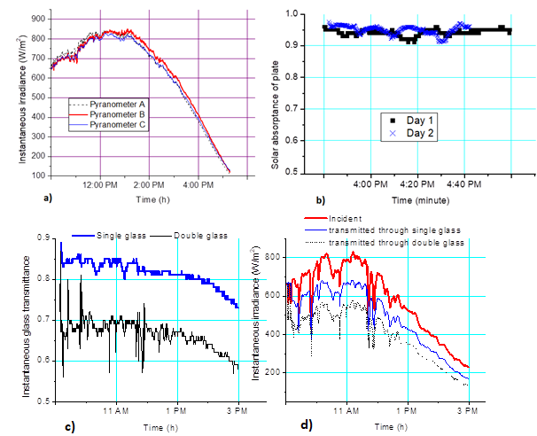
Fig.2: Irradiance readings by Pyranometer A, B & C & and measurement of incident, absorbed & transmitted irradiance
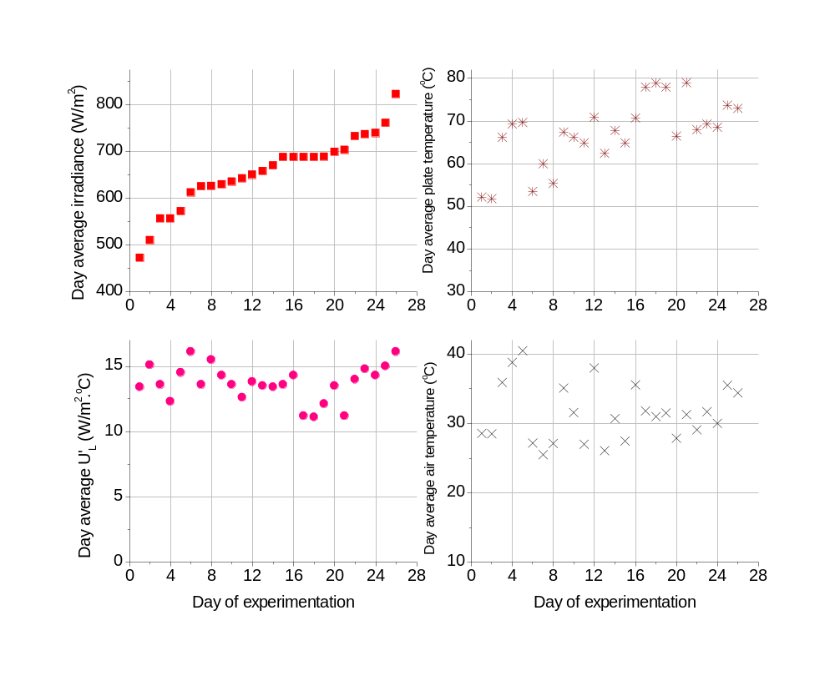
Fig.3: Day average irradiance, ECHLF and plate & ambient air temperatures for glazed regenerator for 26 days.
equation, and c) the thermo-physical property data of liquid desiccant such as specific heat, and energy of evaporation of water which are dependent on concentration and temperature as discussed before. The optical performance of the solar regenerator, detailed in Fig. 2, indicates an average dry absorber plate absorptance of 94.5% based on testing. Instantaneous measurements over two days showed absorptance ranges of 91.9–96.7% and 91.4–96.6%, with average values of 94.9% and 94.2% respectively (Fig.2b). Transmission coefficients for 3.2 mm single glass and 6.4 mm double glass (Fig. 2c) were 0.84–0.79 and 0.7–0.67, respectively, for irradiance over 550 W/m², and 0.81–0.75 and 0.67–0.6 for lower irradiance levels. Mean transmittance at intensities above 250 W/m² was 0.82 for single and 0.67 for double glazing, indicating that double glazing reduces optical performance by approximately 15%. For unglazed collectors, optical efficiency is equivalent the plate absorptance which is equal to the 94.5± 0.25%, but slightly better under flow due to reduced reflection. Average optical efficiencies for single-glazed and double-glazed systems were 77.0 ± 3.2% and 62.5 ± 2.7%, respectively. While glazing prevents dust contamination that reduces, single glazing is prioritized over double due to higher optical efficiency. A high-efficiency glass is recommended to optimize performance compared to window glass. The effective collector heat loss factor (ECHLF) averaged 12.1 ±0.92 W/m²°C for a typical day, ranging from 11 to 15 W/m²°C during operating hours. Seasonal testing across 26 days showed averages of 13.7 W/m²°C in M arch, 15 W/m²°C in April, and 12.2 W/m²°C in September (Fig.3).By creating arrays of vapor pressure at a given desiccant concentration and solution temperature using Conde’s (2004) model and equating it with Collie’s (1979) model, a vector matrices for unknown vapor pressure constants in Eq.(5) for LiCl and caCal2 solutions in the temperature ranges (30–70°C) and concentration ranges (0.3–0.46) were created. Then these Matrices were solved using curve fitting tools of MatLab with an R² of 0.9967 at a 95% confidence bound for both desiccant solutions. As a sample for specific operating temperature range of 55–60°C and a concentration of (0.35–0.4], the constants (a, b, c) were 0.2508 kPa/K, 5.318 kPa, & -92.26 kPa for LiCl solution, and 0.4678 kPa/K, 5.893 kPa and -161.1 kPa for CaCl2 solution. Performance validation against Conde’s (2004) reference equations showed maximum estimation errors of pressure only 1.9% for LiCl and 1.1% for CaCl2 at a concentration of 0.36 & temperature in the range of 55–60°C. For instance, at 58°C and 0.36 concentration, the linear model predicted a water vapor pressure of 5.568 kPa for LiCl & 10.181 kPa for CaCl₂ compared to Conde's 5.565 kPa for LiCl and 10.107 kPa for CaCl₂. These minor variances confirm the reliability of the derived constants. The dataset of constants in the linear vapor pressure correlation for all remaining concentration ranges and solution temperatures is summarized in Table 1 for simulation modeling.
Tab. 1: Values of vapor pressure constants in Eq. (5)
Concentration (kg/kg) | Temperature  (ºC) | LiCl solution |  |  | CaCl₂ solution
Concentration (kg/kg) | Temperature  (ºC) | a (kPa/K) | b (kPa) | c (kPa) | a (kPa/K) | b (kPa) | c (kPa)
[0.3-0.35] | [30-35] | 0.1059 | 1.349 | -34.75 | 0.1719 | 1.165 | -53.19
[0.3-0.35] | (35-40] | 0.1374 | 1.778 | -45.77 | 0.222 | 1.52 | -69.71
[0.3-0.35] | (40-45] | 0.1764 | 2.319 | -59.67 | 0.2837 | 1.962 | -90.41
[0.3-0.35] | (45-50] | 0.2244 | 2.996 | -77.04 | 0.3592 | 2.507 | -116.1
[0.3-0.35] | (50-55] | 0.2829 | 3.833 | -98.55 | 0.4508 | 3.173 | -147.8
[0.3-0.35] | (55-60] | 0.3536 | 4.862 | -124.9 | 0.561 | 3.98 | -186.5
[0.3-0.35] | (60-65] | 0.4365 | 6.087 | -156.4 | 0.6898 | 4.928 | -232.4
[0.3-0.35] | (65-70] | 0.535 | 7.563 | -194.3 | 0.8419 | 6.053 | -287.4
(0.35-0.4] | [30-35] | 0.0721 | 1.431 | -24.66 | 0.1395 | 1.66 | -44.68
(0.35-0.4] | (35-40] | 0.0943 | 1.898 | -32.76 | 0.1811 | 2.182 | -58.89
(0.35-0.4] | (40-45] | 0.1222 | 2.49 | -43.06 | 0.2327 | 2.838 | -76.82
(0.35-0.4] | (45-50] | 0.1568 | 3.236 | -56.03 | 0.2963 | 3.654 | -99.24
(0.35-0.4] | (50-55] | 0.1992 | 4.167 | -72.22 | 0.3739 | 4.661 | -127
(0.35-0.4] | (55-60] | 0.2508 | 5.318 | -92.26 | 0.4678 | 5.893 | -161.1
(0.35-0.4] | (60-65] | 0.3119 | 6.699 | -116.3 | 0.5781 | 7.356 | -201.8
(0.35-0.4] | (65-70] | 0.3849 | 8.375 | -145.5 | 0.709 | 9.11 | -250.8
(0.4-0.46] | [30-35] | 0.0468 | 1.269 | -16.52 | 0.1064 | 1.977 | -35.38
(0.4-0.46] | (35-40] | 0.0619 | 1.694 | -22.16 | 0.1392 | 2.617 | -46.98
(0.4-0.46] | (40-45] | 0.08099 | 2.237 | -29.41 | 0.1801 | 3.429 | -61.66
(0.4-0.46] | (45-50] | 0.1049 | 2.926 | -38.63 | 0.2307 | 4.45 | -80.17
(0.4-0.46] | (50-55] | 0.1345 | 3.792 | -50.23 | 0.2929 | 5.72 | -103.2
(0.4-0.46] | (55-60] | 0.171 | 4.869 | -64.71 | 0.3687 | 7.288 | -131.8
(0.4-0.46] | (60-65] | 0.2144 | 6.172 | -82.22 | 0.4582 | 9.166 | -166
(0.4-0.46] | (65-70] | 0.2667 | 7.763 | -103.6 | 0.5651 | 11.44 | -207.5

Tab. 2: Hourly data for LiCl solution regeneration
Time  (Hour) | I  (W/m² ) | $$ξ_{LiCl}$$  (kg/kg) | $$T_{sol}$$  (ºC) | $C_{p,sol}$  (kJ/kg .K) | $$h_{fg}$$  (kJ/kg) | $$T_{,air}$$  (ºC) | $$t^{*}$$  (ºC) | $$h_{c}$$  W/m².ºC
9-10 am | 675.9 | 0.341 | 51.3 | 2.93 | 2740.6 | 38.8 | 23.9 | 7.1
10-11 am | 808.9 | 0.358 | 56.8 | 2.91 | 2773.1 | 40.9 | 24.7 | 7.4
11-12 pm | 890.2 | 0.378 | 61.4 | 2.87 | 2808.8 | 42.7 | 25.1 | 7.6
12- 1 pm | 880.0 | 0.401 | 64.0 | 2.83 | 2845.0 | 44.0 | 25.0 | 7.7
1 - 2 pm | 813.0 | 0.424 | 65.6 | 2.79 | 2874.6 | 45.0 | 25.2 | 7.9
2 - 3 pm | 680.4 | 0.444 | 64.9 | 2.74 | 2893.4 | 45.6 | 24.9 | 8.0
3 - 4 pm | 527.7 | 0.459 | 63.3 | 2.70 | 2905.0 | 45.8 | 24.4 | 7.9

Tab. 3: Hourly data for CaCl₂ solution regeneration
Time  (Hour) | I (W/m²) | $$ξ_{{CaCl}_{2}}$$  (kg/kg) | $T_{sol}$  (ºC) | $C_{p,sol}$  (kJ/kg .K) | $$h_{fg}$$  (kJ/kg) | $$T_{air}$$  (ºC) | $$t^{*}$$  (ºC) | $$h_{c}$$  W/m².ºC
9-10 am | 640.0 | 0.316 | 42.7 | 2.77 | 2612.7 | 37.0 | 23.9 | 4.9
10-11 am | 845.3 | 0.331 | 50.3 | 2.73 | 2634.4 | 38.9 | 24.7 | 6.2
11-12 pm | 921.9 | 0.353 | 54.1 | 2.67 | 2667.9 | 39.9 | 25.1 | 6.4
12- 1 pm | 936.1 | 0.380 | 56.1 | 2.59 | 2711.0 | 40.7 | 25.0 | 6.5
1 - 2 pm | 896.7 | 0.410 | 57.4 | 2.51 | 2762.1 | 41.7 | 25.2 | 6.7
2 - 3 pm | 763.2 | 0.438 | 57.1 | 2.43 | 2805.9 | 42.1 | 24.9 | 6.9
3 - 4 pm | 580.6 | 0.462 | 55.2 | 2.37 | 2838.6 | 41.7 | 24.4 | 7.0

Tab. 4: Intermediate data required for estimating evaporation rate using species transfer principle
Hour | $$ξ_{Licl,mean}$$  (kg/kg) | $$P_{v,sol}$$  (kPa) | $${P^{*}}_{v,sol}$$  (kPa) | $$W^{*}$$  (kg/kg) | $$W$$  (kg/kg) | $$P_{v,air}$$  (kPa) | $$ρ_{v,sol}$$  (m³/s) | $$ρ_{v,air}$$  (m³/s) | $$h_{m}$$  (m/s)
9-10 am | 0.341 | 4.5 | 2.972 | 0.019 | 0.013 | 2.0 | 0.030 | 0.014 | 0.0063
10-11 am | 0.358 | 5.3 | 3.110 | 0.020 | 0.013 | 2.1 | 0.035 | 0.014 | 0.0065
11-12 pm | 0.378 | 5.8 | 3.181 | 0.021 | 0.013 | 2.1 | 0.037 | 0.014 | 0.0068
12- 1 pm | 0.401 | 5.5 | 3.171 | 0.021 | 0.013 | 2.0 | 0.035 | 0.013 | 0.0068
1 - 2 pm | 0.424 | 5.0 | 3.209 | 0.021 | 0.012 | 1.9 | 0.032 | 0.013 | 0.0070
2 - 3 pm | 0.444 | 4.1 | 3.151 | 0.020 | 0.012 | 1.8 | 0.026 | 0.012 | 0.0071
3 - 4 pm | 0.459 | 3.3 | 3.054 | 0.020 | 0.011 | 1.7 | 0.022 | 0.011 | 0.0070

Tab. 5: Mass of water evaporated from LiCl solution as estimated by Analytical Eq. (3) (Collier, 1979)
Time  ( hour) | a  kPa/K | b  kPa | c  kPa | $β$ x10⁻⁶  (kg s⁻¹ m⁻² Pa⁻¹) | $$A_{1}$$  (kg s⁻¹ m⁻²) | $A_{2}$  x10-4  (kg² s⁻² m⁻⁴ Pa⁻¹) | $A_{3}$  x10-5  (kg² s⁻² m⁻⁴ Pa⁻¹) | $$m_{v}'$$  (g/m.s) | $$m_{v}$$  (g/s) | $$m_{v,∆t}$$  (kg)
9-10 am | 0.282 | 3.833 | -98.55 | 0.446 | 0.01637 | 0.261 | 0.254 | 0.241 | 0.444 | 1.60
10-11 am | 0.250 | 5.318 | -92.26 | 0.446 | 0.01535 | 0.343 | 0.287 | 0.322 | 0.593 | 2.14
11-12 pm | 0.311 | 6.699 | -116.3 | 0.446 | 0.01834 | 0.405 | 0.391 | 0.364 | 0.671 | 2.42
12- 1 pm | 0.214 | 6.172 | -82.22 | 0.446 | 0.01434 | 0.348 | 0.293 | 0.343 | 0.633 | 2.28
1 - 2 pm | 0.266 | 7.763 | -103.6 | 0.446 | 0.01713 | 0.409 | 0.331 | 0.305 | 0.562 | 2.02
2 - 3 pm | 0.214 | 6.172 | -82.22 | 0.446 | 0.01489 | 0.306 | 0.240 | 0.227 | 0.419 | 1.51
3 - 4 pm | 0.214 | 6.172 | -82.22 | 0.446 | 0.01516 | 0.293 | 0.189 | 0.163 | 0.300 | 1.08

Tab. 6: Mass of water evaporated from LiCl solution estimated by the four methods
Time  (hour) | Hourly rate of evaporation, $m_{v,∆t}$ (kg)
Time  (hour) | Conservation of Desiccant mass | conservation of Energy | Conservation of Species | Analytical Equation (Collier, 1979)
9-10 am | 1.97$±$ 0.03 | 1.66$±$ 0.12 | 1.50$±$ 0.13 | 1.60
10-11 am | 2.27$±$ 0.04 | 1.97$±$ 0.14 | 1.98$±$ 0.15 | 2.14
11-12 pm | 2.35$±$ 0.04 | 2.19$±$ 0.15 | 2.29$±$ 0.16 | 2.42
12- 1 pm | 2.28$±$ 0.04 | 2.10$±$ 0.15 | 2.19$±$ 0.16 | 2.28
1 - 2 pm | 1.87$±$ 0.03 | 1.81$±$ 0.15 | 1.90$±$ 0.15 | 2.02
2 - 3 pm | 1.32$±$ 0.02 | 1.44$±$ 0.14 | 1.43$±$ 0.14 | 1.51
3 - 4 pm | 0.94$±$ 0.02 | 1.00$±$ 0.12 | 1.03$±$ 0.13 | 1.08
Total | 13.0 | 12.2 | 12.3 | 13.05

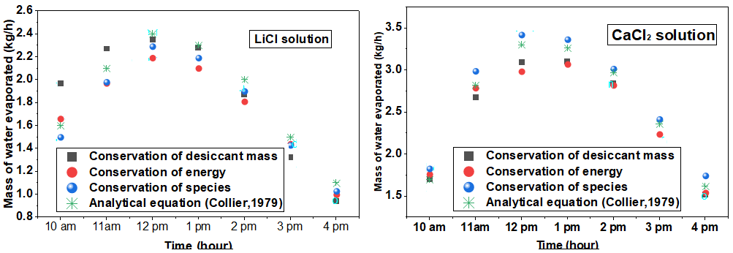
Fig. 4: Evaporation rate of water as estimated by an Analytical Equation and Conservation Principles
To compare the water evaporation rates from LiCl and CaCl₂ solutions estimated via analytical and conservation methods, typical diurnal experimental data were utilized. The solar collector features an absorber area A_{ab} of 4.0 m² (2.2 m x 1.84 m). The solution distributor dimensions were specified with a width of 4 mm slot and a length of1840 mm. Prior to starting the solution circulation at 9:00 AM, the initial tank parameters for the LiCl solution were a volume of 38.43 L, density of 1193 kg/m³, and temperature of 49ºC. This corresponds to an initial solution mass ($M_{sol,t}$ ) of 45.85 kg, a desiccant mass ($m_{d}$) of 15.26 kg, and a concentration ($ξ_{o}$) of 0.333 kg/kg. In comparison, the initial parameters for the CaCl₂ solution were a volume of 38.43 L, density of 1289 kg/m³, temperature of 37ºC, solution mass ($M_{sol,t}$ ) of 49.53 kg, desiccant mass ($m_{d}$) of 15.35 kg, and concentration ($ξ_{o}$) of 0.31 kg/kg. For both solutions, the average volumetric flow rate to the regenerator was maintained at 0.218 L/s. The initial specific heat and latent heat of vaporization were 2.94 kJ/(kg K) and 2717.8 kJ/kg for LiCl and 2.76 kJ/(kg K) and 2598.1(kJ/kg) for CaCl₂. The effective collector heat loss factor and optical efficiency were 12.2 W/m² K and 0.77, respectively.
The hourly diurnal parameters required for analyzing evaporation rate like solar irradiance, solution/absorber temperature, desiccant concentration, solution properties, and the convective heat transfer coefficient are shown Table 2 for LiCl and Table 3 for CaCl₂. Intermediate data necessary for evaporation estimating using the conservation of species, such as the mass transfer coefficient ($h_{m}$), and the analytical equation are presented in Table 4 and Table5 for LiCl solution, respectively. The intermediate data needed for estimating the evaporation rate by conservation of species and the analytical equation are exactly similar to LiCl solution. The convective mass transport coefficient for CaCl₂ solution was determined using the hourly convective heat loss coefficient calacuated in Table 3 and Eq. (28); it was more or less constant after 10 am and its average value was 0.006 m/s.
The hourly evaporation rates calculated across the four evaluation methods are summarized in Table 7 and illustrated in Figure 4. For these representative test days, the total cumulative mass of water evaporated was determined to be13.1kg,12.2 kg, 12.3 kg, and 13.0 kg for LiCl, and 18.0 kg, 17.0 kg, 16.8 kg, and 18.8 kg for CaCl₂ using the analytical, conservation of desiccant mass, energy balance, and conservation of species methods, respectively. The uncertainties in the calculation of the hourly evaporation rate are found to be small as indicated in Table 6 for the conservation methods. As illustrated in Figure 4, all four methods exhibit identical diurnal trends and demonstrate good quantitative agreement in predicting the hourly evaporation rates.

5. Conclusion

This study investigated the optical, heat and mass transfer performance of an open-type solar thermal regenerator using LiCl and CaCl₂ desiccant solutions. It has also estimated the evaporation rate using an analytical method and conservation of energy, water species and desiccant mass. The optical efficiency of unglazed, single glazed and double glazed solar regenerator were found to be 94.9%, 77% and 62.5%, respectively. The average overall collector heat loss, coefficient was found to be 13.7 W/m2oC in M arch, 15 W/m²°C in April and for hot and 12.2 W/m^{2o}C in September. The free convective heat loss coefficient and mass transfer coefficient during regeneration of lithium chloride solution film were found to be of 7.5 W/m^{2o}C and 0.007 m/s (and 0.006 m/s for CaCl₂ solution), respectively for solution temperature in the range of 49-63ºC. Previously unknown constants in the linear vapor pressure correlation of LiCl and CaCl₂ solutions were obtained via MATLAB curve-fitting with statistical confidence (R² = 0.9967 and at 0.95 confidence) for temperature ranges of 30-70oC and concentration ranges of 0.3-0.46. For representative test days, the total cumulative mass of water evaporated was determined to be13.1kg,12.2 kg, 12.3 kg, and 13.0 kg for LiCl, and 18.0 kg, 17.0 kg, 16.8 kg, and 18.8 kg for CaCl₂ using the analytical, conservation of desiccant mass, energy balance, and conservation of species methods, respectively.

Acknowledgement
The author would like to acknowledge Prof. Sanjeev Jain and Prof. S.C. Mullick for their advice & suggestions and the Ministry of New and Renewable Energy, government of India for the financial support.
References
Alizadeh, S., Saman, W.Y., 2002. An experimental study of a solar liquid desiccant regenerator. Solar Energy 72(4), 312–325.
Arora, C.P., 2010. Refrigeration and Air Conditioning, 3rd ed. Tata McGraw-Hill Education, New Delhi.
ASHRAE. ASHRAE Handbook Fundamentals; ASHRAE: Atlanta, GA, USA, 2009.Alizadeh, S., Saman, W.Y., 2002. An experimental study of a solar liquid desiccant regenerator. Solar Energy 72(4), 312–325.
Cheng, Q., Zhang, L.W., Li, X., 2017. Electrodialysis regeneration of liquid desiccant solutions for air conditioning applications. Energy 138, 450–462.
Collier, R.K., 1979. The analysis and performance of solar collector cum regenerators for liquid desiccant systems. Solar Energy 23(4), 333–345.
Duffie JA, Beckman WA,. 1996. Solar engineering of thermal processes. 2nd edition, John Wiley & Sons Inc. New York
Dunn, P.F., 2005. Measurement and Data Analysis for Engineering and Science, Intl. ed. McGraw-Hill, Boston
Elsarrag, E., 2008. Experimental study of a counter-flow solar regenerator for liquid desiccant cooling system. Renewable Energy 33(10), 2235–2244.
Enrica De Cian , Giacomo Falchetta , Filippo Pavanello , Yasmin Romitti , Ian Sue Wing, 2025. The impact of air conditioning on residential electricity consumption across world countries. Journal of Environmental Economics and Management, 131, 103122
Fagbenle, R.O., Karayiannis, T.G., 1998. Wetting efficiency and heat transfer analysis of liquid desiccant films over tilted surfaces. Solar Energy 62(3), 189–199.
Gezahegn, H.T.; Mullick, S.C.; Jain, S.,2014. Transient Performance of a Liquid Desiccant Solar Regenerator. In Proceedings of the 2014 Purdue Conferences, International Refrigeration and Air Conditioning Conference, Paper 1486, West Lafayette, IN, USA, 14–17 .
Gurubalan, A., Simonson, C.J., 2021. Liquid desiccant air conditioning systems: A comprehensive review on energy efficiency and environmental sustainability. Renewable and Sustainable Energy Reviews 145, 111105.
Hawlader, M.N.A., Uddin, M.S., Akhanda, M.A.R., 1993. Heat and mass transfer characteristics of a solar collector/regenerator. Solar Energy 51(3), 191–199.
Hiam, T., Hawlader, M.N.A., Akhanda, M.A.R., 1992. Analytical and empirical correlations for solar desiccant regeneration. Solar Energy 49(1), 45–53.
Incroperra FP, Dewitt DP, Bergman TL, Lavine AS., 2007, Fundamnetals of heat and mass transfer, 6th edition, Wiley student edition, New Delhi.
International Energy Agency (IEA), 2026. Electricity 2026: Analysis and forecast to 2028. IEA Paris, France.
Kabeel, A.E., 2005. Solar powered liquid desiccant regeneration using free and forced convection: An experimental comparative study. Solar Energy 79(5), 514–522.
Kim, D.S., Ferreira, C.I., 2008. Solar refrigeration: A review of low temperature sorption systems. International Journal of Refrigeration 31(4), 573–589.
Mullick, S.C., Gupta, M.C., 1974. Solar desorption of absorbent solutions. Solar Energy 16(1), 19–24.
Tafesse, G.H.; Ahmed, G.M.S.; Badruddin, I.A.; Kamangar, S.; Hussien, M., 2023. Estimation of Evaporation of Water from a Liquid Desiccant Solar Collector and Regenerator by Using Conservation of Mass and Energy Principles. Sustainability, 15, 6520. https://doi.org/10.3390/su15086520
Xiaobo Zhang, Ziyang Guo, Duu-Jong Lee, 2026. Regenerating liquid desiccants with a thermo-responsive solution for energy-efficient indoor humidity control. Applied Energy, 403, Part B, 127107
Yang, L., Wang, Y., 1994. Heat and mass transfer performance of an unglazed solar collector/regenerator. Solar Energy 53(5), 421–430.
Yang, L., Wang, Y., 2001. Comparison of single and double glazed open-cycle solar regeneration systems. Solar Energy 70(2), 143–152.
Yanling Zhang , Yi Chen , Jielin Luo, 2025.Improving air conditioning efficiency using solar-assisted liquid desiccant systems: Experimental and simulation analysis of two desiccants. Renewable Energy, 253, 123572.

NOMENCLATURE AND SYMBOLS
Roman symbols
a | a constant [Pa K⁻¹]
b | a constant [Pa]
c | a constant [Pa]
A | area [m²]
A₁  A₂ | a constant [kg s⁻¹ m⁻²]  a constant [kg² s⁻² m⁻⁴]
A₃ | a constant [kg² s⁻² m⁻⁴ Pa⁻¹]
D_{AB} | diffusion coefficient of water  [m² s⁻¹]
G_{o} | mass flow rate of solution  [kg s⁻¹ m⁻²]
Δh_{d} | differential enthalpy of  dilution [kJ kg⁻¹]
h_{c} | convective heat transfer coefficient  between glass and plate  [W m⁻² °C⁻¹]
h_{m} | convective mass transfer  coefficient [m s⁻¹]
h_{fg} | latent heat of vaporization of  water [kJ kg⁻¹]
I | mean irradiance [W m⁻²]
k | thermal conductivity [W m⁻¹ °C⁻¹]
L_{e} | Lewis number [-]
m | evaporation rate of vapor [kg s⁻¹]
m'' | evaporation flux [kg h⁻¹ m⁻²]
m'_{v} | evaporation per unit width  [kg s⁻¹ m⁻¹]
m_{v,Δt} | evaporation in an hour [kg h⁻¹]
m_{d} | mass of desiccant [kg]
M_{sol,t} | mass of solution in tank  at time t [kg]
Nu | Nusselt number [-]
P_{v} | partial vapor pressure of water [Pa]
P*_{v} | saturation pressure of water in air  at wet bulb temperature [Pa]
P_{v,pw} | vapor pressure of pure water [Pa]
P∞ | free stream pressure of air [Pa]
Pr  Q | Prandtl number [-]  Heat (W/m²)
R | arbitrary result parameter (varies)
R_{v}  Ra | Specific gas constant (J/kg K)  Rayleigh number [-]
t₀ | initial time [h]
t | dry bulb temperature of air [°C]
t* | wet bulb temperature of air [°C]
Δt | time step [h]
T | temperature [°C or K]
T_{sol,t+Δt} | temperature of solution in the tank  at time t+Δt [°C or K]
U'_{L} | effective collector heat loss  factor [W m⁻² °C⁻¹]
W | width of solar collector [m]
W | humidity ratio of air [kg kg⁻¹]
W* | humidity ratio of air at saturation  pressure of water & wet bulb  temperature [kg kg⁻¹]
Greek symbols
α | solar absorptance [-];  thermal diffusivity [m² s⁻¹]
α_{ab} | solar absorptance of plate [-]
β | mass transport coefficient  [kg s⁻¹ m⁻² Pa⁻¹]
ξ | desiccant concentration  [kg kg⁻¹]
ρ | mass density [kg m⁻³]
τ_{g} | solar transmittance of glass [-]
Subscripts
ab | absorber;absorbed
c | convection; corrugated
d | Desiccant;differential
f | flat plate
g | glass; glazed
inc | incident
ref  L | reflected  loss
p | plate
pw | pure water
Sol solution

