EuroSun2026
STATE-SCALE ROOFTOP PHOTOVOLTAIC POTENTIAL MAPPING FROM OPEN LIDAR DATA WITH SHADING-DRIVER DECOMPOSITION AND ROOF-SUPERSTRUCTURE FILTERING: NORTH RHINE-WESTPHALIA (GERMANY)
C. Yaldiz (corresponding author), C. Rehtanz
Technical University of Dortmund
caner.yaldiz@fom-net.de
Summary
Solar cadastres support building- and district-scale electrification planning, yet aggregate potentials alone do not reveal why individual roofs underperform. This paper presents a focused synthesis of a scalable workflow that combines open airborne LiDAR, a semantic 3D building model and a geo-semantic data model to quantify technical rooftop photovoltaic (PV) potential while attributing shading-induced area reductions to building-to-building (G2G), tree-to-building (B2G) and roof-superstructure self-shading (E2G). The method is demonstrated for North Rhine-Westphalia (NRW), Germany, using more than 6.2 TB of LiDAR point clouds. From 1,250 km² of gross roof area, sequential constraint layers and module-layout rules yield approximately 433 km² of deployable module area for a minimum contiguous patch size of 7 m², corresponding to the reported estimates of approximately 63 GWp and 51 TWh·a⁻¹. Across the 53 districts, the arithmetic mean of the fixed-order driver shares is 57.8% for E2G and 9.4% for B2G. Benchmarking the workflow output reported here against published NRW cadastre totals produces lower statewide estimates, while normalised indicators show that area definitions and conversion conventions must be distinguished from geometric effects. The driver-resolved output therefore adds an auditable constraint diagnostic to conventional opportunity maps.
Keywords: Rooftop PV, solar cadastre, LiDAR, 3D shading, roof superstructures, district energy planning, driver decomposition, geo-semantic modelling.
Field of application for the findings: Solar cadastres and district energy planning (technical rooftop PV potential; loss diagnostics for targeted interventions).
Addressed audience: Municipal/regional planners, solar cadastre operators, PV analysts, GIS/ remote sensing researchers.
- Introduction
Rooftop photovoltaics (PV) are increasingly central to decarbonising the building sector. In Germany, PV generated about 92 TWh in 2025, covering 17% of gross domestic electricity consumption, while total installed PV capacity reached about 118 GWp by year-end (Wirth, 2026). A practical challenge is to plan, permit and connect systems at scale, particularly in dense urban districts where roofs are small, shaded and cluttered.
Operational planning therefore relies on solar cadastres: spatial products that translate geodata into roof-level PV potential indicators. Municipalities and utilities often need more than a single number per roof; they need to understand why a roof underperforms and which mitigation lever is relevant (e.g., surrounding buildings, vegetation or roof superstructures). Reviews highlight that many platforms remain opaque with respect to assumptions and limiting factors, constraining targeted district interpretation (Giorio et al., 2025; Mahir et al., 2025). This matters in NRW, where the statutory introduction of §42a “Solaranlagen” increases the relevance of reproducible planning evidence (Land Nordrhein-Westfalen, 2023).
Building on the state-scale workflow and NRW processing outputs developed by Yaldiz (2022), this paper provides a focused, planning-oriented synthesis that makes the fixed-order driver attribution explicit, consolidates the reduction chain and derives normalised benchmark indicators. The analysis covers about 10 million buildings in NRW and uses open airborne LiDAR point clouds and LoD2 building models; LoD2 supplies standardised roof shapes and orientations linked to building footprints. Two questions guide the work: (RQ1) how much roof area remains deployable after transparent geometric constraints, and (RQ2) which driver has the largest district-level share under a fixed G2G → B2G → E2G attribution order? A paper-specific novelty is the explicit benchmark against LANUK’s July 2025 Energieatlas update (potential status March 2025), unavailable when the 2022 workflow was documented.
1.1 Contributions
- An auditable synthesis of the state-scale workflow developed by Yaldiz (2022), linking open LiDAR and semantic 3D building data from source points to administrative aggregates.
- An order-explicit presentation of the 3D shading-driver decomposition into building-to-building (G2G), tree-to-building (B2G) and roof-superstructure self-shading (E2G) across all 53 NRW districts.
- Quantification of the statewide reduction chain (gross roof area → shadow-free patches → module layout → minimum patch size) and source-reported sensitivities for the minimum contiguous patch threshold (7 m² vs 12 m²) and the empirical 1.097 module-layout correction.
- Benchmarking against the NRW solar cadastre baseline (LANUV 2018; now LANUK) with transparent, normalised indicators (Wp·m⁻², kWh·kWp⁻¹) to avoid over-claiming due to non-harmonised assumptions.
Throughout this paper, G2G, B2G and E2G denote three shading drivers only: G2G (building-to-building) is external shading cast by neighbouring buildings, B2G (tree-to-building) is external shading cast by trees, and E2G (self-shading) denotes shading cast by roof superstructures and roof-form elements onto other parts of the same building roof. The area occupied by roof superstructures (roof-obstacle footprints) is handled separately as a non-shading geometric exclusion in the reduction chain (cf. Tab. 3). ‘Technical potential’ refers here to the geometrically deployable PV module footprint under the modelled constraints; structural, economic, ownership and grid constraints remain outside scope.
- Related work and positioning
Large-scale rooftop PV potential assessment and solar cadastres have a long tradition in GIS-based energy planning. Physically based 3D solar radiation modelling for semantic city models has been established for more than a decade (Hofierka and Zlocha, 2012), while early regional assessments converted aggregated roof areas into PV yield potential using simplified radiative transfer models and empirical loss factors (Wiginton et al., 2010). Today, solar cadastres are used as interactive planning platforms (Giorio et al., 2025); large-scale examples include Switzerland (Buffat et al., 2018) and an EU-wide assessment of applied-PV pathways on rooftops, reservoirs and roads (Kakoulaki et al., 2024). A recurring critique is that roof-level scores often conceal key assumptions and limiting factors, reducing interpretability (Giorio et al., 2025; Mahir et al., 2025).
Methodological choices on shading and rooftop obstacles differentiate cadastres. GPU-accelerated and ray-tracing workflows improve spatial resolution and diffuse-shading treatment (Kosmopoulos et al., 2024; Lukač et al., 2024; Schlemminger et al., 2024), but exhaustive temporal simulation is costly at federal-state scale. Statewide workflows therefore require an explicit trade-off between temporal completeness and spatial coverage; an energy-focused sampling window can be appropriate when the objective is geometric suitability rather than high-fidelity performance modelling.
High-fidelity urban solar models and operational state-scale cadastres therefore occupy different methodological regimes. Detailed ray tracing can resolve complex spatial and diffuse-shading effects, whereas large-area cadastres often depend on simplified horizons, coarser surface models or generic obstacle factors to remain tractable (Mahir et al., 2025). The methodological need addressed here is a state-scale workflow that applies consistent radiative assumptions while attributing geometry-related reductions to explicit drivers and retaining inspectable intermediate artefacts. This positioning distinguishes diagnostic transparency from purely higher simulation fidelity.
Roof superstructures and their self-shading are another major uncertainty. Image- and point-cloud-based pipelines, including deep-learning methods, support rooftop PV assessment, roof-information extraction and obstacle modelling (Krapf, Bogenrieder, et al., 2022; Krapf, Willenborg, et al., 2022; Li et al., 2024; Pueblas et al., 2023). Related work addresses detailed roof reconstruction and panel detection (Guo et al., 2024; Yu et al., 2025). Aerial-imagery analysis also demonstrates material PV-potential losses from rooftop superstructures (Boccalatte and Chanussot, 2025). At the same time, robustness across cities, sensors and imaging conditions remains an active question (Kasmi et al., 2025).
Vegetation shading adds seasonal and phenological complexity. Recent work quantifies tree-induced partial shading and highlights leaf-on/leaf-off effects (Schindler et al., 2024; Tian et al., 2023). The present study uses a static vegetation representation, which limits interpretation of absolute B2G values.
The contribution is therefore not a new NRW cadastre, but a planning-oriented, driver-resolved and assumption-transparent synthesis of the previously documented workflow. It exposes intermediate artefacts in a geo-semantic database, distinguishes building, vegetation and roof-superstructure shading, and complements learned roof analytics with physically interpretable, order-explicit loss attribution at state scale.
- Study area and datasets
NRW is Germany’s most populous federal state. The analysis covers all 53 districts (rural districts and independent cities). The workflow relies on the open or publicly accessible geospatial datasets summarised in Tab. 1, including an open monument dataset used as an incomplete, permitting-sensitive reporting flag.
Tab. 1: Main datasets used in the NRW case study.
Dataset/ layer | Provide / access | Purpose
Airborne laser scanning (ALS) point clouds (>490×10⁹ points; >6.2 TB) | opengeodata.nrw / Open.NRW | 3D surface reconstruction; roof and obstacle geometry
3D building model (LoD2) and building footprints | Geobasis NRW / opengeodata.nrw | Building semantics; roof-plane linkage; aggregation
Vegetation objects / land-cover layers | State open-data portals | Vegetation shading candidates (B2G)
Meteorological irradiance time series (global/diffuse) | German Weather Service (DWD) | Irradiance modelling (Perez transposition)
Administrative boundaries (districts, regions) | Geobasis NRW | District aggregation; regional reporting
NRW solar cadastre baseline (LANUV 2018; now LANUK) | LANUK / Energieatlas NRW (archived baseline) | Benchmark comparison
Open monument point records (incomplete linked subset) | denkmal.nrw (open portal) / open-data extraction | Constraint-layer flagging (permitting-sensitive subset analyses)
- Methodology
Fig. 1 summarises the workflow. The geo-semantic data model links source points, building objects and derived results across processing steps, supporting spatial queries, aggregation and an auditable processing chain. Key modelling parameters and conversion assumptions are summarised in Tab. 2.
4.1 Roof surface reconstruction
ALS point clouds are spatially linked to LoD2 building geometries. For each building, roof points are extracted, segmented into planar patches, and fitted with plane parameters (tilt and azimuth). The result is a set of roof surfaces that are compatible with both LiDAR-derived geometry and semantic building identifiers.
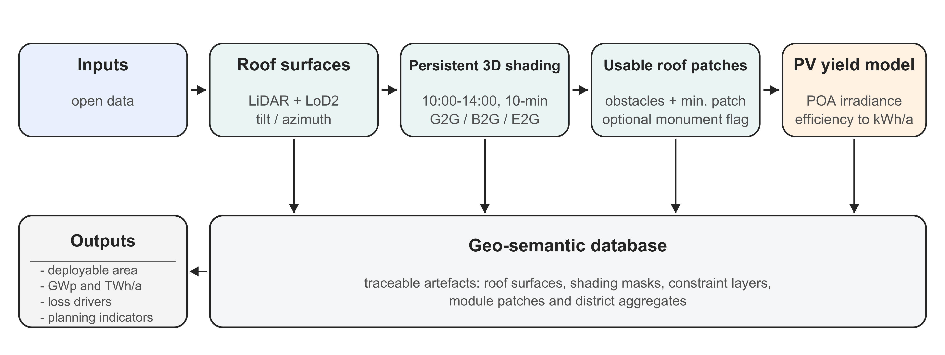
Fig. 1: Workflow overview (state-scale processing from open LiDAR to deployable PV indicators and loss-driver decomposition).
Tab. 2: Key modelling parameters and assumptions (baseline settings; correction factor used only for sensitivity).
Parameter | Value | Rationale/ note
Shading evaluation window | [10:00, 14:00), daily; Δt = 10 min (24 samples/day; 8,760/year) | Standardised energy-dominant sampling; 14:00 is the exclusive endpoint
Persistent shading threshold | ≥33% of timestamps | Geometric robustness criterion: filters transient shadow artefacts while retaining recurrent obstruction during energy-dominant hours
Minimum contiguous module patch | 7 m² (sensitivity: 12 m²) | Benchmark-oriented threshold; filters small and fragmented patches (Yaldiz, 2022)
Module layout | Conservative heuristic; optional factor 1.097 | Derived from 30 manually arranged roofs; source-reported corrected threshold totals treated as an upper-bound sensitivity (Yaldiz, 2022)
Module efficiency (η) | 17% | Used for the reported theoretical electricity conversion; no downstream system losses
Implied effective capacity–area ratio | ≈145 Wp·m⁻² | Ex-post ratio of reported statewide totals (62.94 GWp / 432.97 km²), not derived from η
Irradiance transposition | Perez model | Anisotropic sky model (Perez et al., 1990); robust baseline for comparability across cadastres
Solar position | NREL SPA | High-accuracy solar zenith/azimuth (Reda and Andreas, 2008)
PV module footprint | 1.65 m² (1.65 × 1.00 m) | Assumed module format for heuristic packing and minimum-patch interpretation
Meteorological input | DWD global/diffuse irradiance from >70 stations | NRW and neighbouring stations; transposed to plane-of-array (Yaldiz, 2022)
System losses / PR | Not modelled (theoretical yield) | Electrical yield derived from irradiation using η; additional losses can be applied ex post
4.2 Solar position and time discretisation
Solar positions are computed using the NREL Solar Position Algorithm (Reda and Andreas, 2008). To balance physical representativeness and state-scale computational feasibility, shading is evaluated at 24 ten-minute timestamps per day from 10:00 through 13:50, i.e. the half-open interval [10:00, 14:00), yielding 8,760 timestamps per non-leap year (Yaldiz, 2022).
This reduced window prioritises persistent geometric obstruction during energy-relevant hours over full temporal coverage. It is therefore a standardised suitability filter, not a reconstruction of the complete annual shading chronology.
4.3 3D shading simulation and driver attribution
For each timestamp, shadow polygons are projected onto roof surfaces from three sources, namely neighbouring buildings (G2G), trees (B2G), and roof superstructures / roof-form elements on the same building (E2G). To obtain a compact representation, all timestamp-wise polygons are overlaid and each resulting sub-area is assigned a shading frequency. Only sub-areas shaded in at least 33% of the considered timestamps are retained as persistent shading masks (phase-1 reduction). The 33% persistence threshold is not intended as a physical cut-off for yield reduction but as a geometric robustness criterion: it filters transient shadow artefacts while retaining areas subject to recurrent obstruction during energy-dominant hours. The three persistent masks are applied sequentially (G2G $→$ B2G $→$ E2G) to obtain shadow-free roof patches; driver shares are the marginal removals relative to the total area removed in this fixed order and are therefore order-dependent. Heritage status is retained as a reporting flag, whereas roof-obstacle footprints are removed separately and excluded from the shading-driver decomposition (Tab. 3).
4.4 Module layout and minimum patch threshold
Shadow-free patches are filled with 1.65 m² module rectangles using a conservative raster heuristic. A source-reported factor of 1.097, derived from 30 manually arranged roofs, is used only as an upper-bound sensitivity; the published corrected post-threshold totals are reproduced directly because their recalculation is not documented in sufficient detail by Yaldiz (2022).
The layout task is treated as a two-dimensional geometric packing problem on irregular shadow- and obstacle-free polygons. Each polygon is transformed to local coordinates and enclosed by a bounding box. A regular grid with cells of 1.65 m × 1.00 m is overlaid, and only cells lying completely within the polygon are counted as modules; accepted cell polygons are retained for the subsequent irradiation calculation. This full-containment rule explains why the deployable module footprint is smaller than the underlying free roof area, particularly for narrow or fragmented patches. The grid is a scalable approximation rather than an orientation-optimised packing solution. Roof-specific rotation or rearrangement can improve individual layouts, which motivates the separately reported 30-roof correction sensitivity (Yaldiz, 2022, Sec. 7.2.1).
4.5 Irradiance and electricity yield
Plane-of-array irradiance is computed for each roof surface using the anisotropic sky model by Perez et al. (1990). While alternative transposition models exist (e.g., Hay–Davies and other Perez variants), Perez et al. (1990) remains a robust reference model for state-scale studies and supports comparability with established cadastres. Given the paper’s focus on driver attribution and geometric suitability rather than high-fidelity performance modelling, diffuse-model sensitivity analyses are not pursued here; the chosen model should be seen as an assumption held constant across the state-wide comparison, driven by DWD global and diffuse irradiance inputs. Electricity yield for the deployable module area is derived from annual plane-of-array irradiation by applying a representative module efficiency $η$ = 17%; downstream system losses (inverter, temperature, soiling) are deliberately omitted to report a transparent theoretical potential. These assumptions also enable normalised comparison metrics (Wp$⋅$m$​^{-2}$, kWh$⋅$kWp$​^{-1}$).
4.6 Aggregation and benchmarking
Building-level results are aggregated to districts. Benchmarking uses the NRW solar cadastre launched in 2018 (Ministerium für Wirtschaft, Innovation, Digitalisierung und Energie des Landes Nordrhein-Westfalen, 2018) and the current LANUK reporting context (Landesamt für Natur, Umwelt und Klima Nordrhein-Westfalen (LANUK NRW), 2025). Absolute totals and derived normalised indicators are reported, with non-harmonised assumptions flagged explicitly.
4.7 Implementation and computational footprint
The implementation couples PostgreSQL/ PostGIS with C++ modules. The database links building records and associated point subsets across processing steps and supports spatial queries; C++ performs the computational geometry, including roof reconstruction and shadow-polygon calculation. Empty tiles with an area of 1 km² are excluded before conversion, and potential shadow interactions are screened before roof-level projection (Yaldiz, 2022, Chs. 6.1 and 6.4).
At NRW scale, the input comprises approximately 10 million buildings, 16.55 million roof surfaces and more than 6.2 TB of airborne laser scanning data. Per-timestamp shadow polygons are reduced to persistent frequency masks through overlays and the 33% occurrence threshold (Yaldiz, 2022).
Roof surface reconstruction uses planar candidate faces selected through integer optimisation to balance geometric fidelity and model parsimony; implementation details and validation examples are documented by Yaldiz (2022).
The dissertation reports that the selected SCIP-based reconstruction processed building models with up to 19,804 candidate faces. Spot checks reported no significant anomalies; however, exhaustive statewide ground-truth validation is not reported. Variations in LiDAR point density can therefore affect plane fitting and the recovery of small roof structures. These observations support computational applicability, but not a claim of error-free geometry (Yaldiz, 2022, Sec. 6.2.3).
4.8 Derived indicators and normalised metrics
To support transparent comparisons, absolute totals (km$​^{2}$, GWp, TWh$⋅$a$​^{-1}$) are accompanied by diagnostic ratios. The reported deployable module footprint is denoted by $A_{mod}$, while $H_{POA,i}$ denotes annual plane-of-array irradiation for placed module element $i$.
The effective capacity–area ratio is reported ex post as
$$\begin{aligned}p_{eff}=\frac{P_{inst}}{A_{mod}}\#\left(1\right)\end{aligned}$$
For the statewide baseline, the reported totals imply $p_{eff}≈145$ Wp$⋅$m$​^{-2}$. This diagnostic ratio is not derived from the separate 17% energy-conversion assumption.
The reported theoretical annual electricity yield is obtained from the placed elements as
$$\begin{aligned}E=\sum_{i}{H_{POA,i}η}A_{i}\#\left(2\right)\end{aligned}$$
with constant module efficiency $η=17\%$. Downstream balance-of-system losses are omitted, so $E$ is an idealised technical potential.
From the reported totals, the implied specific yield is
$$\begin{aligned}y=\left(\frac{E}{P_{inst}}\right)\left(kWh·kWp^{-1}·a^{-1}\right)\#\left(3\right)\end{aligned}$$
When external area definitions are comparable, $A_{mod}$ primarily reflects geometric and constraint choices, whereas $y$ is more sensitive to irradiation and performance conventions.
Tab. 3: Statewide reduction chain across shading, obstacle and layout constraints.
Stage | Area [km²] | Remaining [% of gross]
Gross roof area (LoD2) | 1,250.00 | 100.0
Shadow-free after G2G shading (buildings) | 1,080.21 | 86.4
Shadow-free after G2G + B2G | 1,032.24 | 82.6
Shadow-free after G2G + B2G + E2G | 747.52 | 59.8
Additionally without obstacle footprints | 633.49 | 50.7
Deployable module area (heuristic) | 465.55 | 37.2
Alternative layout sensitivity (factor 1.097; before 7 m² filter) | 510.71 | 40.9
Deployable module area ≥ 7 m² (LANUV-compatible) | 432.97 | 34.6
Deployable module area ≥ 12 m² | 395.72 | 31.7
Source: district totals aggregated from Yaldiz (2022, App. C.3, Tab. A.6) and layout values reproduced from Yaldiz (2022, Tab. 8.12). Rows through obstacle removal sum 53 district values reported to 0.01 km². Minor differences from unrounded statewide totals in Sec. 8.1 reflect summing rounded district values.
- Results
Unless stated otherwise, the absolute roof-area, capacity, electricity-yield and district-driver outputs in this section originate from Yaldiz (2022, Chs. 8–9); this paper reorganises them and calculates the explicitly identified derived indicators.
Tab. 3 reports the sequential reduction from gross roof area to deployable module area. Starting from 1,250.00 km², the fixed-order persistent shading masks leave 1,080.21 km² after G2G, 1,032.24 km² after cumulative G2G+B2G and 747.52 km² after cumulative G2G+B2G+E2G. Removing obstacle footprints (e.g., chimneys, dormers, roof windows and antennas) leaves 633.49 km² of obstacle- and shadow-free roof area. The layout heuristic places 465.55 km² of module footprints; the alternative 1.097-factor sensitivity before minimum-patch filtering is 510.71 km². Requiring contiguous patches of at least 7 m² yields 432.97 km², 62.94 GWp and 51.38 TWh·a⁻¹. Raising the threshold to 12 m² yields 395.72 km², 57.53 GWp and 46.96 TWh·a⁻¹. The source reports 439.21 km² for the corrected 12 m² sensitivity; 63.85 GWp and 52.12 TWh·a⁻¹ are proportional conversions calculated here. The source area is reproduced as published because its recalculation is not documented in sufficient detail.
Using the district-aggregated values shown in Tab. 3, persistent shading removes 502.48 km² (40.2%) relative to gross roof area. Obstacle footprints remove a further 114.03 km², corresponding to 9.1% of gross area and 15.3% of the post-shading area. The raster layout removes another 167.94 km², while the 7 m² minimum-patch rule removes 32.58 km² beyond the uncorrected layout result (7.0% of the placed module footprint). Thus, most of the statewide contraction occurs before the minimum-size filter. These are stage-wise differences in the fixed reduction chain, not independent or order-invariant loss fractions.
5.1 District-level heterogeneity and shading drivers
Across the 53 districts, E2G has the largest arithmetic mean share of the fixed-order shading-induced area reduction (57.8%), whereas B2G has the smallest (9.4%). Tab. 4 reports unweighted arithmetic means, standard deviations and ranges of the district-level marginal shares. Because overlapping masks are assigned sequentially, all shares are conditional on the G2G $→$ B2G $→$ E2G order.
Tab. 4: Unweighted district statistics of shading-driver shares across NRW
(% of fixed-order shading-induced roof-area reduction; n = 53).
Driver | Mean (%) | Std (%) | Min (%) | Max (%)
G2G (building-to-building) | 32.8 | 13.1 | 10.5 | 61.9
B2G (tree-to-building) | 9.4 | 6.0 | 0.3 | 25.2
E2G (self-shading) | 57.8 | 13.8 | 34.3 | 83.2
Source: unweighted sample SD (n−1), recalculated from 53 district rows in Yaldiz (2022, App. C.3, Tab. A.6); rounded results reproduce Tab. 8.6.
The district aggregates also show why gross roof area is an insufficient proxy for constrained deployability. In Borken, 39.09 km² of gross roof area decrease to 28.12 km² after persistent shading and to 24.10 km² after obstacle-footprint removal. Cologne starts with a larger gross roof stock of 45.94 km², but only 23.05 km² remain after shading and 19.05 km² after obstacle removal. Thus, the district with the larger initial roof stock has the smaller obstacle- and shadow-free area. This descriptive contrast does not establish an urban-form cause, but it demonstrates that district rankings can change when the modelled constraints are applied.
E2G’s large district mean makes roof-superstructure-aware modelling relevant even when G2G and B2G are represented. The workflow may be transferable where comparable LiDAR and LoD2 data can be harmonised, although transfer was not evaluated here. Fig. 2 shows roof-level variability for Cologne: the distribution has a long tail of moderately to strongly shaded roofs, and 15.8% (approximately 16%) exceed a maximum shading ratio of 30% in the analysed window. This distribution is descriptive and does not by itself identify the responsible driver.
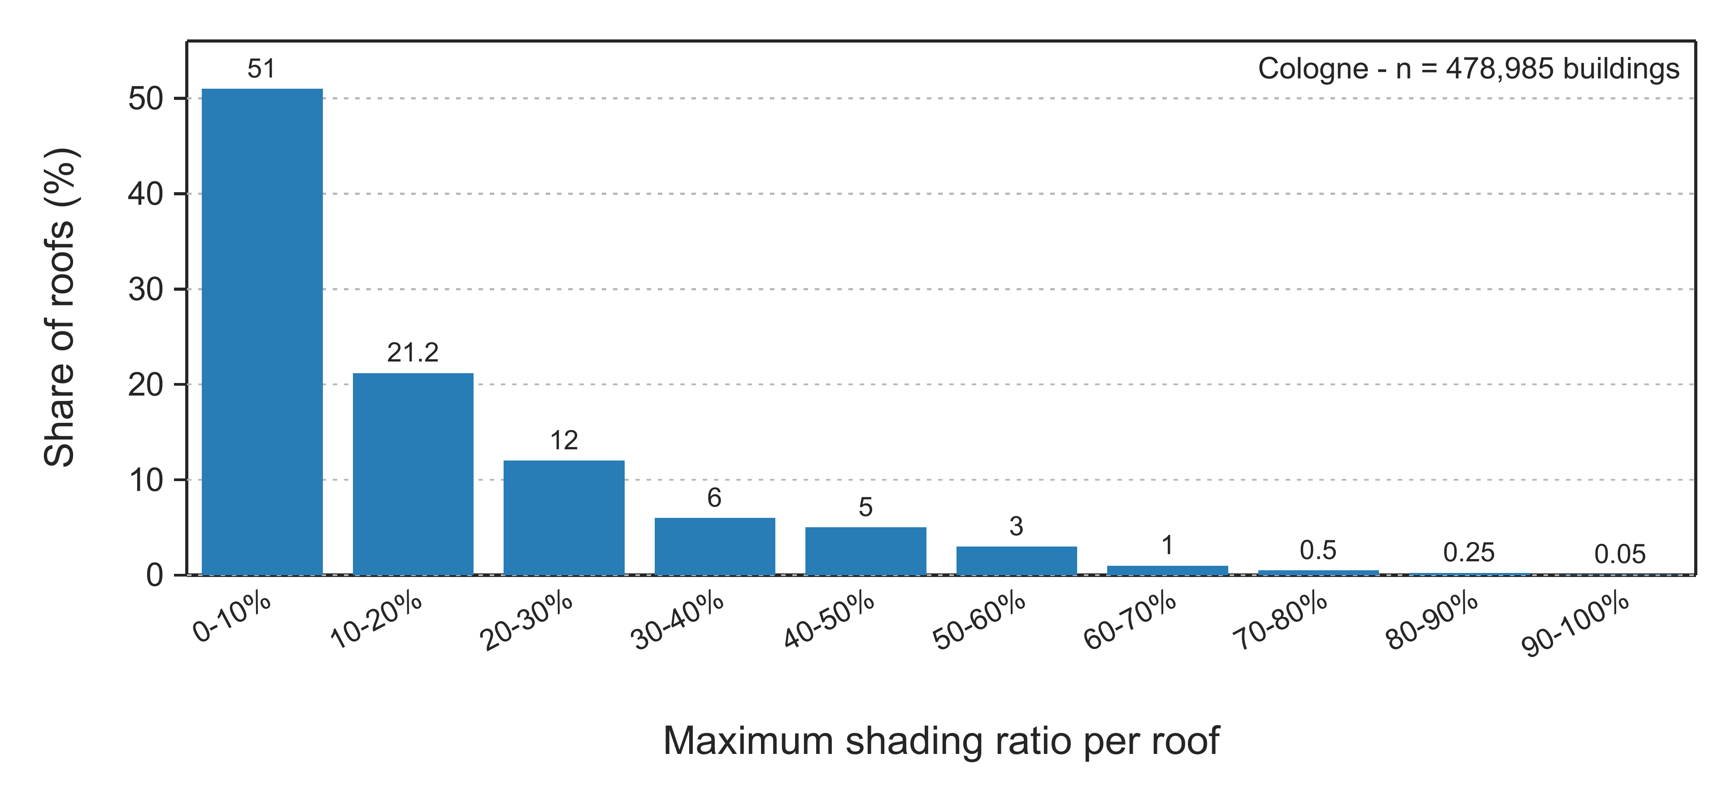
Fig. 2: Cologne: distribution of roof-level maximum shading ratios in the analysed time window (n = 478,985 buildings).
5.2 Regional reporting and benchmarking
Tab. 5 compares the statewide results with the dissertation’s 2018 NRW baseline and LANUK’s Energieatlas NRW update (published July 2025; potential status March 2025). Differences in absolute GWp and TWh·a⁻¹ totals can reflect both geometric treatment and non-harmonised conversion conventions.
Tab. 5: Benchmark comparison and normalised indicators for transparency (NRW totals).
Source/ scenario | Deployable  area  [km²] | Capacity  [GWp] | Electricity  [TWh·a⁻¹] | Power  density  [Wp·m⁻²] | Specific  yield  [kWh·kWp⁻¹·a⁻¹] | Notes
Yaldiz (2022) workflow  (≥7 m²) | 432.97 | 62.94 | 51.38 | 145 | 816 | a
NRW solar cadastre baseline (2018) | 483.00 | 81.40 | 68.40 | 169 | 840 | b
Energieatlas NRW  (potential status 03/2025) | 387.00 | – | 67.80 | – | – | c
a Area, capacity and electricity reproduced from Yaldiz (2022, Tab. 9.1); power density and specific yield calculated here. The area is the geometrically constrained module footprint; η = 17%; no downstream system losses. b LANUV 2018 values reproduced from Yaldiz (2022, Tab. 9.1); the contemporary press release independently reports about 68 TWh/a (Ministerium für Wirtschaft, Innovation, Digitalisierung und Energie des Landes Nordrhein-Westfalen, 2018). c Potential status 03/2025; official update published 16 July 2025 (Landesamt für Natur, Umwelt und Klima Nordrhein-Westfalen (LANUK NRW), 2025). Definitions are not fully harmonised.
Relative to the 2018 baseline, the reported deployable area is 10.36% lower (432.97 vs 483.00 km$​^{2}$) and capacity is 22.68% lower. The corresponding effective capacity–area ratios are approximately 145 and 169 Wp$⋅$m$​^{-2}$, while the implied specific yields are approximately 816 and 840 kWh$⋅$kWp$​^{-1}⋅$a$​^{-1}$. The comparison therefore does not support attributing the full difference to 3D shading; area definitions and conversion conventions also contribute.
LANUK’s July 2025 publication (potential status March 2025) reports 387 km² of installable module area and 67.8 TWh·a⁻¹ of potential electricity, based on DWD irradiance, laser scanning and building footprints in a 0.5 m surface model (Landesamt für Natur, Umwelt und Klima Nordrhein-Westfalen (LANUK NRW), 2025). Because the public summary omits conventions needed for a like-for-like recalculation, the comparison is contextual rather than a quantitative attribution of the gap. Fig. 3 complements Tab. 5 by comparing the Yaldiz (2022) workflow output with the LANUV 2018 baseline, aggregated to administrative regions.
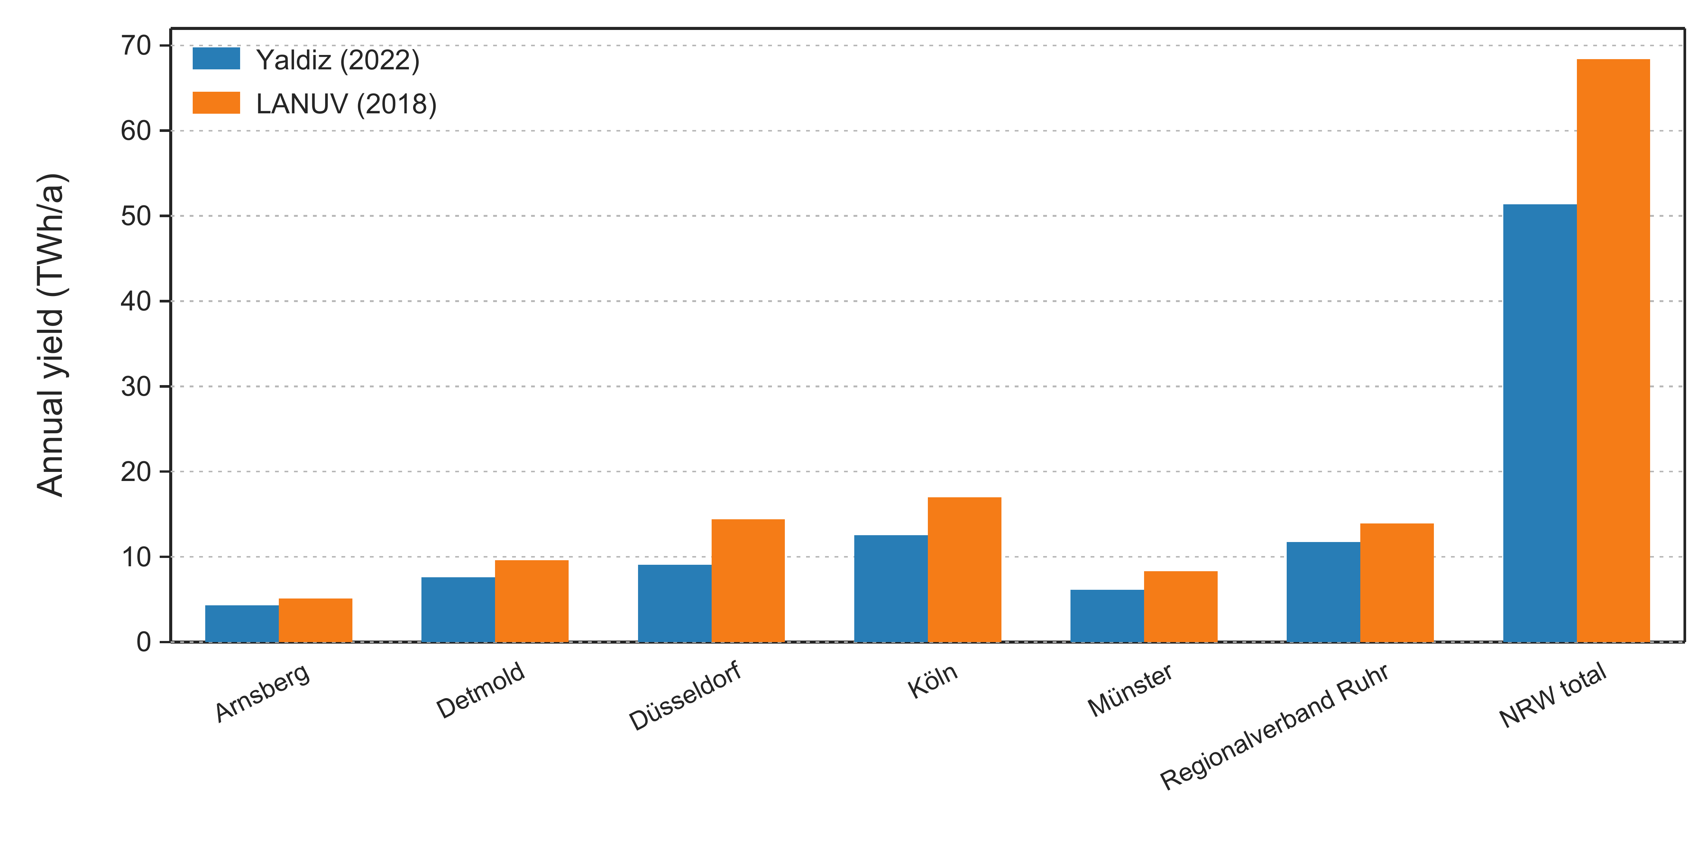
Fig. 3: Comparison of regional PV yield estimates (Yaldiz (2022) workflow output vs LANUV 2018 baseline), based on administrative regions.
5.3 Heritage-linked subset and constraint diagnostics
Heritage protection can require additional permitting, so monument status is used only as a reporting flag, not a hard exclusion. The inherited dissertation snapshot combined more than 23,000 extracted coordinates with denkmal.nrw records into more than 28,000 point records, against more than 82,000 officially reported monuments (Yaldiz, 2022). These counts are records rather than a verified census of unique buildings; the linked subset is therefore not interpreted as complete heritage coverage.
Within this open-monument-linked subset, 87.3% of the shading-induced roof-area reduction is attributed to E2G, 11.7% to G2G and 1.0% to B2G under the same fixed attribution order (Yaldiz, 2022).
Roof superstructures cast shadows (E2G) and occupy area (obstacle footprints). For the linked subset, Yaldiz (2022) reports mean building-level area reductions of 54% for obstacle-footprint removal and 11.3% for combined shading. Because the dissertation does not formally define their denominators, they remain source-reported subset means. The 11.3% is not comparable with the statewide 40.2%, an aggregate loss-to-gross-area ratio, because population and aggregation differ. Fig. 4 shows the driver-share contrast.
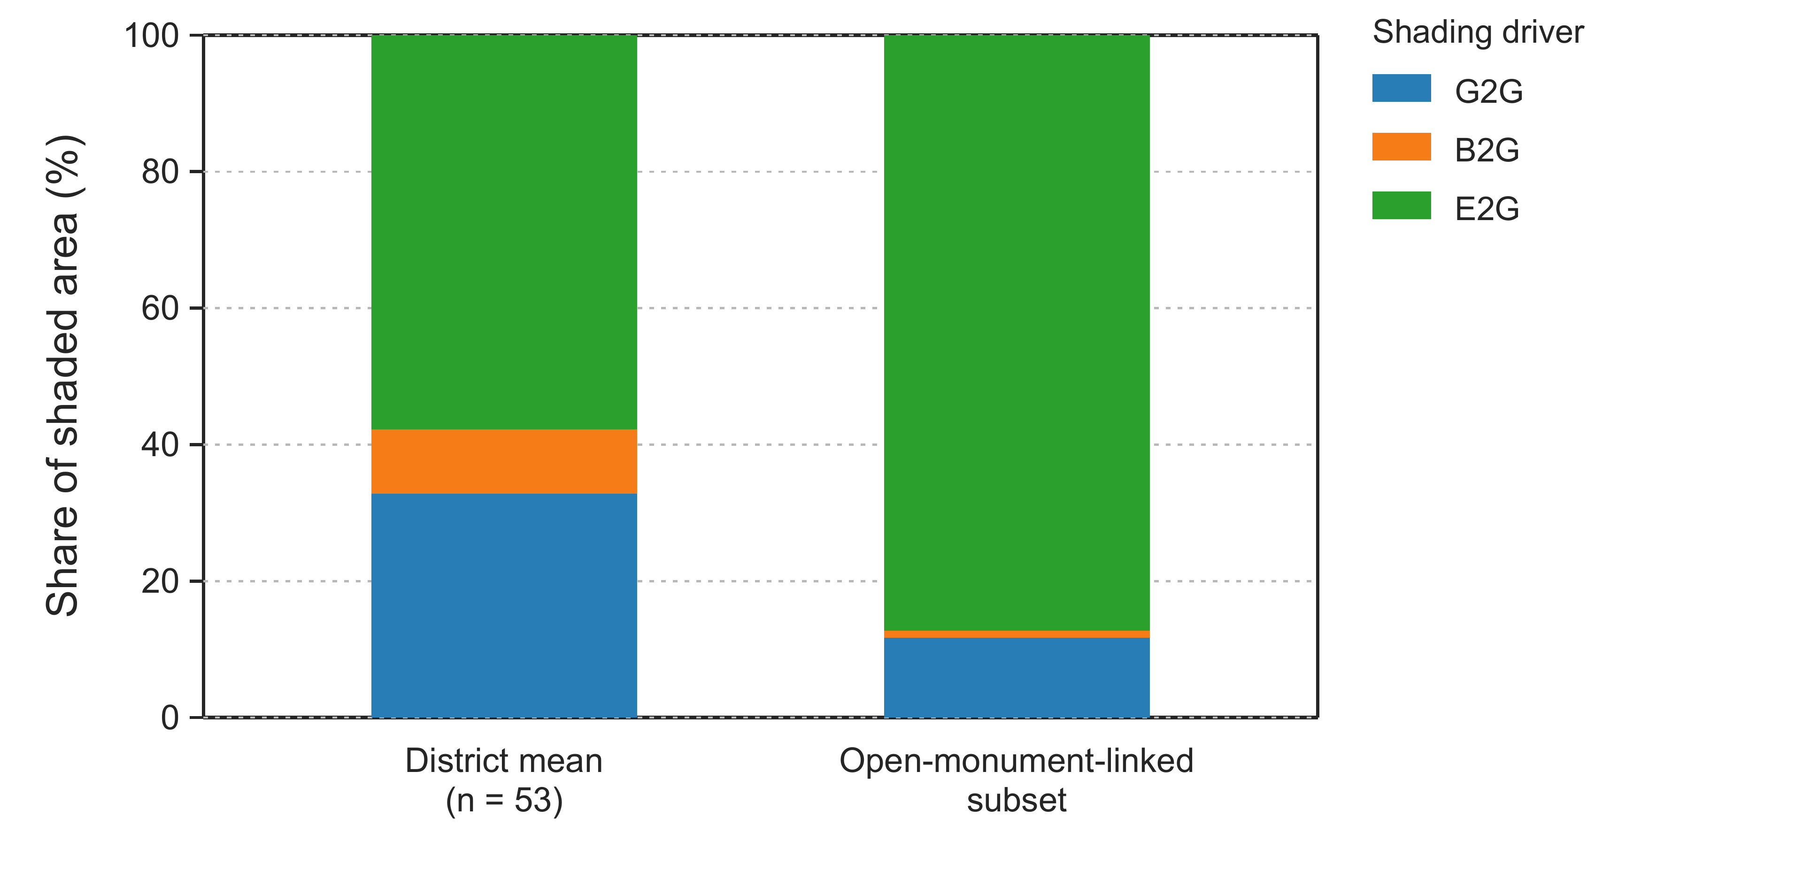
Fig. 4: Arithmetic district mean and the source-reported open-monument-linked subset. Their aggregation bases differ. Shares refer only to fixed-order shading-induced area reduction; obstacle footprints are excluded separately.
The deployable module fraction ($≥$7 m$​^{2}$ relative to gross roof area) provides a compact district indicator for prioritising follow-up analysis.
District values support targeted follow-up without implying causality: B2G reaches 24.9% in Borken (about 2.6 times the 9.4% district mean) but is below 0.5% in Bochum and Duisburg. Elevated G2G, B2G or E2G shares respectively motivate building-context, vegetation/seasonality or roof-superstructure checks.
5.4 Sensitivity to minimum-patch threshold and module-layout correction
Two modelling choices affect statewide results. Relative to the 7 m² baseline, the reported correction raises deployable area by 9.7% to 474.96 km² (paper-calculated proportional conversions: 69.04 GWp; 56.36 TWh·a⁻¹), equal within rounding to 432.97 × 1.097 = 474.97 km². At 12 m², the uncorrected 395.72 km² would scale to 434.10 km², whereas the source reports 439.21 km² (paper-calculated proportional conversions: 63.85 GWp; 52.12 TWh·a⁻¹); thus, the near equality at 7 m² does not generalise. The correction is based on only 30 roofs and remains an upper-bound sensitivity (Yaldiz, 2022).
- Discussion
The NRW case study shows that state-scale rooftop PV potential mapping does not have to be a black box. With open LiDAR and LoD2 geometries, it is possible to compute statewide technical potentials while keeping key geometric assumptions explicit and intermediate artefacts inspectable. Importantly, the workflow does not only report how much potential remains; it also answers what limits it at district scale through a driver-resolved shading decomposition.
Benchmarking reveals why headline numbers are fragile: capacity and yield depend on reporting conventions and assumptions as well as geometry. The explicit Energieatlas comparison (published July 2025; potential status March 2025), unavailable in 2022, is a paper-specific external benchmark, but normalised indicators cannot fully harmonise methods.
Uncertainty arises from LoD2 generalisation, LiDAR point density/classification and DSM/input-geometry quality (Mahir et al., 2025; Polo and García, 2023), incomplete monument records, and solar-resource/sky-model assumptions. Irradiance datasets and diffuse-shading treatment are known sources of dispersion (Forstinger et al., 2023; Lukač et al., 2024). The [10:00,14:00) window samples every day of the year but should not be interpreted as a complete annual shading chronology: it provides a standardised proxy for recurrent obstruction during energy-dominant hours while omitting early- and late-day shading and thus the full seasonal daylight envelope. Full-day, year-round ray tracing, explicit acquisition-year harmonisation and leaf-on/leaf-off scenarios would be required to quantify temporal and phenological bias (Schindler et al., 2024; Tian et al., 2023); no correction is inferred here. The reported G2G/B2G/E2G areas therefore remain model-specific diagnostics rather than temporally complete loss estimates.
From a planning perspective, driver decomposition turns a cadastre from a map of opportunities into a map of modelled constraints. In Cologne, Fig. 2 shows a long tail of moderately to strongly shaded roofs, with 15.8% (about 16%) exceeding 30% maximum shading. Across the 53 NRW districts, E2G has the largest arithmetic mean share of the fixed-order shading-induced area reduction (57.8%; Tab. 4). Driver shares are useful because similar deployable-area totals can imply different follow-up questions. Elevated G2G points to surrounding building geometry, for which roof-level micro-siting may have limited leverage and building-context or facade-level alternatives may deserve examination. Elevated B2G calls for seasonal vegetation assessment rather than an automatic vegetation-removal recommendation, because the present static representation does not resolve phenology. Elevated E2G motivates roof-detail acquisition, obstacle-aware layout and, where appropriate, roof refurbishment. This is the planning value that a single opaque roof score cannot provide (Giorio et al., 2025), but the shares remain descriptive, order-dependent indicators rather than causal prescriptions. Moreover, the reported technical potential is not a deployment forecast: structural, economic, ownership and grid constraints, as well as downstream system losses, remain outside the model.
The NRW comparisons should thus be read as transparent, geometry-driven reference points that can be aligned with alternative assumption sets, not as a single authoritative ranking. With solar obligations in building regulation (Land Nordrhein-Westfalen, 2023) and applied-PV potential being assessed at European scale (Kakoulaki et al., 2024), auditable decision support is increasingly relevant. Driver-resolved cadastres complement, rather than replace, learned roof analytics and high-fidelity solar models.
- Conclusions
A state-scale rooftop PV workflow integrating open LiDAR, semantic 3D building data and a geo-semantic database provides driver-resolved shading diagnostics. For NRW, it yields approximately 433 km$​^{2}$ of deployable module area ($≥$7 m$​^{2}$), with reported estimates of 63 GWp and 51 TWh$⋅$a$​^{-1}$. E2G has the largest arithmetic district mean share; its shading effect remains distinct from obstacle-footprint exclusions. Benchmarking confirms that area definitions and conversion conventions must be harmonised before differences are attributed to shading. Future work should refine diffuse and seasonal shading, quantify uncertainty, document data vintages more completely, and test transfer and periodic updates in other regions.
- References
Boccalatte, A., Chanussot, J., 2025. Quantifying urban solar potential losses from rooftop superstructures via aerial imagery and convolutional neural networks. Renewable Energy 249, 123088.
Buffat, R., Grassi, S., Raubal, M., 2018. A scalable method for estimating rooftop solar irradiation potential over large regions. Applied Energy 216, 389-401.
Forstinger, A., Wilbert, S., Jensen, A.R., Kraas, B., Fernández Peruchena, C., Gueymard, C.A., Ronzio, D., Yang, D., Collino, E., Polo Martínez, J., Ruiz-Arias, J.A., Hanrieder, N., Blanc, P., Saint-Drenan, Y.-M., 2023. Worldwide benchmark of modelled solar irradiance data. Technical Report IEA-PVPS T16-05:2023, IEA Photovoltaic Power Systems Programme (IEA PVPS), Task 16.
Giorio, M., Manni, M., Köker, N.I., Bertolin, C., Thebault, M., Lobaccaro, G., 2025. Interactive platforms for solar energy planning in smart cities: a state-of-the-art review of solar cadasters. Solar Energy 287, 113227.
Guo, Z., Lu, J., Chen, Q., Liu, Z., Song, C., Tan, H., Zhang, H., Yan, J., 2024. TransPV: refining photovoltaic panel detection accuracy through a vision transformer-based deep learning model. Applied Energy 355, 122282.
Hofierka, J., Zlocha, M., 2012. A new 3-D solar radiation model for 3-D city models. Transactions in GIS 16, 681-690.
Kakoulaki, G., Taylor, N., Szabo, S., Kenny, R., Chatzipanagi, A., Jäger-Waldau, A., 2024. Communication on the potential of applied PV in the European Union: rooftops, reservoirs, roads (R³). EPJ Photovoltaics 15, 2.
Kasmi, G., Dubus, L., Saint-Drenan, Y.-M., Blanc, P., 2025. Space-scale exploration of the poor reliability of deep learning models: the case of the remote sensing of rooftop photovoltaic systems. Environmental Data Science 4, e22.
Kosmopoulos, P., Dhake, H., Kartoudi, D., Tsavalos, A., Koutsantoni, P., Katranitsas, A., Lavdakis, N., Mengou, E., Kashyap, Y., 2024. Ray-tracing modeling for urban photovoltaic energy planning and management. Applied Energy 369, 123516.
Krapf, S., Bogenrieder, L., Netzler, F., Balke, G., Lienkamp, M., 2022. RID—roof information dataset for computer vision-based photovoltaic potential assessment. Remote Sensing 14, 2299.
Krapf, S., Willenborg, B., Knoll, K., Bruhse, M., Kolbe, T.H., 2022. Deep learning for semantic 3D city model extension: modeling roof superstructures using aerial images for solar potential analysis. ISPRS Annals of the Photogrammetry, Remote Sensing and Spatial Information Sciences X-4/W2-2022, 161-168.
Land Nordrhein-Westfalen, 2023. Zweites Gesetz zur Änderung der Landesbauordnung 2018. Gesetz- und Verordnungsblatt für das Land Nordrhein-Westfalen, GV. NRW. 2023 Nr. 31, S. 1172. Available at: https://recht.nrw.de/gvnrw/2023-s1172/ (accessed 2026-08-13).
Landesamt für Natur, Umwelt und Klima Nordrhein-Westfalen (LANUK NRW), 2025. Solarpotenziale der Dachflächen aktualisiert! Energieatlas NRW. Archived official page: https://web.archive.org/web/20250806143854/https://energieatlas.nrw.de/site/aktuelles/potenzial-dachpv-neu (accessed 2026-08-18).
Li, Q., Krapf, S., Mou, L., Shi, Y., Zhu, X.X., 2024. Deep learning-based framework for city-scale rooftop solar potential estimation by considering roof superstructures. Applied Energy 374, 123839.
Lukač, N., Mongus, D., Žalik, B., Štumberger, G., Bizjak, M., 2024. Novel GPU-accelerated high-resolution solar potential estimation in urban areas by using a modified diffuse irradiance model. Applied Energy 353, 122129.
Mahir, I.H., Bachour, D.A., Abedrabboh, K., Perez-Astudillo, D., Al Fagih, L., 2025. Processing airborne LiDAR point cloud for solar cadasters: a review. Applied Energy 382, 125325.
Ministerium für Wirtschaft, Innovation, Digitalisierung und Energie des Landes Nordrhein-Westfalen, 2018. Erstes landesweites Solarkataster für Nordrhein-Westfalen ist online. Land.NRW press release. Available at: https://www.land.nrw/pressemitteilung/erstes-landesweites-solarkataster-fuer-nordrhein-westfalen-ist-online (accessed 2026-08-13).
Perez, R., Ineichen, P., Seals, R., Michalsky, J., Stewart, R., 1990. Modeling daylight availability and irradiance components from direct and global irradiance. Solar Energy 44, 271-289.
Polo, J., García, R.J., 2023. Solar potential uncertainty in building rooftops as a function of digital surface model accuracy. Remote Sensing 15, 567.
Pueblas, R., Kuckertz, P., Weinand, J.M., Kotzur, L., Stolten, D., 2023. ETHOS.PASSION: an open-source workflow for rooftop photovoltaic potential assessments from satellite imagery. Solar Energy 265, 112094.
Reda, I., Andreas, A., 2008. Solar position algorithm for solar radiation applications (revised). NREL/TP-560-34302. National Renewable Energy Laboratory (NREL).
Schindler, Z., Larysch, E., Frey, J., Sheppard, J.P., Obladen, N., Kröner, K., Seifert, T., Morhart, C., 2024. From dawn to dusk: high-resolution tree shading model based on terrestrial LiDAR data. Remote Sensing 16, 2189.
Schlemminger, M., Bredemeier, D., Mahner, A., Niepelt, R., Breitner, M.H., Brendel, R., 2024. Rooftop PV potential determined by backward ray tracing: a case study for the German regions of Berlin, Cologne, and Hanover. Progress in Photovoltaics: Research and Applications 32, 912-929.
Tian, B., Loonen, R.C.G.M., Hensen, J.L.M., 2023. Combining point cloud and surface methods for modeling partial shading impacts of trees on urban solar irradiance. Energy and Buildings 298, 113420.
Wiginton, L.K., Nguyen, H.T., Pearce, J.M., 2010. Quantifying rooftop solar photovoltaic potential for regional renewable energy policy. Computers, Environment and Urban Systems 34, 345-357.
Wirth, H., 2026. Aktuelle Fakten zur Photovoltaik in Deutschland (Fassung 05.05.2026). Fraunhofer-Institut für Solare Energiesysteme ISE, Freiburg. Available at: https://www.ise.fraunhofer.de/de/veroeffentlichungen/studien/aktuelle-fakten-zur-photovoltaik-in-deutschland.html (accessed 2026-08-13).
Yaldiz, C., 2022. Konstruktion eines geo-semantischen 3D-Datenmodells zur Ermittlung der Einflussgrößen auf die PV-Dachpotentiale in NRW unter Verwendung von open-source Daten. Dissertation, Technische Universität Dortmund. Available at: https://eldorado.tu-dortmund.de/items/472ade17-eada-4d7e-bf00-3aeb2a23dd5d (accessed 2026-08-13).
Yu, D., Ye, F., Yue, P., Chen, M., Biljecki, F., 2025. RooFormer: reconstructing detailed 3D roof models from high-resolution remote sensing imagery using transformer. ISPRS Journal of Photogrammetry and Remote Sensing 227, 745-758.

