Hyperelastic modeling of woven structures undergoing large deformations

M.R. Mansouri^{1, 3}, P.F. Fuchs² and C. Schuecker³

¹Polymer Competence Center Leoben GmbH, Roseggerstrasse 12, 8700 Leoben, Austria
mohammad.mansouri@pccl.at, https://www.pccl.at/forschung-de/simulation-und-modellierung.html
²Polymer Competence Center Leoben GmbH, Roseggerstrasse 12, 8700 Leoben, Austria peter.fuchs@pccl.at, https://www.pccl.at/forschung-de/simulation-und-modellierung.html
³Department Kunststofftechnik, Montanuniversität Leoben, Austria
clara.schuecker@unileoben.ac.at, http://www.kunststofftechnik.at/konstruieren/

Keywords: dry woven fabrics, hyperelastic constitutive model, shear interaction strain energy, inextensible fibers, finite element simulation.

Abstract
This work presents a compressible hyperelastic constitutive model for dry woven fabrics with two families of inextensible fibers. In recent works it was demonstrated that shear interaction of the fibers is the dominant deformation mode in state of the art characterization methods of dry woven fabrics as for example the bias-extension test. Therefore, an angular-based deformation invariant is introduced. This invariant excludes the elongation in fiber direction but only considers the shear interaction of the fibers. In order to model woven fabrics, a Helmholtz free-energy function is proposed with two parts: a mathematical exponential shear interaction strain energy and a workless reaction to the kinematic constraint that results from the inextensibility of the fibers. The shear interaction strain energy is decomposed into a volumetric and an isochoric parts. To evaluate the proposed model, it is implemented in a commercial finite element analysis program as a user-defined material model. An FEM-model of the bias-extension test is used to demonstrate the performance of the model implementation. The results show that there is an excellent correlation between experiment and simulation.

1. Introduction

A number of researchers [1-4] have proposed hyperelastic models to capture the response of dry woven fabrics. A common approach to define a function for the strain-energy density for dry woven fabrics is to divide it into the contributions of the fibers and fiber-fiber shear interaction energy . Hence, the total strain-energy function can be written as

(1)

Thereby, is considering the angle change between fibers during deformation and is defined based on pseudo-invariants of the right Cauchy-Green tensor , and [5]. Since and are defined as square of the fiber stretch, it implies a dependence of the shear interaction strain energy , and thus also the Cauchy stress , on the elongation of the fibers.

The shear interaction is the dominant mode of the deformation for dry woven fabrics [6-11]. Therefore, the bias-extension test featuring a high shear deformation state is an effective method to characterize woven fabrics. The deformation mechanism in a bias-extension test is schematically shown in Fig. 1. As can be seen in the literatures [12-18], no fiber elongation is observed in these tests. Therefore an approach assuming zero elongation of fibers for the shear interaction strain energy is presented in this work.

2    1  230 cm  115  cm | 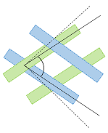

Figure 1. Shear deformation mechanism for two families of fibers in a bias-extension test. The fibers at reference configuration deform to in the deformed configuration, respectively.

2. Kinematics

Since the deformation of woven composites can be expressed based on the rotation of the two families of fibers, an angular-based deformation invariant is assumed to represent the deformation field. Consider a material line element in fiber orientation as that is transformed to the spatial line element . Hence, the stretch in the direction of the unit vector is in the form , where the notation indicates the dependence of on the fiber orientation. Using [5], where is the deformation gradient, it is found that . The same can be written for the fibers in the orientation as . Referring to Fig. 1, the angle between the two families of fibers at the deformed configuration is defined as so that

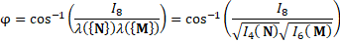 | (2)

where , , , and is right Cauchy-Green tensor. Since the fibers are inextensible consequently . Now, we can introduce invariant which represents the shear angle according to

(3)

3. Model development

In order to model the woven fabrics, a suitable strain energy is proposed with two parts: shear interaction strain energy () that is associated with the dominant mode of the deformation, and a workless reaction to the kinematic constraint on the deformation field [5] that represents the inextensibility of the fibers,

(4)

with the indeterminate Lagrange multipliers . The scalar quantities are fiber tensions as reactions associated with the inextensibility constraints . Based on the experimental observations and following the work by Holzapfel et al. [19] and the works done in [20, 21], an exponential mathematical function for shear interaction strain energy is suggested as

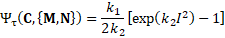 | (5)

where is a positive material parameter with the dimension of stress, is a positive dimensionless material parameter, while is defined by Eq. (3). It can be shown that can be used instead of in Eq. (5) since the invariant is a function of . The parameters and are related to the shear interaction properties of the fibers and are independent from extensibility of the fibers. For computational simulation, the shear interaction part of the proposed model is decomposed into volumetric and isochoric parts as

(6)

where , and is determinant of the deformation gradient . In Eq. (6), , where is the compressibility parameter of the woven fabric and is treated as a penalty parameter. The Cauchy stress tensor for the proposed model is defined as

(7)

where , , is a fourth-order unit tensor with the components , and is the second-order unit tensor. Herein, the indeterminate terms and are identified as reaction stresses associated with the fibers inextensibility constraints, with the fiber tensions

4. Fitting procedure

For the purpose of material characterization, the experimental result of a bias-extension test of a benchmark study [22] is selected. Since the stress component is zero for thin woven fabrics can be determined from Eq. (7). To fulfill the stress free boundary condition in transverse direction the stress component should be also zero. Therefore, the scalar can also be found directly from Eq. (7). Replacing these values into the Cauchy stress in principal direction can be obtained as

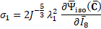 | (8)
is principal stretch ratio which corresponds to the 1-direction in the local coordinate system of the Fig. (1). The material properties obtained from fitting procedure are and =12.50. Fig. 2 shows a good agreement between correlation of the proposed model with the bias-extension test results.

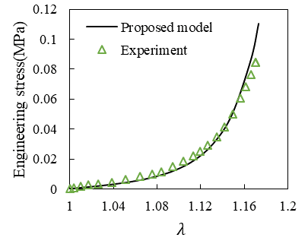
Figure 2. Fitting the proposed model with bias-extension test in order to find material properties.

5. Finite element analysis of the woven fabrics

The proposed constitutive model is implemented into finite element framework in Abaqus/Standard (Abaqus 6.13) as user-defined subroutine UMAT. The mesh of the geometry shown in Fig. (1) is discretized with 4232 S4R bilinear quadrilateral finite strain shell elements with discrete Kirchhoff thin-shell kinematics and is shown in Fig. 3. This figure illustrates stress-stretch comparison between the computational prediction and the bias-extension test clamped by two ends for a displacement of 40 mm in longitudinal direction. Fig. 3 shows that the proposed model correlates accurately with the bias-extension experiment.

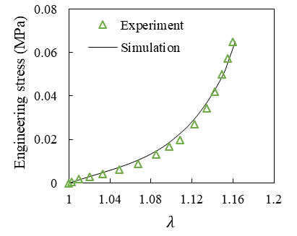 | 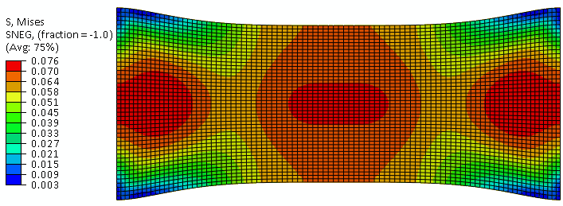

Figure 3. Comparison of the computational evaluation of the proposed model with experimental results of a bias-extension test for woven fabrics.

Conclusions

Based on the real deformation mechanism, an angular-based deformation invariant was used in order to model the deformation field of the woven-fabric structures. This invariant excludes the elongation in fiber direction and therefore considers the inextensibility of the fibers. In the next step, a Helmholtz strain-energy function consisting of two parts was developed: shear interaction strain energy and strain energy associated to the workless reaction to the kinematic constraint that results from the inextensibility of the fibers. The proposed model was decomposed into volumetric and isochoric parts and treated as nearly incompressible material. The stresses were derived to find the material properties. The elasticity tensors were developed and the proposed model was implemented as user-defined subroutine UMAT for computational evaluation. The comparison of the bias-extension test with theoretical and computational approaches showed that there is an excellent agreement between the test results, theoretical fitting and the computational approach.

References

[1] Aimène, Y., Vidal-Sallé, E., Hagège, B., Sidoroff, F. and Boisse, P., 2010. A hyperelastic approach for composite reinforcement large deformation analysis. Journal of Composite materials, 44(1), pp.5-26.
[2] Peng, X., Guo, Z., Du, T. and Yu, W.R., 2013. A simple anisotropic hyperelastic constitutive model for textile fabrics with application to forming simulation. Composites Part B: Engineering, 52, pp.275-281.
[3] Milani, A.S. and Nemes, J.A., 2004. An intelligent inverse method for characterization of textile reinforced thermoplastic composites using a hyperelastic constitutive model. Composites science and technology, 64(10), pp.1565-1576.
[4] Charmetant A, Vidal-Sallé E, Boisse P. Hyperelastic modelling for mesoscopic analyses of composite reinforcements. Composites Science and Technology. 2011 Sep 30;71(14):1623-31.
[5] Holzapfel, A.G., 2000. Nonlinear Solid Mechanics II.
[6] Boisse, P., Hamila, N., Vidal-Sallé, E. and Dumont, F., 2011. Simulation of wrinkling during textile composite reinforcement forming. Influence of tensile, in-plane shear and bending stiffnesses. Composites Science and Technology, 71(5), pp.683-692.
[7] Suemasu, H., Friedrich, K. and Hou, M., 1994. On deformation of woven fabric-reinforced thermoplastic composites during stamp-forming. Composites Manufacturing, 5(1), pp.31-39.
[8] Zhu, B., Yu, T.X. and Tao, X.M., 2007. Large deformation and slippage mechanism of plain woven composite in bias extension. Composites Part A: Applied Science and Manufacturing, 38(8), pp.1821-1828.
[9] Cao, J., Akkerman, R., Boisse, P., Chen, J., Cheng, H.S., De Graaf, E.F., Gorczyca, J.L., Harrison, P., Hivet, G., Launay, J. and Lee, W., 2008. Characterization of mechanical behavior of woven fabrics: experimental methods and benchmark results. Composites Part A: Applied Science and Manufacturing, 39(6), pp.1037-1053.
[10] Haghi Kashani, M., Hosseini, A., Sassani, F., Ko, F.K. and Milani, A.S., 2017. The Role of Intra-Yarn Shear in Integrated Multi-Scale Deformation Analyses of Woven Fabrics: A Critical Review. Critical Reviews in Solid State and Materials Sciences, pp.1-20.
[11] Harrison, P., Clifford, M.J. and Long, A.C., 2004. Shear characterisation of viscous woven textile composites: a comparison between picture frame and bias extension experiments. Composites Science and Technology, 64(10), pp.1453-1465.
[12] Haghi Kashani, M., Hosseini, A., Sassani, F., Ko, F.K. and Milani, A.S., 2017. The Role of Intra-Yarn Shear in Integrated Multi-Scale Deformation Analyses of Woven Fabrics: A Critical Review. Critical Reviews in Solid State and Materials Sciences, pp.1-20.
[13] Hosseini, A., Kashani, M.H., Sassani, F., Milani, A.S. and Ko, F., 2017. A Mesoscopic Analytical Model to Predict the Onset of Wrinkling in Plain Woven Preforms under Bias Extension Shear Deformation. Materials, 10(10), p.1184.
[14] Lin, G., Wang, Y., Du, X. and He, X., 2008. Research on the shear behaviour of plain weave prepreg at lateral compaction stage. Strain, 44(2), pp.164-169.
[15] Zhu, B., Yu, T.X. and Tao, X.M., 2007. Large deformation and slippage mechanism of plain woven composite in bias extension. Composites Part A: Applied Science and Manufacturing, 38(8), pp.1821-1828.
[16] Page, J. and Wang, J., 2000. Prediction of shear force and an analysis of yarn slippage for a plain-weave carbon fabric in a bias extension state. Composites Science and Technology, 60(7), pp.977-986.
[17] Milani, A.S. and Nemes, J.A., 2004. An intelligent inverse method for characterization of textile reinforced thermoplastic composites using a hyperelastic constitutive model. Composites science and technology, 64(10), pp.1565-1576.
[18] Zhu, B., Yu, T.X. and Tao, X.M., 2007. An experimental study of in-plane large shear deformation of woven fabric composite. Composites Science and Technology, 67(2), pp.252-261.
[19] Holzapfel, G.A., Gasser, T.C. and Ogden, R.W., 2000. A new constitutive framework for arterial wall mechanics and a comparative study of material models. Journal of elasticity and the physical science of solids, 61(1-3), pp.1-48.
[20] Darijani, H. and Naghdabadi, R., 2010. Hyperelastic materials behavior modeling using consistent strain energy density functions. Acta mechanica, 213(3-4), pp.235-254.
[21] Mansouri MR, Darijani H. Constitutive modeling of isotropic hyperelastic materials in an exponential framework using a self-contained approach. International Journal of Solids and Structures. 2014 Dec 1;51(25-26):4316-26.
[22] Cao, Jian, Remko Akkerman, Philippe Boisse, Julie Chen, H. S. Cheng, E. F. De Graaf, J. L. Gorczyca et al. "Characterization of mechanical behavior of woven fabrics: experimental methods and benchmark results." Composites Part A: Applied Science and Manufacturing 39, no. 6 (2008): 1037-1053.

