EuroSun2026
A SCENARIO-BASED ASSESSMENT OF COMPETING TECHNOLOGIES FOR INDUSTRIAL DECARBONIZATION

Navdeep Bhadbhade (corresponding author), Jonas Grand, Benjamin H.Y. Ong
Lucerne University of Applied Sciences and Arts
Navdeep.bhadbhade@hslu.ch
Summary
Industrial process heat decarbonization requires combinations of energy efficiency measures, energy-conversion technologies, renewable heat, and sustainable fuels. This study investigates the role of solar thermal (ST) within such integrated decarbonization pathways. A screening framework combining Pinch Analysis, life-cycle assessment, techno-economic evaluation, and multi-objective optimization is applied to five industrial thermal-demand archetypes under five European regional scenarios. Pareto-optimal configurations of direct heat recovery, heat pumps, ST, biomass, and residual conventional utilities are evaluated. The role of ST is characterized by its integration temperature, entry point along the decarbonization pathway, solar fraction, and required collector area. Results show that ST deployment does not follow a simple regional irradiation gradient. Process thermodynamics largely determines the duties accessible to ST, while regional conditions influence when ST becomes competitive and the contribution it achieves. In most scenarios, ST acts as a complementary heat source, although substantially larger contributions emerge for selected process–region combinations. Collector-area constraints further reduce the practical feasibility of some otherwise Pareto-optimal solutions. The results demonstrate the value of considering process thermodynamics, competing technologies, regional conditions, and spatial feasibility jointly when screening industrial ST opportunities.
Keywords: solar thermal, industrial process heat, Pinch Analysis, process integration, multi-objective optimization, industrial decarbonization, process archetypes
Field of application for the findings: Screening and preliminary planning of industrial process-heat decarbonization.
Addressed audience: Industrial energy managers, engineering consultants, technology providers, and researchers in process integration and solar process heat.
- Introduction
Process heating is the largest energy end use in European industry, accounting for approximately half of industrial energy demand, and remains predominantly supplied by fossil fuels (Fraunhofer ISI, 2024). The decarbonization of process heat will require a combination of energy-efficiency measures, electrification, renewable heat, and sustainable fuels. Relevant technology levers include direct heat recovery (DHR) via heat exchanger networks (HENs), heat valorization with heat pumps (HPs), renewable heat supply via solar thermal (ST) systems, and substitution of residual fossil-fuel demand with biomass (BM) or other low-carbon fuels. Their suitability depends not only on the required process temperature but also on the distribution of heating and cooling duties and on regional conditions such as energy prices, electricity-related emissions, solar resources, and technology costs. (Rehfeldt et al., 2018).
These decarbonization technologies are rarely integrated in isolation. DHR changes the residual heat demand available to downstream supply technologies; HPs and ST may compete for some low- and medium-temperature duties while complementing one another at others; and BM or conventional fuels may be retained for duties that cannot be supplied technically or economically by the preceding measures. Consequently, the contribution attributed to ST depends on the configuration of the entire process energy system. Evaluating ST against the original process demand may overestimate its role if cost-effective heat recovery is not considered first, whereas imposing a fixed integration sequence may overlook configurations where ST is advantageous. Therefore, its role should be assessed within a broader landscape of competing and complementary decarbonization pathways.
Process integration provides a framework for identifying and exploiting decarbonization opportunities in industrial process heat. Pinch Analysis (PA) was initially developed to estimate the maximum achievable heat recovery potential and the optimal placement of hot and cold utilities. PA methods have since evolved to identify optimal opportunities for integrating energy conversion and renewable technologies into industrial processes. Atkins et al. (2010) integrated ST into a low-pinch milk powder process; Nemet et al. (2012) introduced targeting curves linking solar capture temperature to process demand; and Eiholzer et al. (2017) combined heat-recovery targeting with the optimization of ST integration in a brewery. In parallel, optimization methods for heat exchanger networks and heat pumps have evolved from simultaneous superstructure-based formulations to hybrid approaches that leverage PA insights to reduce the search space (Stampfli et al., 2019).
The present study extends a previously developed screening framework (Bhadbhade et al., 2025) that combines PA, life-cycle assessment, techno-economic evaluation, and multi-objective optimization. The framework generates technically feasible configurations of DHR, HPs, ST, BM, and residual conventional utilities and identifies the configurations that are Pareto-optimal with respect to total annual cost and total annual environmental impact. Previous applications under Swiss conditions showed that heat recovery generally establishes the cost-effective baseline, whereas the contribution of ST depends strongly on the process configuration and assumed resource conditions. In this work, we evaluate representative continuous process types with contrasting thermodynamic demand profiles across five European regions. Regional scenarios vary solar resources, energy prices, electricity-related emissions, and technology parameters, while the collector technology is selected according to the required ST integration temperature. The broader optimization remains technology-neutral; we then examine the ST-active Pareto-optimal configurations to determine the role assigned to ST within each decarbonization pathway.
This role is characterized using four complementary indicators: the energy-weighted mean temperature of the heat sinks supplied by ST; the minimum degree of integration at which ST first appears on the Pareto front; the solar fraction achieved by ST-active Pareto-optimal configurations; and the proportion of these configurations that exceed a defined rooftop collector-area limit. Together, these indicators describe where ST is integrated, when it enters the pathway, how much heat it supplies, and whether its deployment remains spatially feasible.
- Methodology and data
2.1. Industrial thermal demand archetypes
Despite differences in products and sectors, industrial processes can exhibit recurring thermal process signatures, defined here by the temperature distribution and nature of their heating and cooling demands as represented by Pinch Analysis. These patterns arise from combinations of common unit operations and can be characterized by their temperature levels, distribution of thermal loads, phase-change requirements, and the relative positioning of heat sources and sinks. These recurring patterns are defined as industrial thermal-demand archetypes in this work. Grouping processes by their thermal process characteristics, rather than by sector or product, provides a basis for narrowing the set of thermally compatible decarbonization options and indicating which integration concepts merit detailed assessment for the given set of processes.
A database of Pinch Analyses conducted at industrial sites in Switzerland is used to identify these archetypes. The reports provide process-stream information including source and target temperatures, thermal loads, stream media, and underlying unit operations. From these data, we derive features describing each process's thermal structure, including pinch temperature, heating and cooling temperature spans, latent-heat contribution, and the concentration of heating and cooling demand around the pinch. Hierarchical clustering of these features groups the processes into five thermally distinct archetypes. Table 1 summarizes the resulting archetypes, their characteristic thermal-demand signatures, and a representative process type chosen for investigation in this work.
To demonstrate how these archetypes can be used for first-pass technology screening, one representative real process from each cluster, selected based on its proximity to the cluster centroid, is subsequently used to assess the role of solar thermal (ST) within broader industrial decarbonization pathway
Table 1. Definitions of process types
Process type | Example | Thermal demand signature
A | Surface Finishing | Low-T sensible: duty almost entirely <100 C, dominated by sensible loads (process baths)
B | Chocolate production | Low-Med mixed: duty split across <100 C and 100-200 C, sensible + latent (drying)
C | Dairy processing | Med-T sensible: duty dominated by 60-160 C sensible pasteurization/drying loads
D | Paper production | Med-T mixed: roughly half low-T sensible, roughly a third medium-T latent steam demand (drum drying)
E | Die Casting | High-T dominant: duty dominated by >200 C loads, largely outside ST's reach

2.2. Scenario analysis
Industrial decarbonization pathways are defined here as the progressive combination of energy-efficiency measures, energy-conversion technologies, renewable heat sources, and sustainable fuels used to reduce process-related emissions. The optimal technology mix and its placement within the process depend on both the thermodynamic characteristics of the heat demand and regional boundary conditions, including electricity-grid emission factors, relative electricity and fossil-fuel prices, solar resource availability, and biomass costs. To assess how these external conditions influence the role of solar thermal, each process archetype is evaluated for five European regions. One representative country is selected for each region, and region-specific average values are assigned for solar irradiation, grid emission factor, and electricity, fossil-fuel, and biomass prices.
2.3. Integration framework
The integration framework identifies all technically feasible configurations of DHR, ECTs, and RTs for continuous processes. It supports the evaluation of two primary integration sequences, conventional and non-conventional, by combining PA with heuristic and optimization principles. In the conventional sequence, EEMs are prioritized by identifying DHR potential, followed by integrating ECTs (e.g., HPs) to valorize waste heat, and finally RTs (e.g., ST) to meet any residual demand. In the non-conventional sequence, ECTs or RTs are first locally integrated into specific processes or process clusters before DHR is estimated globally.
Figure 1 illustrates how the framework leverages PA tools to identify various integration configurations for EEMs, ECTs, RTs, and sustainable fuels. Composite curves (CCs) are used to estimate DHR potential (Figure 1(a)). The minimum approach temperature (ΔT_{min}) is varied between 5 °C and 20 °C to simulate different levels of DHR. It is then assumed that the maximum theoretical recovery is achieved by a maximum-energy-recovery heat exchanger network (MER HEN) when estimating DHR potential at each ΔT_{min} value. This assumption serves as a thermodynamic upper bound for screening, not a detailed, realizable retrofit design, and keeps the broader retrofit configuration space computationally tractable. Accordingly, the framework identifies Pareto-optimal configurations within the explored sequential configuration space rather than claiming a fully simultaneous global optimum for combined HEN–utility synthesis. The net source-sink profiles (NSSPs) are used to determine feasible integration points (IPs) for the ECTs and RTs. The IPs are discrete temperature coordinates derived from the target temperatures in the process stream table. The corresponding installed capacities (in kW) are then calculated using the enthalpy axis (in kWh) and the expected annual operating hours.
For the conventional sequence (i.e., EEMs priority), CCs are derived from existing process heating and cooling demands, and NSSPs are derived for residual heating and cooling demands after the DHR potential is realized. In contrast, for the non-conventional sequence (priority given to ECTs or RTs), the current process requirements form the NSSP, and the residual requirements after integrating ECTs/RTs are used to generate CCs.

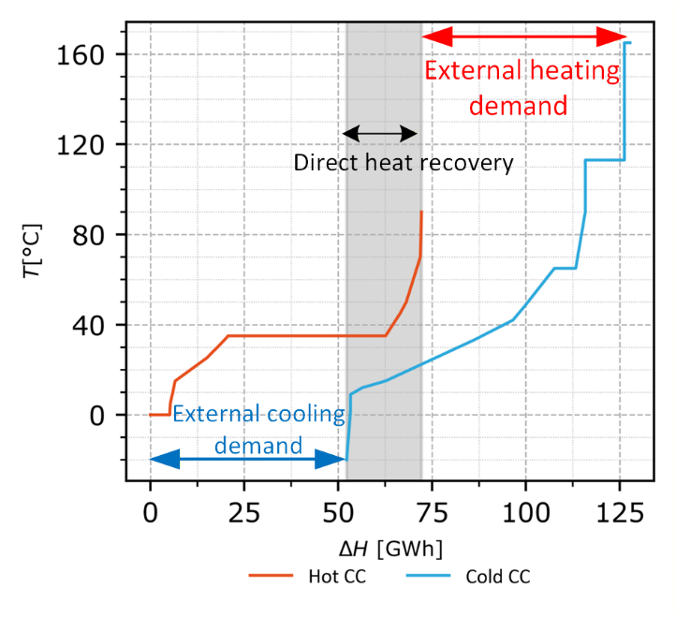  (a) | 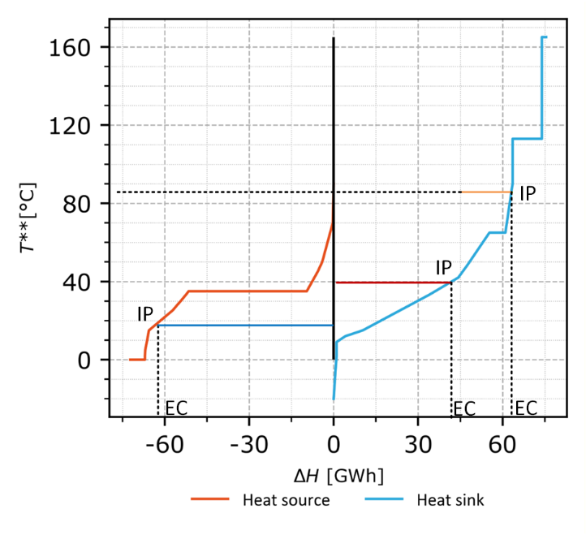  (b)
Figure 1. Integration framework tools (a) composite curves (b) net source-sink profiles
Each technology is integrated within its defined operating temperature range to ensure technical feasibility and adherence to Pinch constraints. For example, the condenser of the standard heat pump (SHP) will be integrated at all technically feasible points between the Pinch point and 100 °C. The framework's flexibility enables it to simulate a wide range of integration strategies and scenario conditions. The final output is a comprehensive solution space comprising feasible configurations across a spectrum of ΔT_{min} values (DHR potentials), integration sequences, and technology mixes. The optimization step then evaluates these configurations to identify Pareto-optimal solutions that balance cost and environmental impact.
2.4. Cost data modeling
The total annual cost (TAC) presented in Eq. (1) for all EEMs, ECT, and RTs considered in this work is comprised of the amortized capital cost (CAPEX_{annual}) and annual operating costs (OPEX). While amortized CAPEX is estimated based on the total capital investment cost and assumptions of the discount rate and the technical lifetime of the technologies (Eq. (2)), OPEX is estimated as a share of the overall CAPEX and related fuel costs. Table 2 presents cost functions derived for all the EEMs and technologies considered in this study. These cost functions estimate module costs adjusted to 2024. Total installation costs are estimated using a Lang factor of 3 to account for installation, piping, site preparation, and engineering (Smith, 2005). The technical lifetime of technology Li is assumed to be 10 years for HEX, 15 years for HPs, and 25 years for STs. The discount rate (r) is assumed to be 10 %.
$$TAC=\sum_{i=1}^{n}{{CAPEX}_{annual,i}}+\sum_{i=1}^{n}{{OPEX}_{i}}$$ | (1)
$${CAPEX}_{annual,i}={CAPEX}_{i}×\frac{r}{1-{(1+r)}^{{-L}_{i}}}$$ | (2)
Table 2. Power law relationships for cost functions (abbreviations- K: thousand, A: Heat exchange area, Q: Heat capacity)
Equipment | Cost function | Source
Plate HEX | $${CAPEX}_{HEX}=14K+17.5K({\frac{{\overline{A}}_{L}}{40m2})}^{0.61}$$ | Ong et al., 2022
Shell and tube HEX | $${CAPEX}_{HEX}=45K+6K({\frac{{\overline{A}}_{L}}{100m2})}^{0.71}$$ | Rast, 2018
Standard heat pump | $${CAPEX}_{SHP}=148K×{{(Q}_{cond,HP}/100)}^{0.42}$$ | Jakobs and Stadtländer, 2021
High-temperature heat pump | $${CAPEX}_{HTHP}=10K×{{(Q}_{cond,HP}/100)}^{-0.322}$$ | Arpagaus et al, 2023
Solar thermal total | $${{CAPEX}_{ST}=CAPEX}_{solar collectors}+{CAPEX}_{storage}$$ | Rittmann-Frank et al., 2021
Solar thermal (flat plate collector) | $${CAPEX}_{solar collectors}=2.4k×A^{-0.192}$$  $${CAPEX}_{storage}=0.54×V×1000+9045$$ | OST, 2022
Solar thermal (parabolic trough collector) | $${CAPEX}_{solar collectors}=2k×A^{-0.088}$$  $${CAPEX}_{storage}=0.54×V×1000+9045$$ | OST,2022
Biomass boiler | $${CAPEX}_{boiler}=123×Q$$ | Pantaleo et al., 2014

2.5. Environmental data modeling
The Environmental impact (EI) of the technologies and EEMs considered in this study is evaluated using a cradle-to-end-use system boundary. This boundary includes emissions generated throughout each technology's life cycle, from raw material extraction and processing to system implementation and use, expressed in CO₂-equivalent emissions. This analysis balances Scope 1 emissions reductions achieved through integrating selected EEMs and technologies against the Scope 3 emissions incurred up front during manufacturing and the Scope 2 emissions generated during operation. The end-of-life phase is excluded from the present manuscript to focus the screening on the manufacturing and operational phases of newly integrated technologies in a retrofit-oriented comparison. This choice may affect absolute TAEI values, particularly for technologies with disposal-sensitive components, and is therefore treated as a limitation of the present study. The climate change impact category is selected to align with the focus on decarbonization and global warming potential, and to simplify the analysis by excluding other environmental impact categories.
The estimation of raw material requirements for each technology component is based on parameterized relationships adopted from literature and product catalogs, ensuring scalability. Life Cycle Inventory (LCI) data for raw material extraction and component manufacturing are sourced from the Ecoinvent 3.9 database (Wernet et al., 2016), which provides a robust and internally consistent basis for the implemented Brightway 2.5 workflow. This study employs the Allocation, Cut-off system model because of its widespread acceptance and practicality in LCA. The LCA models are implemented using the Brightway 2.5 framework, enabling detailed and transparent analysis. Where regionalized datasets were available, Swiss datasets were prioritized, followed by Germany and Rest of Europe proxies. Impacts are quantified using the IPCC 2021, Climate Change, GWP100 method, which offers up-to-date characterization factors for evaluating global warming potential over a 100 y timeframe.
To ensure the credibility of the findings, the LCA model results are validated against peer-reviewed literature and relevant case studies. While the parametric models used in this study offer flexibility, simplifying scaling assumptions may introduce errors in some cases. The EI for the technologies considered in the project is ultimately estimated as a power-law relation given by Eq. (3). In this relationship, a and b are technology-specific coefficients derived from regression analysis of LCA results over a range of installed capacities. Coefficient a represents the scale factor, while b captures how emissions scale with increasing size. The parametric models developed in the Brightway framework are used to estimate the overall LCA scores for a range of installed capacities to develop these power-law relations, which are then combined with Scope 1 and Scope 2 emissions from residual utilities during the optimization phase (Eq.(4)).
$${EI}_{i,scope3}=a×{{Functional unit}_{i}}^{b}$$ | (3)
$$TAEI=\sum_{i=1}^{n}{{EI}_{scope 1}}+\sum_{i=1}^{n}{{EI}_{scope 2}} +\sum_{i=1}^{n}{{EI}_{scope 3}}$$ | (4)
Scope 1 EI is estimated based on potential fossil-fuel savings and typical emission factors, and Scope 2 EI is estimated based on electricity demand and typical grid emission factors for the studied regions.
2.6. Pareto-screening
Each combination of minimum temperature approach (ΔT_{min}) and technology integration temperatures defines a distinct integration configuration, which is evaluated in terms of total annualized cost (TAC; Eq.(1)) and total annual environmental impact (TAEI; Eq.(4)). The resulting configuration space is then analyzed using a non-dominated sorting procedure to identify the Pareto-optimal configurations, representing the trade-off between cost and environmental impact.
To ensure thermodynamic and operational feasibility, equality constraints are imposed so that the combined heating and cooling contributions from all technologies, including energy efficiency measures (EEMs), energy conversion technologies (ECTs), renewable technologies (RTs), and conventional utilities, exactly satisfy the process heating and cooling requirements determined for a given ΔT_{min}. These constraints are expressed in Eqs. (5) and (6):
$Q_{HP,cond}+Q_{ST}+Q_{HU,res}=Q_{HU.min}$ | (5)
$$Q_{HP,evap}+Q_{CU,res}=Q_{CU.min}$$ | (6)
In addition, inequality constraints ensure that ECTs and RTs operate within feasible temperature ranges. These bounds reflect the technical limitations of the technologies and the temperature requirements of the process streams. Table 3 summarizes the corresponding constraints for continuous and non-continuous processes.
Table 3. Inequality constraints derived from the operating temperature ranges for EEMs and technologies chosen in this case study
EEM/ Technology | Decision variable | Continuous process constraints | Non-continuous  process constraints
Heat recovery | Minimum approach temperature (ΔT_{min}) | 5 °C ≤ ΔT_{min} ≤ 20 °C
Heat recovery | Amount of indirect HR (IHR_{set}) | - | 0 % ≤ IHR_{set} ≤ 95 %
Solar thermal  (flat plate/vacuum tube) | Integration temperature (T_{solar_fp/vt}) | Pinch ≤ T_{solar_fp} ≤ 100 °C | Pinch ≤ T_{solar_fp} ≤ 100 °C
Solar thermal  (parabolic trough) | Integration  temperature (T_{solar_pt}) | 100 °C ≤ T_{solar_vt} ≤ 150 °C | -
SHP condenser | Integration temperature (T_{cond_shp}) | Pinch ≤ T_{cond_shp}≤ 100 °C | Pinch ≤T_{cond_shp}≤100 °C
HTHP condenser | Integration temperature (T_{cond_hthp}) | 100 °C ≤ T_{cond_hthp}≤ 150 °C | -
HP evaporator | Integration temperature (T_{evap}) | T_{h_min}* ≤ T_{evap} ≤ Pinch | T_{h_min}* ≤ T_{evap} ≤ Pinch
*Minimum target temperature for hot streams
SHP: Standard heat pump| HTHP: High temperature heat pump

The optimization problem, therefore, consists of minimizing the two objective functions defined in Eqs.(1) and (4), subject to the equality constraints given in Eqs.(5) and (6) and the inequality constraints listed in Table 4. Because the resulting problem is bi-objective, Pareto-efficient configurations are identified using a fast non-dominated sorting procedure tailored to the simultaneous minimization of TAC and TAEI. Candidate configurations with undefined objective values are removed prior to sorting. The remaining feasible configurations are first ordered in ascending TAC and, for equal TAC values, in ascending TAEI. For this minimization problem, configuration a is said to dominate configuration b if TACa ≤ TACb and TAEIa ≤ TAEIb, with at least one strict inequality. After sorting, the configurations are scanned once from left to right while tracking the lowest TAEI encountered so far. A configuration is retained on the Pareto front only if its TAEI is strictly lower than this running best value. For the present two-objective case, this procedure yields the same Pareto-efficient set as exhaustive pairwise comparison, while reducing the computational effort from O (n2) to O (n log n) due to the initial sorting step followed by an O(n) sweep. This deterministic and memory-efficient implementation is well-suited to the large configuration sets generated by the temperature and technology screening loops under favorable and adverse scenarios.
Once the Pareto Front of optimal configurations is identified, knee points indicate zones of diminishing returns. To identify the knee point, where the direction of the trade-off changes most significantly, the algorithm computes the change in slope between consecutive points along the Pareto front. The slope at each point is estimated as the ratio of the change in TAC to the change in TAEI (i.e., the marginal abatement cost). The first difference of the slope between adjacent points is then calculated. Points where the absolute change in slope exceeds the median plus two standard deviations of all slope changes are identified as knee points. This statistical threshold, corresponding to approximately 95% of the data assuming normality, captures only the most significant transitions in the trade-off trajectory. This approach identifies locations where additional cost yields diminishing returns in emissions abatement, making them strategically important decision points for stakeholders balancing economic and environmental objectives.
- Results and discussion
3.1. Pareto-optimal solutions
Figure 2 presents the Pareto-optimal solutions obtained for all investigated process types under the different regional scenarios. Across the fronts, several pronounced knee points can be observed. These points reflect a recurring structural transition in the solution space into the zone of diminishing returns. In the current technology set, they occur when the Degree of Integration (DoI) reaches its upper bound of 100%, corresponding to configurations in which biomass replaces the remaining natural-gas hot utility.
The DoI immediately before this transition varies considerably between process types and regions, ranging from approximately 20% for Die Casting (Type E) in the West to approximately 83% for Surface Finishing (Type A) in the West, whereas the subsequent configuration reaches 100% by definition. The associated reduction in total annual environmental impact (TAEI) is therefore often pronounced, amounting to approximately 35–91% of the maximum observed TAEI for the representative cases examined. The magnitude of this reduction is primarily governed by the amount of residual fossil-fuel demand remaining before the transition. In other words, the sharp drop reflects substituting the remaining natural-gas utility rather than the marginal effect of any technology already present in the configuration.
This distinction matters when interpreting the role of solar thermal (ST) along the Pareto front. ST is frequently present in configurations located close to these knee points, but the pronounced reduction in TAEI at the transition to 100% DoI should not be attributed to ST itself. Instead, ST increases integration before the final substitution step, while biomass eliminates the remaining fossil-fuel demand and completes the transition to full integration. Consequently, the role of ST cannot be inferred reliably from its proximity to the knee point alone. Its contribution is therefore evaluated separately by conditioning directly on DoI and examining the point at which ST enters the Pareto-optimal pathway, the fraction of heat it supplies, and the temperature level at which it is integrated.
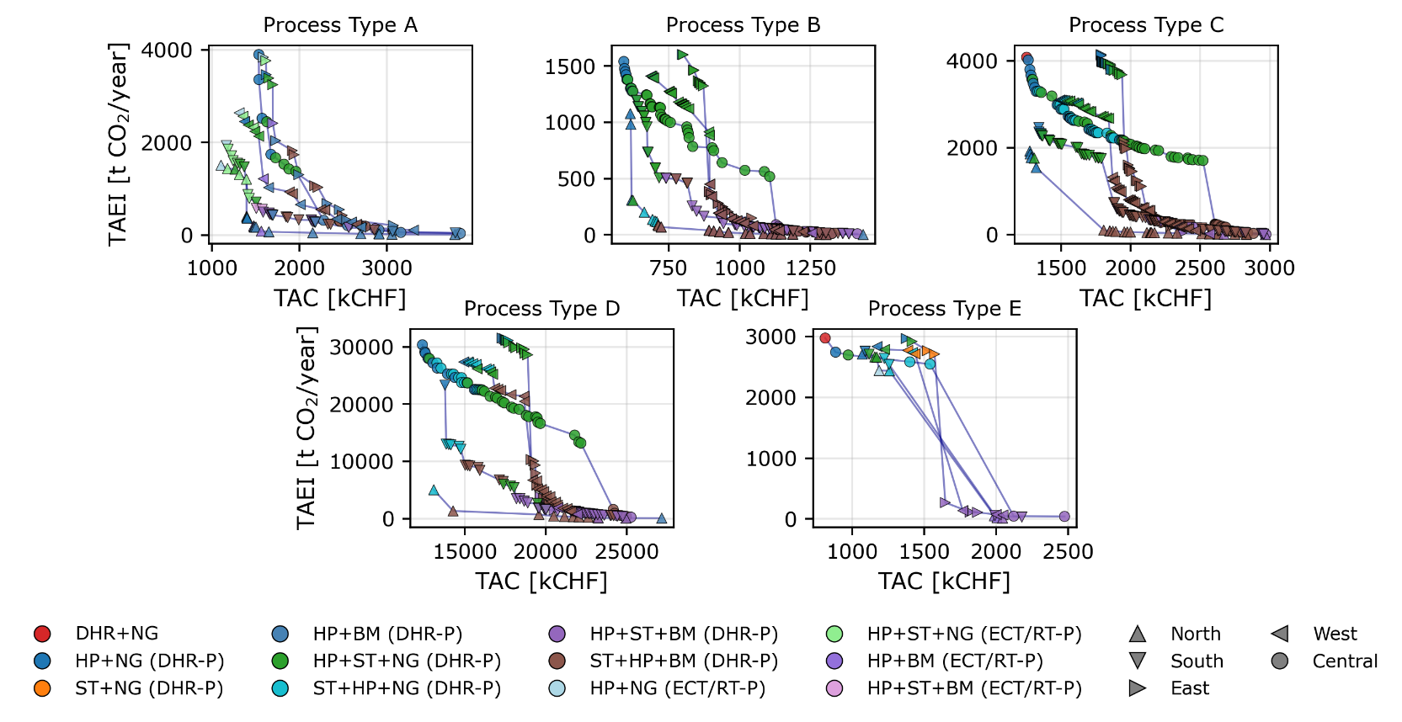
Figure 2. Pareto-optimal configurations under various regional constraints for (a) Surface Finishing (b) Chocolate processing (c) Dairy processing (d) Paper production and (e) Die casting process
3.2. Role of Solar Thermal across process types and regions
This subsection summarizes the role of solar thermal within the Pareto-optimal decarbonization pathways for the five process types and five European regions considered. Four indicators are used to characterize this role: the energy-weighted mean sink temperature supplied by ST (Figure 3), the minimum degree of integration at which ST first appears on the Pareto front (Figure 4), the mean solar fraction among ST-active Pareto-optimal configurations (Figure 5), and the share of those configurations that exceed the assumed rooftop-area constraint (Figure 6).
Taken together, the results show that the role of ST is governed by both process thermodynamics and regional conditions. A clear north-to-south increase in ST attractiveness is not observed across all process types. Instead, regional solar availability modifies a process-dependent baseline established by the temperature distribution, heat-recovery potential, and competition with alternative technologies. This is important because it implies that annual solar irradiance and process supply temperature alone are insufficient to characterize the suitability of industrial ST.
The energy-weighted mean sink temperature supplied by ST varies substantially across the process types, ranging from approximately 33 to 123 °C across the investigated scenarios. Process Types A and B consistently select ST at relatively low temperatures, with mean sink temperatures mostly between approximately 30 and 70 °C. This indicates that ST primarily supplies low-temperature residual duties after heat recovery and competing energy-conversion options have been considered.
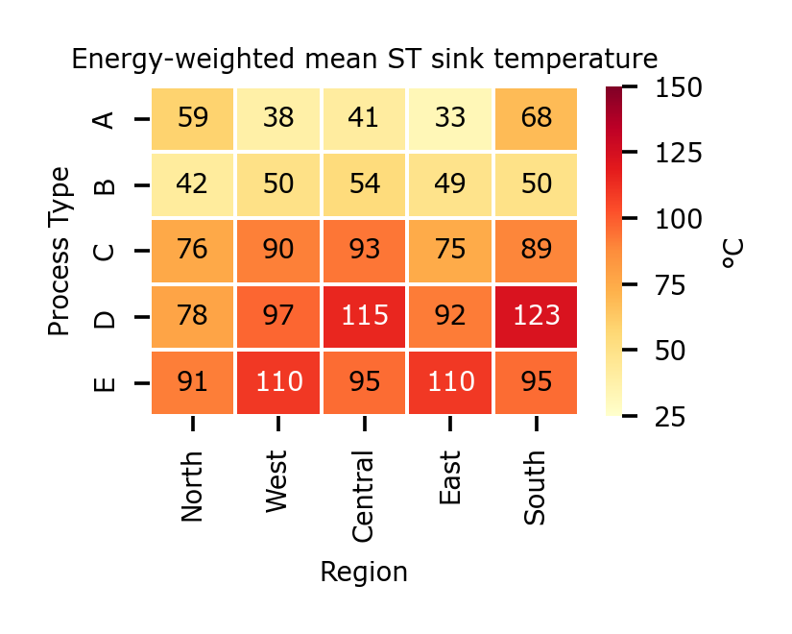
Figure 3. Typical solar thermal integration temperatures for Pareto-optimal configurations for all processes and regions investigated
Process Type C occupies an intermediate range, with mean ST sink temperatures of approximately 75–93 °C depending on region. ST therefore contributes mainly to medium-temperature heating duties for this process type. In contrast, Types D and E exhibit substantially higher preferred integration temperatures. Type D reaches mean ST sink temperatures of 115 °C in the Central region and 123 °C in the South, while Type E consistently lies around 90–110 °C. These differences illustrate the importance of the underlying thermal energy demand structure. Two processes located in the same region may assign ST to fundamentally different duties because their residual heating requirements occur at different temperatures. Similarly, moving a given process between regions does not necessarily shift the preferred ST integration temperature monotonically with irradiance. All regional conditions (including the grid emission factor, spark gap ratio, and biomass availability) determine which configurations remain Pareto-optimal, but the process itself primarily constrains the accessible temperature levels.
The selected temperature also affects collector technology. The low-temperature integration observed for Types A and B is compatible with conventional flat-plate and vacuum tube collectors, whereas the higher-temperature duties appearing for Types D and E require higher-performance collector technologies such as parabolic trough collectors. The regional influence on ST performance must therefore be interpreted together with the temperature-dependent collector choice rather than purely through available irradiation.
The minimum degree of integration at which ST appears on the Pareto front indicates whether ST contributes to early-stage decarbonization or only becomes attractive once deeper emissions reductions are pursued. Substantial differences emerge across process types. For Type E, ST enters consistently at a relatively low degree of integration, around 20–23%, across all regions. This suggests that ST forms part of the Pareto-optimal technology mix comparatively early and that its role is relatively insensitive to the regional scenario.
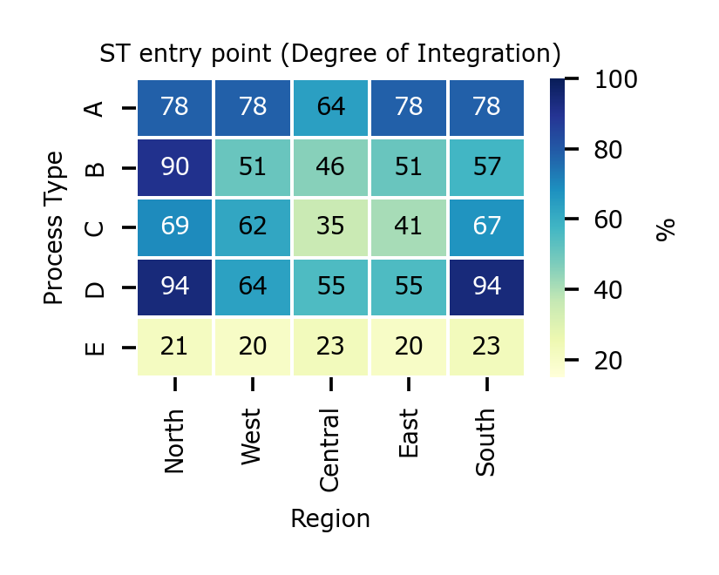
Figure 4. Entry point for solar thermal along the Pareto Front in the form of degree of integration for all processes and regions studied in this work
Type A shows the opposite behavior: ST typically appears only at about 78% integration, with the Central scenario reducing this threshold to 64%. For this process type, ST is therefore predominantly a deep-decarbonization option rather than part of the initial cost-effective pathway. Types B and C occupy an intermediate position. For Type B, ST enters between approximately 46% and 90% integration, whereas Type C varies from only 35% in the Central region to 69% in the North. Type D is particularly region-sensitive. ST enters at approximately 55–64% integration in the West, Central, and East, but only appears at about 94% integration in both the North and South. These results demonstrate that a favorable solar resource does not automatically imply earlier ST integration. Other decarbonization options such as DHR, HPs, or BM could provide more favorable TAC–TAEI trade-offs for a specific combination of process type and regional constraints. The ST entry point therefore reflects the competition between technologies along the entire Pareto front.
The solar fraction provides a complementary perspective because early entry does not necessarily mean ST supplies a large share of total heating demand. Across most process–region combinations, the mean solar fraction remains modest, generally below 10%. Process type A ranges from approximately 3% in the North to 10.4% in the South, while Type C remains below approximately 6% in all regions. These results indicate that ST often acts as a complementary heat source, supplying a specific temperature interval rather than replacing a large share of overall industrial heating demand.
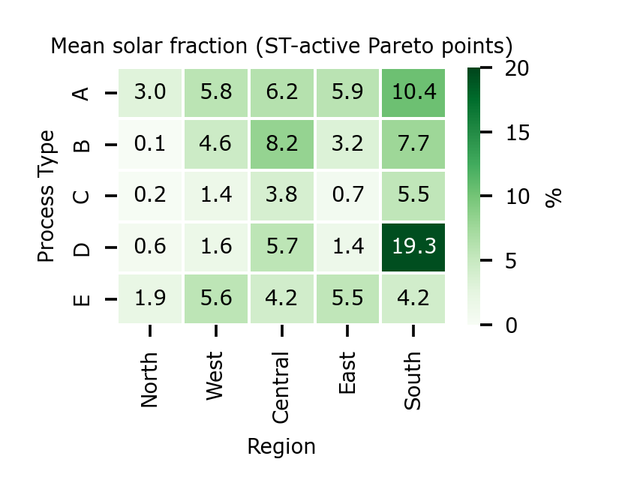
Figure 5. Mean solar fractions for Pareto configurations for all processes and regions
The regional influence is more pronounced for Types B and D. For Type B, the mean solar fraction increases from only 0.1% in Northern Europe to 8.2% in Central Europe. Type D shows the strongest regional response, increasing from below 2% in the North, West and East to 5.7% in the Central region and 19.3% in the South. The entry point determines when ST becomes competitive, whereas the solar fraction determines how important it becomes once selected. These two metrics are not strongly coupled. For example, Type E exhibits the earliest ST entry across all regions but achieves only moderate solar fractions of approximately 2–6%. Conversely, Type D enters relatively late in several regions but can provide the largest mean solar contribution under favorable southern conditions.
Thermodynamic and Pareto optimality do not guarantee practical deployability. ST-active Pareto solutions are screened post hoc against an assumed rooftop limit using the IEA SHC Task 64 exploitation factor of 0.33 (Pag, 2022), which accounts for spacing, shading, and orientation constraints. Because sector-specific roof areas are unavailable, process Types A, B, and C are assigned a 5,000 m² roof area (1,650 m² collector cap), while Types D and E are assigned 20,000 m² (6,600 m² cap). These illustrative limits are applied uniformly across regions, and Figure 6 reports the share of ST-active Pareto solutions exceeding them. The results reveal substantial differences across process types. Type C is the least spatially constrained, with essentially no rooftop violations in four regions and only 8% in the Central scenario. This suggests that the comparatively small ST contributions observed for Type C are generally compatible with rooftop installation.
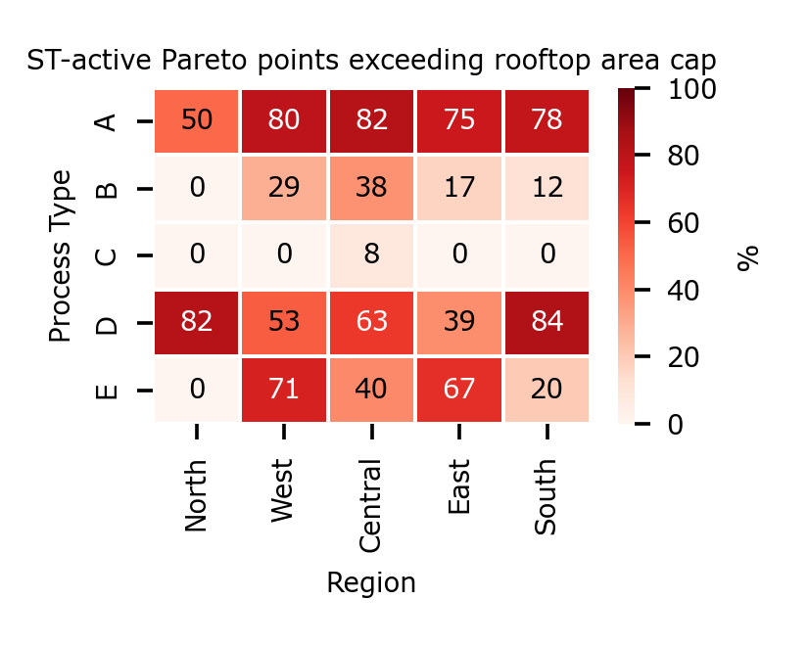
Figure 6. Share of Pareto optimal configurations where solar collectors exceed assumed rooftop area
Process type D shows the opposite behavior; it exhibits the highest exceedance rates, ranging from 39% in the East to 84% in the South. This means many configurations optimal from a TAC–TAEI perspective would require additional ground-mounted collectors, carport integration, or other available site area. The southern result for Type D is particularly instructive. The same scenario that produces the highest mean solar fraction, approximately 19%, also produces one of the highest spatial infeasibility rates, approximately 84%. Favorable irradiance therefore improves the economic and environmental competitiveness of ST but does not remove spatial constraints when the optimal system scale becomes large. Type B displays moderate spatial limitations, with exceedance rates between 0 and 38%. Type E shows a more heterogeneous response, ranging from no violations in the North to more than 70% in the West. These findings suggest treating available installation area as a screening constraint rather than a secondary implementation detail. Without this constraint, the optimization may identify configurations that are economically and environmentally attractive but practically unavailable at the industrial site.
- Conclusions
This study shows that the role of solar thermal (ST) in industrial decarbonization cannot be inferred from process temperature or regional solar irradiation alone. Instead, it emerges from interactions among the thermal process demand structure, competing decarbonization technologies, and regional boundary conditions. Across the investigated archetypes, ST assumes different roles: it may enter early but supply only a small fraction of heat, appear later as a complementary technology after heat recovery and electrification have been exploited, or contribute more substantially to deep decarbonization under favorable regional conditions. In most process–region combinations, the mean solar fraction remains below 10%, although selected archetypes and regions can achieve substantially higher contributions. Spatial constraints further limit some otherwise Pareto-optimal ST configurations.
The results demonstrate why industrial ST potential should be evaluated within the complete decarbonization pathway rather than as a stand-alone technology. The proposed framework provides a first-pass screening method to identify where ST enters the Pareto-optimal pathway, which temperature duties it serves, how much heat it can potentially contribute, and whether the corresponding collector area is practically plausible. The framework remains a sequential screening approach rather than a simultaneous global optimization and is subject to uncertainties in cost, LCA, and spatial assumptions. Nevertheless, it provides a transferable basis for prioritizing process–region combinations for more detailed ST feasibility assessment.
- References
Arpagaus, C., Bless, F., Bertsch, S., Krummenacher, P., Flórez-Orrego, D.A., Pina, E.A., Maréchal, F., Calame Darbellay, N., Rognon, F., Vesin, S., Achermann, P., Jansen, C., 2023. Integration of high-temperature heat pumps in Swiss industrial processes (HTHP-CH). Proceedings of the 14th IEA Heat Pump Conference, Chicago, IL, 15–18 May 2023, Paper No. 494.
Atkins, M.J., Walmsley, M.R.W., Morrison, A.S., 2010. Integration of solar thermal for improved energy efficiency in low-temperature-pinch industrial processes. Energy 35, 1867–1873. https://doi.org/10.1016/j.energy.2009.06.039.
Bhadbhade, N., Grand, J., Klinac, E., Ong, B.H.Y., 2025. Optimum integration strategy for Energy Efficiency Measures, Energy Conversion Technologies, and Renewable Technologies under various resource constraints, Proceedings of the 28th Conference on Process Integration, Modeling and Optimization for Energy Saving and Pollution Reduction, 24 – 27 August 2025, Port Dickson, Malaysia
Eiholzer, T., Olsen, D., Hoffmann, S., Sturm, B., Wellig, B., 2017. Integration of a solar thermal system in a medium-sized brewery using pinch analysis: Methodology and case study. Applied Thermal Engineering 113, 1558–1568. https://doi.org/10.1016/j.applthermaleng.2016.09.124.
Fraunhofer ISI, 2024. Direct electrification of industrial process heat: An assessment of technologies, potentials and future prospects for the EU. Study on behalf of Agora Industry, Karlsruhe. Publication No. 329/04-S-2024/EN.
Jakobs, R.M., Stadtländer, C., 2021. Final Report Annex 48: Industrial Heat Pumps, Second Phase. IEA Technology Collaboration Programme on Heat Pumping Technologies, Report HPT-AN48-1.
Nemet, A., Kravanja, Z., Klemeš, J.J., 2012. Integration of solar thermal energy into processes with heat demand. Clean Technologies and Environmental Policy 14, 453–463. https://doi.org/10.1007/s10098-012-0457-6.
Ong, B.H.Y., Lucas, E.J., Olsen, D.G., Roth, S., Wellig, B., 2022. A user workflow for combining process simulation and pinch analysis considering ecological factors. Chemical Product and Process Modeling 17, 341–363. https://doi.org/10.1515/cppm-2021-0004.
OST, 2022. SolInd2Service – Solar Heat for Swiss Service Sector. OST, SPF Institute for Solar Technology.
Pag, Felix. 2022. "How Load Profile and Roof Area Limit Solar Fractions of SHIP Plants." IEA SHC Solar Update, July 2022. https://www.iea-shc.org/Data/Sites/1/publications/2022-07-Task-64--How-to-Load-Profile-and-Roof-Area-Limit-Solar-Fractions-of-SHIP-Plants.pdf.
Pantaleo, A.M., Giarola, S., Bauen, A., Shah, N., 2014. Integration of biomass into urban energy systems for heat and power. Part II: Sensitivity assessment of main techno-economic factors. Energy Conversion and Management 83, 362–376. https://doi.org/10.1016/j.enconman.2014.03.051.
Rast, L., 2018. Development of equipment module and investment cost estimating functions and integration concept in the PinCH software. Master’s Thesis, Lucerne University of Applied Sciences and Arts, Horw, Switzerland.
Rehfeldt, M., Fleiter, T., Worrell, E., 2018. Inter-fuel substitution in European industry: A random utility approach on industrial heat demand. Journal of Cleaner Production 187, 98–110. https://doi.org/10.1016/j.jclepro.2018.03.179.
Rittmann-Frank, M.H., Theiler, D., Ruesch, F., Bamberger, E., Wellig, B., Stirnimann, P., Olsen, D., 2021. BillySolar – Konzernrelevante Verringerung von CO₂-Emissionen durch die Integration von skalierbaren und kostengünstigen Solarwärme-Einheiten. SPF Institut für Solartechnik, Switzerland. https://doi.org/10.5281/zenodo.6472404.
Smith, R., 2005. Chemical Process Design and Integration. John Wiley & Sons, Chichester, West Sussex, UK.
Stampfli, J.A., Atkins, M.J., Olsen, D.G., Walmsley, M.R.W., Wellig, B., 2019. Practical heat pump and storage integration into non-continuous processes: A hybrid approach utilizing insight-based and nonlinear programming techniques. Energy 182, 236–253. https://doi.org/10.1016/j.energy.2019.05.218.
Wernet, G., Bauer, C., Steubing, B., Reinhard, J., Moreno-Ruiz, E., Weidema, B., 2016. The ecoinvent database version 3 (Part I): Overview and methodology. The International Journal of Life Cycle Assessment 21, 1218–1230. https://doi.org/10.1007/s11367-016-1087-8.

DoI is defined as the share of fossil fuels replaced by EEMs, ECT, RTs and sustainable fuels within the annual process heat demand.

