EuroSun2026
SHC TASK 70 / EBC ANNEX 90
LOW CARBON, HIGH COMFORT INTEGRATED LIGHTING
BOOK ON HUMAN VISUAL AND NON-VISUAL RESPONSE TO THE BUILT ENVIRONMENT

Barbara S. Matusiak¹, Mandana S. Khanie², Jan de Boer³, Edward Barrett²
¹ Norwegian University of Science and Technology NTNU, Trondheim (Norway), barbara.matusiak@ntnu.no
² UCL Institute for Environmental Design and Engineering (IEDE), London (United Kingdom)
³ Fraunhofer Institute for Building Physics IBP, Stuttgart (Germany)
Summary
Research on human responses to light is moving beyond frameworks developed decades ago. The discovery of intrinsically photosensitive retinal ganglion cells in 2002 transformed understanding of light perception. Light affects not only vision but also important physiological and behavioral processes. Emerging findings suggest that near-ultraviolet and near-infrared radiation may also influence humans. The significance of non-visual and beyond-visual effects is proving broader than previously assumed. Visual research is likewise improving knowledge of window views and their relationship to glare perception. Attention has therefore expanded from indoor lighting conditions to the environment outside the window. The book examines recent discoveries and their practical implications for lighting research and application. Its contributions are mainly drawn on the international work of IEA SHC Task 70 and its four subtasks. The content is based on 34 recent scientific articles and doctoral theses, each condensed to about six pages. Carefully adapted illustrations support the subjects, and the articles are organized into six thematic parts.
Keywords: human response to light, non-visual effects of lighting, visual comfort and glare, window view quality, user-centred lighting research
- Background
Despite major research advances, our understanding of human responses to the visual environment remains grounded in frameworks developed decades ago. The discovery of the intrinsically photosensitive retinal ganglion cells (ipRGC) in the human retina in 2002 by David Berson marks an era in which the human response to light is about to be completely rewritten. It turns out that humans’ response to light extends well beyond the visual aspects of vision, with a much greater role in regulating physiological and behavioral processes than previously assumed. The emerging evidence also points to broader spectral ranges, spanning the near ultraviolet and near infrared ranges, that influence us in ways that we are only beginning to understand. The importance of non-visual and beyond-visual effects surprises us with its scope and importance. Moreover, even within research purely dealing with visual responses, the view out of the window and the complex relation between the perception of glare and the quality of the window view are about to be much better understood. The focus has shifted from indoor lighting conditions to a broader perspective of including the environment outside the window and its contribution to the visual experience. These developments raise important questions: what can we learn from these emerging developments in research, and what are the practical implications? To answer these questions, we summarize the newest research results in a book form (Figure 1).
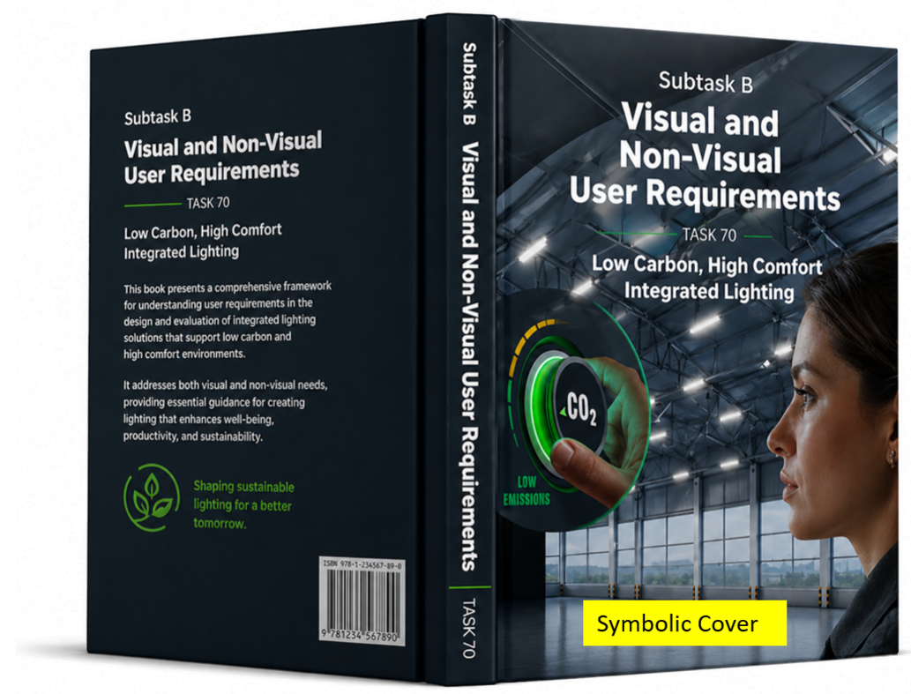
Fig. 1: Symbolic book cover
- Content
The book takes the pulse of research that has been developed in recent years across countries and continents. Most authors are members of the IEA SHC Task 70 Subtask B – Visual and non-visual User Requirements. In addition, the expertise from all other subtasks is included, namely A – Low Carbon Lighting and Passive Solar, C – Digitalized Lighting Solutions, and D – Lab and Field Study Performance Tracking. The content of the book is literary based on thirty-four recently published scientific articles or doctoral thesis (Figure 2).
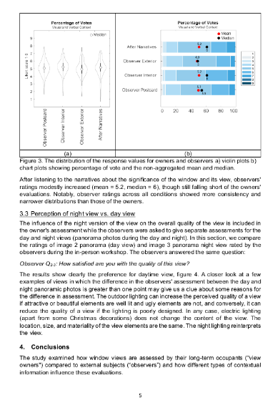
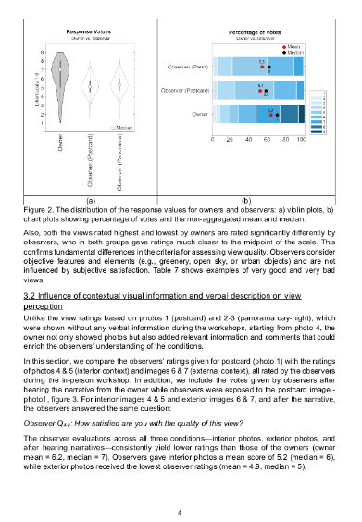
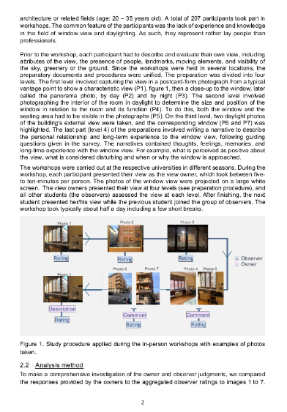
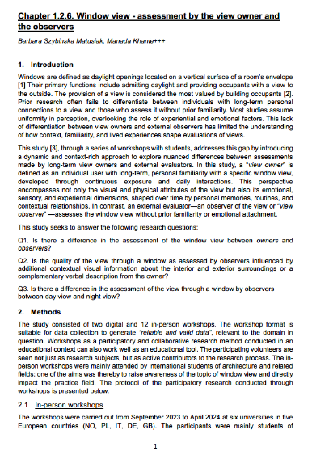

Fig. 2: Example of one of thirty-four articles comprising the book
Each article is shortened to about six pages, which helps to convey the new scientific discoveries in a short, simple, and convincing way. Illustrations are carefully chosen and adjusted to the research topic and to the book’s layout. The articles are structured in six parts.
Part 1. Visual Stress & Mitigation: Improved understanding of the visual environment for humans
Part 2. Window View: Understanding of window view. Relationship between window view and urban morphology
Part 3. Non-Visual Effects: New developments in non-visual aspects. Measurement and assessment methods of non-visual aspects
Part 4. Digital Tools: Digital tools and emerging technologies
Part 5. Case Study: Applied case studies and practical implementation
Part 6. Carbon Footprint: Carbon footprint and sustainability considerations
- Publication
The book is planned to be published end of 2026 in the IEA SHC Book Series with Wiley: https://www.iea-shc.org/shc-book-series

