EuroSun2026
INTEGRATING MEDIUM-TEMPERATURE HEAT PUMPS AND BIOMASS CHP IN DISTRICT HEATING NETWORKS: SYSTEM-LEVEL COST, EMISSIONS AND HYDRAULIC TRADE-OFFS

Luca Vittorio Valentini (corresponding author), Alexander Thür, Wolfgang Streicher
University of Innsbruck, Unit of Energy Efficient Building
luca.valentini@uibk.ac.at
Summary
This study evaluates system‑level impacts of integrating a sewage-water medium‑temperature heat pump into a planned 4th generation district heating (4GDH) network containing a biomass CHP (internal‑combustion gas engine) and an electric boiler. In this study, a benchmark return‑to‑supply configuration is compared with a study case in which the heat pump preheats network return upstream of the CHP, using annual simulations in the Leanheat Network tool with explicit main-pipes topology. The Study case reduces annual operating costs by 11.4% (1,703 vs. 1,510 kEUR/year) and CO₂‑eq. emissions by 15.0% (801.9 vs. 681.4 t CO₂‑eq./year). Benefits stem mainly from an improved heat‑pump seasonal performance factor (SPF: 2.73 vs. 3.46) and, secondarily, a 4.5% reduction in network thermal losses (3,939 vs. 3,761 MWh/year). The main drawback of the Study case is the increased hydraulic stress due to the reduced supply-return temperature difference: the flow rate through the CHP doubles, and electricity consumption of feeding pumps increases. Because CHP performance was modelled as fixed for the studied engine, results are not directly transferable to other CHP technologies (e.g., steam turbines or ORC) that are sensitive to condenser or extraction temperature. The authors recommend adopting heat‑pump return preheating for its clear cost and emissions advantages while assessing CHP heat‑exchanger capacity and acceptable operating temperatures early in project planning to ensure reliable combined heat and power performance.
Keywords: district heating networks, heat pumps, ammonia heat pumps for district heating, combined-heat-and-power
Field of application for the findings: district heating operation
Addressed audience: researchers
- Introduction
Heat pumps (HPs) are increasingly deployed in district heating (DH) systems as a decarbonization measure. Recent literature describes multiple integration approaches: medium–high-temperature HPs in fourth-generation DH (4GDH) topologies (Sayegh et al., 2018), booster HPs for domestic hot water in fifth‑generation DH (5GDH) (Zhu et al., 2023), and hybrid configurations combining decentralized HPs with other heat sources in the DH network (Soleimani et al., 2025). Studies indicate potential operational cost savings and CO₂ reductions from DH–HP integration, but the magnitude of benefits depends strongly on how the HP is connected to the heat source and sink (Ommen et al., 2014; Barco-Burgos et al., 2022).
1.1. Research gap, novelty, and scope
Low-temperature HPs can be particularly advantageous when they exploit relatively cool sinks. A pre-heating of the return line, where the HP raises the temperature up to an intermediate temperature level, tends to increase COP/SPF compared to lifting to a warmer sink temperature. Prior numerical examples (Ommen et al., 2014; Barco-Burgos et al., 2022) report favourable HP performance for pre-heating layouts, but they impose boundary conditions at the component level rather than modelling network-scale interactions. Component analysis alone does not reveal whether HP pre‑heating helps or harms the system (or by how much): downstream efficiencies and recoverable heat depend on the network’s actual supply and return temperatures.
This study explicitly models the hydraulic integration of a medium‑temperature heat pump with two co‑located downstream plants, a biomass combined heat and power (CHP) unit and an electric boiler (P2H), within a 4GDH network. In the proposed series layout, the HP pre heats the return up to an intermediate temperature level, so the biomass CHP sees elevated inlet temperatures compared with the conventional configuration.
- Methods
2.1 Network model
The case study examines a DH network in Austria that is currently in the planning phase. The backbone topology and four consumer clusters were identified in an ongoing feasibility study. Backbone pipe diameters and lengths follow the planning documents. The yearly energy density is approximately 1.5 MWh/m. Pipe insulation and friction factors are derived from manufacturer datasheets. Feeder pipe diameters to consumer clusters are sized to meet a peak velocity constraint of 2 m/s. Annual simulation runs are performed with the DH simulation tool Leanheat Network (Danfoss, Leanheat Network) with 15-minute timesteps.
2.2 Heat demand and consumers grouping
The network heat demand comprises space heating (SH) and domestic hot water (DHW) for buildings (residential and public: schools, offices, supermarkets, hospital), with no industrial consumers present. Annual SH and DHW demands for each consumer are taken from a feasibility study for the planned DH network. SH consumption profiles are derived based on room to outdoor temperature difference (including night setback), and considering in a simplified way the effect of building thermal inertia and solar gains. DHW consumption is modelled following standard profiles (Fuentes et al., 2018) with randomized household profiles to account for simultaneity. Consumers are aggregated in four clusters based on their location in the network.
The feasibility study identified a different supply temperature requirement between clusters:
- Cluster 1 has a supply temperature requirement at secondary side of 65 °C both in the heating season (01.09 to 31.05) and in the summer season (01.06 to 31.08).
- Clusters 2 to 4 have a supply temperature requirement at secondary side of 80 °C in the heating season (01.09 to 31.05) and 65 °C in the Summer season (01.06 to 31.08).
Figure 1 summarizes the test-year total DH demand and its distribution.
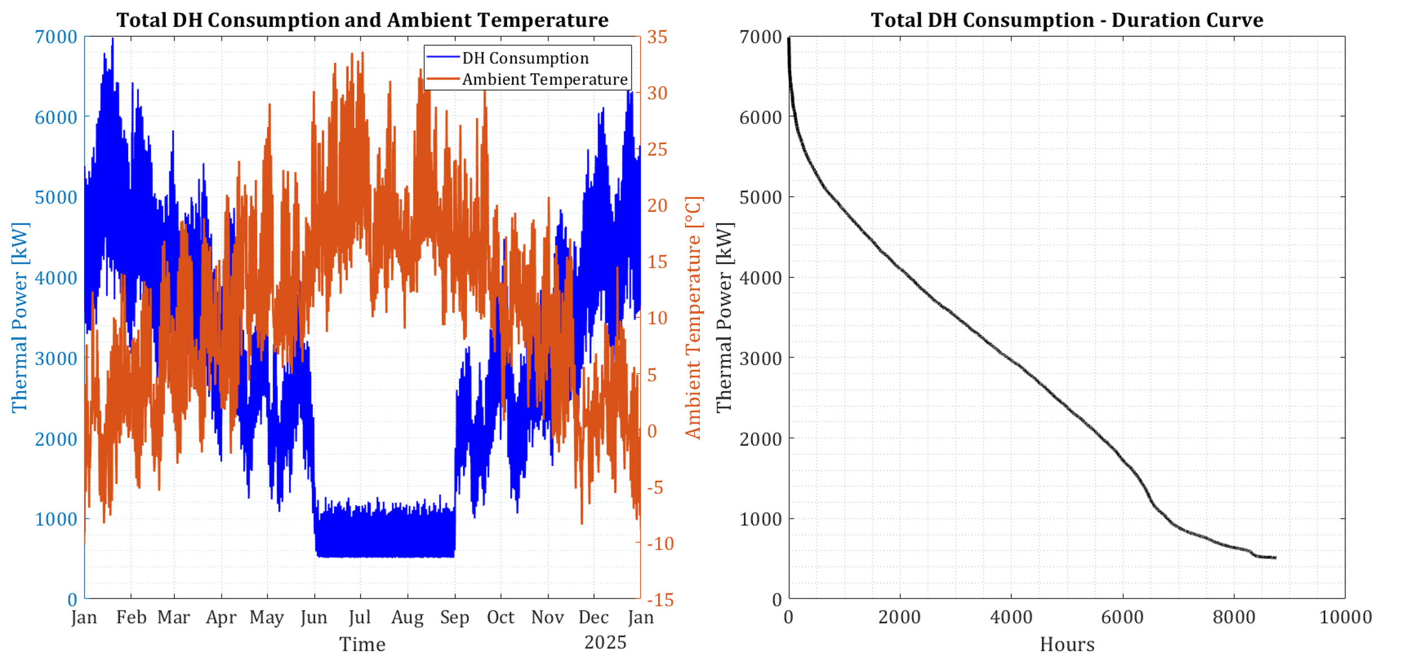
Fig. 1 (left): Total DH consumption (excluding heat losses) [kW] (left y-axis) and ambient temperature [°C] for the test-year. Fig. 1 (right): Duration curve for the same DH Consumption (excluding heat losses) [kW].
The left panel shows the time evolution of total DH consumption excluding network’s distribution heat losses (left axis) and ambient temperature for 2025 (right axis). The right panel shows the duration curve of the same DH consumption, which ranges from a minimum of 509 kW to a maximum of 6,980 kW for the test year. The total DH consumption for the test-year 2025 is equal to 24,070 MWh: 8786 MWh demand for Cluster 1, and 15284 MWh for Clusters 2 to 4.
2.3 Simulation scenarios and hydraulics
The study compares two different scenarios: Benchmark and Study case. Each scenario considers different hydraulic connection and control logic for the heating plants.
Benchmark (Figure 2): all three plants (HP, biomass CHP, and P2H) are all connected in parallel supplying the same supply setpoint temperature to the network.
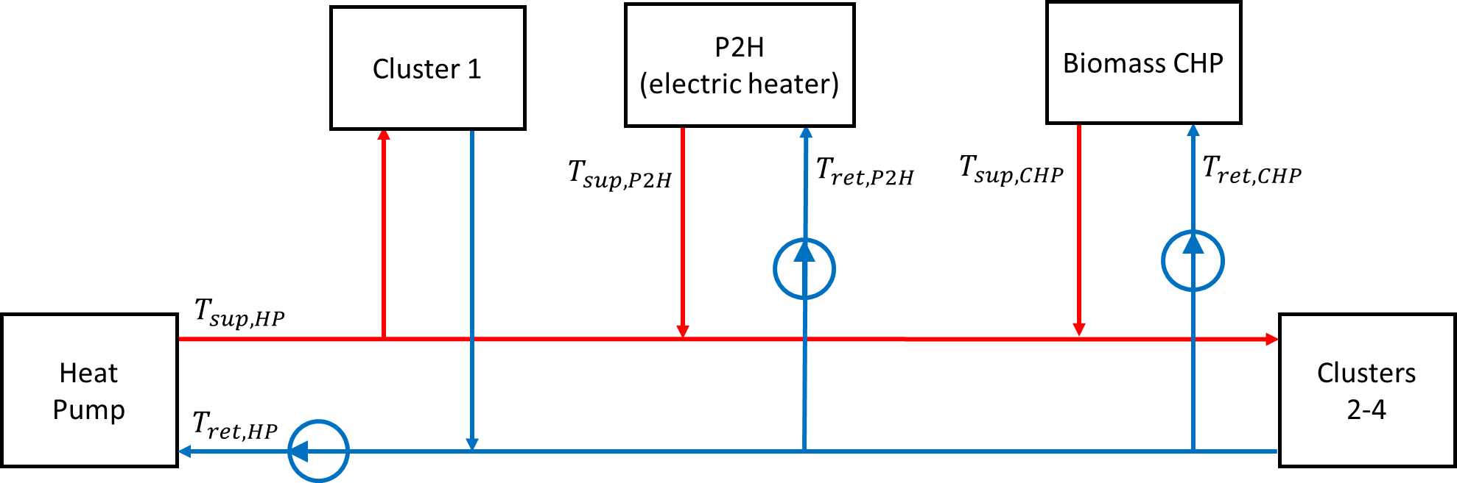
Fig. 2: Conceptual hydraulic scheme used in the Benchmark scenario
Study case (Figure 3): the HP is installed upstream the biomass CHP and the electric boiler (P2H). It primarily supplies Cluster 1 ($T_{sup,HP} = 70 °C$) and can also feed a controlled flow into the intermediate pipe toward Clusters 2 to 4.
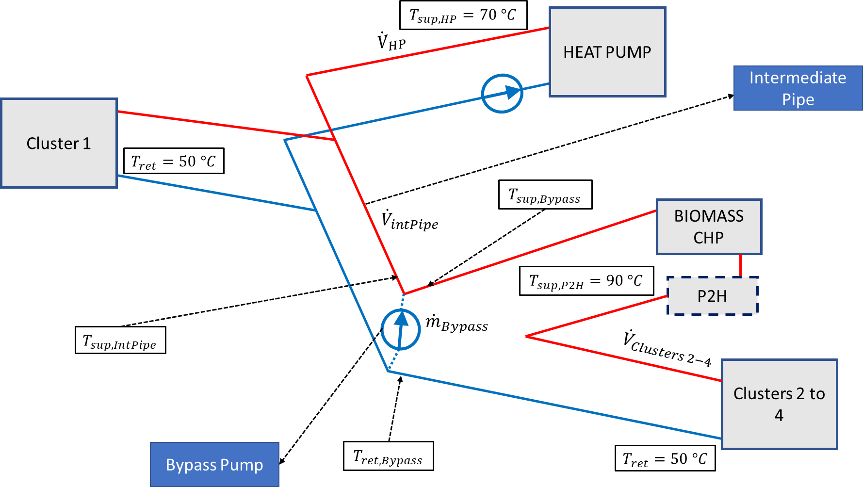
Fig. 3: Conceptual hydraulic scheme used in the Study case scenario
A bypass pump draws a portion of the return line flow and mixes it with the HP flow delivered through the intermediate pipe to form the supply feed for Clusters 2 to 4. The mixed flow temperature $T_{sup,Bypass}$ is then heated up by the downstream biomass CHP and/or the P2H so that the supply setpoint for Clusters 2 to 4 ($T_{sup,P2H}$ = 90 °C) is met.
If total network demand falls below biomass CHP nominal capacity, the HP is switched off and the CHP unit supplies the network alone in return-to-supply (RtS) configuration, according to the hydraulic scheme shown in Figure 2.
In order to simplify the modelling of the hydraulics of biomass CHP and P2H (electric boiler) the modelled configuration differs from the real hydraulic configuration. Figure 4 shows: a) the modelled biomass CHP and P2H (electric boiler) hydraulics in the simulation tool, and b) the real hydraulics of biomass CHP and P2H (electric boiler).
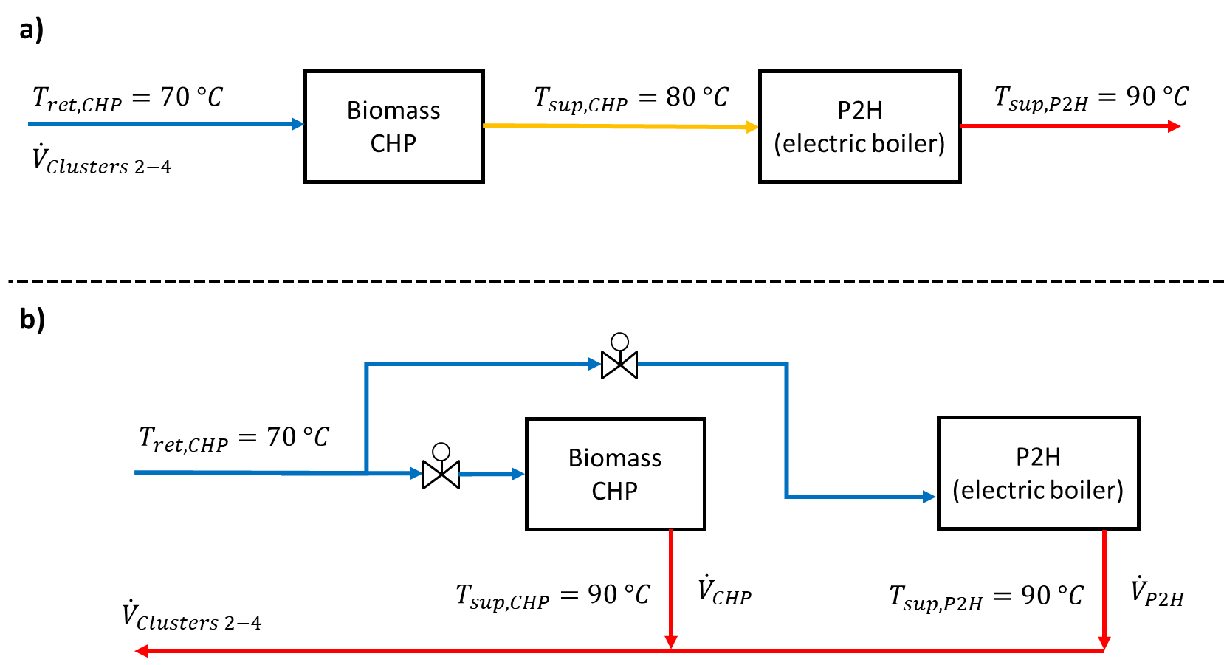
Fig. 4: Conceptual hydraulics for the Biomass CHP and P2H (electric boiler): a) Configuration modelled in the simulation tool; b) Actual plant connection, where the flow is split between the CHP and the P2H.
Under the modelled hydraulics (Fig. 4a) both CHP and P2H serve the volume flow demanded by clusters 2 to 4 (${\dot{V}}_{Clusters 2-4}$). At peak load, the CHP supply temperature reaches only 80 °C (below the 90 °C setpoint). Under the real hydraulics (Fig. 4b), the CHP supplies a controlled portion of flow to clusters 2 to 4 (${\dot{V}}_{Clusters 2-4}$) and is regulated to reach the supply setpoint temperature $T_{sup,CHP}=90 °C$, with the P2H delivering the remaining flow (${\dot{V}}_{P2H}$). This simplification is possible because the total branch flow is identical in the model and the real plants’ connection, so the CHP/P2H flow split can be calculated in post-processing to enforce $T_{sup,CHP}=90 °C$.
2.4 Heating plants: supply temperatures and control
For both the Benchmark and Study case scenario, the thermal power supplied by the heating plants is controlled based on volume flow in a constant temperature variable flow (CT-VF) manner. The thermal power supplied by each plant is controlled based on the following merit order:
- Biomass CHP: maximum thermal power: 2,000 kW; minimum thermal power: 500 kW.
- Sewage‑water source HP: maximum thermal power: 4,000 kW (4 units in parallel, each with a nominal power of 1,000 kW) (measured 15‑min source inlet temperatures 8–22 °C); minimum thermal power: 500 kW.
- P2H electric boiler: maximum thermal power: 3,000 kW; minimum thermal power: 0 kW.
For both the Benchmark and Study case scenario, the return temperature at consumers is set equal to 50 °C during the heating season (01.09 to 31.05), and equal to 55 °C during the Summer (01.06 to 31.08). The higher summer return temperature reflects operation of the DHW circulation loop, which is maintained at minimum 55 °C to prevent Legionella growth.
Benchmark hydraulics and control. During the heating season (01.09 to 31.05), the network is supplied according to the merit order by all the plants in the network: biomass CHP, HP, P2H. The set point for supply temperature is 90 °C from all plants.
During the Summer (01.06 to 31.08), the lower network demand permits the network to be supplied by the biomass CHP alone. The biomass CHP is supplying the network at 75 °C supply temperature. A lower supply setpoint temperature is possible due to the absence of SH demand in this period, and useful to keep the flow rate high enough to respect supply temperature limits at consumers’ substations.
Study case hydraulics and control. In Winter (01.10 to 30.04), the heating plants are operated according to the series connection represented in Figure 3. The supply temperature setpoints are:
- 70 °C for the HP unit
- 90 °C for the unit biomass CHP + P2H.
When the demanded volume flow in the network is low enough, the biomass CHP is able to supply 90 °C to the network and the P2H is shut down. In case the maximum power (2,000 kW) provided by the CHP is not enough, the P2H post-heats the supply line to provide the 90 °C set-temperature. In order to guarantee the correct realization of the merit order, a bypass pump (Figure 4) is installed upstream the biomass CHP. In cases of low demand, the HP is modulating the power (and volume flow) down, while the additional flow demanded by the network is bypassed from the return line upstream the CHP. In this way, the biomass CHP can provide its maximum thermal power (2000 kW) to the network (base-load operation).
However, the flow modulation from the HP is constrained by the satisfaction of the demand in Cluster 1. If the HP modulation needed to respect the merit order would go below this threshold, the HP supplies the thermal power demanded by Cluster 1 at 70 °C, while the biomass CHP supplies Clusters 2 to 4 with 90 °C. In this case, both plants are supplying the network in return-to-supply (RtS) connection and the flow rate in the intermediate pipe is null. The switch between heat-pump preheating and the RtS configuration causes substantial changes in the flow regime in the intermediate pipe. These changes produce short-term hydraulic and thermal transients (e.g., pressure and flow oscillations, brief temperature swings) that cannot be resolved with the 15-minute timestep used in annual simulations. These dynamic effects are therefore neglected in this study but they must be addressed in detailed operational or commissioning analyses and are assumed to be manageable by plant control systems in practice.
In the pure series arrangement, with no flow bled by the bypass pump, the same mass flow passes through the upstream HP and the downstream CHP/P2H. Therefore, the HP contribution to downstream clusters is limited by its temperature lift relative to the total lift required to reach the downstream setpoint (90 °C). Assuming a constant specific heat for the working fluid (water), the HP’s maximum contribution to clusters 2 to 4 is constrained by the temperature lifts as:
$${\dot{Q}}_{HP,max,2-4}={\dot{Q}}_{clusters 2-4}*\frac{T_{sup,HP}-T_{ret}}{T_{sup,CHP}-T_{ret}} (eq. 1)$$
and, including the thermal demand at cluster 1, the HP absolute limit is:
$${\dot{Q}}_{HP,max}={\dot{Q}}_{cluster 1}+{\dot{Q}}_{clusters 2-4}*\frac{T_{sup,HP}-T_{ret}}{T_{sup,CHP}-T_{ret}} (eq. 2)$$
If the demand at clusters 2 to 4 exceeds the temperature-limited contributions of HP and CHP, the electric boiler (P2H) provides the remaining post-heating. Example: with $T_{ret}=50 °C$, $T_{sup,HP}=70 °C$ and ${\dot{Q}}_{cluster 1}=0 kW$, ${\dot{Q}}_{clusters 2-4}=5000 kW$ → ${\dot{Q}}_{HP,max}=0 + 5000*(20/40) = 2500 kW$; with ${\dot{Q}}_{CHP}=2000 kW$, the P2H supplies the remaining 500 kW. In practice this extreme case is unlikely: Cluster 1 represents roughly 37% of total demand, the temperature-limit only becomes relevant for total demand above 4000 kW (below this the HP never provides more than 50% of demand by merit order), and cold weather conditions that produce 5,000 kW demand in Clusters 2 to 4 would almost certainly produce substantial simultaneous demand in Cluster 1 (SH drives demand in Winter). Therefore, the scenario is physically possible but of very low probability in the analysed year.
In Mid-season (01.05 to 31.05 and 01.09 to 30.09), the heating demand is relatively low, so the control is realized so that the HP supplies the thermal power demanded by Cluster 1 while the biomass CHP supplies the thermal power demanded by Clusters 2 to 4.
During the Summer (01.06 to 31.08), the network is supplied in the same way described in the Benchmark scenario. The CHP is running alone, supplying the network at 75 °C supply temperature.
2.5 Heating plants modelling
Heat Pump and P2H efficiency. The heat pump considered in the study consists in a group of four ammonia HPs installed in parallel. The HP group has a total maximum power of 4,000 kW and a minimum power of 500 kW. The evaporator of the HP-group is supplied by sewage water. The temperature of the inlet sewage water channel has been monitored for one year and it ranges from 8 to 22 °C. The HP efficiency is evaluated using a Carnot-based COP model:
$$COP=η_{Carnot}*\frac{T_{sup,HP}}{T_{sup,HP}-T_{in,source}} (eq. 3)$$
where temperatures are in Kelvin. Here, $T_{sup,HP}$ is the HP supply temperature. $T_{in,source}$ is the inlet temperature of the secondary fluid feeding the evaporator, not the raw sewage water temperature. The sewage stream exchanges heat via an intermediate heat exchanger to a secondary loop that feeds the evaporator, and 3 K are subtracted to the sewage water temperature to represent the temperature loss across the exchanger. The factor $η_{Carnot}$accounts for real-machine irreversibilities and auxiliary loads; $η_{Carnot}=0.60$ is adopted based on calibration to manufacturer performance data. The P2H is modelled with a constant thermal efficiency of 0.99.
Biomass CHP. The study considers a gas engine biomass CHP (internal combustion engine) running on gas from biomass gasification (Figure 5). For gas‑engine CHP the recoverable heat is delivered via two streams: the exhaust‑gas heat exchanger, and the engine coolant circuit. As shown in Figure 5, the DH return line is pre-heated by the cooling circuit and post-heated by the exhaust gas. In this study the planned increase of CHP inlet temperature is limited to 70 °C, in line with manufacturer guidance, so as to avoid operational limits: exhaust gas recovery is constrained by the need to prevent flue‑gas condensation in the chimney, and the engine cooling circuit has an indicated maximum acceptable return temperature of 70 °C. Within this bound no reduction in the CHP’s nominal electrical or thermal output is assumed, nor in its electrical or thermal efficiencies.
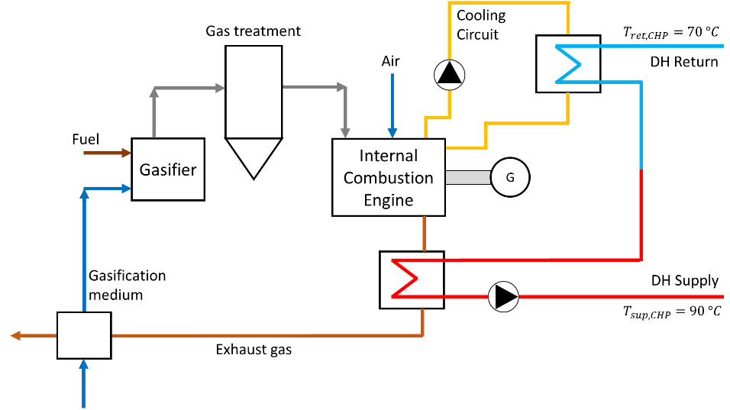
Fig. 5: Working principle of the biomass gasification CHP considered in the study. Own representation from Strzalka et al., 2017.
2.6 Calculation of costs and CO₂ emissions
The operational expenses (OPEX) for heating plants are limited to the direct cost of heat production. Other OPEX components (auxiliary electricity, maintenance, insurance, etc.) are neglected. These omitted OPEX items are assumed equal across the compared operating scenarios and therefore are not expected to affect the relative outcomes. Capital Expenditure (CAPEX) is excluded since the study compares alternative operation strategies, and the different scenarios are assumed to have the same CAPEX.
Heat from the HP, and from the electric boiler (P2H) is priced using the day-ahead energy-component of the electricity price for Austria in year 2025 (Fraunhofer ISE, Energy-Charts). Total electricity cost includes the energy-component of the electricity price and additional price-charges (grid-usage price, taxes, etc.). The HP cost of heat is computed using a variable COP dependent on source temperature (Section 2.5).
The cost of heat for the biomass CHP is fixed at 50 EUR/MWh throughout the year. The specific CO₂ emission for the fuel of the biomass CHP is assumed to be equal to $e_{fuel}$= 9 g CO₂/kWh, as reported in the guidelines of the Austrian Institute of Civil Engineering (OIB-Richtlinie 6, 2025). The specific CO₂ emission per unit of heat produced is calculated as:
$$e_{CHP}=\frac{e_{fuel}}{η_{CHP}} (eq.4)$$

Where $η_{CHP}$ is the total efficiency of the CHP, equal to 0.82. The specific CO₂-eq. emission per unit of heat produced $e_{CHP}$ is equal to 11 g CO₂/kWh. According to the assumptions chosen, the thermal output of the biomass CHP is treated as having near-zero CO₂ emissions. Different allocation and accounting methods for biomass assign different emission factors and can therefore change the overall results.
For the HP, the electric boiler (P2H), and feeding pumps, the CO₂-eq. emission is related to their respective electricity consumption. The monthly carbon intensity of electricity for is sourced from (Ember Energy Research CIC) for the test year 2025, and it ranges from a maximum of 165 g CO₂/kWh in January to a minimum of 42 g CO₂/kWh in August. The total annual CO₂-eq. emission is calculated by summing the monthly components both for the HP, the electric boiler (P2H), and feeding pumps. For both scenarios, a fixed CO₂ price of 80 EUR/ton is considered, which represents an approximate average for the European carbon price in 2025 (European Commission, EU ETS).
- Results
3.1 Study case scenario results
In this section the results related to the Study case scenario are reported. Figure 6 shows three time-dependent plots (17-20 January) illustrating the Study case hydraulics and control during peak demand.
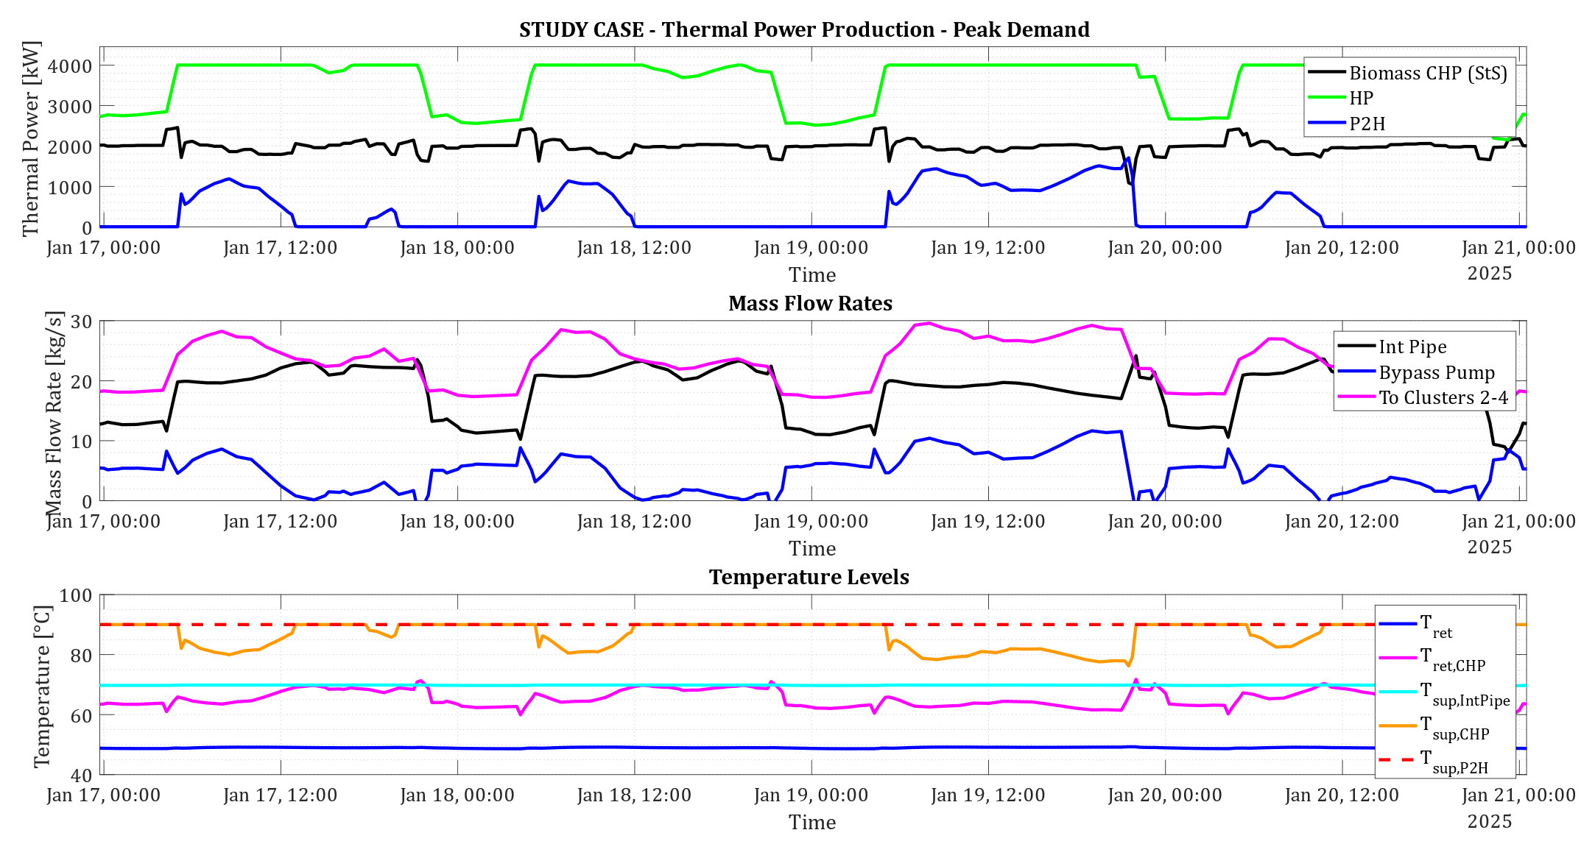
Fig. 6: Study‑case time series (17–20 Jan): plant thermal outputs [kW] (top), mass flow rates [kg/s] (middle), and temperatures [°C] (bottom), showing HP feeding and bypass/series lifting dynamics.
Top (Thermal power production): thermal output of each plant (biomass CHP, HP, P2H). Middle (Mass flow rates): mass flow through the intermediate pipe (black) and the bypass pump (blue), and the mass flow to clusters 2-4 (pink), i.e. the sum of intermediate pipe and bypass pump flows. Bottom (Temperature Levels): return temperature at the bypass pump (blue), supply temperature in the intermediate pipe (cyan), supply temperature downstream the bypass (resulting from the mixing) (magenta), the supply temperature downstream the CHP (orange), and the supply temperature downstream the P2H (= 90 °C) (red dotted).
On January 17th, between midnight and 5:00 AM, the HP (green) is modulating the power and flow rate according to the merit order. In order to permit the CHP to supply the nominal baseload power of 2,000 kW (black), the bypass pump (blue) is extracting a portion of the flow from the return line. In this demand condition, the CHP is supplied with a temperature around 63 °C and it is able to satisfy the supply setpoint temperature of 90 °C, with null thermal input from the P2H.
On January 19th, between 5:00 and 22:00, the HP (green) is supplying its maximum power and flow rate according to the merit order. In order to satisfy the demand at clusters 2 to 4, the bypass pump is extracting a controlled flow rate (blue) in order to satisfy the flow requirement from clusters 2 to 4 (magenta). In this demand condition, the CHP supplies its 2,000 kW maximum power but since the flow rate is too high, it is only able to supply a temperature around 80 °C. The P2H provides the missing thermal power (blue), reaching the supply setpoint temperature of 90 °C.
Figure 7 shows three time-dependent plots (11-14 April) illustrating the Study case hydraulics and control during moderate demand. The variables are reported in subplots, organised in the same way explained for Figure 6.
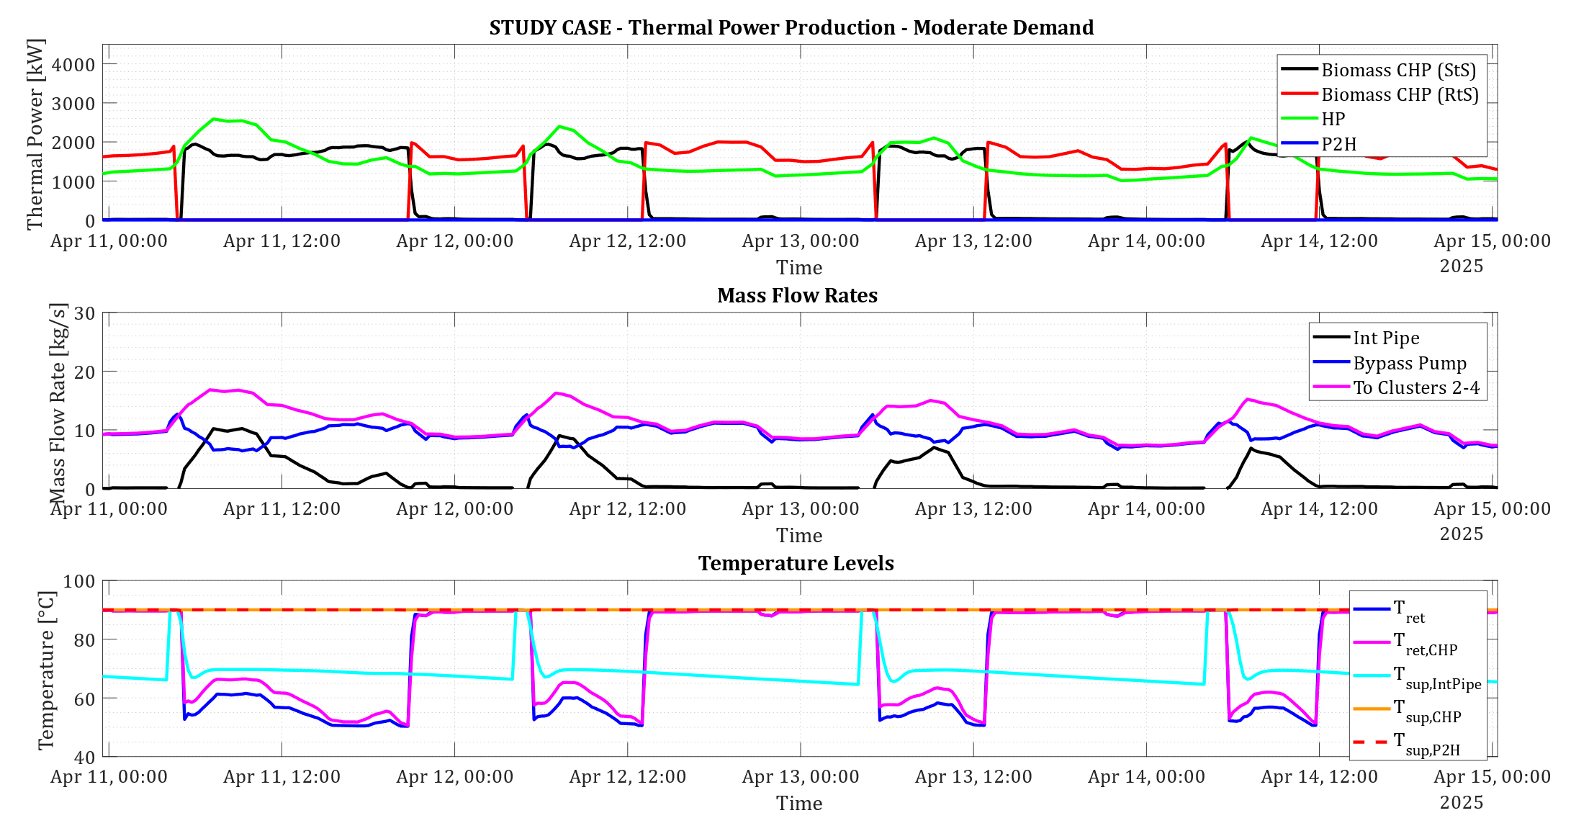
Fig. 7: Study‑case time series (11–14 Apr): plant thermal outputs [kW] (top), mass flow rates [kg/s] (middle), and temperatures [°C] (bottom), showing the shift between series and parallel operation of the biomass CHP.
On April 11th, between 05:00 and 21:00, the HP is modulating the power and flow to the network according to the merit order. In this time-window, the HP is supplying some flow to the CHP through the intermediate pipe (black). A non-null flow is pumped from the bypass pump (blue) to permit the CHP to supply the nominal baseload power of 2,000 kW (black). Under this demand condition, the biomass CHP remains connected in supply-to-supply configuration (StS - black), even if the effective series coupling is reduced by the flow rate passing through the bypass pump (blue).
During the night between April 11th and April 12th, the merit order would require the HP to modulate its thermal power and flow so much that it would not be able to satisfy the demand at Cluster 1. At this demand condition, the merit order is overruled and the HP (green) is supplying the thermal power and flow rate to satisfy Cluster 1 only. In this case, the flow rate provided by the HP to the CHP through the intermediate pipe (black) is null and the biomass CHP is, in practise, operated in return-to-supply (RtS - red), satisfying the demand of clusters 2 to 4.
3.2 Overall results
In this section the annual results related to the network operation in Benchmark and Study case connection and control are reported for the test-year considered. Table 1 reports the annual heat-related key performance indicators (KPIs) for both the Benchmark (second column) and the Study case (third column), together with an absolute and percentage variation for each KPI between Benchmark and Study case (fourth and fifth column).
Tab. 1: Annual heat-related KPIs for the Benchmark and Study case scenarios, with absolute variation and percentage variation relative to the Benchmark.
KPI | Benchmark | Study case | Absolute Variation | Percentage Variation
Heat Consumption [MWh] (INPUT) | 24070 | 24070 | 0 | 0.0%
Heat Production [MWh] | 28009 | 27831 | -178 | -0.6%
Network Heat Losses [MWh] | 3939 | 3761 | -178 | -4.5%
Biomass CHP Production [MWh] | 15398 | 14467 | -931 | -6.0%
HP Production [MWh] | 12476 | 13163 | 687 | +5.5%
P2H Production [MWh] | 146 | 147 | 1 | +1.0%
Total Pump Electricity [MWh] | 64.5 | 83.4 | 18.9 | +29.2%
SPF HP Annual [-] | 2.73 | 3.46 | 0.73 | +26.6%

Due to reduced network heat losses (3,761 vs. 3,939 MWh), the total annual heat production is lower in the Study case compared to the Benchmark, while the annual pump electric energy increases by 29.2% (83.4 vs. 64.5 MWh). Lower heat losses are due to a lower supply temperature (70 °C vs. 90 °C) for the portion of the network supplied by the HP. Higher pump electric energy is caused by the reduced temperature difference on the HP‑supplied branch to Cluster 1 and the bypass pump node (70/50 °C → 20 K vs. 90/50 °C→ 40 K), which raises mass flow for the same heat delivery.
Due to the different control logic applied in mid-season months, the HP is used to a higher degree in the Study case when it is operated to supply Cluster 1 only (+5.5%). Vice versa, in the Benchmark scenario, the HP is used in mid-season months only when the heating demand in the network is above the nominal power supplied by the biomass CHP alone. Complementarily, the CHP is used to a higher degree in the Benchmark compared to the Study case (+6.0%).
The annual results show an increase in HP seasonal performance factor (SPF) between the Benchmark and the Study case: from 2.73 to 3.46 (+26.6%). This is obviously due to the lower supply temperature delivered by the HP in the Study case scenario.
Table 2 reports the annual CO₂ equivalent (CO₂-eq.) emissions for both the Benchmark (second column) and the Study case (third column), together with the absolute and percentage variation for each KPI between Benchmark and Study case (fourth and fifth column).
Tab. 2: Annual CO₂ equivalent emissions for the Benchmark and Study case scenarios, with absolute variation and percentage variation relative to the Benchmark.
KPI | Benchmark | Study case | Absolute Variation | Percentage Variation
CO₂-eq. emission Biomass CHP [ton] | 168.5 | 158.4 | -10.2 | -6.0%
CO₂-eq. emission HP [ton] | 604.0 | 489.3 | -114.7 | -19.0%
CO₂-eq. emission P2H [ton] | 21.9 | 23.8 | 1.9 | +8.7%
CO₂-eq. emission Pump electricity [ton] | 7.5 | 9.9 | 2.5 | +33.4%
CO₂-eq. emission overall [ton] | 801.9 | 681.4 | -120.5 | -15.0%
Specific CO₂-eq. emission [gCO₂/kWh_{th}] | 28.7 | 24.5 | -4.2 | -14.5%

In the Study case the CO₂-eq. emission associated to the biomass CHP is decreased by 6.0% due to the accordingly lower use of the CHP compared to the Benchmark scenario (158.4 vs. 168.5 ton). Despite the higher heat production from the HP in the Study case, the CO₂-eq. emission for the HP is reduced in the Study case by 19.0% (489.3 vs. 604.0 ton) thanks to the higher HP SPF (3.46 vs. 2.73). The total CO₂-eq. emission for the electric boiler (P2H) is low in comparison with biomass CHP and HP in both scenarios (23.8 vs. 21.9 ton). The CO₂-eq. emission related to pump electricity is 33.4% higher in the Study case but they account for a marginal part of the total emissions of the system (9.9 vs. 7.5 ton)
The overall CO₂-eq. emission, calculated as the sum of all single contributions, is 15.0% lower in the Study case scenario compared to the Benchmark scenario (681.4 vs. 801.9 ton). The specific CO₂-eq. emission is calculated by dividing the overall emission for the total heat production in both scenarios. The percentage reduction of specific CO₂-eq. emission in the Study case scenario (-14.5%) is slightly lower than the percentage reduction of overall emission (-15.0%) due to the slightly lower heat production in the Study case scenario compared to the Benchmark (due to slightly lower heat losses in the network).
Table 3 reports the annual economic KPIs in thousands of euros [kEUR] for both the Benchmark (second column) and the Study case (third column), together with the absolute and percentage variation for each KPI between Benchmark and Study case (fourth and fifth column).
Tab. 3: Annual economic KPIs (OPEX) in thousands of euros [kEUR] for the Benchmark and Study case scenarios, with absolute variation and percentage variation relative to the Benchmark.
KPI | Benchmark | Study case | Absolute Variation | Percentage Variation
Cost of heat Biomass CHP [kEUR] | 770 | 723 | -47 | -6.0%
Cost of heat HP [kEUR] | 813 | 669 | -144 | -17.7%
Cost of heat P2H [kEUR] | 46.2 | 49.6 | 3.4 | +7.4%
Cost of Pump Electricity [kEUR] | 10.0 | 13.1 | 3.1 | +31.4%
Cost of CO₂ emissions [kEUR] | 64.1 | 54.5 | -9.6 | -15.0%
Total Cost [kEUR] | 1703 | 1510 | -193 | -11.4%

In the Study case the cost of heat of biomass CHP is lower by 6.0% due to the accordingly lower heat production from the CHP compared to the Benchmark scenario. In fact, the specific cost of heat of the biomass CHP is identical in both scenarios and equal to 50 EUR/MWh (Section 2.6). Despite the higher heat production from the HP in the Study case (13,163 vs. 12,476 MWh), the HP annual cost of heat in the Study case is 17.7% lower in the Study case (669 vs. 813 kEUR) due to the higher HP SPF in the Study case (3.46 vs. 2.73). The HP specific cost of heat is reduced from 65.2 to 50.8 EUR/MWh in the Study case, lowering it to almost the same specific cost of heat of the biomass CHP. The cost of pump energy is 31.4% higher in the Study case but this accounts for a marginal part of the total cost of the system (13.1 vs. 10.0 kEUR). The cost of CO₂ emissions is 15.0% lower in the Study case (64.1 vs. 54.5 kEUR).
The total cost is calculated by summing the cost of heat production for all the plants in the network, the cost of pumping electric energy, and the cost of CO₂ emissions, and it is reduced by 193 kEUR (-11.4%) in the Study case scenario compared to the Benchmark (1,703 vs. 1, 510 kEUR).
3.3 Biomass CHP operating conditions
Benchmark scenario. In the Benchmark scenario, in Winter, the biomass CHP provides the baseload to the DH network, operating at very stable volume flow and temperature conditions. The nominal volume flow rate elaborated by the CHP is calculated as:
$${\dot{V}}_{CHP,nom}=\frac{{\dot{Q}}_{CHP,nom}}{ρ*c_{p}*(T_{sup,CHP}-T_{ret,CHP})} (eq.5)$$
Where ${\dot{Q}}_{CHP,nom}$ is the nominal thermal power from the biomass CHP (2,000 kW), and $ρ$ and $c_{p}$ are water density and specific heat respectively. The return temperature $T_{ret,CHP}$ to be used for the heat exchanger sizing in nominal conditions is 50 °C. The supply temperature $T_{sup,CHP}$ is the supply setpoint temperature (= 90 °C). The resulting ${\dot{V}}_{CHP,nom}$ in the Benchmark scenario is equal to 44.0 m³/h.
Study-case scenario. In the Study case scenario and according to the real hydraulic connection (Figure 4b), the biomass CHP never elaborates a higher volume flow ${\dot{V}}_{CHP}$ than the nominal one defined by (eq. 5). In this case though, the return temperature $T_{ret,CHP}$ to be used for the heat exchanger sizing is 70 °C, neglecting temperature loss in the intermediate pipe line. The resulting ${\dot{V}}_{CHP,nom}$ in the Study case scenario is equal to 88.0 m³/h, which is the double compared to the maximum volume flow in the Benchmark scenario.
- Discussion
The Study case hydraulics and control reduce total operating costs by 11.4% (1,703 vs. 1,510 kEUR) and CO₂‑eq. emission by 15.0% (801.9 vs. 681.4 ton) relative to the Benchmark. The dominant driver for these reductions is the increased seasonal performance factor (SPF) of the heat pump (2.73 vs. 3.46), which delivers the same heat production with lower electricity consumption. A secondary contributor is a 4.5% reduction in network thermal losses (3,761 vs. 3,939 MWh) that reduces the heat production required to meet the demand. Economic benefits are mildly offset by an increase in pumping costs (10.0 vs. 13.1 kEUR), caused by the smaller temperature spread between supply and return. Results are reported using Austria’s 2025 electricity price and grid carbon intensity. While absolute cost and emission values will change under different market or electric grid conditions, the comparison between Benchmark and Study case remains internally consistent.
The main drawback of the Study case scenario is the doubled nominal flow rate through the biomass CHP ${\dot{V}}_{CHP,nom}$ caused by the smaller temperature spread between supply and return. This has two practical consequences: (i) if a larger heat exchanger to the DH line must be installed, capital expenditures increase; (ii) if the existing heat exchanger is retained, its finite heat transfer capacity (UA: overall heat-transfer coefficient times exchanger area) can limit recoverable thermal power, reducing the CHP’s deliverable heat. Alternatively, recoverable thermal power can be maintained only if the temperature of the available heat source (e.g., flue gases or engine coolant) is raised, which may not be possible for all CHP designs or operating conditions.
- Conclusions
Heat pumps are increasingly deployed in district heating (DH) to reduce CO₂ emissions. Prior work has evaluated HPs at the component level, examining SPF gains from lowering the HP heat sink temperature, whereas this study examines system level consequences of integrating a HP into a DH network together with other plants. This study compares a Benchmark return to supply (RtS) configuration with a Study case in which a medium temperature HP pre-heats the network return upstream of a co-located biomass CHP (internal combustion engine fed by biomass gasification) and an electric boiler (P2H). The analysis uses a planned DH network as case study. Annual simulations for a representative test year were run in the Leanheat Network tool, with the network main-pipes topology explicitly modelled to compare the two configurations. The study case reduces total operating costs by 11.4% (1,703 vs. 1,510 kEUR/year) and CO₂ eq. emissions by 15.0% (801.9 vs. 681.4 tonnes CO₂-eq./year) relative to the Benchmark. The primary reason for costs and emissions reductions is an improved HP seasonal performance factor (SPF: 2.73 in Benchmark vs. 3.46 in Study case), which lowers electricity consumption. A secondary reason is a 4.5% reduction in network thermal losses (3939 vs. 3761 MWh/year). The main drawback is the hydraulic impact at the biomass CHP: the Study case roughly doubles the nominal CHP flow, which may necessitate a larger heat recovery exchanger or, if the existing exchanger is retained, constrain recoverable thermal power and thus the CHP’s deliverable heat. Additionally, higher pumping electric energy is an unavoidable trade‑off when difference between supply and return temperature is reduced. Finally, because CHP performance was treated as fixed for the internal‑combustion engine studied, these results cannot be reliably extrapolated to CHP technologies whose electrical and thermal output are sensitive to condenser or extraction temperature. The authors recommend integrating heat pump preheating, which can yield considerable cost and emissions reductions, while early in project planning assessing CHP heat recovery exchanger capacity, the temperature levels the CHP can tolerate, and any necessary CHP hardware upgrades.
- Outlook
The implications of HP‑preheating on a downstream-located CHP are technology‑dependent. For the internal‑combustion gas engine considered in this study, inlet temperatures are constrained to manufacturer guidance (≤70 °C) and have a negligible impact on electrical and thermal efficiencies. By contrast, other biomass CHP technologies can be much more sensitive: steam‑expansion turbines (back‑pressure or extraction) and ORC units exhibit thermodynamic coupling between turbine expansion/condensing conditions and heat‑recovery temperature. Raising the heat‑sink (condenser/extraction) temperature can increase condensing pressure or degrade ORC cycle performance, reducing electrical output and altering electrical and thermal efficiencies. Consequently, the results obtained in this study for an internal combustion engine cannot be reliably extrapolated to other CHP technologies. To address this, future work will extend the present system level modelling to steam expansion turbines and ORC units, explicitly capturing the coupling between DH temperature levels, condenser/extraction temperature and CHP performance to identify thresholds where return preheating or intermediate temperature HP pre heating is beneficial or counterproductive.
- References
Barco-Burgos J., Bruno J.C., Eicker U., Saldana-Robles A.L, Alcantar-Camarena V., “Review on the integration of high-temperature heat pumps in district heating and cooling networks”, Energy, vol. 239, p. 122378, 2022.
Danfoss Leanheat Network, version 3.0. Simulation software. Available at URL: https://www.danfoss.com/en/products/dhs/software-solutions/products/danfoss-leanheat-software-suite-services/leanheat-network/#tab-overview. (visited on 10.03.2026).
Ember Energy Research CIC. URL: https://ember-energy.org/data/electricity-data-explorer/?entity=Austria&chart=trend&data=co2_intensity&fuel=total (visited on 13.08.2026)
Energy Charts – Price spot market. URL: https://www.energy-charts.info/charts/price_spot_market/chart.htm?l=en&c=AT (visited on 10.08.2026)
European Commission – EU Emission Trading System. URL: https://climate.ec.europa.eu/areas-action/carbon-markets/eu-emissions-trading-system-eu-ets_en (visited on 26.08.2026)
Ommen T., Markussen W. B., Elmegaard B., “Heat pumps in combined heat and power systems”, Energy, vol. 76, p. 989-1000, 2014.
Richlinien des Osterreichischen Institut für Bautechnik. “OIB-Richtlinie 6 – Energieeinsparung und Wärmeschutz“, September 2025.
Sayegh M.A., Jadwiszczak P., Axcell B.P., Niemierka E., Brys K., Jouhara H., “Heat pump placement, connection and operational modes in European district heating”, Energy & Buildings, vol. 166, p. 122-144, 2018.
Soleimani A., Davidsson P., Malekian R., Spalazzese R., “Modeling hybrid energy systems integrating heat pumps and district heating: A systematic review”, Energy & Buildings, vol. 329, 115253, 2025.
Strzalka R., Schneider D., Eicker U., “Current status of bioenergy technologies in Germany”, Renewable and Sustainable Energy Reviews, vol. 72, p. 801-820, 2017.
Zhu T., Du Y., Liang J., Rohlfs W., Thorsen J. E., Elmegaard B., “Integration of booster heat pumps in ultra-low temperature district heating network: Prototype demonstration and refrigerant charge investigation”, Energy & Buildings, vol. 298, 113516, 2023.

