SOLAR ENERGY POTENTIAL ASSESSMENT ON HERITAGE PROTECTED VENETIAN OLD TOWN ROOFTOPS BASED ON LIDAR DATA, CLOUD COMPUTING AND RADIATION MODELING: AN AGENT-BASED CONCEPTUAL USE-CASE IN SLOVENIA

Alen Hausmeister¹*, Jošt Rogelj¹, Črtomir Tavzes², Jovan Pavlović³, Tadej Bevk⁴, Marko Bizjak⁵ and Miklós Krész³
¹ Slovenian National Building and Civil Engineering Institute, Slovenia
² Institute for the protection of Cultural Heritage of Slovenia, Slovenia
³ Faculty of Mathematics, Natural Sciences and Information Technologies, University of Primorska, Slovenia
⁴ Department of Landscape Architecture, Biotechnical Faculty, University of Ljubljana, Slovenia
⁵ Faculty of Electrical Engineering and Computer Science, University of Maribor, Slovenia
*Corresponding Author: alen.hausmeister@zag.si

Summary
The Mediterranean region offers significant solar energy potential while containing extensive protected built heritage, creating challenges for photovoltaic (PV) integration in historic centres. Existing heritage guidelines are often broad and inconsistently interpreted, while conventional solar potential mapping frequently lacks building-scale precision and neglects heritage constraints. Focusing on the historic centre of Koper-Capodistria, a North Adriatic Venetian town where rooftop PV installations are largely restricted, this study develops a digital twin-like decision-support framework combining LiDAR-derived rooftop reconstruction, cadastral data, solar radiation modelling, visibility analysis, and agent-based decision modelling. The methodology generates heritage-sensitive solar deployment scenarios and spatially explicit solar zoning maps at the building scale. Results demonstrate that accurate rooftop geometry reconstruction is a foundation for reliable assessments and that integrating heritage constraints with homeowner decision-making can provide a balanced alternative to both complete PV prohibition and unrestricted deployment. Despite limitations related to manual processing of complex geometries and visibility assessments, the workflow highlights opportunities for future automation and policy testing. The proposed approach increases transparency in heritage management by enabling roof-section-level evaluation and offers a transferable framework for historic towns with LiDAR data but without comprehensive digital twins, supporting energy transition and the gradual development of Positive Energy Districts while preserving cultural heritage values.
Keywords: Solar Energy Potential, Solar Radiation Modelling, Energy Positive Districts, Built Heritage, Agent-Based Modelling
Field of application for the findings: Sustainable and Efficient Districts
- Introduction
The Mediterranean is one of Europe’s sunniest regions, offering significant solar energy potential (Perpiña Castillo et al., 2016), while also containing a rich and often strictly protected built heritage (Stegnar et al., 2026). The integration of photovoltaics (PV) on historic rooftops is therefore complex. National guidelines are typically broad and not adapted to specific urban morphologies, which may lead to inconsistent interpretations among heritage officials involved in the approval process. This creates uncertainty for homeowners and communities considering investment in PV systems. Moreover, solar potential mapping frequently fails to distinguish between heritage-restricted and unrestricted areas (Kojaković & Vaskalis, 2022; SOLAR ADRIA Project, 2021), generating expectations that may not be achievable in practice. Available cadastre data are often limited in geographic scope and resolution, suitable for general assessments but insufficient at the building scale (CEU | Solarni Kataster DEDIS, n.d.). North Adriatic Venetian towns present additional challenges due to their specific morphology (See Fig. 1.a): pitched roofs with traditional tiles, dominant vertical elements such as bell towers, narrow streets, and coastal or island settings (Gherri et al., 2021). These features significantly influence solar exposure and urban radiation patterns (Morganti et al., 2017). The Old Town of Koper–Capodistria, protected as a cultural monument, currently prohibits rooftop PV installations primarily to preserve its medieval character. Nevertheless, some residents informally install PV systems, reflecting the tension between heritage protection and the urgent need for sustainable energy solutions in the Mediterranean context. This study addresses the gap between conservation and energy transition through a detailed building-scale solar potential assessment based on LiDAR data (See Fig. 1.b), cloud computing, and radiation modelling, aligned with the most recent heritage guidelines (Gantar et al., 2025; Tomšič et al., 2025). Scenarios of potential PV applications were developed Scenarios were developed in collaboration with the heritage department excluding buildings under special heritage treatment (monuments of regional or national importance) and taking visibility analyses into account (from sea level, street level, and bell tower viewpoints). The results inform an agent-based decision-making model for energy-efficient renovation and retrofitting, supporting multiple stakeholders. In addition to technical solar potential, the model incorporates socio-economic conditions, dwelling characteristics, and subsidy availability, generating a feedback loop for the development of a precise solar zoning map similar to that implemented in Prague (Odbor památkové Péce, 2022). This approach enables the identification of rooftop sections that may accommodate PV—fully or partially—without compromising the visual integrity of the historic urban fabric. Ultimately, the proposed workflow may support the establishment of Positive Energy Districts (PEDs) within Monument-Protected Areas (MPAs) across the Northern Adriatic, including Venetian historic towns such as Piran, Rovinj or Venice.
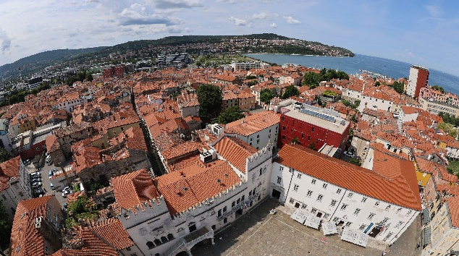 | 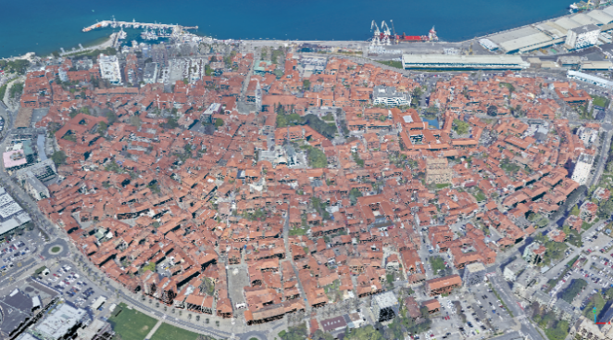
(a) | (b)
Fig. 1: Panoramic view of the rooftops from the belltower (a) LiDAR data (2026) from the old town of Koper (b).
- Methodology
Slovenian cities and towns are generally not equipped with digital twins in the strict sense of the term. A digital twin is an advanced digital representation of a physical object, system, or environment that integrates digital models, Internet of Things (IoT) technologies, artificial intelligence (AI), and machine learning to create interactive simulations that continuously adapt to changes in their physical counterparts. These systems are updated through multiple data sources, including sensor networks, historical records, expert knowledge, and contextual information from related systems, enabling near real-time monitoring, analysis, and prediction. Fully developed digital twins also require bidirectional communication, including actuators that allow interventions in the physical system (Zavod za gradbeništvo Slovenije; Slovensko združenje za informacijsko modeliranje gradenj, 2023). Compared with global urban contexts, Slovenia is characterized by a dispersed settlement structure in which most urban areas are classified as towns rather than cities (national definition for a city by law – population > 3,000 inhabit.). Given the substantial technological and financial requirements of implementing comprehensive digital twins, their widespread deployment in Slovenian towns remains uncertain.
Therefore, this research proposes an alternative workflow for creating a detailed rooftop model from available GIS and LiDAR data. This “digital twin-like” model is developed through seven methodological stages (See Fig. 2): data acquisition, preprocessing and model development, solar radiation modelling, rooftop visibility analysis, agent-based behavioural modelling, scenario development, and output generation.
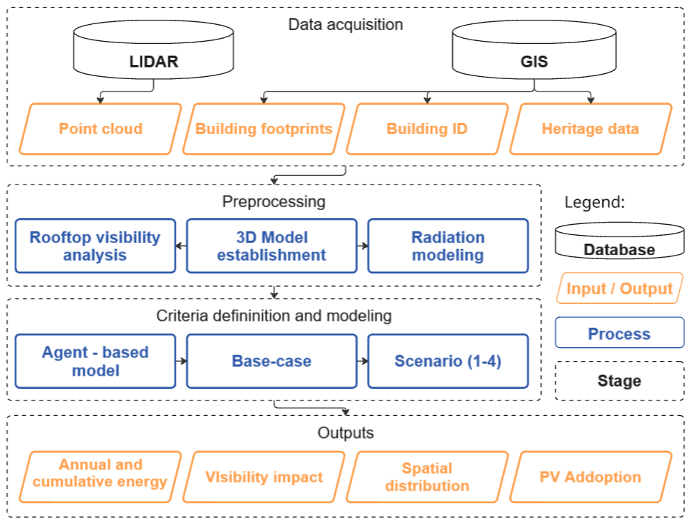
Fig. 2: Methodological diagram with stages: Data acquisition, Preprocessing, 3D Model establishment, Radiation modelling, Rooftop visibility analysis, Agent-based behavioural model, Scenario development and Outputs
Preprocessing and Model Establishment
The building reconstruction method comprises two sequential stages: (i) data preprocessing and model initialization, and (ii) roof reconstruction using half-space analysis and 3D Boolean operations. By integrating two-dimensional (2D) building footprints with classified airborne LiDAR data, the approach generates watertight three-dimensional (3D) building models (Bizjak et al., 2021). The first stage establishes an initial building model and derives roof-related half-spaces from segmented LiDAR data. In the second stage, these half-spaces are classified and processed to reconstruct roof geometries, including both convex and concave forms. The input data include georeferenced building footprints and classified airborne LiDAR point clouds referenced to a common coordinate system. Only points classified as ground or building are used. For each building, roof reconstruction relies exclusively on building-class points located within the corresponding footprint, thereby eliminating interference from neighbouring structures.
An initial watertight building model is created for each footprint. The model consists of a floor face, a top bounding face, and exterior wall faces. The floor face is placed at the elevation of the lowest neighbouring ground point, while the top bounding face is positioned above the highest building point to avoid restricting roof formation. Exterior walls are generated by connecting the edges of the floor and top faces, producing a closed polyhedral volume that serves as the basis for roof reconstruction. Roof reconstruction is driven by half-spaces derived from planar roof segments. Building points are segmented into clusters representing individual roof planes, and a least-squares plane is fitted to each segment. The resulting plane parameters define half-spaces that act as geometric constraints on the roof shape.
Orthophoto | Segmented PC | Final model
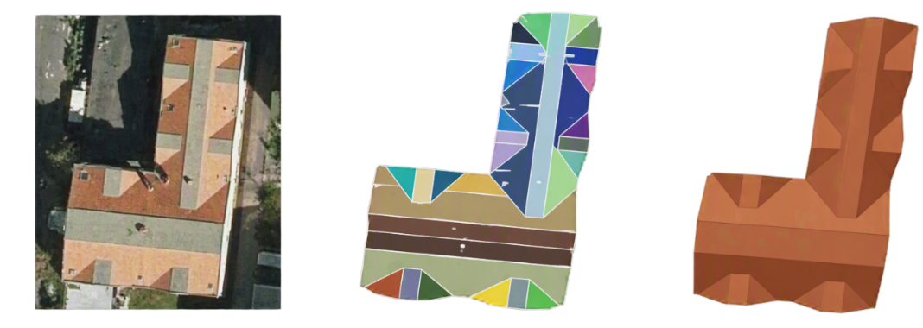
Fig. 3: Illustrations of shaping several layouts of buildings, where for the buildings (left) segments of points (middle) were obtained from the input point cloud (PC) for the reconstruction of buildings (right); adapted from (Bizjak et al., 2021)
The extracted half-spaces are classified as unobstructed or obstructed according to their spatial relationships. Unobstructed half-spaces, which do not contain points from other roof segments, usually represent convex roof components and are directly applied through Boolean subtraction of open half-spaces from the base volume. Obstructed half-spaces indicate more complex or concave roof configurations and require additional processing based on their visible intersections. The combined use of unobstructed and processed obstructed half-spaces enables the reconstruction of watertight 3D building models with both convex and concave roof geometries. The method is limited to roofs without height discontinuities between adjacent roof faces.
Parametric Workflow and Radiation Modelling
Solar radiation modelling was conducted within the Rhino 3D (Robert McNeel & Associates, 2024) and Grasshopper (Rutten, 2024) computational design environment using the Ladybug Tools plugin (Roudsari et al., 2013). Two datasets were integrated for the analysis: a vector dataset containing building footprint geometries and a tabular dataset containing official building records. Building footprints were imported as closed planar polygons, while official records provided unique building identifiers and centroid coordinates. The centroid coordinates were converted into point geometries within Grasshopper, enabling the integration of official building data with the corresponding geometric representations. A spatial matching procedure was implemented to establish a relationship between building footprints and official building identifiers (building ID). Using the Grasshopper Point In Polygon (PIP) component, each centroid was evaluated with respect to the footprint polygons, and a match was assigned when the centroid was located within a building boundary. This procedure created a unique correspondence between geometric footprint objects and official building records, forming the basis for subsequent data processing and aggregation. (See Fig. 4).
Roof geometries were imported as surface and polysurface objects and analysed individually. For each roof segment, geometric properties including surface area and centroid coordinates were calculated using native Grasshopper components. Roof centroids were then spatially assigned to building footprints using the same PIP methodology applied during the building matching process. Through the previously established footprint-building relationship, each roof surface was linked to its corresponding official building ID. This enables the creation of a many-to-one relationship in which multiple roof segments may be associated with a single building, allowing roof-level results to be aggregated at the building scale. Prior to simulation, roof surfaces with an area smaller than 5 m² were excluded, as such surfaces are generally unsuitable for practical PV installations and may introduce bias into estimates of available solar potential.
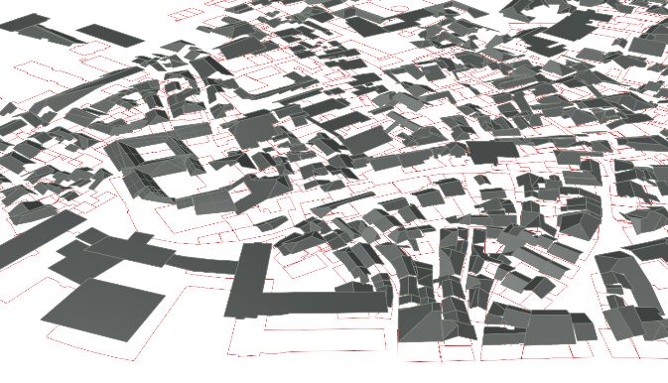 | 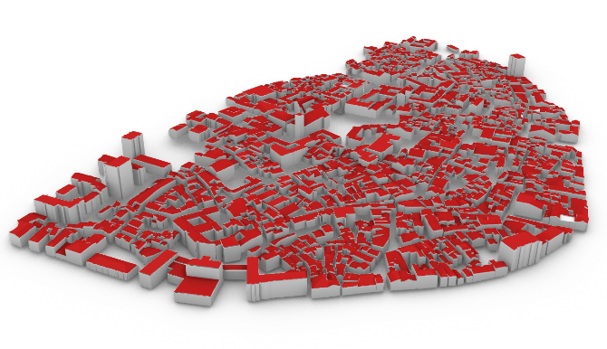
(a) | (b)
Fig. 4: Reconstruction of rooftops and the vector building footprint of corelated buildings with the Building ID from GIS (a). 3D model of Koper’s old town established from LiDAR (b).
Annual solar radiation simulations were performed using the Ladybug Incident Radiation component. Analysis points were generated on each roof surface using the Generate Point Grid (GenPts) component (Generate Point Grid | Ladybug Primer, n.d.). A regular grid spacing of 1 m was selected to provide an appropriate compromise between computational efficiency and spatial representation of roof geometry. To avoid potential numerical errors associated with coincident geometries, all analysis points were offset by 0.20 m along the local surface normal. Consequently, the number of analysis points varied according to roof size and geometric complexity. The simulations calculated annual global incident solar radiation for each analysis point (kWh/m²/a). Because radiation values were generated at the point level, a post-processing procedure was required to derive representative roof-scale metrics. Analysis points were grouped according to the roof surface on which they were located, and the arithmetic mean of all associated radiation values was calculated. This produced a single representative annual solar radiation value for each roof segment, accounting for spatial variability across the surface.
The final database integrated geometric and simulation-derived attributes, including building footprint identifiers, official building identifiers, roof area (m²), and average annual solar radiation (kWh/m²/a). This dataset served as the foundation for the subsequent photovoltaic potential assessment feeding the agent-based model. In addition to the baseline dataset, several alternative scenarios were generated by applying different roof suitability criteria and excluding predefined categories of roof surfaces. These scenario-specific datasets enabled comparative evaluation of PV potential under varying assumptions regarding roof availability and technical suitability.
Rooftop Visibility Analysis
To assess different visibility models three visibility analyses were made in ArcGIS Pro 3.7.1: visibility of rooftops from streets within the heritage settlement to assess the perception when moving through the town, visibility from the sea, as the sea-side silhouette is among the most recognizable characteristic of the town, and visibility from the belltower as a key observation point offering characteristic views of the town (see Fig. 5). Each visibility analysis was made using the same digital surface model created from two LIDAR datasets. The detailed dataset with average point density of about 49 points per square meters was captured from the Slovenian Surveying and Mapping Authority (Portal CLSS: Pregledovalnik Podatkov Cikličnega Laserskega Skeniranja Slovenije (Geodetska Uprava Republike Slovenije), n.d.) last updated 2026. For the area around the town a national classified LiDAR dataset with average point density of about 17.7 points per square meter was used. These two datasets were used to create a digital surface model in 0.5 x 0.5 m resolution reflecting the hight of ground and buildings but excluding vegetation – this decision was made to model the worst-case scenario visibility and under assumption that vegetation might not significantly obscure visibility during winter when the foliage is not present.For each analysis a different set of points, representing observers were used.
To model visibility from streets, we used OpenStreetMap (OpenStreetMap, n.d.) data sourced from geofabrik.de. Using all the line features from the layer roads, we generated points every 10 meters. To model visibility from the sea, we created a 100 m buffer from the coastline and again generated points every 10 meters of the line. We used the 100 m distance as we assessed that this is the buffer in which recreational activities on the sea will take place. To model visibility from the belltower we manually created four points on each side of the square bell tower to capture views in all directions. Finally, using the ground elevation data we assigned heights to all created points, except the belltower points which were added manually. When running the visibility analysis for each model, we additionally offset each point by 1.6 meters above surface elevation to estimate the eye height of a potential observer. We also used different outer radiuses for each analysis, both to more realistically represent the mode of observation from different points as well as to reduce computing difficulty of the analysis.
To define the outer radius in which a rooftop solar power plant still has a visual impact on we took guidance from the visual prominence by distance as suggested by (Palmer, 2021). While this reference deals with large-scale utility solar power plants, it is one of the rare studies that discusses different perception of solar power plant based on distances. As we are dealing with smaller rooftop solar installations we have opted for closer proximity. For street points we used outer radius of 150 m reflecting both the distance at which a solar power plant can be clearly recognized as well as the more closed setting of moving through the town. For points at the sea we used 200 m, reflecting the more open setting, and for belltower points we did not assign any outer radius, thus modelling the whole town with the assumption that observers on the tower will be there specifically for the views and thus pay closer attention to visible structures. The resulting models are in the same resolution as the input surface elevation model, which is 0.5 m x 0.5 m. Finally, the visibility models were clipped to show results only on roofs – OpenStreetData layer of buildings was used for this.

(a) | (b)
(c) | (d)
Fig. 5: Areas of visible rooftop surface per visibility model with different observation points; sea- (a) street- (b) belltower- (c) and combined- (d) observation point (color gradient representing number of viewpoints from which a rooftop can be observed; yellow - lower density and red - higher density.
Agent-Based Behavioural Model
The agent-based model simulates how property owners in heritage-protected urban districts decide whether to adopt energy-related building interventions. The model focuses on rooftop solar photovoltaic and aims to support policy testing by estimating how regulations, subsidies, costs, and social influence shape renovation decisions. It includes two explicit agent types, the Homeowner and Business Entity, while buildings are treated as aggregate entities whose state depends on the collective willingness of corresponding property owners. Each property owner is assigned fixed dwelling-related attributes and dynamic behavioural variables derived from the Theory of Planned Behaviour (Ajzen, 1991; Rai & Robinson, 2015) that is, attitude, perceived behavioural control. These attributes determine behavioural intention, while PV installation requires at least 75% of a building’s agents to support adoption. Social influence is modelled through the Bounded Confidence Model (Hegselmann & Krause, 2000) on a small-world network built from neighbourhood structure (See Fig. 6.b).
For each dwelling or building, estimated rooftop solar yield, together with costs and subsidies, shapes residents’ attitudes. Attitude values are calculated from the estimated payback period for each available photovoltaic option, consistent with the literature. Because most studies report acceptable payback periods of between 5 and 10 years for different groups of property owners (Karytsas et al., 2019; Sommerfeldt et al., 2022), the final attitude value is calculated as 5 years divided by the estimated payback period, capped at 1.
Perceived behavioural control summarizes all factors affecting an individual’s ability to install photovoltaics. Because data are currently unavailable for individual owners, these values are drawn from a standard normal distribution truncated to the interval [0, 1]. If a particular photovoltaic option is prohibited for a building, the perceived behavioural control of residents associated with that option is set to 0.
Homeowner agents (unlike business entities) are connected through a network constructed from the city’s neighbourhood structure, identified using a K-means clustering algorithm (See. Fig. 6.a). The network is then rewired according to the Watts–Strogatz model (Watts & Strogatz, 1998) to produce a "small-world" property. At each iteration, the attitude of each homeowner is updated based on the average behavioural intentions of their neighbours, according to the Bounded Confidence Model. Because the model includes stochastic components, each simulation is repeated 1000 times, and the results are averaged.
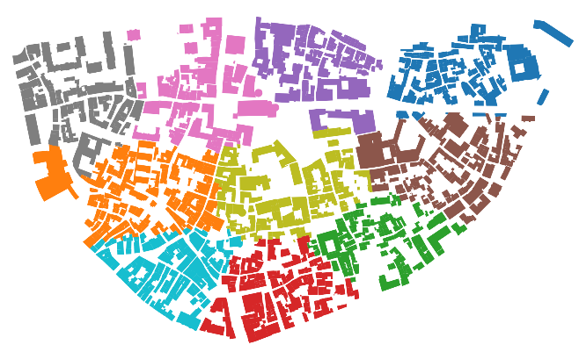 | 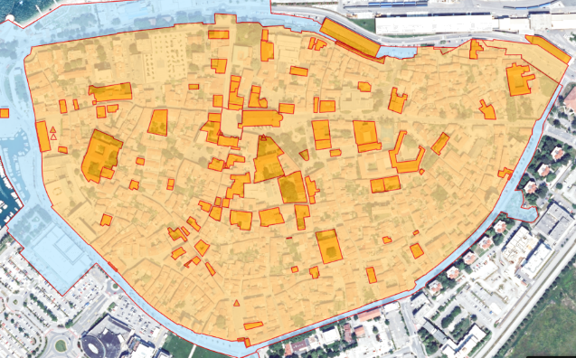
(a) | (b)
Fig. 6: Neighborhood structure identified by K-means clustering (color per neighborhood) (a). Old Town Koper and buildings under special heritage treatment in dark orange (b).
Across repeated simulation runs, the model estimates cumulative and annual solar-energy production based on building area, irradiation, and the characteristics of the installed PV option (See Tab. 1). Two PV options were determined to be the most suitable variables for comparative analysis within this study. PV Modules (Full-black monocrystalline silicon photovoltaic module) and PV Tiles (Opaque “terracotta-like” tiles with embedded monocrystalline silicon cells).
Tab. 1. Input data for investment evaluation criterion (PV Modules and PV Tiles)
Input data | Acronym | Units | PV Modules | PV Tiles
Active PV area | A | % | 0.7 | 0.8
Module efficiency | $$η$$ | % | 0.26 | 0.2217
Performance ratio | PR | % | 0.8 | 0.7
Total installed cost (PV) | $$C$$ | €/m² | 350 | 900
Value of electricity | $$p$$ | €/kWh | 0.21 | 0.21
Lifetime | $$n$$ | years | 25 | 25
Payback attractiveness |  | years | 5 | 5

Based on the input data presented in Tab.1, two criteria have been used to distinguish between the two options in the Agent-based model. Payback period which estimates the number of years required for an investment to recover its initial cost through the value of the electricity generated annually; calculated by dividing the total investment cost by the annual revenue from electricity production (annual production multiplied by electricity price), where payback attractiveness was set to 5 years (see Eq. 1). And minimum annual electricity production required for a project to recover its initial installation cost over its operational lifetime as a division of the total installed cost $C$(€) by the product of the electricity value $p$(€/kWh) and the project lifetime $n$(years), thereby determining the annual energy output necessary to achieve cost neutrality (see eq. 2).

$$\begin{aligned}\text{Payback}=\frac{\text{Investment}}{\text{Annual Production}⋅\text{Electricity Price}}\#(eq. 1)\end{aligned}$$

$$\begin{aligned}E_{\text{min}}=\frac{C}{p⋅n} \#(eq.2\end{aligned})$$

Scenario Development
The following scenarios were developed to assess the technical and economic potential of rooftop solar deployment under different levels of heritage protection constraints. The results of each scenario were compared with a theoretical base case to quantify the impact of heritage preservation requirements on photovoltaic PV adoption. In the base case it is assumed that all available rooftops are fully covered with conventional PV modules, regardless of visibility or heritage considerations. Although this represents a non-realistic and hypothetical situation, it serves as an upper-bound reference scenario, illustrating the solar potential that could be achieved in the absence of heritage protection restrictions.
Scenario 1 - In the first scenario, visible rooftops are equipped with PV tiles to preserve the visual character of the urban landscape, while non-visible rooftops are fitted with conventional PV modules. This scenario represents a heritage-sensitive approach that balances renewable energy generation with aesthetic considerations (See Fig. 7.a). Scenario 2 - The second scenario builds upon Scenario 1 by additionally excluding buildings subject to special heritage protection. Visible rooftops are covered with PV tiles and non-visible rooftops with conventional PV modules, while protected landmark buildings are omitted from solar installations altogether (See Fig. 7.b). Scenario 3 - In the third scenario, both visible and non-visible rooftops are covered exclusively with PV tiles, while special heritage-protected buildings remain excluded. This scenario evaluates the implications of applying uniform, visually integrated solar technology across the entire eligible building stock (See Fig. 7.c). Scenario 4 - The fourth scenario represents the most restrictive approach. All visible rooftops are excluded from solar deployment, non-visible rooftops are equipped with PV tiles, and buildings under special heritage protection are excluded. This scenario reflects a highly conservative heritage preservation strategy in which solar installations are limited to locations with minimal visual impact on the historic urban environment (See Fig. 7.d).
S1
S2
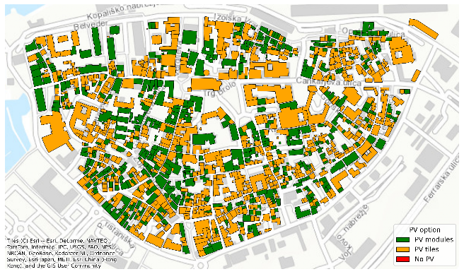 | 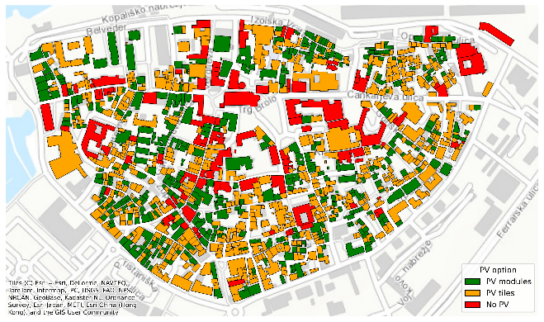
(a)  S3  S4 | (b)
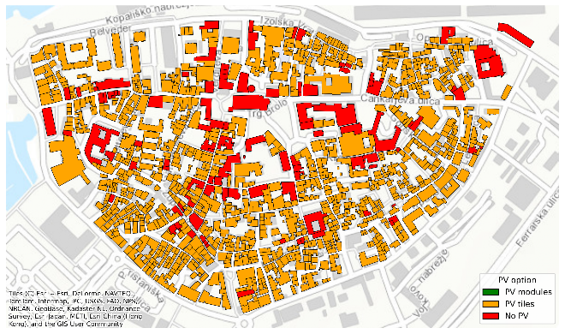 | 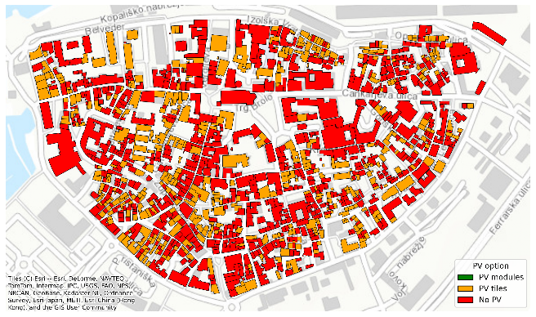
(c) | (d)
Fig. 7: Developed scenarios to access the technical and economic potential of rooftop solar deployment under different levels of heritage protection constraints; Green – PV Modules allowed; Orange – PV Tiles allowed; Red - no PV system allowed. Scenario 1 (a) Scenario 2 (b) Scenario 3 (c) Scenario 4 (d).
- Results
A total of 3,245 rooftop surfaces were identified within the study area, corresponding to 1,161 unique buildings, resulting in an average of 2.8 rooftop surfaces per building. The cumulative annual solar irradiation received by the rooftops of the old town amounts to approximately 210 GWh/a. Solar irradiation levels vary considerably among rooftop surfaces, with maximum values reaching 1,663.5 kWh/m²/a and an average irradiation of 1,168 kWh/m²/a. These differences are primarily driven by variations in roof orientation and inclination, which substantially influence the amount of incident solar radiation received by individual surfaces.
To evaluate the visual impact of rooftop photovoltaic deployment, visibility results were initially classified into visible and non-visible rooftop surfaces. This approach follows the “do least significant harm” principle by first assessing the solar potential of rooftops that are not visible from key observation points. The analysis showed that 45% of rooftop surfaces are not visible from any investigated viewpoint, whereas 55% are visible from at least one observation location, including the sea, streets, bell tower, or a combination thereof (See Fig. 8). Within the visible category, 23% of rooftops are visible exclusively from the bell tower, 13% only from the street, and 3% only from the sea. Combined visibility classes account for smaller shares, including 8% visible from both the bell tower and streets, 4% from the street and sea, 2% from the sea and bell tower, and 2% from all three observation points simultaneously.
Fig. 8: Share of non-visible and visible rooftop surfaces according to all rooftops in the Old Town.
Comparing visibility restrictions with the corresponding reduction in available solar potential reveals notable differences between visibility models (See Fig. 9). The area of multi-viewpoint visibility models, such as street + sea (4% excluded rooftop area and 4% solar energy deficit) and bell tower + street (7% excluded rooftop area and 8% solar energy deficit) is low and they are showing a relatively consistent relationship between excluded area and solar energy deficit. In contrast, visibility models based on a single observation model exhibit substantially larger deviations. For example, rooftops visible only from the sea account for approximately 3% of the total rooftop area but contain nearly 9% of the total solar potential. Similarly, rooftops visible only from the bell tower represent 23% of the rooftop area but account for approximately 40% of the available solar potential. These findings indicate that visibility-based restrictions can disproportionately affect solar energy generation potential, depending on the observation point considered.
Fig. 9: Solar deficit and excluded rooftop area share based on visibility models

The agent-based simulations further demonstrate the implications of these restrictions for photovoltaic adoption. In the baseline scenario, where no visibility-related limitations are imposed, 54% of buildings decide to install photovoltaic systems. Adoption rates decrease progressively as restrictions become more stringent. Between Scenario 1 and Scenario 3, the share of buildings willing to install PV systems declines from 36.5% to 21.8%, representing a reduction of approximately 15 percentage points. Potential energy production follows the same pattern across all scenarios, indicating a strong relationship between homeowner willingness to invest and total electricity generation. In Scenario 4, where all visible rooftop areas are excluded from photovoltaic deployment and only non-visible roof sections are permitted to host PV tiles, adoption drops to just 4.7% of builidngs, resulting in the lowest energy production potential among all investigated scenarios.
The choice of photovoltaic technology also changes across scenarios (See Fig. 10.b). In the baseline scenario, despite unrestricted installation possibilities, approximately 10% of buildings select PV tiles rather than conventional PV modules. In Scenarios 1 and 2, the distribution between technologies stabilizes at roughly one-third PV modules and two-thirds PV tiles. The reduction in adoption observed between these two scenarios occurs primarily among PV tile installations. In Scenarios 3 and 4, where conventional PV modules are prohibited, PV tiles account for 100% of all installed photovoltaic systems. Overall, the results demonstrate that increasing visual and heritage-related restrictions not only reduce adoption rates and energy generation potential but also significantly influence technology selection among homeowners.
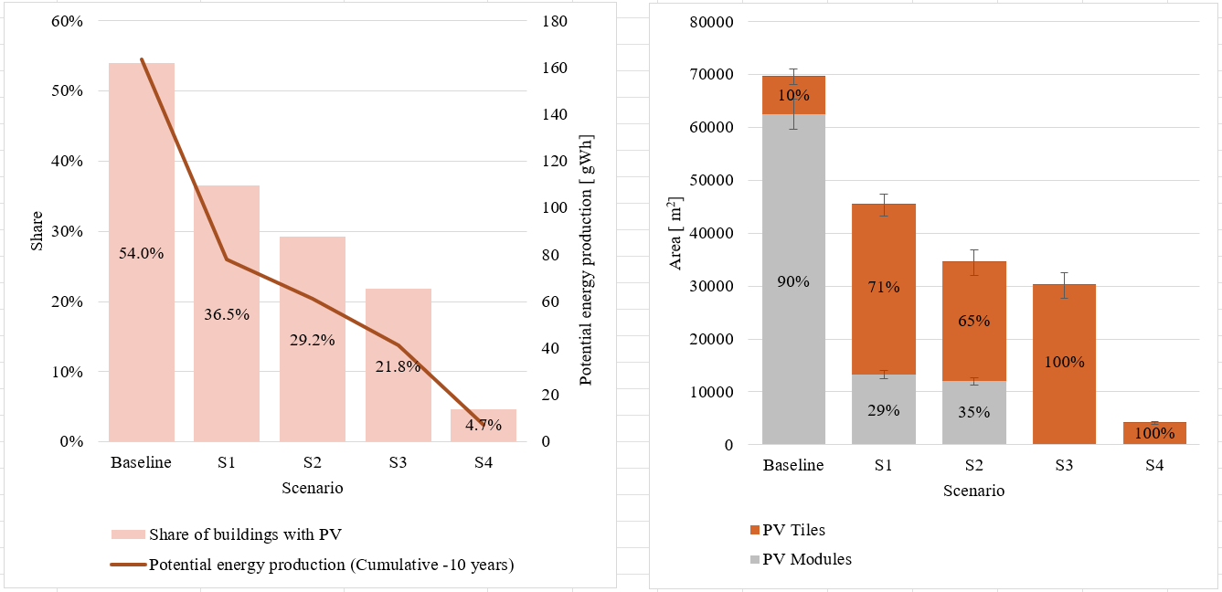
(a) | (b)
Fig. 10: Share of builidngs willing to adopt PV systems on their rooftop and the potential energy produced for each scenario (a). Share and proportion of adopted PV systems (PV modules, PV tiles) per scenario (b).
- Discussion and Conclussion
This study demonstrates that the development of a digital twin-like decision-support tool for monument-protected Mediterranean historic centres requires both high spatial accuracy and careful consideration of heritage values. In the Old Town of Koper–Capodistria, substantial preprocessing was necessary due to the limited availability of fully digitalized building data. The reconstruction of rooftop geometries from LiDAR and cadastral datasets proved to be a critical prerequisite for reliable building-scale solar potential assessments. At the same time, the workflow highlights significant opportunities for future automation through parametric modelling, cloud-based radiation simulations, and more standardized geospatial data processing. Several methodological limitations need to be acknowledged. The modelling of complex building geometries, particularly structures containing atria, required manual intervention. In the radiation analysis, flat roofs were not excluded from the assessment of PV tile applicability. Roof visibility information also required manual processing prior to its integration into the solar model. Furthermore, the visibility analysis itself is sensitive to the number and distribution of observation points, as visibility values increase with the number of potential observers. Consequently, visibility results should be interpreted as relative indicators rather than absolute measures of visual impact. In this study, roofs were excluded when a substantial proportion of their surface was visible, regardless of the number of viewpoints from which they could be observed. The development of automated visibility criteria based on heritage authority requirements represents an important direction for future research.
The findings suggest that both overly restrictive and overly permissive approaches to photovoltaic deployment in historic centres should be avoided. A complete prohibition of rooftop PV installations may encourage uncoordinated informal interventions, limit opportunities for energy renovation, and reduce incentives for residents to invest in historic properties. Conversely, unrestricted deployment would maximize solar generation, but may significantly compromise the historic urban landscape and necessitate infrastructure upgrades incompatible with protected heritage fabric. By integrating spatial constraints, heritage considerations, and homeowner decision-making within an agent-based framework, the proposed methodology may demonstrate a viable middle path between conservation and energy transition objectives. The analysis also points to several areas for refinement. Future studies could incorporate dedicated visibility analyses for PV tiles to better understand at what distances they become visually indistinguishable from traditional roof coverings. Fire safety regulations and building-specific technical constraints should likewise be included. The agent-based model could be expanded through the integration of electricity district level network capacity, transformer limitations, more detailed heritage restrictions, and policy-testing functions, including the evaluation of optimal subsidy schemes. Such developments would increase the practical relevance of the model for heritage authorities, municipal decision-makers, utility operators, and other stakeholders involved in the energy transition of protected urban areas.
Importantly, the results indicate that building-specific and spatially explicit analyses can support more transparent and flexible heritage management. Interactive solar zoning maps allow rooftop sections to be assessed individually rather than through generalized guidelines, providing greater clarity for both homeowners and heritage authorities. The integration of drone photogrammetry and LiDAR-based visualisation further strengthens confidence in digital assessments by enabling direct comparison between simulated and real-world conditions. As a result, the proposed methodology offers a transferable framework for historic towns that possess LiDAR data but lack comprehensive digital twins. As such, it can contribute to the gradual establishment of PED within MPAs while preserving the cultural and architectural values that define these historic urban landscapes.
- Acknowledgements
The authors gratefully acknowledge receiving funding from the Slovenian Research and Innovation Agency (ARIS) (grant number H2-8298) under the Driving Urban Transitions Partnership, which has been co-funded by the European Union.
- References
Ajzen, I. (1991). The theory of planned behavior. Organizational Behavior and Human Decision Processes, 50(2), 179–211. https://doi.org/10.1016/0749-5978(91)90020-T
Bizjak, M., Žalik, B., & Lukaˇ, N. (2021). Parameter-Free Half-Spaces Based 3D Building Reconstruction Using Ground and Segmented Building Points from Airborne LiDAR Data with 2D Outlines.
CEU | Solarni kataster DEDIS. (n.d.). Retrieved February 24, 2026, from https://ceu.ijs.si/projekti/solarni-kataster-dedis.html
Gantar, D., Goršič, N., Mujkić, S., Kozamernik, J., Gerdin, T., Tomšič, M. G., Jejčič, N., Šijanec-Zavrl, M., Bevk, T., Debevec, M., & Stegnar, G. (2025). Priporočila za namestitev fotonapetostnih naprav na območjih stavbne in naselbinske dediščine.
Generate Point Grid | Ladybug Primer. (n.d.). Retrieved September 9, 2026, from https://docs.ladybug.tools/ladybug-primer/components/4_extra/generate_point_grid#inputs
Gherri, B., Maiullari, D., Finizza, C., Maretto, M., & Naboni, E. (2021). On the thermal resilience of venetian open spaces. Heritage, 4(4), 4286–4303. https://doi.org/10.3390/heritage4040236
Hegselmann, R., & Krause, U. (2000). OPINION DYNAMICS AND BOUNDED CONFIDENCE. 5(3).
Karytsas, S., Polyzou, O., & Karytsas, C. (2019). Factors affecting willingness to adopt and willingness to pay for a residential hybrid system that provides heating/cooling and domestic hot water. Renewable Energy, 142, 591–603. https://doi.org/10.1016/j.renene.2019.04.108
Kojaković, A., & Vaskalis, loannis. (2022). How To bring solar energy into your city. 1–40.
Morganti, M., Salvati, A., Coch, H., & Cecere, C. (2017). Urban morphology indicators for solar energy analysis. Energy Procedia, 134, 807–814. https://doi.org/10.1016/j.egypro.2017.09.533
Odbor památkové Péce. (2022). Fotovoltaické systémy v památkově chráněných územích hlavního města Prahy.
OpenStreetMap. (n.d.). Retrieved September 6, 2026, from https://www.openstreetmap.org/#map=8/46.150/14.975
Palmer, J. (2021). Which locations in a solar energy project contribute the greatest visual impact? Journal of Digital Landscape Architecture, 2021(6), 287–294. https://doi.org/10.14627/537705025
Perpiña Castillo, C., Batista e Silva, F., & Lavalle, C. (2016). An assessment of the regional potential for solar power generation in EU-28. Energy Policy, 88(2016), 86–99. https://doi.org/10.1016/j.enpol.2015.10.004
Portal CLSS: Pregledovalnik podatkov cikličnega laserskega skeniranja Slovenije (Geodetska uprava Republike Slovenije). (n.d.). Retrieved September 6, 2026, from https://clss.si/
Rai, V., & Robinson, S. A. (2015). Agent-based modeling of energy technology adoption: Empirical integration of social, behavioral, economic, and environmental factors. Environmental Modelling and Software, 70, 163–177. https://doi.org/10.1016/j.envsoft.2015.04.014
Robert McNeel & Associates. (2024). Rhinoceros 3D. https://www.rhino3d.com/
Roudsari, M. S., Pak, M., & Viola, A. (2013). Ladybug: A Parametric Environmental Plugin for Grasshopper to Help Designers Create an Environmentally-Conscious Design. Proceedings of Building Simulation 2013: 13th Conference of IBPSA, 3128–3135. https://doi.org/10.26868/25222708.2013.2499
Rutten, D. (2024). Grasshopper. https://www.grasshopper3d.com/
SOLAR ADRIA Project. (2021). Mapping solar potential in pilot municipalities Deliverable D II.1. 1–35.
Sommerfeldt, N., Lemoine, I., & Madani, H. (2022). Hide and seek: The supply and demand of information for household solar photovoltaic investment. Energy Policy, 161(July 2021), 112726. https://doi.org/10.1016/j.enpol.2021.112726
Stegnar, G., Čižman, J., Bevk, T., Debevec, M., & Gantar, D. (2026). Cultural heritage as a structural modifier of rooftop solar deployment: A building-level framework for heritage-constrained urban decarbonisation. Applied Energy, 426(May). https://doi.org/10.1016/j.apenergy.2026.128610
Tomšič, M., Jejčič, N., Gantar, D., Goršič, N., Mujkić, S., Šijanec-Zavrl, M., & Gjerkeš, H. (2025). Smernice za energetsko prenovo stavb kulturne dediščine.
Watts, D. J., & Strogatz, S. H. (1998). Collective dynamics of “small-world” networks. Nature, 393(June), 440–442.
Zavod za gradbeništvo Slovenije; Slovensko združenje za informacijsko modeliranje gradenj. (2023). BIM slovar: razlaga osnovnih pojmov na področju informacijskega modeliranja gradenj (1. izdaja). https://www.sibim.si/f/docs/dokumenti/BIM_Slovar_2023.pdf

