**Table 1.** Effect of roxadustat on body weight, renal somatic index, urine output and flow in gentamicin-induced acute kidney injury in rats.

|  |  |  |  |  |
| --- | --- | --- | --- | --- |
| **Parameter** | **Control** | **GEN** | **GEN + RXD 10** | **GEN + RXD 25** |
| Body weight change (g) | 43.83 ± 14.69 | 19.17± 9.52* | 12.50 ± 16.71**### | -14.50 ± 7.12****@@ |
| RSI | 0.42 ± 0.03 | 0.41 ± 0.02 | 0.40 ± 0.03 | 0.40 ± 0.02 |
| 24-hr urine volume (mL) | 14.17 ± 0.82 | 8.83 ± 2.58** | 10.62 ± 2.94 | 10.25 ± 3.19 |
| Urine flow (mL/min) | (9.84 ± 0.57) x 10-3 | (6.13 ± 1.79) x 10-3** | (7.37 ± 2.04) x 10-3 | 7.12 ± 2.22 |

Data are presented as mean ± SD (n = 6); one-way ANOVA followed by Tukey’s multiple comparison test; * *p* < 0.05, ** *p* < 0.01, **** *p* < 0.0001 vs. control; ### *p* < 0.001, vs. GEN; @@ *p* < 0.01 vs. GEN + RXD 10. GEN, gentamicin; RSI, renal somatic index; RXD, roxadustat.

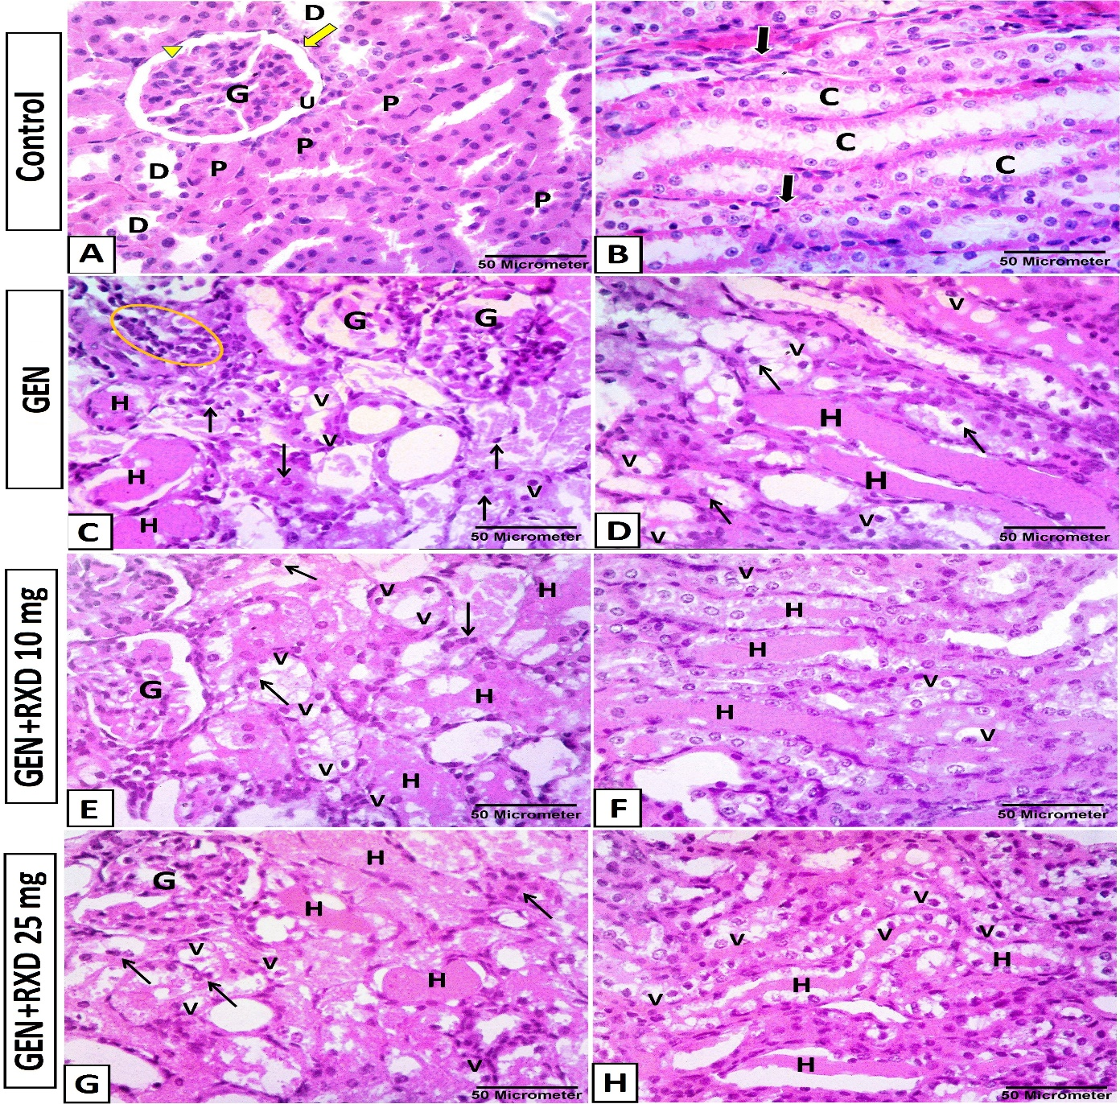

**Fig 1.** Photomicrographs of kidney tissue sections from all groups. **(A)** Renal cortex of control group shows normal glomerulus (G), simple squamous parietal layer (arrow) and visceral layer of Bowman's capsule (arrowhead), regular urinary space (U), narrow proximal convoluted tubules (P), and wider distal convoluted tubules (D). **(B)** Medullary section of control group shows elongated collecting tubules (C) lined by simple cubical epithelium and separated by minimal interstitium with peritubular capillaries (arrows). **(C-D)** Gentamicin (GEN) group shows degenerated glomeruli (G), mononuclear inflammatory cell infiltrations (circle) within the interstitial space, tubular dilatation with cellular debris (arrows). Intraluminal hyaline casts (H) along with vacuolar degeneration (V) in the cytoplasm of the cortical convoluted tubules and medullary collecting tubular cells are noticed. **(E-F)** GEN + roxadustat (RXD) 10 and **(G-H)** 25 mg groups are highly similar to those from the GEN group with no improvement in the histopathological structure of renal glomeruli (G) and tubules as revealed in the cloudy swelling, vacuolated cytoplasm (v), epithelial shedding with small darkly stained pyknotic nuclei (black arrows). Intraluminal hyaline casts (H) are also noticed inside the tubular lumen [H&E stain, x400; scale bar = 50µm].

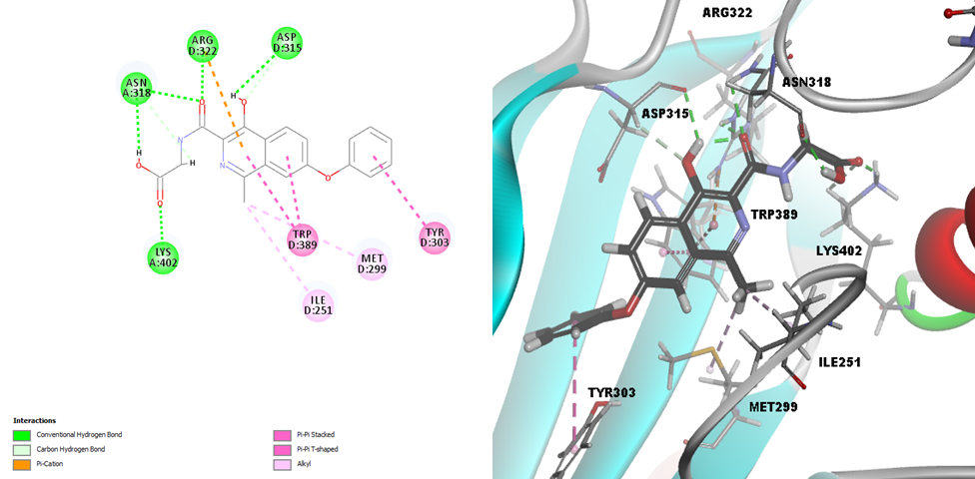

**Fig 2.** **(A)** 2D image of Roxadustat displaying all interactions with the receptor PHD. **(B)** 3D image of Roxadustat displaying all interactions with the receptor PHD.

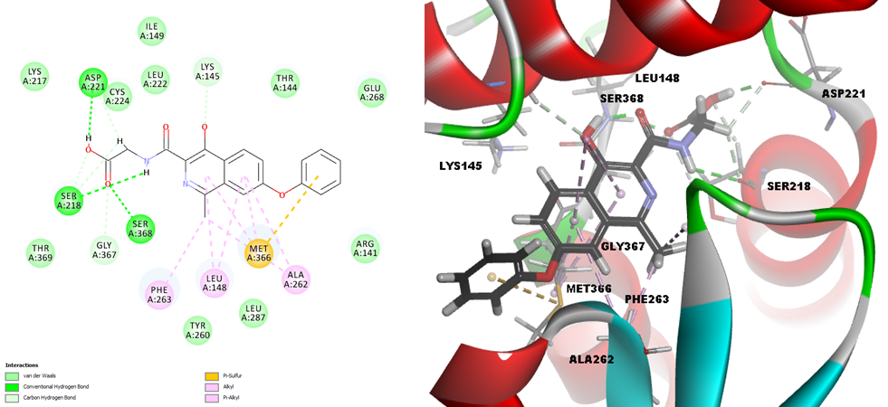

**Fig 3. (A)** 2D image of Roxadustat displaying all interactions with the receptor E3 ubiquitin ligase. **(B)** 3D image of Roxadustat displaying all interactions with the receptor E3 ubiquitin ligase.