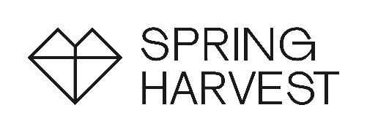
Risk Assessment – Exhibitors
Spring Harvest 2026

Organisation:
Name of person responsible for Health & Safety: | :
Mobile no | E-mail:

Exhibitor’s responsibilities
An exhibition stand is a workplace covered by Health and Safety legislation. As the exhibitor it is your responsibility to ensure that a suitable and sufficient risk assessment is completed and followed. Failure to do so could lead to delays or ultimately the closure of your stand.

This risk assessment is for an exhibition space which does not require any structural approval from the organiser or venue. Please speak to the exhibition team if you plan a more complex stand as it will require a more detailed risk assessment.

Hazard | Control measures | Who is at risk?
Injury by other stand builders or contractors
Muscle strains, sprains and injuries caused by lifting and moving heavy loads
Injury caused by falling
Trip hazards from cables
Injury from unsecured free-standing equipment
Injury from electrical equipment
Have your electrical appliances been PAT (electrical equipment) tested?
* Fire
Injury from items being promoted/sold from your exhibition space
Any other hazards for consideration?
Add more rows as required

* Fire prevention - Stands and their fittings and any materials used must be fire retardant (in accordance with appropriate authorities and British Standard 5867 part 2). Spray-on applications must have been applied within the last 12 months. Please include a copy of your appropriate certification or a note indicating you will not be using any potentially combustible materials.

We will be at (delete as applicable): Skegness: 30 March - 3 April Minehead: 6 - 10 April

