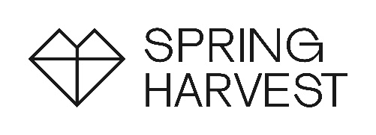
Risk Assessment – Exhibitors
Spring Harvest 2026

Organisation Click here to enter text.
Name of person responsible for Health & Safety: Click here to enter text. | Mobile no: Click here to enter text.  E-mail: Click here to enter text.

Exhibitor’s responsibilities
An exhibition stand is a workplace covered by Health and Safety legislation. As the exhibitor it is your responsibility to ensure that a suitable and sufficient risk assessment is completed and followed. Failure to do so could lead to delays or ultimately the closure of your stand.

This risk assessment is for an exhibition space which does not require any structural approval from the organiser or venue. Please speak to the exhibition team if you plan a more complex stand as it will require a more detailed risk assessment.

Hazard | Control measures | Who is at risk?
Injury by other stand builders or contractors | Click here to enter text. | Click here to enter text.
Muscle strains, sprains and injuries caused by lifting and moving heavy loads | Click here to enter text. | Click here to enter text.
Injury caused by falling | Click here to enter text. | Click here to enter text.
Trip hazards from cables | Click here to enter text. | Click here to enter text.
Injury from unsecured free-standing equipment | Click here to enter text. | Click here to enter text.
Injury from electrical equipment  Have your electrical appliances been PAT (electrical equipment) tested? | Click here to enter text. | Click here to enter text.
* Fire | Click here to enter text. | Click here to enter text.
Injury from items being promoted/sold from your exhibition space | Click here to enter text. | Click here to enter text.
Any other hazards for consideration?  Add more rows as required | Click here to enter text. | Click here to enter text.

* Fire prevention - Stands and their fittings and any materials used must be fire retardant (in accordance with appropriate authorities and British Standard 5867 part 2). Spray-on applications must have been applied within the last 12 months. Please include a copy of your appropriate certification or a note indicating you will not be using any potentially combustible materials.

Skegness: 30 March - 3 April ☐
Minehead: 6 - 10 April ☐

