Real-time, continuous in vivo monitoring of biomolecular targets via electrochemical aptamer-based (EAB) sensors

- Idili*
University of Rome Tor Vergata, Department of Chemical Science and Technologies
Via della Ricerca Scientifica 1, 00133, Rome (Italy)
andrea.idili@uniroma2.it

Real-time, in vivo monitoring of drugs, metabolites and biomarkers with high temporal resolution is a significant challenge, but also a remarkable opportunity for electrochemistry to advance personalized medicine and deepen our fundamental understanding of biology. To address this challenge, we have developed an electrochemical aptamer-based (EAB) sensor platform for the continuous, calibration-free detection of analytes directly within living organisms. Using indwelling EAB sensors, we have achieved real-time, seconds-resolved measurements of multiple, chemically unrelated targets, ranging from antibiotics such as vancomycin to endogenous metabolites such as phenylalanine, directly in the bloodstream, brain and peripheral tissues of living animals, with a temporal resolution of the order of ten seconds and a precision of a few micromolar. These measurements have resolved rapid pharmacokinetic and metabolic dynamics, including transient, few-seconds responses and inter-subject and feeding-dependent variability, that conventional, intermittent sampling simply cannot capture.

Most recently, we have extended the continuous operation of these sensors from a few hours to an entire week, encompassing tens of thousands of individual, seconds-resolved measurements collected in vivo, a decisive step toward our overarching goal of robust, long-duration, real-time molecular monitoring. Building on this trajectory, we are now advancing the platform beyond small molecules toward the continuous in vivo measurement of protein biomarkers, which would dramatically broaden the range of physiological and disease processes that can be followed in real time.

Our approach relies on aptamers immobilized at the electrode surface that undergo target-induced conformational switching. When the aptamers bind their specific molecular targets, they undergo structural rearrangements that modulate the electrochemical properties of the electrode interface—such as the electron-transfer kinetics of an attached redox tag, thus translating molecular recognition events into measurable electrical signals. The exceptional specificity of aptamer–target interactions ensures highly selective, reproducible and frequent monitoring of clinically relevant analytes in vivo, irrespective of their intrinsic electrochemical properties. This sensing platform thus provides clinicians and researchers with a powerful new tool for precisely quantifying biomolecules within complex biological matrices, offering unprecedented insights and paving the way for the development of advanced closed-loop drug-delivery strategies in personalized healthcare.
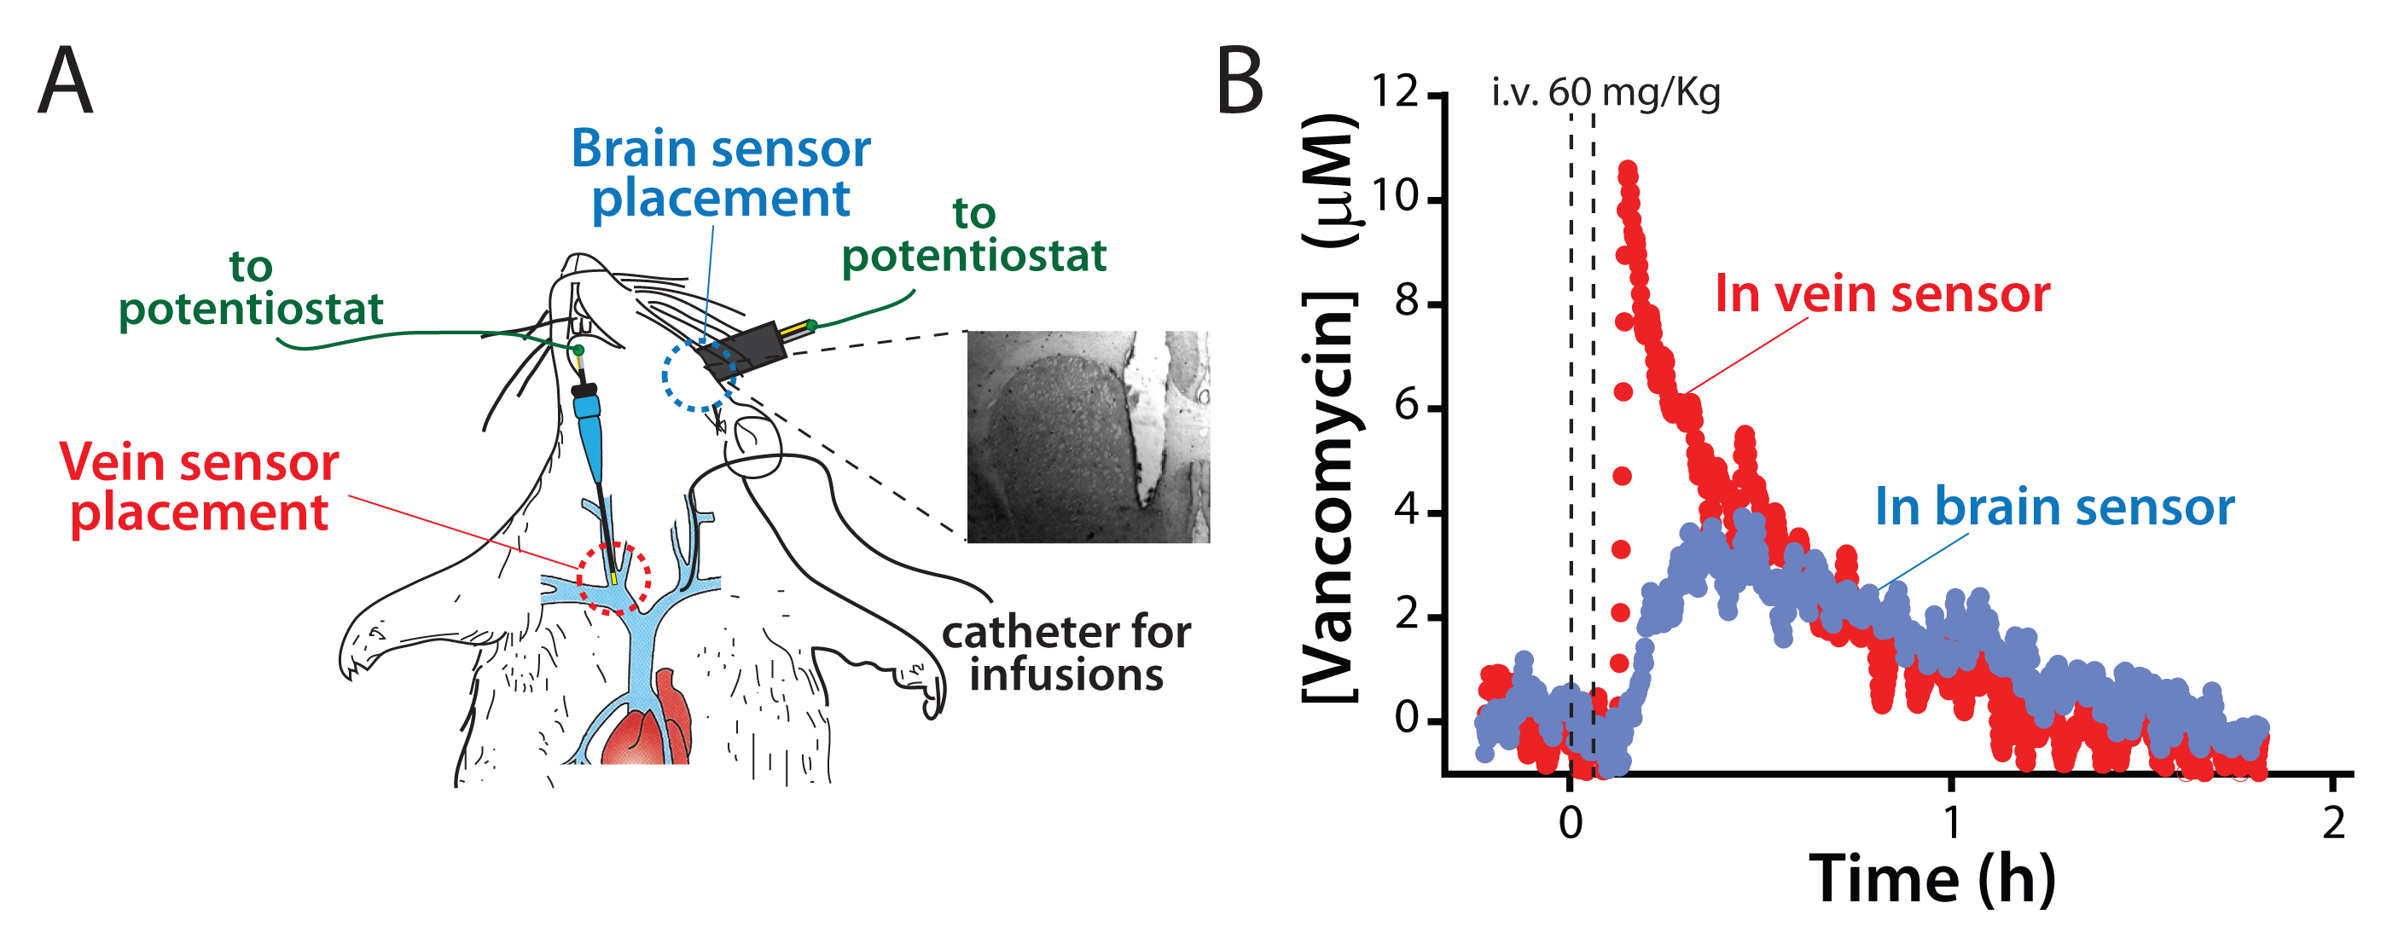
Figure 1: The convenience of electrochemical DNA (EAB) sensors makes it relatively easy to collect data in two compartments simultaneously. Here we used this approach to collect data in the left ventricle and the right external jugular vein of anesthetized rats. (b) Upon intravenous challenge with the drug vancomycin, we observe a rapid increase in its plasma concentration followed by its slow decline. In the cerebrospinal fluid (CSF), in contrast, the initial rise is slower and the subsequent decline lightly lags that seen in the vein.

