Ionic liquid–electrode electrochemical interface at saturation:
To crowd or not to crowd?

Vladislav Ivanistsev,ª Anna Stepanova,ª Ba Long Nguyen,^{b} Nadezda Kongi,^{b} and Iuliia V. Voroshylova^{c}
ª Department of Chemistry, University of Latvia, Riga, Latvia
^{b} Institute of Chemistry, University of Tartu, Tartu, Estonia
^{c} REQUIMTE-LAQV, Department of Chemistry and Biochemistry, University of Porto, Porto, Portugal
vladislav.ivanistsev@lu.lv

Electrochemical interfaces govern the operation of actuators, batteries, capacitors, desalinators, electrolyzers, fuels cells, etc. Still, the interpretation of electrical double layer structure and dynamics remains challenging, especially in concentrated electrolyte, because interfacial charge is distributed over multiple ionic layers whose arrangement evolves with electrode polarization. Consequently, connecting microscopic structure to experimentally measurable quantities remain one of the central problems of interfacial electrochemistry.
Here we present the Potential of Monolayer Charge (PMC) as a structural reference potential for electrified interfaces. The PMC corresponds to the state where a single compact monolayer of counterions exactly screens the electrode surface charge. In this state, the interface reaches a structurally simple configuration that naturally separates the classical overscreening and crowding regimes of ionic organization.¹ Our recent theoretical developments, molecular simulations, meta-data analysis, and theoretical derivations for ionic-liquid interfaces,^{2–5} suggest that PMC provides a consistent framework for interpreting differential capacitance, surface charge screening, and saturation phenomena across a wide potential range. We further demonstrate that the experimentally observed power-law dependence of capacitance on potential emerges from overscreening yet commonly confused with crowding. Thus, to address the question – to crowd or not to crowd? – we emphasize the importance of structural characterization beyond conventional capacitance measurements.
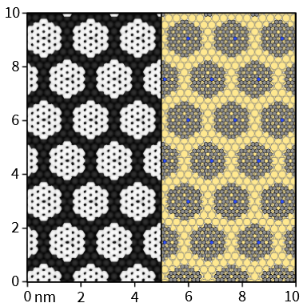
Our density functional theory and molecular dynamics simulations indicate that enlarging planar aromatic ions can shift the PMC into experimentally accessible potential ranges,^{4,5} opening opportunities for direct verification of the concept. In particular, the ordered monolayer expected at the PMC should be accessible to real-space characterization by scanning tunnelling microscopy. If verified experimentally, the PMC concept establishes a common reference scale for comparing electrified interfaces and offers a route toward unifying simulation, theory, and experiment. Beyond ionic liquids, this approach may provide new tools for understanding charge screening phenomena in a broad range of electrochemical systems and for guiding the design of advanced electrochemical materials and architectures.
Acknowledgements: This work was supported by the Estonian Ministry of Education and Research (TK210), the Estonian Research Council (PRG3174), FCT/MECI (UID/50006/2025, DOI 10.54499/UID/50006/2025), the Erasmus+ Programme of the European Union (EACH EM JMD, No. 619658), and project No. 1.1.1.8/1/24/I/003.
References
1. M.Z. Bazant, B.D. Storey, A.A. Kornyshev, Double Layer in Ionic Liquids: Overscreening versus Crowding, Phys. Rev. Lett. 106 (2011) 046102. doi.org/10.1103/PhysRevLett.106.046102.
2. B.L. Nguyen, E. Roos Nerut, A. Beditski, N. Kongi, V. Ivanistsev, I.V. Voroshylova, Ionic Liquid–Electrode Interface at Saturation: To Crowd, or Not to Crowd?, J. Phys. Chem. Lett. 17 (2026) 2374–2379. doi.org/10.1021/acs.jpclett.5c03710.
3. B.L. Nguyen, V. Ivanistsev, Ionic liquid–electrode interface: From one law to fit them all to one model to predict them all, Electrochem. Commun. 180 (2025) 108049. doi.org/10.1016/j.elecom.2025.108049.
4. Anna Stepanova, Heigo Ers, Ritums Cepitis, Michal Malček, Vladislav B. Ivanistsev, and Iuliia V. Voroshylova, Potential of monolayer charge, (2026). arxiv.org/abs/2301.13681v3.
5. K. Karu, E.R. Nerut, X. Tao, S.A. Kislenko, K. Pohako-Esko, I.V. Voroshylova, V.B. Ivaništšev, Ionic liquid–electrode interface: Classification of ions, saturation of layers, and structure-determined potentials, Electrochimica Acta 503 (2024) 144829. doi.org/10.1016/j.electacta.2024.144829.

