Operando Raman Spectroelectrochemistry for Tracking Phase Evolution in Nickel-Based Catalysts

David Ibáñez^{1,*}, María González-Ingelmo², Zoraida González-Arias², Victoria García-Rocha², David Hernández-Santos¹, Pablo Fanjul-Bolado¹.
¹Metrohm DropSens S.L.U., Parque Tecnológico de Asturias, C/ Faya 28, 33428 Llanera (Asturias) Spain.
²Instituto de Ciencia y Tecnología del Carbono, INCAR-CSIC, C/ Francisco Pintado Fe 26, Oviedo, 33011, Spain
*david.ibanez@metrohm.com

Time-resolved Raman spectroelectrochemistry is a versatile and powerful technique that integrates the dynamic control of electrochemical processes with the molecular specificity of Raman spectroscopy. The synergy between electrochemical and spectroscopic perspectives enables the in-situ optical characterization of a wide variety of systems and processes, providing both structural and mechanistic information under realistic operating conditions. This combined approach is particularly valuable for studying dynamic phenomena at electrified interfaces, where transient species and structural transformations often determine overall performance.

Additionally, operando Raman spectroelectrochemistry provides direct insight into the structural evolution of nickel-based catalysts for oxygen evolution reaction. Tracking these changes through Raman spectroelectrochemistry makes it possible to identify the formation of active phases and correlate them with electrochemical performance.

For instance, the electrochemical conversion of Ni(OH)₂ into NiOOH is demonstrated by the detection of the characteristic bands at 475 and 550 cm⁻¹ (Figure 1) [1,2]. Monitoring these vibrational signatures provides valuable information about the formation, evolution, and stability of the active oxyhydroxide phase, which plays a crucial role in OER performance. Furthermore, time-resolved measurements enable the observation of kinetic aspects of this transformation, offering insights into activation processes and potential-dependent behavior.
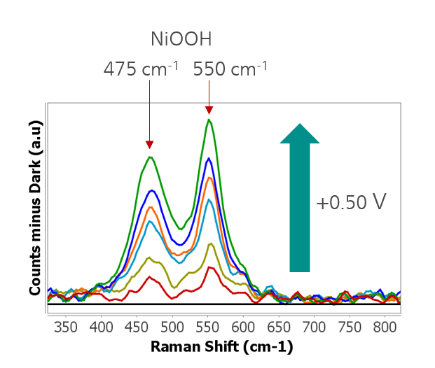
Figure 1. Evolution of the characteristics Raman bands of NiOOH with potential.

Overall, Raman spectroelectrochemistry emerges as a key analytical tool for the rational design and optimization of electrocatalysts. Its application to nickel-based systems highlights its potential for advancing the development of efficient and robust materials for energy conversion technologies.

References
[1] Z. Yan, H. Sun, X. Chen, H. Liu, Y. Zhao, H. Li, W. Xie, F. Cheng, J. Chen, Nat. Commun. 9 (2018) 2373.
[2] X. Yang, H. Zhang, B. Yu, Y. Liu, W. Xu, Z. Wu, Energy Technology 10 (2022) 2101010.

