Modifying Au(111) Electrodes for an Enhancement of the Alkaline Hydrogen Evolution Reaction

Lara Elisabeth Handle¹, Toni Moser¹, Christoph Griesser¹, Francesc Valls-Mascaro¹, Alexey Cherevan², Julia Kunze-Liebhäuser¹
¹Institute for Physical Chemistry, University of Innsbruck,
Innrain 52c, Josef-Möller-Haus, A-6020, Innsbruck, Austria
²Institute of Materials Chemistry, Technical University of Vienna
Lara.handle@uibk.ac.at

Green hydrogen production from renewable sources is a key step towards the realization of the energy transition. Thus, a deep understanding of its electrochemical production, i.e., the hydrogen evolution reaction (HER), is necessary to design cheaper and more effective catalysts. While the HER in alkaline electrolytes is less explored than in acidic media, an alkaline environment is more reasonable for large-scale implementations due to their compatibility with non-noble metal catalysts. One example of such a catalyst is thiomolybdate [Mo₃S₁₃]²⁻ in the form of clusters, which have demonstrated high activity towards proton reduction to hydrogen gas under various conditions, including photocatalysis [1,2] and electrocatalysis in acidic media [3,4].

In this work, we observed a pronounced enhancement of the HER activity of Au(111) in alkaline media (0.1 M NaOH) through modification with [Mo₃S₁₃]²⁻, which results in a marked decrease of the onset potential by approximately 350 mV (Figure 1a) compared to pristine Au(111). X-ray photoelectron spectroscopy (XPS) as well as electrochemical scanning tunneling microscopy (EC-STM) (Figure 1b,c) reveal the presence of well-dispersed [Mo₃S₁₃]²⁻ clusters on the Au(111) surface. XPS further indicates that the oxidation states of Mo remain unchanged i.e., at +IV, upon deposition, which is deduced from the Mo 3d peak positions at 229.4 and 232.9 eV.

The catalytic activity decreases upon polarization to 0.5 V_{RHE} (see Figure 1a), while EC-STM images show concomitant surface flattening, The reason for this activity change with changing electrode potential has yet to be understood. Identification of the electrochemical stability range where the [Mo₃S₁₃]²⁻ clusters have their highest activity will enable a systematic and targeted design of powerful catalyst materials for the alkaline HER.
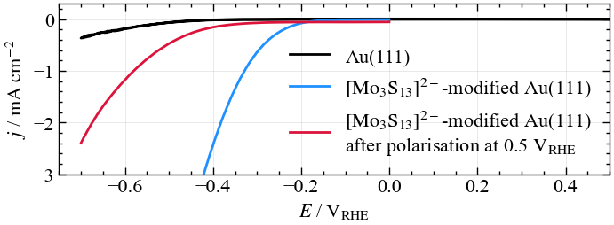
a)
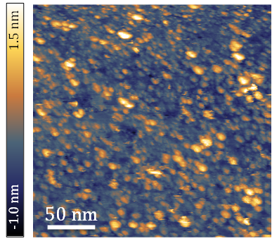
c)

b)
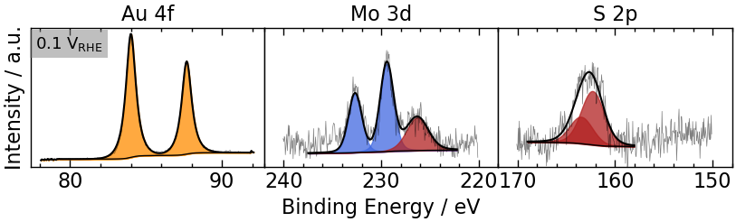

Figure 1: (a) Cathodic potential sweeps of Au(111) and [Mo₃S₁₃]²⁻-modified Au(111) at 50 mV∙s⁻¹ (b) Ex-situ emersion XPS spectra after polarisation at 0.1 V_{RHE}. (c) EC-STM image of [Mo₃S₁₃]²⁻-modified Au(111) at 0.1 V_{RHE}. Electrolyte: 0.1 M NaOH.
References
1. S. Batool, et. al. ACS Catal. 12 (11), 6641-6650 (2022)
2. S. Batool, et. al. Sustainable Energy Fuels, 8,1225 (2024)
3. K. Du, et. al. ACS Applied Materials & Interfaces 9 (22), 18675-18681 (2017)
4. T. R. Hellstern, et. al. ACS Catal. 7 (10), 7126-7130 (2017)

