Study of Electrochemical Depolymerization of Lignin in Alkaline Media Over MnO₂

Dr. Lucas D. Germano¹, Prof. Dr. Antonio A. S. Curvelo², Prof. Dr. Hamilton Varela², Prof. Dr. André H. B. Dourado¹
1.Universidade Estadual Paulista, 2. Universidade de São Paulo
Av. Prof. Francisco Degni, 55 - Jardim Quitandinha, Araraquara - SP, 14800-900, Brazil
lucas.germano@unesp.br

Fossil fuel, as primary energy source, undeniably resulted in the development of humanity over time. However, such growth resulted in a massively uncompensated rate of greenhouse gases emission. ^{1,2} Scientific efforts have been focused in finding different ways to overcome it. Alternatively, lignin biomass biorefinery presents a renewable and robust source to produce biofuel, chemical compounds, and polymeric materials.^{3,4} Yet, structural complexity hinders its depolymerization, challenging the transition to a cleaner process. Electrocatalysis can be used as feasible, and selective approach to depolymerize lignin instead. Thus, this work investigates the electrochemical depolymerization of industrial Kraft lignin extracted from a hybrid of Eucalyptus grandis and Eucalyptus urophylla in alkaline media using MnO₂ nanostructures as low-cost and versatile electrocatalyst. MnO₂ nanostructures were synthesized via hydrothermal method, and characterized by X-ray diffraction (XRD) using a Rigaku Smartlab (Cu-Kα: 1.54186 Å). For electrochemical tests, the material was drop-casted onto glassy carbon electrode (working electrode). Reference and auxiliary electrodes were a reversible hydrogen, and a graphite rod, respectively. Tests were performed using a potentiostat 302N Autolab. Before each lignin assay, MnO₂ film underwent several voltametric cycling in 2 mol L⁻¹ NaOH. Firstly, the nanostructures of MnO₂ were characterized by XRD, and the patterns, shown in Figure 1A, correspond to the diffraction of an α-phase, which is desired for electrocatalytic applications due to its tunnel structure.
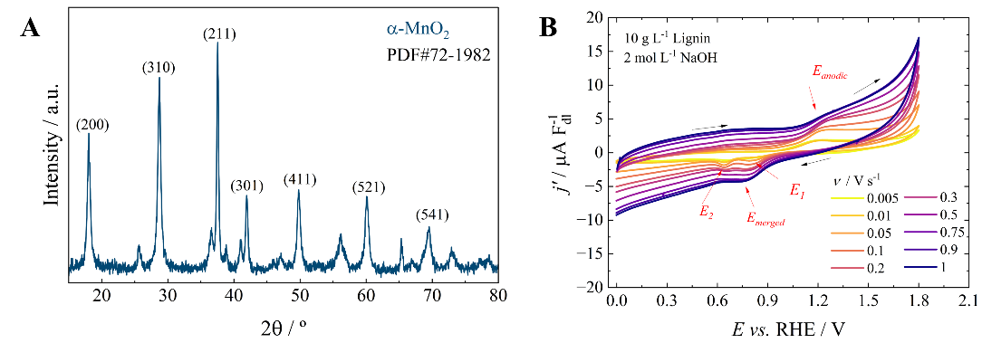
Figure 1. A) XRD patters of MnO₂ nanostructures; B) j-E potentiodynamic profiles at various scan rates.

Figure 1B shows j-E potentiodynamic profiles in various scan rates for MnO₂ in 10 g L⁻¹ lignin (2 mol L⁻¹ NaOH). Detailed analysis of these peaks revealed a pseudocapacitive adsorption for reaction intermediates, and a multistep electron transfer prior the rate determining step. Moreover, products analysis after an oxidative stress at specific potentials confirmed the formation of monophenolic species, through a probable radical oxidation mechanism.⁵ To further evaluate this reaction pathway hypothesis, the electrochemical system is currently under investigation by coupling it to an UV-Vis spectrometer setup in reflectance mode to follow the reaction intermediates on the electrode, and finally propose a robust and reliable lignin electrooxidation mechanism in aqueous media over MnO₂.

References
1. Chen, L. et al. J. Environ. Manage. 349, 119345 (2024).
2. Sun, S. et al. Applied Catalysis B: Environment and Energy 358, 124404 (2024).
3. Yang, C. et al. ACS Catal. 11, 10104–10114 (2021).
4. Balk, M. et al. Int. J. Mol. Sci. 24, 11668 (2023).
5. Dourado, A. H. B. et al. Langmuir 41, 22390–22399 (2025).

Acknowledgments
FAPESP Grants #2019/22183–6, #2020/01177–5, #2025/02191-5, #2022/06405-1; CNPq Grants #306060/2017–5, #161023/2021–5, #311419/2023–2.

