Direct evidence of confinement enabled electrosynthesis towards Urea

Yannick Weidemann¹, Pouya Hosseini², Andrés Rodríguez-Camargo³, Bettina V. Lotsch³, Kristina Tschulik¹
¹ Chair of Analytical Chemistry, Ruhr University Bochum, 44801 Bochum, Germany
²Chair Atomic scale Characterization, Ruhr University Bochum, 44801 Bochum, Germany
³Nanochemistry Department, Max Planck Institute for Solid State Research, 70569 Stuttgart, Germany
Yannick.Weidemann@ruhr-uni-bochum.de

Electrochemical urea synthesis is a rapidly growing field in part due to its potential to replace the Bosch-Meiser process. Still, this is a non-trivial task. The electrocatalytic synthesis of urea via co-reductive pathways however depends on a multitude of factors.¹ Finding suitable electrocatalyst is therefore just as complex, however optimizing existing catalyst remains largely unexplored. One possibility to alter and optimize catalyst selectivity is introducing confining elements.² Herein, we present the application of a covalent organic framework (COF), to enable reductive urea electrosynthesis on Au electrodes based on the co-reduction of CO₂ and NO₃⁻ via confinement. We prove this in-situ by employing electrochemical surface enhanced infrared absorption spectroscopy (EC-SEIRAS). We observed the emergence of a carbonyl stretch (1680 cm⁻¹) band as well as a surface-bound C-N stretch (1450 cm⁻¹) band both likely related to urea on metallic Au modified with a, a electrochemically inert COF containing a Azo-function in its linker.³ To further validate urea formation, we performed long-term electrolysis and determined a urea formation rate of $5.74±1.73 \frac{µMol}{h{ cm}^{2}}$ via the coulometric DAMO (diacetylmonoxime) approach. This work highlights the possibilities of identifying and exploiting confinement to steer reaction pathways and selectivity based on knowledge driven electrocatalyst design.

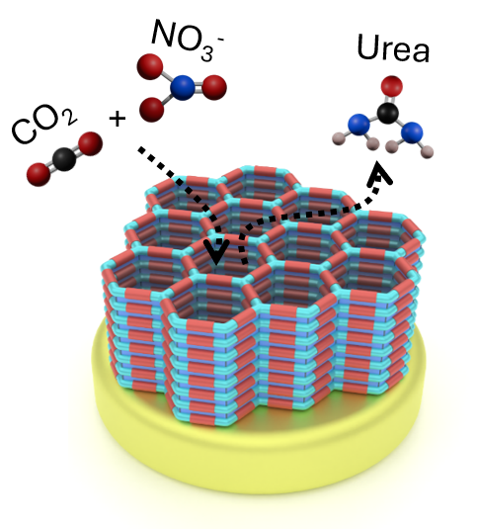
Figure 1: Schematic showing electrochemical urea synthesis with a Covalent organic framework modified Au electrode.

(1) Costa, G. F.; Escudero-Escribano, M. Electrode-Electrolyte Engineering and In Situ Spectroscopy for Urea Electrosynthesis from Carbon Dioxide and Nitrate Co-Reduction. JACS Au 2025, 5 (4), 1538–1548. https://doi.org/10.1021/jacsau.5c00065.
(2) Wordsworth, J.; Benedetti, T. M.; Somerville, S. V.; Schuhmann, W.; Tilley, R. D.; Gooding, J. J. The Influence of Nanoconfinement on Electrocatalysis. Angew. Chem. Int. Ed Engl. 2022, 61 (28), 202200755. https://doi.org/10.1002/anie.202200755.
(3) Weidemann, Y.; Hosseini, P.; Rodríguez-Camargo, A.; Liu, L.; Moussa, B.; Graf, D.; Ochsenfeld, C.; Petersen, P.; Lotsch, B. V.; Tschulik, K. Controlling Confinement: Covalent Organic Frameworks Induced Confinement of Water Probed via EC-SEIRAS; 2026. https://doi.org/10.26434/chemrxiv.15000669/v1.

