From waste to energy future: recycling carbon from spent batteries for application in new electrodes for flexible supercapacitors

Khan Nishat S.ª*; Taryba Marynaª, Sampaio Ruiª, Montemor M. Fátimaª
ª Centro de Química Estrutural - Institute of Molecular Sciences, Universidade de Lisboa.
Nishat.khan@tecncio.ulisboa.pt

The increasing generation of end-of-life lithium-ion batteries poses a significant environmental challenge, requiring sustainable recycling and valorisation strategies. Although hydrometallurgical processes are widely used to recover valuable metals, the graphite fraction is often underutilised or discarded as a low-value byproduct. Considering that graphite constitutes a substantial portion of battery anodes and contributes to the overall CO₂ footprint [1], its effective reuse is essential for improving the sustainability of battery recycling. This work, therefore, aims to develop a viable strategy for the direct reutilisation of graphite recovered from spent lithium-ion batteries as a functional material.
In this context, graphite was employed to render textile substrates electrically conductive, forming a flexible current-collecting scaffold for energy storage applications [2]. The resulting conductive textile was subsequently functionalised via electrochemical polymerisation of polypyrrole to introduce additional electroactive sites. The electrochemical performance of the resulting electrodes was systematically evaluated, with emphasis on specific capacitance, cycling stability, and operational potential window. The optimised system demonstrates that integrating recycled graphite with polypyrrole yields flexible, electrochemically stable electrodes suitable for supercapacitor applications. These results highlight a scalable and sustainable route for converting battery waste into high-value textile-based energy storage materials.

.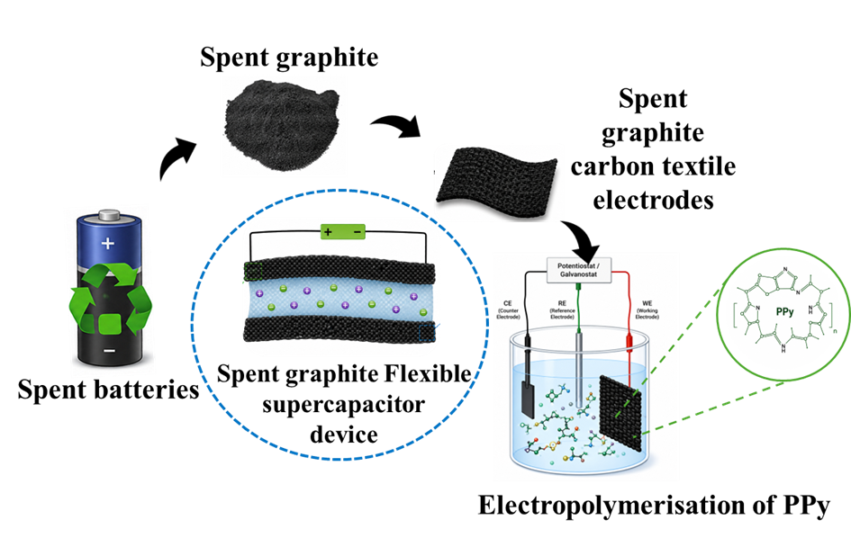

Acknowledgments

The authors acknowledge Fundação para a Ciência e Tecnologia (FCT) for project funding under the project 2022.05187.PTD and Centro de Química Estrutural, a Research Unit funded by FCT, the projects UID/00100/2025 and UID/PRR/00100/2025 and IMS, a laboratory associated funded by FCT: LA/P/0056/2020. This work was developed within the scope of the project “NGS – New Generation Storage” [C644936001-00000045], financed by PRR – Plano de Recuperação e Resiliência under the Next Generation EU from the European Union

References
[1] K. R. Ngoy et al., “Lithium-ion batteries and the future of sustainable energy: A comprehensive review,” Renew. Sustain. Energy Rev., vol. 223, no. July, p. 115971, 2025, doi: 10.1016/j.rser.2025.115971.
[2] P. Kumar, P. Sephra, M. Gupta, V. Jeoti, C. Tharini, and G. M. Stojanovi, “Flexible and sustainable energy storage : Recent progress and prospects in wearable supercapacitors,” vol. 141, no. January 2025, 2026.

