In-situ Pressure and Temperature Mapping via Embedded MEMS Sensors in Electrochemical CO₂ Reactor Flow Channels

C. De Preter, Q. Van Laere, J. Van den Hoek, J. Schalck, L. F. Leon-Fernandez, and T. Breugelmans
Applied Electrochemistry and Catalysis (ELCAT), University of Antwerp
Campus Drie Eiken, Universiteitsplein 1 Building B, 2610 Wilrijk, Belgium
Clem.DePreter@uantwerpen.be

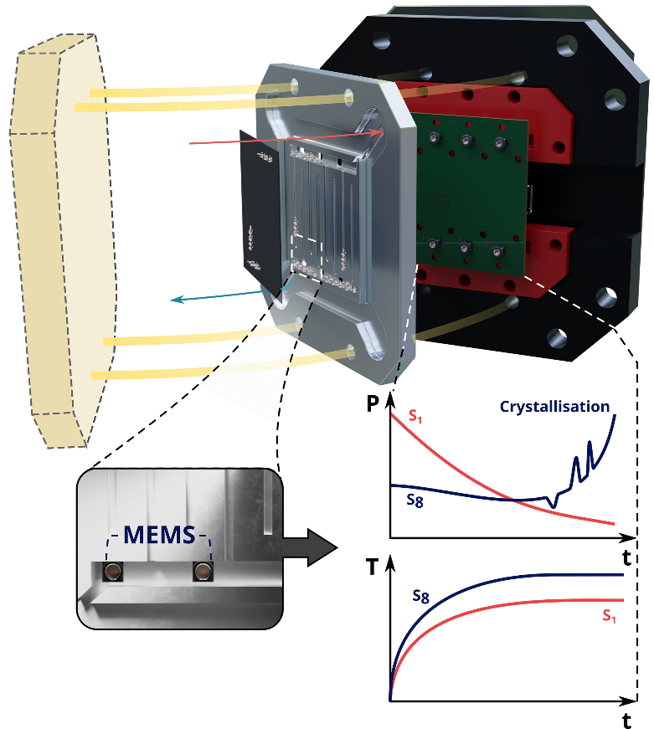
The electrochemical reduction of carbon dioxide (CO₂) to C₁ (e.g. carbon monoxide and formate) and C₂₊ products (e.g. ethanol and ethylene) is regarded as one of the most promising Carbon Capture and Utilisation techniques to reduce atmospheric and anthropogenic CO₂ levels⁽¹⁾. While several start-ups have publicly reported the successful low-temperature production of C₁ products in pilot plants at scales exceeding 10 kW, key operational challenges remain, hindering faster adoption and commercialisation⁽²⁾. One key challenge lies in managing the pressure and flow distribution of reactants and products, which play a significant role in governing mass transport processes within CO₂ electrolysers. During operation, these distributions continuously evolve due to complex and dynamic reaction environments which are heavily influenced by operating conditions (e.g. membrane type, applied current density (CD) and CO₂, anolyte and direct water injection (DWI) flow rates), catalyst properties (e.g. catalyst type, morphology and deposition methodology) and the selected flow field design and electrode type⁽³⁾. As a result, CO₂ electrolysers are susceptible to local failures, including electrolyte precipitation, flooding and local starvation zones. Next to pressure and flow distribution-related challenges, heat management in CO₂ electrolysers is critically important. Thermal gradients during operation exert a key impact on the integrity, stability and performance of the membrane, catalyst and selected sealing systems – thereby directly influencing mass transport properties and product selectivity^{(4, 5)}. As CO₂ electrolysers continue to advance, monitoring in-situ pressure and temperature becomes increasingly important for understanding and controlling mass transport processes, thus improving reactor lifetime and performance.

In this work, we sought to understand and overcome these challenges by integrating micro-electrochemical systems (MEMS) pressure and temperature sensors into the cathodic flow channels of a zero-gap CO₂ electrolyser to enable real-time, in-situ, pressure and temperature mapping. Under steady-state conditions with an anion-exchange membrane, the applied CD was found to have the largest influence on temperature, resulting in a relative temperature increase of 5 °C and 7.5 °C for the inlet and outlet flow channels, respectively. Other parameters, including the membrane type and flow rates of DWI, anolyte and CO₂ streams, were also found to affect the temperature evolution, albeit to a lesser extent. In addition to temperature mapping, salt precipitation was successfully monitored under both polarised and non-polarised conditions. Distinct pressure profiles were obtained where (i) under polarised conditions, the inlet flow channels exhibited a linear pressure increase of up to 40 hPa, and (ii) under non-polarised conditions, this linear pressure rise was followed by an exponential increase due to partial clogging or the formation of a precipitated salt “cake” layer within the electrode and/or flow channels, resulting in a pressure difference of 150 hPa. Our results demonstrate that integrating MEMS sensors into CO₂ electrolyser flow channels enables precise, real-time and in-situ insights into mass transport phenomena, operational failure modes and structure-property relations, providing a game-changing tool for diagnostics and reactor optimisation.

1. M. Tayyab et al., Energy Environ. Sci. 18, 6854–6873 (2025).
2. B. S. Crandall et al., Nature Chemical Engineering. 1, 421–429 (2024).
3. B. S. Crandall, et al., Nature Chemical Engineering (2026).
4. H. M. Pelzer, et al., Scaling and heating will drive low-temperature CO2 electrolysers to operate at higher temperatures. Nat. Energy. 10 (2025), pp. 549–556.
5. M. P. Schellekens, et al., Chemical Engineering Journal. 483 (2024).

