Tracking Ammonia Electrooxidation Reaction via in-situ Electrochemical Raman Spectroscopy
Sara Sumbal¹, Marek Lieder¹, Mirosław Sawczak², Justyna Łuczak¹
Gdańsk University of Technology, Gdańsk, Poland
Institute of Fluid-Flow Machinery, Polish Academy of Sciences, Gdańsk, Poland
Email: sara.sumbal@pg.edu.pl
Ammonia electrooxidation reaction (AOR) has gained attention among researchers as a promising source of green hydrogen. AOR can replace oxygen evolution (OER) at the anode in alkaline water electrolysis while producing hydrogen at the cathode. The desired product of AOR is N₂, while undesired side products could be nitrates, nitrites, or nitric oxides. AOR occurs on the electrode surface, resulting in the formation of several intermediates. Identifying reaction intermediates is key to controlling the reaction pathways and product selectivity.
In-situ Raman spectroscopy has emerged as an ideal tool for investigating electrode-electrolyte interfaces, electrocatalytic reaction mechanisms, and identifying the true active sites during electrocatalysis. Herein, we employed in-situ electrochemical Raman spectroscopy to investigate Ni-based electrocatalysts for AOR in a custom-made cell. Raman spectra were collected during chronoamperometry (CA) measurements in 1 M KOH and 1 M KOH + 1 M NH₃ electrolytes. In the Raman spectra of Ni-based electrocatalysts, two distinct bands located at ~320 cm⁻¹ and ~465 cm⁻¹, corresponding to Ni²⁺-O and Ni³⁺-O vibrational modes of Ni(OH)₂ and NiOOH, were observed. In 1M KOH electrolyte, at potentials 1.35-1.55 V, the intensity of the Ni³⁺-O band remained unchanged. However, as the potential increased from 1.55 to 1.75 V, a gradual decrease in this intensity is observed. On the other hand, in the case of 1M KOH + 1 M NH₃ electrolyte, at potentials 1.35-1.55 V, the intensity of the Ni³⁺-O band is constant, and starts to increase for higher potentials gradually. Despite being used for the AOR, the surface is replenished with the continuously formed Ni³⁺. Additionally, the Raman bands corresponding to adsorbed and aqueous NH₃/NH_{x}, NO₃¯, and NO₂¯ species were identified during AOR.
Overall, in-situ Raman spectroscopy revealed the interaction of NH₃ and related species on metal surfaces and identified the active sites during AOR.
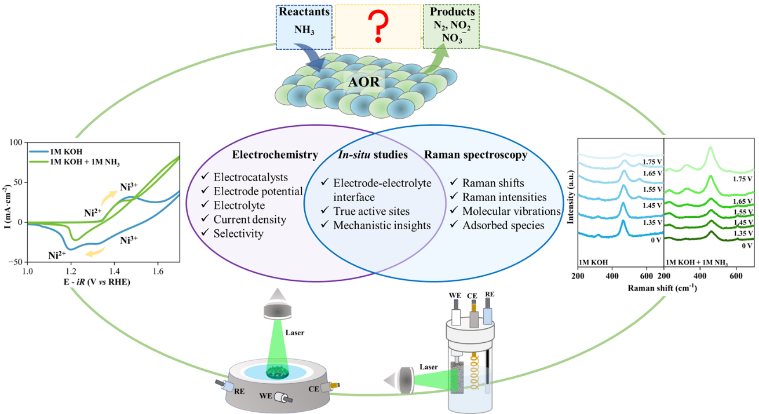
Figure 1. Overall schematics of the in-situ electrochemical Raman spectroscopy for AOR.

