Scanning Electrochemical Microscopy as a Powerful Tool for Investigating the Solid Electrolyte Interphase at Hard Carbon in Sodium-Ion Batteries
Anita Cymann-Sachajdak¹, Carsten Dosche², Gunther Wittstock²
¹ Gdansk University of Technology, Department of Chemistry, Institute of Energy Conversion and Storage, ul. G. Narutowicza 11/12, 80-233 Gdańsk, Poland
² Carl von Ossietzky University of Oldenburg, Institute of Chemistry, Ammerländer Heerstraße 114-118,
26129 Oldenburg, Germany
anita.cymann-sachajdak@pg.edu.pl

The solid electrolyte interphase (SEI) plays a critical role in rechargeable batteries by governing ion and electron transport across the electrolyte–electrode interface¹. In sodium-ion batteries (SIBs), the properties of the SEI formed on hard carbon anodes are particularly important for achieving high Coulombic efficiency, prolonged cycle life, and stable electrochemical performance. Despite its importance, the SEI formed on hard carbon has received considerably less attention than its counterpart in lithium-ion batteries^{2,3}.

In this work, scanning electrochemical microscopy (SECM) is employed as a powerful tool to investigate the formation, evolution, and stability of the SEI on a commercial hard carbon anode in a series of 1 M NaPF₆-based electrolytes with varying solvent compositions, including linear and cyclic carbonates as well as the widely used additives fluoroethylene carbonate (FEC) and vinylene carbonate (VC). Electrochemical measurements demonstrate a strong influence of electrolyte composition on the sodiation/desodiation behavior of hard carbon. SECM was shown to effectively identify and spatially resolve in situ interfacial phenomena, including dendrite growth and gas bubble evolution (Figure).
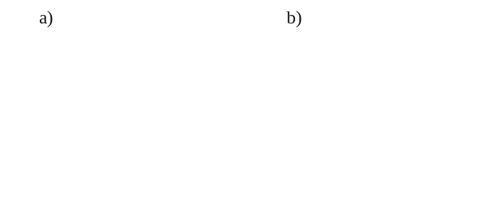
Figure: Representative SECM feedback-mode maps highlighting the ability of scanning electrochemical microscopy to identify and spatially resolve interfacial phenomena occurring at the solid electrolyte interphase (SEI): (a) dendrite formation and (b) gas bubble evolution.

SECM mapping reveals pronounced changes in the interfacial properties of hard carbon during successive sodiation/desodiation cycles, providing direct insight into the dynamic nature and limited long-term stability of the SEI. To correlate local electrochemical activity with interphase chemistry, SECM investigations were complemented by X-ray photoelectron spectroscopy (XPS), which revealed substantial solvent-dependent differences in SEI composition and structure.

These results demonstrate the strong impact of electrolyte formulation on the formation and evolution of the SEI at hard carbon anodes and highlight the unique capabilities of SECM for probing dynamic interfacial processes in sodium-ion batteries. The study further establishes SECM as a powerful tool for investigating the structure, stability, and functionality of battery interphases.

References
1. Huang, Z.-X. et al. Electrode/electrolyte additives for practical sodium-ion batteries: a mini review. Inorg. Chem. Front. 10, 37–48 (2023).
2. Saleh, S. et al. Probing the Properties of Locally Formed Solid Electrolyte Interphases on Hard Carbon Anodes. ChemElectroChem 12, e202400707 (2025).
3. Daboss, S. et al. Characterization of the solid/electrolyte interphase at hard carbon anodes via scanning (electrochemical) probe microscopy. Electrochimica Acta 453, 142345 (2023).

