3D-Printed Three-Electrode Platform for Operando Raman Spectroelectrochemistry in Droplet-Volume Electrolytes

Katarzyna Szwabińska¹, Hamed Zafarani^{1,2}, Bartłomiej Hurny^{1,3}, Martin Perez-Estebanez⁴,
Aranzazu Heras⁴, Alvaro Colina⁴, Lukasz Poltorak¹
¹University of Lodz, Electrochemistry@Soft Interfaces Team, Faculty of Chemistry, Department of Inorganic and Analytical Chemistry, Tamka 12, 91-403 Lodz, Poland
²BioMedChem Doctoral School of the University of Lodz and Lodz Institutes of the Polish
Academy of Sciences, Matejki 21/23, 90-237 Lodz, Poland
³University of Lodz, Doctoral School of Exact and Natural Sciences, Matejki 21/23, 90-237 Lodz, Poland
⁴Universidad de Burgos, Department of Chemistry, Pza. Misael Bañuelos s/n, E-09001 Burgos, Spain
katarzyna.szwabinska@chemia.uni.lodz.pl

Low-cost disposable Raman spectroelectrochemical substrates were obtained through fabrication of a 3D-printed three-electrode system and subsequent electrodeposition of Cu onto the working electrode. Non-conductive parts of three-electrode platform were made of polylactic acid (PLA), whereas the electrodes and conductive paths were printed from carbon black/polylactic acid (CB/PLA) filament. Copper was electrodeposited under potentiostatic conditions from an acidic CuSO₄ solution containing polyethylene glycol (PEG) additive. The fabricated 3D-printed platform with an electrodeposited Cu layer was assessed for operando SERS substrate generation by cyclic voltammetry Raman SEC experiments in chloride medium (0.1 M HCl) using adenine and rhodamine 6G, as illustrated in Figure 1.

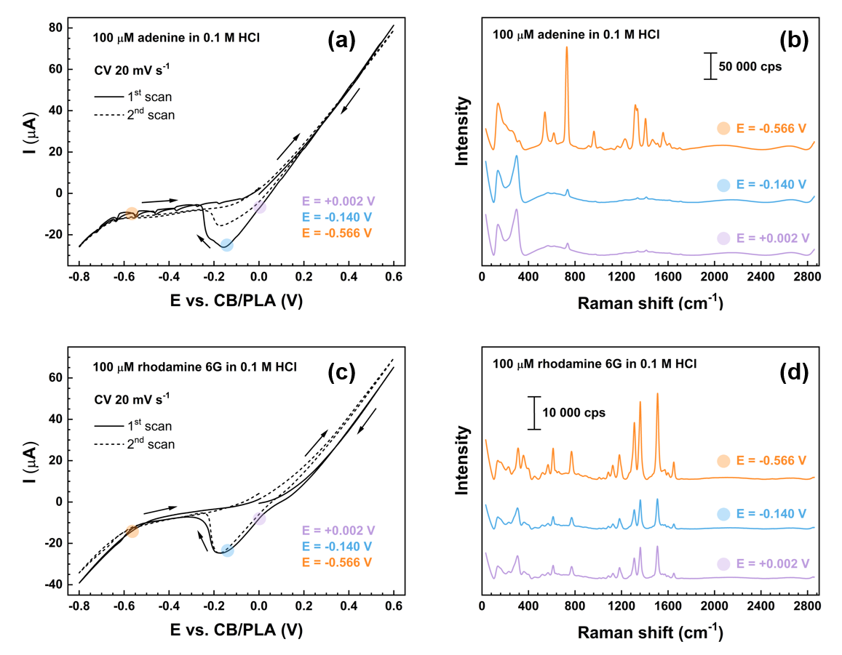

Figure 1. CVs and corresponding Raman spectra recorded at the Cu-based substrate for (a,b) 100 μM adenine in 0.1 M HCl and (c,d) 100 μM rhodamine 6G in 0.1 M HCl.

Acknowledgments
K.S. acknowledges support from the Polish National Agency for Academic Exchange (NAWA) under the Bekker NAWA Programme, project no. BPN/BEK/2024/1/00200.

