Platform-Dependent Surface Functionalization of Gold Electrodes for Gold-Based Biosensing
Songül Koçoğlu¹, Olivia McGleish¹, Julien Reboud ¹, and Jonathan M. Cooper¹
¹ Division of Biomedical Engineering, University of Glasgow, Glasgow G12 8LT, UK
s.kocoglu.1@research.gla.ac.uk
Gold is a standard electrode material in electrochemistry due to its broad potential window, high conductivity, chemical inertness, and resistance to oxidation, supporting efficient interfacial signal transfer. Its strong affinity for thiol-based chemistry makes it highly attractive for biosensing, enabling stable attachment of biomolecules via gold-sulphur (Au-S) interactions [1]. However, if the electrode platform changes, the optimal coupling conditions may shift. In situ ATR-SEIRAS studies reveal that EDC/NHS immobilization on gold is highly sensitive to the local interfacial environment; even standard conditions (200 mM EDC/50 mM NHS) are strongly affected by phosphate ions and pH [2]. Additionally, layer thickness and immobilization chemistry heavily influence detection performance, reinforcing that surface architecture dictates sensor response [4,3].
This study examines how platform architecture influences the surface chemistry used for protein immobilization. Our findings demonstrate that tuning NHS/EDC coupling conditions to each specific electrode platform significantly enhances assay consistency and interface stability across various test solutions (Figure 1). This carries practical implications for biosensor development, particularly when transitioning from laboratory-fabricated systems to commercially available platforms. Rather than merely confirming NHS/EDC applicability on gold, these findings prove that effective reagent concentrations and coupling efficiency depend strictly on electrode architecture.
For instance, a custom-fabricated lithographic Ti/Au electrode achieved efficient carboxyl activation and protein immobilization at low concentrations (0.4 mM EDC / 0.1 mM NHS). Conversely, these conditions failed on a commercial Linxens electrode, requiring 100-fold higher concentrations for successful immobilization (Figure 2). This discrepancy, unattributable to gold thickness alone, highlights the influence of platform-specific surface morphology, interfacial chemistry, and fabrication processes. Consequently, transferring standardized chemical protocols between distinct formats without optimization is unfeasible. Biofunctionalization strategies must be systematically tailored to the specific platform to ensure reproducible modification, stable interfaces, and consistent biosensing performance.
.
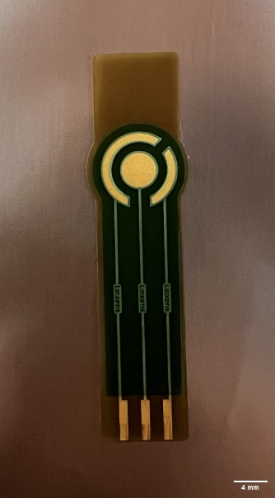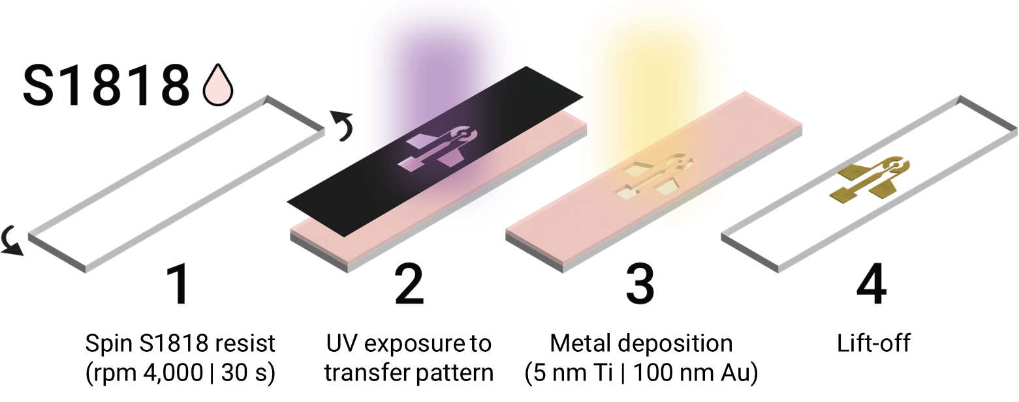
Figure 1. Commercial-Linxens-gold electrode(left side) and schematic illustration of the photolithography steps for a custom-fabricated Ti/Au electrode(right side)
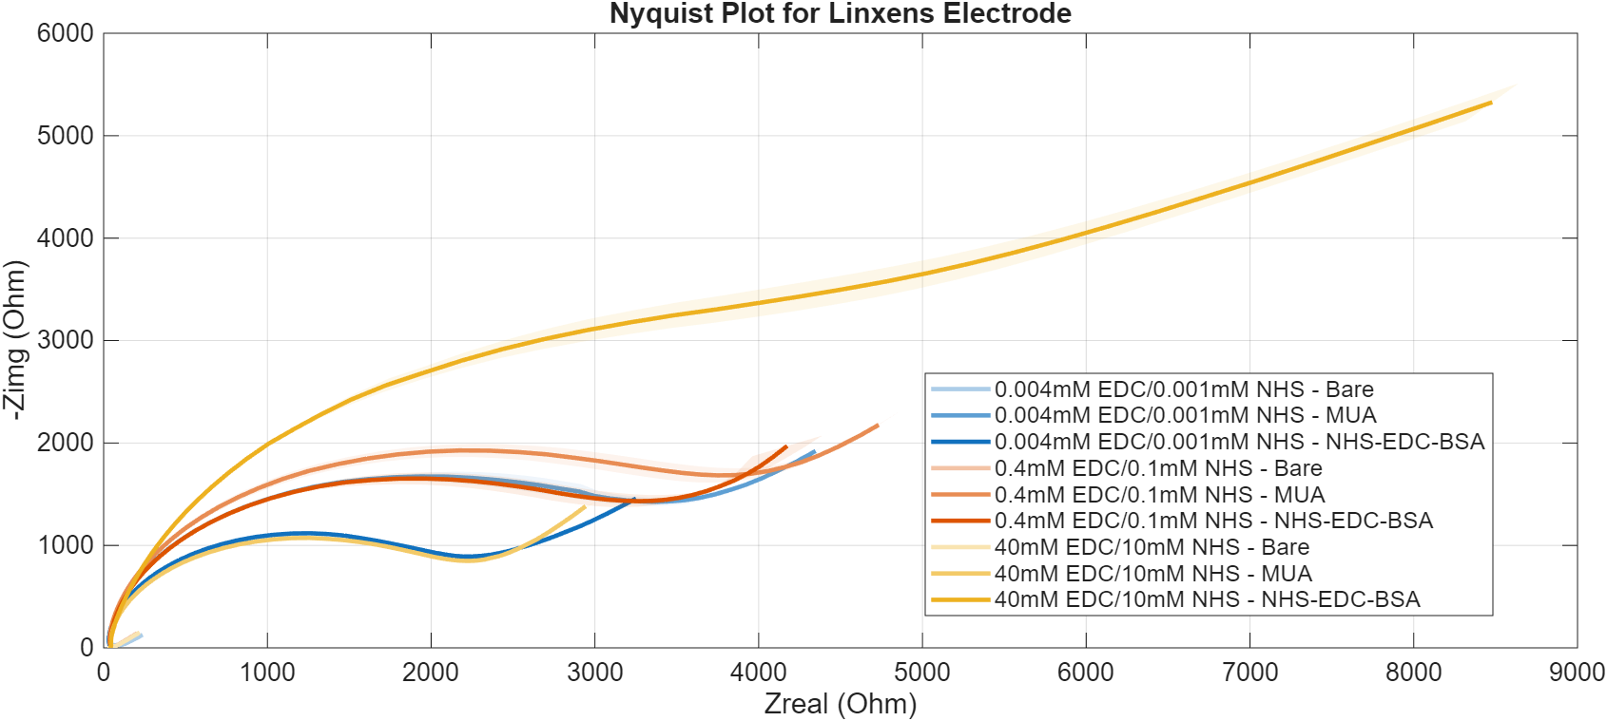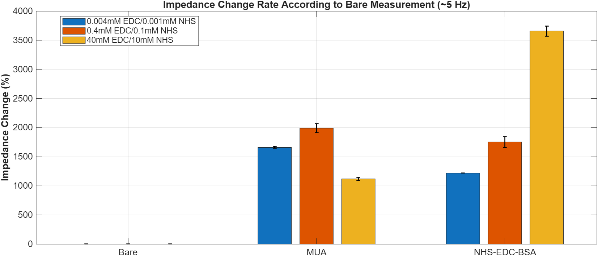
References
[1] Zamani M, et al. (2023). Lab on Chip.23(5), 1410.
[2] Tsai T, et al. (2019). Colloids and Surfaces B: Biointerfaces. 175, 300-305.
[3] Kastner S, et al. (2022). Scientific Report. 12(1):836.
[4] Bahadir E.B, et al (2016).Nanomedicine, and Biotechnology.44(2), 462-470.

Figure 2. Electrochemical impedance spectroscopy (EIS) analysis of Linxens gold electrodes under varying NHS/EDC coupling conditions. (Left) Nyquist plots illustrating impedance responses. (Right) Quantified impedance change at low frequency (~5 Hz) relative to the bare electrode, highlighting the dependence of surface activation and protein immobilization efficiency on reagent concentration.

