Cation Dependent Inter- and Inlayer Structure of Nickel Iron Oxy Hydroxide During Operando Oxygen Evolution

Jordy J. J. Eggebeen^{*a}, Ida Kær Mønge^{b}, Onno van der Heijdenª, Marc T.M. Koperª and Rebecca K. Pittkowski^{b}
ªLeiden Institute of Chemistry, Leiden University. Einsteinweg 55, 2333 CC Leiden, The Netherlands
^{b}Department of Chemistry, University of Copenhagen, Universitetsparken 5, 2100 Denmark
*j.j.j.eggebeen@lic.leidenuniv.nl

NiFe-layered double hydroxides (LDH) are promising electrocatalysts for alkaline water electrolysis due to their low cost and high activity towards the oxygen evolution reaction (OER). While common OER optimization strategies focus on enhancing the catalysts’ inherent activity, the role of electrolyte composition is often overlooked. The layered structure of NiFe LDH contains sub-nanometer pores where electrolyte intercalates, forming a confined double-layer structure. Previous studies have shown that intercalated cations influence the alkaline OER activity through electrostatic interactions with the negatively charged surface (hydr)oxyl groups, formed during Ni²⁺→Ni³⁺ oxidation.^{1,2} Yet whether cations also drive structural transformations of layered double hydroxides had not been resolved.
In this study, we directly track interlayer contraction and expansion of NiFeOOH under operating conditions using operando synchrotron X-ray Diffraction and X-ray total scattering with Pair Distribution Function analysis.^{3,4} We show that the interlayer d-spacing decreases reversibly upon Ni oxidation and OER, and expands upon Ni reduction (Fig. 1a, b), aligning with observed mass changes.³ Cs⁺ expands the layer by 0.23 Å relative to Li⁺ and K⁺, demonstrating that cation size can influence the layer stacking. Li⁺, by contrast, intercalates kinetically slowly (Fig. 1c), requiring a higher overpotential, yet binds more strongly to the surface (hydr)oxyl groups, causing a M-M and M-O bond elongation (Fig. 1d). Over extended cycling, these electrolyte-driven structural effects become clear: cation identity affects nanoparticle size distribution, long-term stability, and electrochemically accessible surface area. Together, our findings reveal that alkali cations play both a structural and electrostatic role during the electrocatalyst phase transformation and electrochemical oxygen evolution.

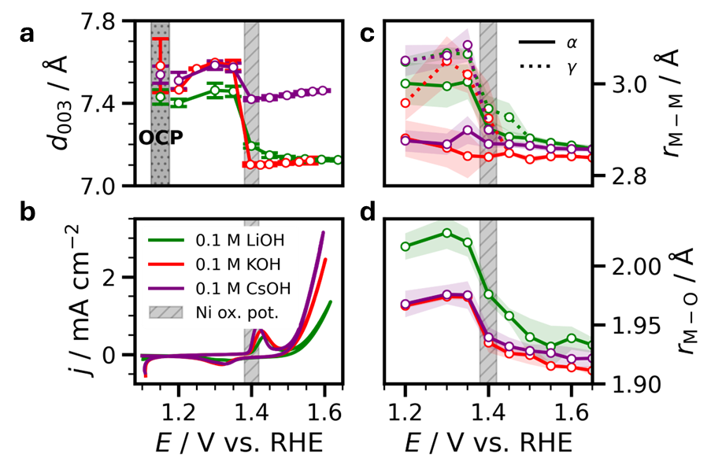
Figure 1: Interlayer spacing (d₀₀₃), Metal-Metal (M-M), and Metal-Oxygen (M-O) bond distances as a function of electrolyte and potential, showing a cation-dependent structural change (oxidation, cation intercalation, and layer contraction) around the Ni oxidation peak indicated by the gray bar in the bottom left.
References:
- Garcia, A. C., et al. Angew. Chem. Int. Ed. 58, 12999–13003 (2019).
- Van der Heijden, O. et al. Angew. Chem. Int. Ed. 63, e202318692 (2024).
- Aalling-Frederiksen, O. et al. Small 21, 2411211 (2025).
- Eggebeen, J. J. J., Kær Mønge, I., Van der Heijden, O., … Koper, M. T. M. & Pittkowski, R. K. In preparation (2026).

