Understanding Cation Effects Through Interfacial Structure in Alkaline Hydrogen Evolution on Single-Crystal Platinum Electrodes

Nicci L. Fröhlich¹, Finn Schröter², Karen van den Akker¹, Jan O. Fehrs², Dechun Si², Sheena Louisia¹, Jakub Drnec³, Olaf Magnussen², Marc T.M. Koper¹
¹ Leiden Institute of Chemistry, Leiden University, Einsteinweg 55, 2333 CC Leiden, the Netherlands; ² Institute of Experimental and Applied Physics, Kiel University, Kiel, Germany; ³ European Synchrotron Radiation Facility, ID 31 Beamline, BP 220, F-38043 Grenoble, France
n.l.frohlich@lic.leidenuniv.nl

Despite extensive research, the structure of the Pt/aqueous interface – one of the key model interfaces in alkaline water electrolysis – remains poorly understood [1]. Pronounced structure-dependent electrolyte effects have been reported for the hydrogen evolution reaction (HER) across different Pt facets [2]. Although HER is highly efficient in acidic media, the alkaline electrolytes used in practical electrolysers exhibit lower activity [3], highlighting the need for a detailed in situ understanding of the electric double layer structure and its role in HER kinetics [1]. Interestingly, at constant pH (e.g., pH 11), where the interfacial electric field strength is effectively fixed, HER activity exhibits markedly different cation concentration dependencies on Pt(111) and Pt(110) [2]. On Pt(110), HER activity increases strongly with increasing cation concentration (Fig. 1a), whereas only a weak enhancement is observed on Pt(111). This facet-dependent behaviour suggests fundamental differences in interfacial composition, particularly in the relative arrangement of the water adlayer and the cation plane of closest approach.
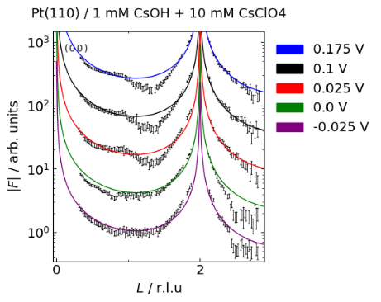
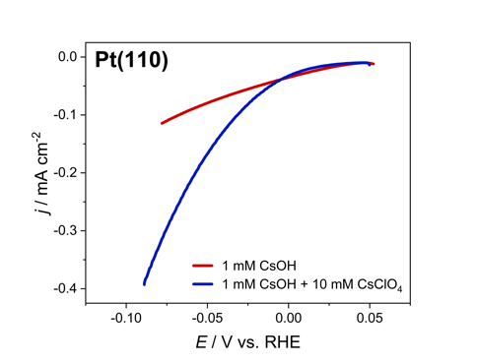
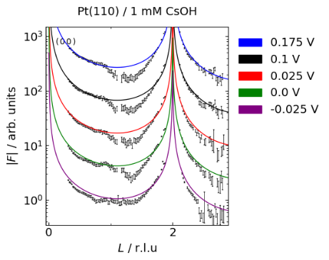
To probe this directly, we employ high-energy surface x-ray diffraction (HESXRD), a highly surface-sensitive technique capable of resolving interfacial cation distributions and, in principle, interfacial water structure. Preliminary analysis of our HESXRD results reveal significant changes along the specular crystal truncation rods at potentials close to the onset of the HER (Fig. 1b,c). These changes can be associated with changes in near-surface cation density and Pt surface relaxation, indicating chemisorption. The occurrence of these changes in interface structure shifts to more positive potentials with alkali cation concentration, supporting that they are caused by the cations. Measurements on Pt(111) show similar qualitative trends, however the intensity change associated with cation adsorption occurs at more negative potentials than for Pt(110), suggesting weaker cations adsorption at Pt(111) compared to Pt(110) at the same HER potential. Therefore, these results provide direct structural evidence for such cation accumulation at the Pt/electrolyte interface and suggest a possible origin for the cation-dependent enhancement of HER activity in alkaline media.
(a)
(b)
(c)
Figure 1 (a) HER activity measurements of Pt(110) in 1 mM CsOH (pH 11) with and without 10 mM CsClO₄; specular crystal truncation rods of unreconstructed Pt(110) in (b) 1 mM CsOH and (c) 1 mM CsOH + 10 mM CsClO₄ at 0.175 (blue), 0.1 (black), 0.025 (red), 0 (green), and -0.025 (purple) V_{RHE}.
References
[1] K. Ojha et al., Proc. Nat. Acad. Sci. 119 (2022) e2116016119.
[2] A. Goyal et al., J. Am. Chem. Soc. 146 (2024) 7305–7312.
[3] M.T.M. Koper, Nat. Chem. 5 (2013) 255-256.

