Polynorepinephrine-Functionalized Chitosan Hydrogels for Optical and Electrochemical Applications

Agata Smułkaª, Adrian Olejnik^{b}, Tadeusz Ossowskiª
ªDepartment of Analytical Chemistry, University of Gdańsk
Wita Stwosza 63, 80-308 Gdańsk, Poland Affiliation
^{b}Department of Optoelectronics, Faculty of Electronics, Telecommunications and Electronics, Gdańsk University of Technology
Narutowicza 11/12, 80-233 Gdańsk, Poland
agata.smulka@phdstud.ug.edu.pl

Chitosan is a natural polysaccharide capable of forming hydrogel membranes with significant functional properties. The presence of amino and hydroxyl groups in the chitosan structure enables its chemical modification, allowing the physicochemical properties of the material to be tailored for specific applications. Important parameters affecting the properties of chitosan hydrogels include pH and the composition of the hydrogel system. Even slight modifications in composition may lead to changes, for example, in the interactions between the hydrogel matrix and analytes [1], [2]. An additional advantage of chitosan-based hydrogels is the possibility of further functionalization, for example through the introduction of active centers or electropolymers.
In this work, we present chitosan hydrogels containing polynorepinephrine as a redox-active functional component. The hydrogels were prepared by electropolymerization under controlled conditions and characterized with respect to their optical and electrochemical properties. The incorporation of polynorepinephrine influenced the surface properties and electrochemical response of the obtained materials due to the presence of catechol- and quinone-based structures within the polymer network. The obtained systems were also characterized in terms of their electrochemical properties and potential applications in functional materials and sensing systems.
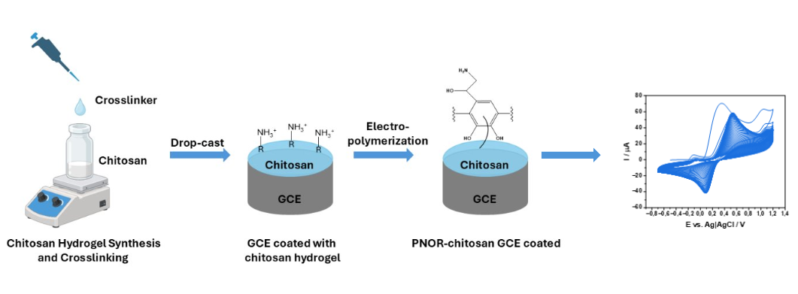
Schematic preparation of an electrode with a surface coated with chitosan and polynorepinephrine.

References:
[1] A. Smułka, M. Cieślik, A. Olejnik, A. Zieliński, J. Ryl, T. Ossowski, Bioelectrochemistry, 161, 2025, 108804.
[2] A. Smułka, A. Olejnik, D. Zarzeczańska, A. Wcisło, J. Ryl, A. Zieliński, T. Ossowski, Electrochimica Acta 533, 2025, 146541.

Acknowledgement
Research funded by NCN OPUS „Electrochemical memristive systems based on the electrode-polymer interface” 2025/57/B/ST11/02010

