Design and Characterization of Ruddlesden-Popper La₂NiO_{4+δ} Thin-Film Oxide Electrodes for Intermediate-Temperature Solid Oxide Cells
Bartłomiej Lemieszekª, Piotr Jasińskiª, Sebastian Molinª
ª Advanced Materials Centre, Faculty of Electronics, Telecommunications and Informatics, Gdańsk University of Technology,
ul. G. Narutowicza 11/12, 80-233 Gdańsk, Poland
Bartlomiej.lemieszek@pg.edu.pl

Cobalt-free alternative materials suitable for use as efficient oxygen electrode catalysts are highly desirable in solid oxide cell technology. Reducing or eliminating cobalt can significantly lower cell and stack production costs, while also decreasing dependence on a critical raw material that is subject to considerable market price fluctuations, particularly due to its extensive use in battery applications.
Among cobalt-free materials, praseodymium oxide appears to be a promising alternative, as it can exhibit very low polarization resistance values, around 20 mΩ·cm² at 600 °C [1], [2]. However, the relatively high cost of praseodymium also limits its broader application, and its use is therefore commonly restricted to that of an additive to a base electrode material.
Another interesting class of materials is represented by Ruddlesden–Popper oxides, which have demonstrated promising electrochemical performance in the intermediate-temperature range, with polarization resistance values below 1 Ω·cm² at 600 °C. Within this family, La₂NiO_{4+δ} (LNO), is particularly attractive due to its high electronic conductivity, on the order of 90 S·cm⁻¹ at 650 °C, and ionic conductivity of 0.013-0.015 S·cm⁻¹ at 700 °C [3].
In this work, a thin-film spin-coating technique was employed to fabricate oxygen electrode layers with thicknesses below 1 µm. The effect of annealing temperature on the electrochemical performance of LNO was investigated. It was demonstrated that applying a low sintering temperature of 600 °C enables optimal electrochemical performance, yielding low polarization resistance values below 0.5 Ω cm² at 600 °C. Furthermore, electrical conductivity measurements performed using the van der Pauw technique indicate that the conduction mechanism of the material changes as a function of the sintering temperature.
Overall, the results demonstrate that LNO is an effective and promising cobalt-free alternative to commonly used oxygen electrode materials such as LSC (La_{1-x}Sr_{x}CoO_{3-δ}) and LSCF (La_{1-x}Sr_{x}Co_{1-y}Fe_{y}O_{3-δ}) for intermediate-temperature solid oxide cells.

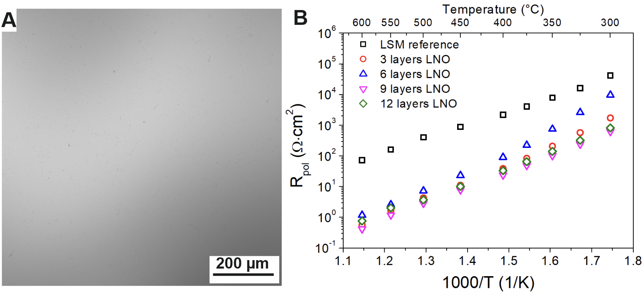
Figure 1.Surface of the LNO electrode deposited on the CGO substrate (A) and determined R_{pol} values in the temperature range of 600 -300 °C (B).
References:
[1] C. Nicollet, A. Flura, V. Vibhu, A. Rougier, J. M. Bassat, and J. C. Grenier, “An innovative efficient oxygen electrode for SOFC: Pr6O11 infiltrated into Gd-doped ceria backbone,” Int. J. Hydrogen Energy, vol. 41, no. 34, pp. 15538–15544, 2016, doi: 10.1016/j.ijhydene.2016.04.024.
[2] B. Lemieszek et al., “Unveiling the potential of praseodymium oxide as efficient oxygen electrode for low-temperature solid oxide cell applications,” Chem. Eng. J., vol. 531, p. 173949, 2026, doi: 10.1016/j.cej.2026.173949.
[3] M. A. Morales-Zapata, A. Larrea, and M. A. Laguna-Bercero, “Lanthanide nickelates for their application on Solid Oxide Cells,” Electrochim. Acta, vol. 444, no. January, p. 141970, 2023, doi: 10.1016/j.electacta.2023.141970.

