Brownmillerite-type oxide anode for Li-ion batteries

Wiktor Kępiński^{1,2}, Sandra Sajeev¹, Monika Srivastava¹, Damian Kowalski¹
¹ Faculty of Chemistry, University of Warsaw, Zwirki i Wigury 101, 02-089 Warsaw, Poland
² The MISMaP College, University of Warsaw, Stefana Banacha 2C, 02-087 Warsaw
w.kepinski@student.uw.edu.pl

Brownmillerite-type oxide having a general formula of A₂BB’O₅ is an oxygen-deficiency-ordered perovskite-like material typically used for the Oxygen Evolution Reaction (OER) in water splitting and metal-air batteries. [1,2] Recent reports demonstrate the capability of A₂BB’O₅ to store a charge in the classic configuration of a lithium-ion battery [3,4], giving a potential window for graphite electrode substitution, which is limited by its theoretical capacity (372 mAhg⁻¹) vs. Ca₂Fe₂O₅ (394,4−591,6 mAhg⁻¹). An analogous mixed oxide, Ca₂Co₂O₅, has been reported to exhibit enhanced electrochemical performance [3]. In this work, cobalt-substituted Brownmillerite-type Ca₂Fe_{2−x}Co_{x}O₅, where x = 0, 0.25, 0.5, 0.75, and 1 was synthesized via the sol–gel method and studied as positive electrode material in classic Li-ion battery, including discharge-charge performance, rate capability, and cycling stability. The X-ray diffraction study revealed the presence of Brownmillerite-type crystallographic structure for all B-substituted oxides, presented in Fig. 1a. All compounds exhibited similar trend of discharge–charge profiles, as shown in Fig. 1b. A characteristic ~50% capacity loss after the first discharge process is observed. This behavior is typically attributed to irreversible Li⁺ insertion and SEI layer formation accompanying the conversion reaction [4]. Raman spectroscopy was used to further investigate the formation of the SEI layer and the reactions occurring during battery operation. The Ca₂Fe_{2−x}Co_{x}O₅ compounds exhibited discharging specific capacity of 833-947 mAhg⁻¹ and 348-386 mAhg⁻¹ in the first and second cycles, respectively. Cobalt substitution has a little effect on the electrochemical performance of Ca₂Fe₂O₅ in terms of specific capacity values and much more pronounced effect on cycling stability. The results will be discussed in view of possible applications of Brownmillerite-type oxides in the battery systems.

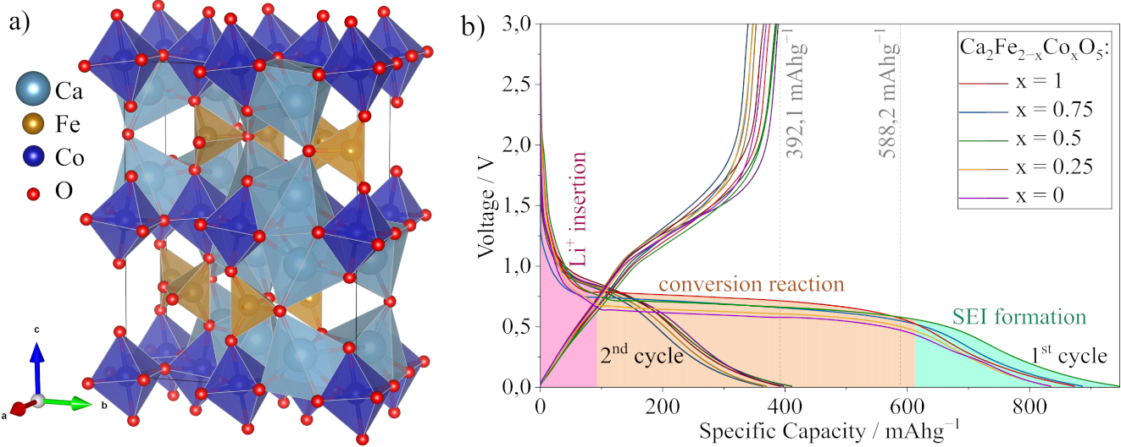
Figure 1. (a) Crystallographic structure of Brownmillerite-type Ca₂FeCoO₅ having a 57 Pbcm symmetry [5], (b) the discharge-charge profiles for Ca₂Fe_{2−x}Co_{x}O₅, where x = 0, 0.25, 0.5, 0.75, and 1 for first and second cycles.

References:
[1] E. Tsuji, T. Motohashi, H. Noda, D. Kowalski, et al., ChemSusChem 2010 10 (14), 2864.
[2] D. Kowalski, H. Kiuchi, T. Motohashi, Y. Aoki, and H. Habazaki, ACS Applied Materials and Interfaces 2019 11 (32), 28823.
[3] N. Sharma, K. M. Shaju, G. V. Subba Rao, and B. V. R. Chowdari, Electrochimica Acta 2004 49 (7), 1035.
[4] S. K. Sundriyal, and Y. Sharma, Applied Surface Science 2021 560, 150055.
[5] F. Ramezanipour, J. E. Greedan, A. P. Grosvenor, et al., Chemistry of Materials 2010 22 (21), 6008.

