LSMN double perovskite for Na-CO₂ battery application

Sandra Sajeev, ª Monika Srivastava,ª Yoshitaka Aoki,^{b} Damian Kowalski ª
^{a)} Faculty of Chemistry, University of Warsaw, Zwirki i Wigury 101, 02-089 Warsaw, Poland
^{b)} Faculty of Engineering, Hokkaido University, Kita-Ku Kita 13, Jo Nishi 8, Sapporo 060-8628, Hokkaido, Japan
s.kannachanpurakkal-sajeev-kumar@uw.edu.pl

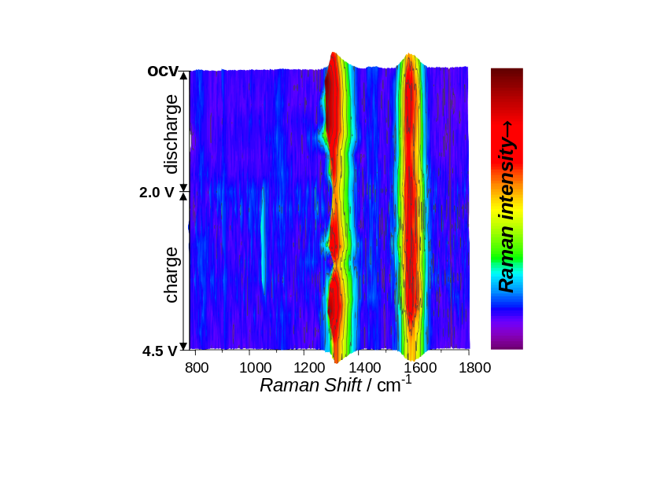
Rechargeable sodium-carbon dioxide (Na-CO₂) batteries have been proposed as a promising approach for CO₂ utilization that can simultaneously reduce CO₂ and generate electricity. However, they suffer from several practical limitations, including sluggish CO₂ reduction and evolution kinetics and poor cycling stability. In this work, nickel-substituted perovskite oxides, La_{0.7}Sr_{0.3}Mn_{1-x}Ni_{x}O₃ (x = 0, 0.1, 0.3, and 0.5), were employed as catalysts in a Na-CO₂ battery operating with 1 mol.dm⁻³ sodium perchlorate (NaClO₄) in tetraethylene glycol dimethyl ether (TEGDME) electrolyte. The La_{0.7}Sr_{0.3}Mn_{0.9}Ni_{0.1} electrode showed enhanced electrocatalytic activity, with improved specific capacity and stable cycle performance. In-situ Raman spectroscopy reveals the details on formation of the major discharge products, decomposed at relatively low charging potential due to effective electron transfer at the cathode. Substitution of Mn with Ni in La_{0.7}Sr_{0.3}Mn_{0.9}Ni_{0.1}O₃ led to enhanced charge-transfer kinetics due to a high surface population of low valence state B site ions (Mn³⁺). This study highlights Ni-substituted manganite perovskites as efficient electrocatalysts for high-performance Na-CO₂ batteries.
(b)
(a)

Figure a) Scheme of Na-CO₂ battery with La_{0.7}Sr_{0.3}Mn_{1-x}Ni_{x}O₃ catalyst (LSMN) in the cathode, b) in-situ Raman spectrum of a Na-CO₂ battery composed of the La_{0.7}Sr_{0.3}Mn_{0.5}Ni_{0.5} catalyst.
References
[1] S. Sajeev, M. Vincent, P. Garbacz, M. Strawski, C. Zhu, Y. Aoki, and D. Kowalski, ‘’ The role of Ni substitution in manganite perovskite Li-O₂ battery’’, RSC Applied Interfaces. 2025, 2, 1051.
[2] S. Sajeev, P. Henkiel, M. Srivastava, S. Srinivasan, K. Wang, E. Kowalska, and D. Kowalski, “Lithium-ion storage capability of P25, ST01, FP6 and isolated phases of anatase and rutile”, Electrochimica Acta. 2025, 544, 147650.
[3] M. Vincent, D. Kowalski, In-Situ Raman Spectroscopy of Li⁺ and Na⁺ storage in Anodic TiO₂ Nanotubes: Implications for Battery Design. ACS Appl. Nano Mater. 2023, 6, 8, 6528-6537.

