Investigation and Validation of a 3-Electrode Measurement Methodology for Fuel Electrode Characterization in Solid Oxide Electrolysis Cells
Md Shoriful Islam, Piotr Jasiński
Department of Functional Materials Engineering, Faculty of Electronics, Telecommunication and Informatics, Gdańsk University of Technology, Poland
Email: md.shoriful.islam@pg.edu.pl

Abstract:

Solid oxide electrolysis cells (SOECs) are highly promising for efficient hydrogen production through high-temperature steam electrolysis. However, conventional 2-electrode electrochemical impedance spectroscopy (EIS) cannot isolate individual electrode contributions, limiting the understanding of fuel electrode degradation and activation under realistic operating conditions. In this work, a 3-electrode EIS methodology was systematically developed and validated for the characterization of fuel electrodes in symmetric SOECs at 700 ℃. 2-electrode symmetric cells and 3-electrode configurations under anodic and cathodic DC polarization were also investigated. Symmetric Pt-Pt, Ni-Ni, and asymmetric Ni-Pt cells were examined under 3-80% H₂O atmospheres with DC biases of 0-50 mV. Validation results confirmed excellent agreement between symmetric and isolated half-cell measurements, demonstrating accurate reference electrode positioning and reliable electrode separation. Application of the methodology revealed a dependence of Ni/YSZ polarization resistance on steam concentration. Under anodic DC bias, the Ni fuel electrode showed significant activation, achieving up to 54% reduction in polarization resistance due to enhanced oxygen vacancy generation and removal of surface hydroxyl species. In contrast, cathodic polarization caused severe degradation, particularly at high steam concentrations, resulting from oxygen ion accumulation and hydroxyl passivation. A maximum five-fold asymmetry between anodic and cathodic electrode responses was observed, which remains completely hidden in conventional two-electrode measurements. The proposed 3-electrode methodology provides critical insight into electrode-specific mechanisms in SOECs and offers a powerful approach for the rational design and optimization of advanced fuel electrode materials.

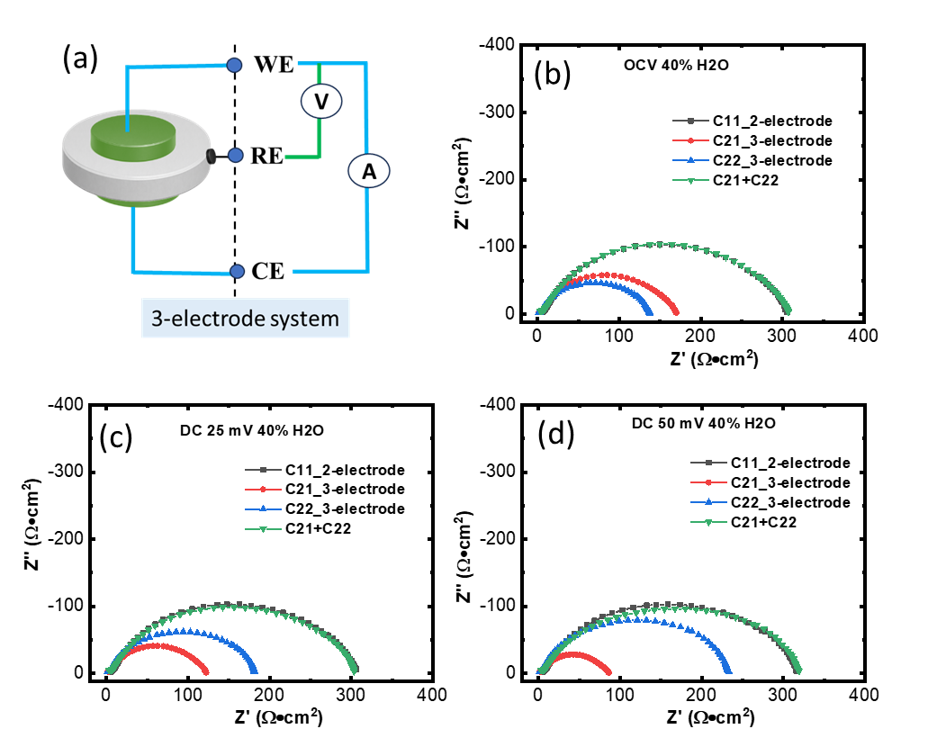

Fig. (a) Schematic of cell configuration, 2-electrode and 3-electrode measurement under (b) OCV, (c) DC bias 25 mV, and (d) DC Bias 50mV under 40% H₂O balanced by H₂ at 700 ℃.

