Electrochemical Ammonia Oxidation for Ammonia Remediation: in situ XAS investigations of Pd catalysts.

Keziah Langdon, Peter Wells, Richard Wills and Andrea Russell
University of Southampton
University Road, Southampton, SO17 1BJ
kll1g20@soton.ac.uk

Background: Liquid ‘hydrogen carriers’, such as ammonia, can be used to supply hydrogen for fuel cells with Pd-based materials a possible catalyst for these systems. [1,2] Trace ammonia still present in the H₂ feed causes significant degradation of fuel cell performance. One strategy to remediate this ammonia involves having an anode catalyst (e.g. Palladium) that can react with NH₃ (e.g. through ammonia oxidation) to remove it from the system.

Aims and Objectives: Investigations into speciation of Pd over hydrogen and ammonia oxidation by carrying out in situ XAS measurements during analogous voltametric investigations assessing the evolution of the Pd structure (hydride vs. nitride) at different potentials.
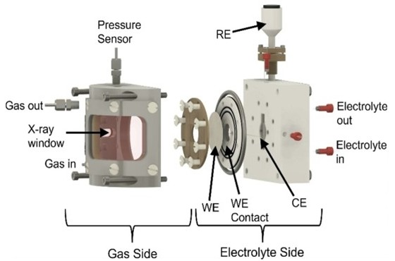
Methods: Initial electrochemical experiments carried out in three electrode cell with Pd/C material dropcast onto a rotating disc electrode with SCE reference and Pt counter. Utilised spectro-electrochemical X-ray absorption spectroscopy (SPEC-XAS) cell (Figure 1) developed by our group at B18 at Diamond Light Source. [2] Allowed analogous XAS and electrochemical measurements to be acquired to assess changes in structure of Pd.

Results: Our studies have shown that Pd catalysts can be used to electrochemically oxidise ammonia and this functionality could be able to remediate trace amounts of ammonia in a hydrogen gas feed. We have also shown that these same catalysts can also reduce nitrate either produced as a by product of AOR or when nitrate added to the system (Figure 2a). Initial in situ XAS results show the Pd retains metallic character in air after cycling in alkaline electrolyte under gaseous H₂ and NH₃ (Figure 2b). This indicates a structural change in the Pd stopping the formation of surface PdO through reaction of O₂ in the air. Data at several potential holds under various gaseous conditions were also collected of the Pd to assess structural changes over these reactions.
Figure 1. Exploded view of the cell showing the working electrode (WE), counter electrode (CE), reference electrode (RE) placement and large Kapton X-ray windows.
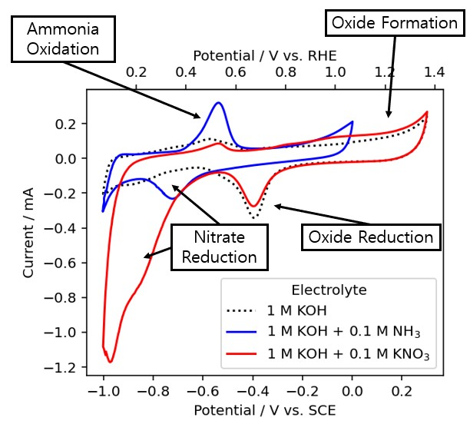
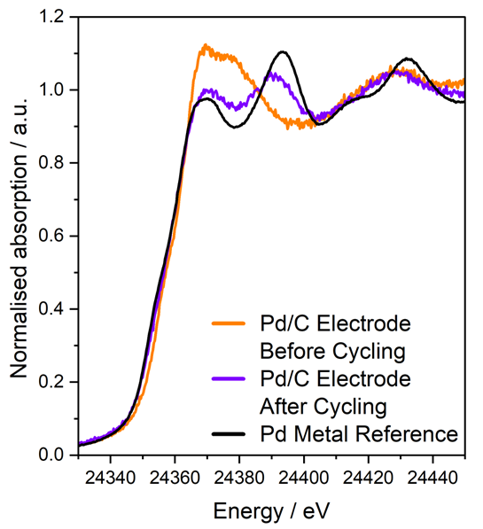
(b)
(a)
Figure 2.(a) Pd/C CVs 20 mV/s in various electrolytes. (b) Pd K edge XANES showing Pd/C Electrode before and after cycling in SPEC-XAS Cell under H₂ and NH₃ gaseous conditions compared to Pd foil.

Conclusions: Structural changes occur to the Pd surface after electrochemical measurements using NH₃ are carried out which do not entirely revert once Pd is exposed to air. This indicates that a possible interstitial structure which remains stable in air is formed.

References: [1] J. C. Ganley et al., Catalysis Letters, 2004, 96, 117-122.; [2] M. Shao, Journal of Power Sources, 2011, 196, 2433-2444.; [3] C. Sherwin et al., ChemCatChem, 2024, 16, e202400221.

