Unravelling the Dynamics of Electrochemical Interfaces with Advanced In-situ and Operando Characterization Techniques

Yaolin Xu
Department of Applied Physics, School of Science, Aalto University
Puumiehenkuja 2, 02150 Espoo, Finland
Email: yaolin.xu@aalto.fi

Understanding in detail the dynamic morphological and chemical evolutions of electrochemical materials and interfaces is crucial for the rational design of electrochemical energy devices but has remains tremendously challenging.¹ Advanced X-ray and electron spectroscopy and microscopy are powerful for unveiling the interfacial dynamics and to deepen mechanistic understanding of lithium-based batteries. For instance, cryogenic electron microscopy, such as FIB/SEM & cryo-TEM and tomography, has emerged as a useful tool for ex situ visualizing the native states of sensitive lithium metal and interfaces on the nanoscale. Operando & in situ X-ray spectroscopy (e.g., XPS and XAS) and microscopy (e.g., XCT) are particularly useful for monitoring the dynamic evolution of chemistry and morphology of battery materials and interfaces during operation.

Here I will present the structural and interfacial changes to the active materials and electrodes in lithium batteries²⁻³ and mechanistic understandings of lithium deposition and solid-electrolyte-interphase (SEI) formation in lithium metal batteries⁴⁻⁶ obtained with these advanced operando and in-situ characterization techniques. For instance, we utilized operando XAS to investigate the crystallographic structure evolution of LiNi_{0.5}Mn_{0.3}Co_{0.2}O₂ cathodes under different cycling protocols of commercial lithium-ion batteries.² We utilized in-situ XCT for visualizing the morphological evolution of lithium metal electrodes in solid-state lithium metal batteries using poly(ethylene oxide) (PEO)-based solid polymer electrolyte (SPE).⁴ Moreover, we visualized on nanoscale the polymeric nature and self-healing property of operando polymerized SEI on lithium deposits with in-situ electrochemical atomic force microscopy (EC-AFM), cryogenic transmission electron microscopy and tomography (cryo-TEM & cryo-ET), which facilitates the growth of micrometer-sized and low-tortuosity lithium deposits and high lithium stripping efficiency.⁵

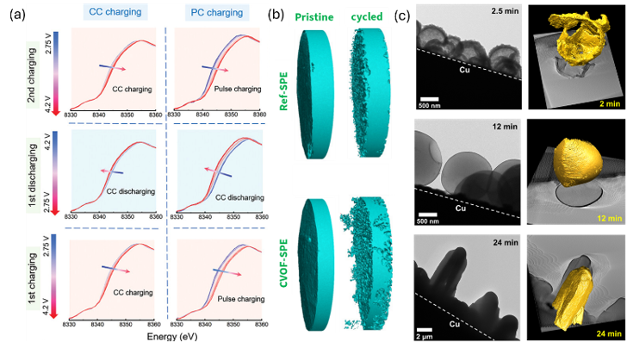

Figure 1: a) Operando Ni K-edge XAS spectroscopy of LiNi_{0.5}Mn_{0.3}Co_{0.2}O₂ cathode.² b) In situ XCT of Li electrodes.⁴ c) cryo-TEM and cryo-ET of Li deposits under a polymerized SEI.⁵

References:
¹ Adv. Energy Mater. 2022, 12, 2200398.
² Adv. Energy Mater. 2024, 14, 2400190.
³ Energy Storage Mater. 2025, 80, 104441.
⁴ J. Mater. Chem. A 2024, 12, 1694-1702.
⁵ Cell Rep. Phys. Sci. 2022, 3,101057.
⁶ ACS Energy Lett. 2021, 6, 1719.

