Ni-Cu Hollow Nanocages as Active Catalysts for Ammonia Oxidation

Abraham Castilla-Silvestreª, Sergio Díaz-Coello^{a,b}, Julia Kunze-Liebhäuser^{b}, Rubén Rizo^{c}, Elena Pastorª

ª Institute of Materials and Nanotechnology, Department of Chemistry, University of La Laguna, PO 456, 38206, San Cristóbal de La Laguna, Spain
^{b} Department of Physical Chemistry, University of Innsbruck, Innrain 52c, Innsbruck, Austria
^{c} Institute of Electrochemistry, University of Alicante, Alicante E-03080, Spain
epastor@ull.edu.es

Carbon-based energy sources - such as coal, oil, and natural gas - have led to a substantial increase in CO₂ emissions, contributing significantly to climate change and environmental pollution. To mitigate these impacts, transitioning to sustainable energy carriers like hydrogen is essential. However, hydrogen storage typically requires high-pressure conditions, posing logistics challenges and increasing operational costs. In this context, ammonia has emerged as a promising alternative hydrogen carrier due to its well-established infrastructure for storage and transport. Furthermore, ammonia can be directly utilized in fuel cells, generating energy by coupling the ammonia oxidation reaction (AOR) with the oxygen reduction reactions (ORR). Nevertheless, the AOR involves complex reaction kinetics, and current catalysts often suffer from limited stability and durability.
To address these challenges, Cu₂O nanocubes were employed as templates to synthesize Ni(OH)₂@Cu₂O hollow nanocages. The physicochemical characterization of the nanoparticles was carried out using X-ray diffraction (XRD), scanning electron microscopy (SEM) coupled with energy-dispersive X-ray spectroscopy (EDX), and X-ray photoelectron spectroscopy (XPS).
The synthesized nanocages exhibited high catalytic activity toward the AOR, along with excellent stability during long-term electrochemical measurements. Differential electrochemical mass spectrometry (DEMS) was employed to monitor the volatile species generated during the AOR. Notably, the nanocages preserved their original morphology throughout the electrochemical experiments. The combination of structural integrity and enhanced catalytic performance highlights the potential of these nanocages as durable and efficient electrode materials for direct ammonia fuel cells.

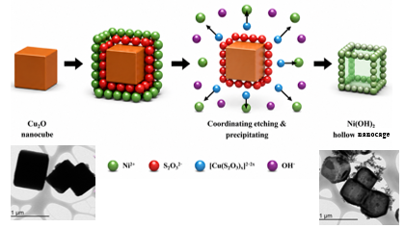

Figure 1. Synthesis of Ni(OH)₂@Cu₂O

Acknowledgement
This work was supported by project PID2023-1507070B-100 funded by MCIN/AEI/10.13039/501100011033 and the Cabildo de Tenerife-TALENTUM program, exp. 2024/0002355. A. C. C. S. acknowledges ACIISI (Agencia Canaria de Investigación, Innovación y Sociedad de la Información, Consejería de Universidades, Ciencia e Innovación y Cultura) and the European Social Fund Plus (ESF+) (Operative Integrated Program of Canary Islands 2021–2027, Area 3 Priority Theme 74 (85%)) for the predoctoral contract FPI2024010100.

