In situ EC-SERS at the polarized liquid-liquid interface

Grégoire Herzog, Madjid Tarabet, Manuel Dossot
Université de Lorraine, CNRS, LCPME, F-54000 Nancy, France
gregoire.herzog@cnrs.fr

Electrocatalysis at polarized liquid-liquid interface (LLI) is an emerging field of research [1]. Catalytic nanomaterials and supramolecular films can be assembled at the polarized LLI. Such biphasic systems allow (i) direct probing of the electrocatalytic activity of the catalytic materials free from the influence of an underlying support, and (ii) the reactants can be separated according to their lipophilicity. Furthermore, we have used an electrified LLI that mimicked in vivo cytochrome c (Cyt c) interactions with cell membranes [2]. We observed interfacial electron transfer between an organic electron donor and O₂, electrocatalyzed by Cyt c. This interfacial reaction requires partial Cyt c unfolding, mimicking its in vivo peroxidase activity, demonstrating the usefulness of electrified LLI for the investigation of biological objects. Metallic nanomaterials may also be plasmonically active and serve as substrates for Surface Enhanced Raman Spectroscopy (SERS).

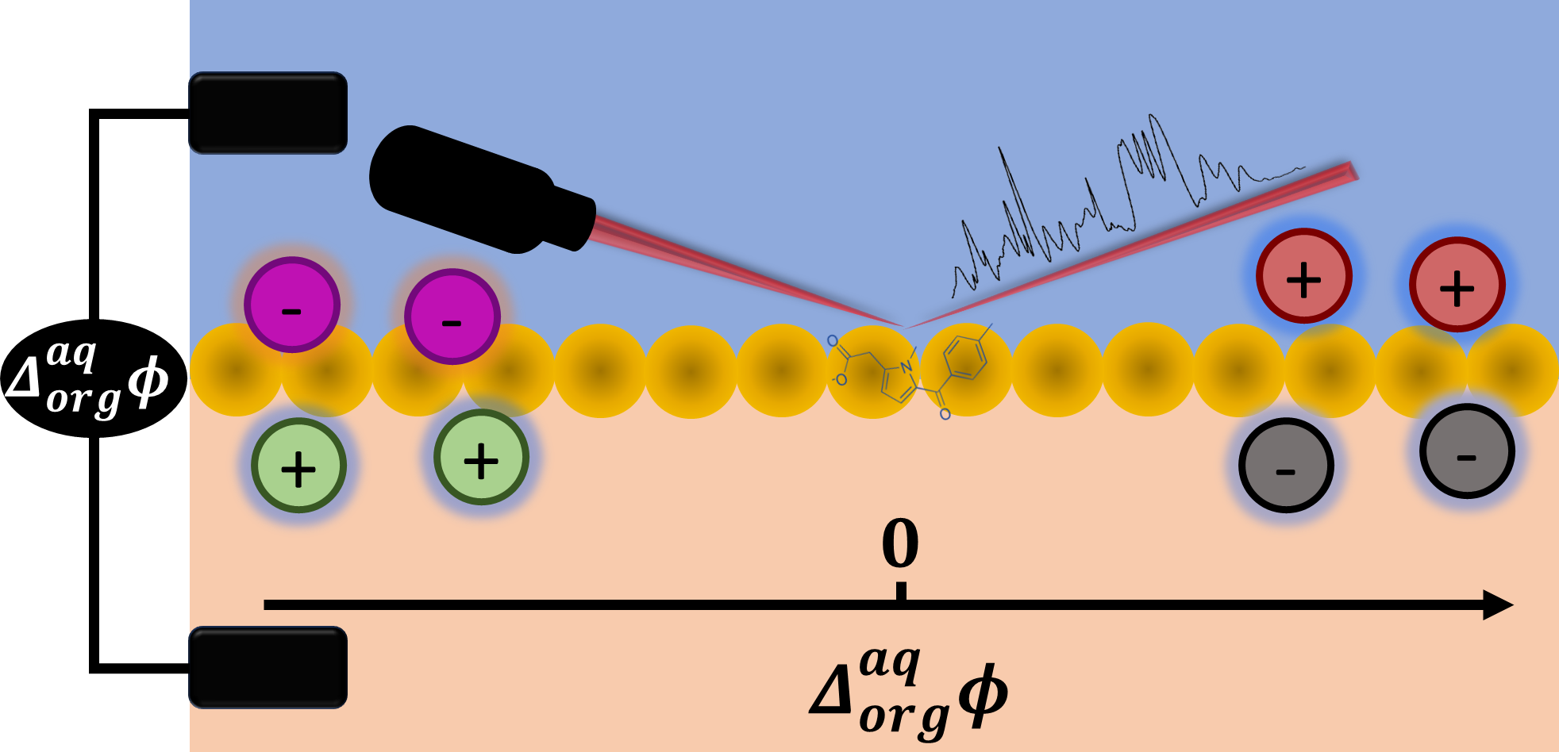
Figure 1: Schematic representation of EC-SERS experiments at the polarized LLI.

Gold nanoparticles (AuNPs) have been assembled at the polarized LLI for SERS under electrochemical control (EC-SERS) [3,4]. Plasmonic soft interfaces provide opportunities to create highly reproducible, scalable and low-cost EC-SERS substrate with high Raman enhancement factor. Recently, we have investigated the use of AuNP films floating at a water | trifluorotoluene interface for EC-SERS of organic molecules, highlighting the impact of interfacial polarization [3,4]. EC-SERS of several organic ions were recorded at varying interfacial potential differences. The ions selected include a model cation, methylene blue, and two pharmaceutic compounds: tolmetin, an anionic nonsteroidal anti-inflammatory drug, and norfloxacin, a cation from the class of fluoroquinolone antibiotics. The application of the interfacial potential difference, modifies the distribution of ions on either side of the interface, and thus impacting the SERS signal of target molecules.

[1] A. Gamero-Quijano, G. Herzog, P. Peljo, M.D. Scanlon, Curr. Opin. Electrochem. 38 (2023) 101212.
[2] A. Gamero-Quijano, S. Bhattacharya, P.-A. Cazade, A.F. Molina-Osorio, C. Beecher, A. Djeghader, T. Soulimane, M. Dossot, D. Thompson, G. Herzog, M.D. Scanlon, Sci. Adv. 7 (2021) eabg4119.
[3] M. Tarabet, N.R. Muñoz, M.D. Scanlon, G. Herzog, M. Dossot, J. Phys. Chem. C 128 (2024) 7936–7947.
[4] M. Tarabet, Y. Zou, D.S.M. Shukri, N. Yahaya, M. Dossot, G. Herzog, Phys. Chem. Chem. Phys. 28 (2026) 3236–3244.

