Determination of Psilocybin at the ITIES: How Does the Extraction Method Affect the Analysis?

Emilia Paszkowska^{1,2}, Sylwia Budzyńska³, Łukasz Półtorak¹, Konrad Rudnicki¹
¹Electrochemisty@Soft Interfaces Team, Department of Inorganic and Analytical Chemistry,
University of Lodz, Tamka 12, 91-403 Łódź, Poland
²BioMedChem Doctoral School of the University of Lodz and Institutes of Polish Academy of Sciences, University of Lodz, Jana Matejki 21/23, 90-237 Łódź, Poland
³Poznań University of Life Sciences, Faculty of Forestry and Wood Technology,
Wojska Polskiego 75, 60-625 Poznań, Poland
emilia.powalka@edu.uni.lodz.pl

Psilocybin, a potent psychoactive indole alkaloid produced by Psilocybe mushrooms¹, is currently gaining significant clinical and regulatory attention. Consequently, efficient methods for its determination are essential. While current chromatographic techniques offer excellent sensitivity, their reliance on expensive infrastructure and lengthy procedures underscores the necessity for novel, low-cost analytical tools suitable for rapid screening.
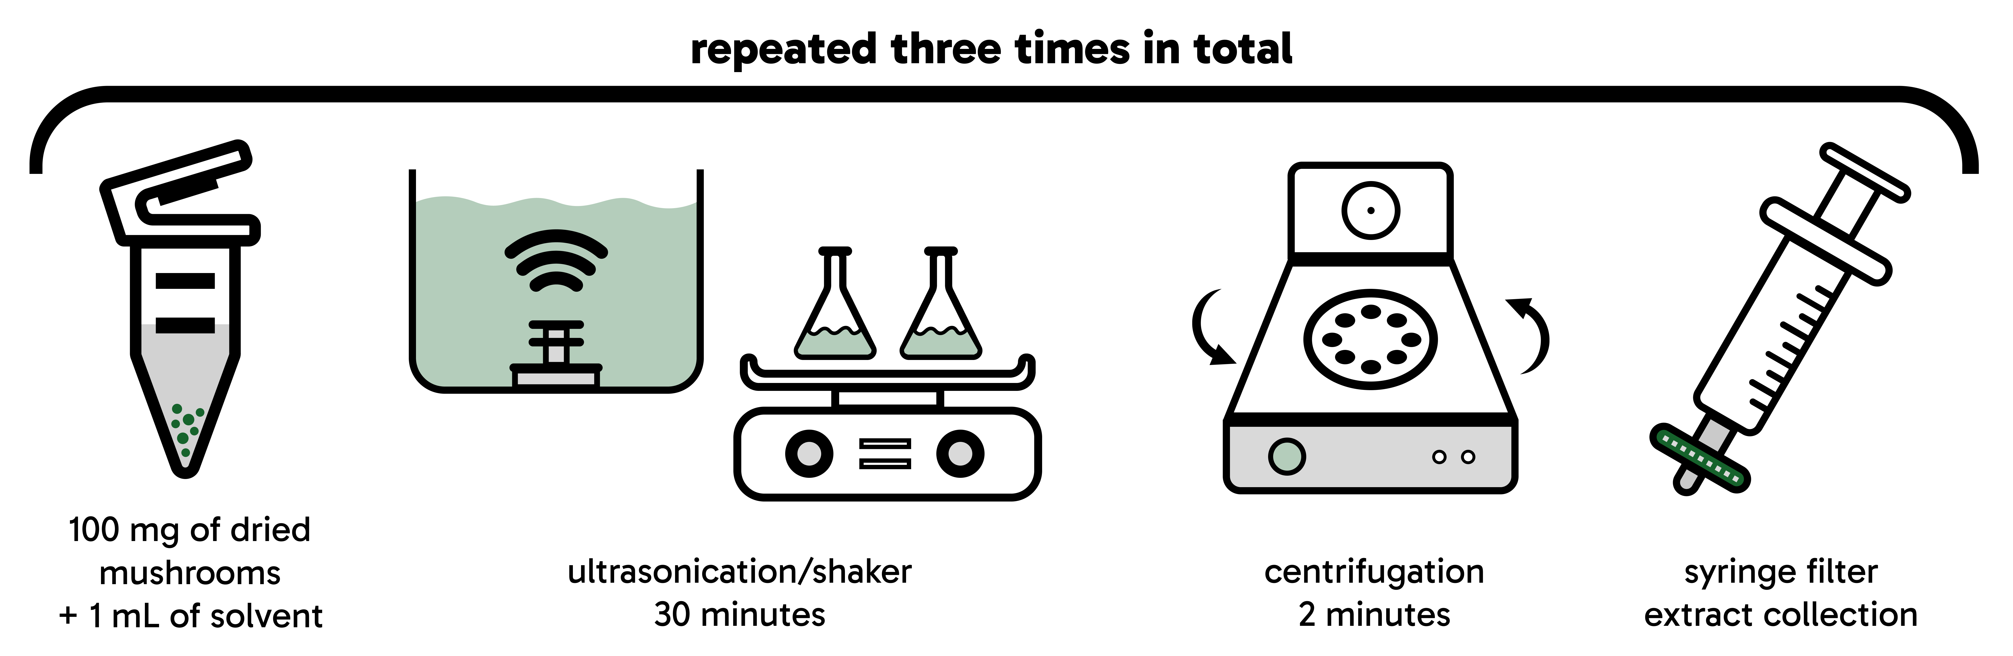

Fig. 1: Extraction procedure scheme.

In this study, a novel electrochemical methodology utilizing the interface between two immiscible electrolyte solutions (ITIES) was developed for the determination of psilocybin. Compared to traditional solid electrodes, ITIES offers significant advantages, including a defect-free, renewable liquid-liquid interface, inherent resistance to surface fouling by complex biological matrices, and the capability of direct ion-transfer detection². The electrochemical behavior of psilocybin at the pristine liquid-liquid interface was systematically investigated across various aqueous phases using cyclic voltammetry (CV). Furthermore, differential pulse voltammetry (DPV) was employed to determine the relationship between the concentration of psilocybin in aqueous phase and the transfer peak current. To evaluate the analytical applicability of the proposed method, dried and mortar-ground Psilocybe cubensis mushroom samples were analyzed. The extraction procedure, schematically illustrated in Figure 1, involved comparing two solvent systems (pure methanol and a 1:1 mixture of methanol and 20 mM Li₂SO₄) and two agitation techniques (ultrasonic bath and mechanical shaker). Finally, the developed DPV procedure was successfully applied to quantify the psilocybin content across all prepared extracts.

References
¹J. van Amsterdam, A. Opperhuizen, W. van den Brink, Regulatory Toxicology and Pharmacology, 2011, 59,
423-429.
²H. D. Jetmore, E. S. Anupriya, T. J. Cress, M. Shen, Analytical Chemistry, 2022, 94, 16519-16527.

This research was financially supported by the National Science Center (NCN) in Krakow, Poland within the PRELUDIUM project (2025/57/N/ST4/02255).

