The electric double layer from a different perspective:
Study of the Pt-H₂O interface under ultrahigh vacuum conditions
Laurens P.M. de Jong, Irene M.N. Groot, Marc T.M. Koper
Leiden Institute of Chemistry, Universiteit Leiden
Einsteinweg 55, 2333 CC Leiden, the Netherlands
l.p.m.de.jong@lic.leidenuniv.nl

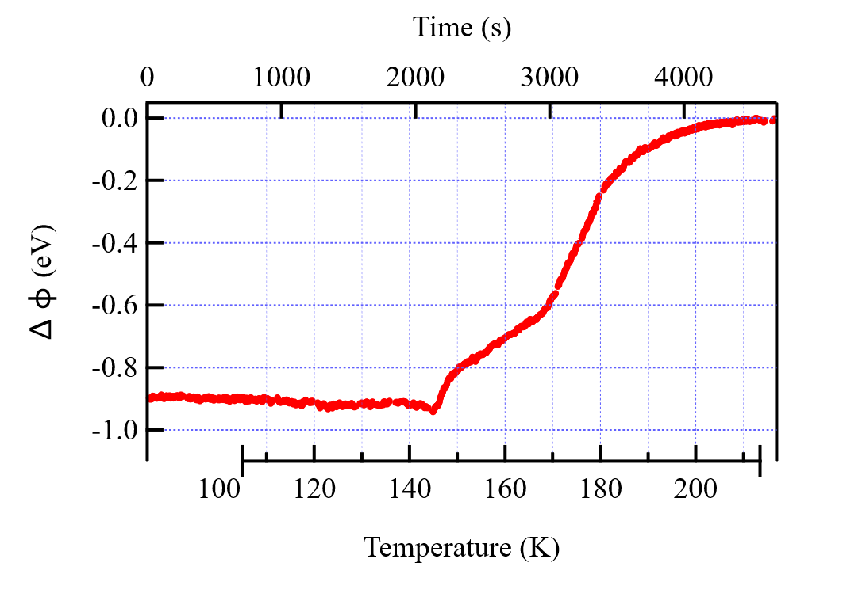
Accurately understanding the structure of the electrode-electrolyte interface is pivotal to elucidating the dynamics and mechanisms of electrochemical processes [1]. Many experimental electrochemical studies on Pt(111) show that the presence of cations, adsorbed hydrogen, and/or the surface structure significantly impact the structure of the electric double layer (EDL) [2]. The most widely used model to describe the EDL is the Gouy-Chapman (GC) model. However, in many cases, experimental results show significant deviations from GC theory [2, 3]. Recently, our group showed the direct relation between the work function (WF) and the potential of zero charge on stepped Pt surfaces, and how properly understanding this relationship can improve our understanding of the EDL [3].
Figure 1: Temperature-programmed Kelvin probe (TPKP) measurement of water on Pt(977), with a dosage of 3.5 Langmuir. The data is represented as ΔΦ compared to the highest measured work function at the end of the experiment, i.e., bare Pt.

By creating a UHV-based model of the EDL on Pt, we can study EDL dynamics from a different perspective and employ surface science techniques that are not possible under wet electrochemical conditions. Here, we present recent work in which we investigate changes in the WF due to the adsorption of water on single-crystalline Pt surfaces with different step densities, using temperature-programmed Kelvin probe (TPKP) measurements. In these TPKP measurements, we continuously measure WF changes of H₂O-covered Pt surfaces whilst controlling the temperature. With increasing temperature, the water desorbs from the Pt surface, leading to an increase in the WF. Because multilayer, full-monolayer (step and terrace), and step-edge adsorbed water molecules have distinct desorption temperatures [4], we can clearly distinguish WF changes across different types and amounts of surface coverage. This allows us to investigate the (difference in) orientation of water molecules in the first or second adsorption layer and to identify the influence of step and terrace sites upon the adsorption dynamics.
These new WF measurements on the UHV-based Pt-H₂O model interface bridge the gap between surface science and wet electrochemistry. Whereas in electrochemistry one can change the (surface) potential, thereby altering the nature and structure of adsorbates at the electrode surface, we can modify the nature, structure, and number of adsorbates and measure the subsequent change in the surface potential, thereby linking the two fields.
This technique can, furthermore, be employed to study the impact of co-adsorbed oxygen, cations, anions, and other adsorbates on adsorbed H₂O and the resulting changes in the WF, which translate directly into the experimentally observed PZC.

References
[1] Ojha, K., Doblhoff-Dier, K., & Koper, M. T. M. (2022). Proceedings of the National Academy of Sciences, 119(3)
[2] Doblhoff-Dier, K., & Koper, M. T. M. (2023). Current Opinion in Electrochemistry, 39, 101258.
[3] Fröhlich, N. L., Liu, J., Ojha, K., Hagopian, A., Doblhoff-Dier, K., & Koper, M. T. M. (2026). Nature Chemistry, 1-8.
[4] den Dunnen, A., van der Niet, M. J., Badan, C., Koper, M. T., & Juurlink, L. B. F. (2015). Physical Chemistry Chemical Physics, 17(13), 8530-8537.

