Development of Membrane-Free Electrochemical Flow Reactor with Vertically Eccentric Non-Coaxial Electrodes for Impure Water Electrolysis

Padinjarethil Vishnu, Manoj Kumar Tripathi and Ijjada Mahesh
Department of Chemical Engineering, Indian Institute of Science Education and Research (IISER) Bhopal; Bhopal, MP-462066, India.
vishnup23@iiserb.ac.in ; manojkt@iiserb.ac.in ; mahesh@iiserb.ac.in

Abstract

As global demand for green hydrogen increases, several research groups across the world are working to develop efficient and low cost approaches to produce green hydrogen. It is well known that the traditional water electrolyzers use ion-exchange membrane to separate the two product gases (H₂ and O₂) during electrolysis, and that these membranes can be of higher cost and can have limited life spans due to damage from using impure water sources in the electrolyzer. In this regard, this work reports on the design and development of a membrane-free flow water electrolyzer with vertically eccentric non coaxial electrodes to improve performance and stability of the generation of hydrogen. This electrolyzer design and electrode configuration helps in the confinement of produced hydrogen above the cathode and effective detachment of gas bubbles. This unique design allows for continuous flow of the electrolyte throughout the electrolyzer, reduces gas crossover and enhances efficient hydrogen generation. The performance of this electrolyzer with various inflow velocity of electrolytes were evaluated using different types of water (tap water, simulated brackish water, and conventional caustic electrolyte solution) to simulate real world operating conditions. Using chronoamperometric technique, it is observed that rates of current/hydrogen generation increase with increase in inflow velocity and stable operation for long periods of time (limited to the overall volume of the proposed electrolyzer). Furthermore, improved hydrogen generation at cathode and gas crossover elimination is achieved, which can be observed from the transparent nature of electrolyzer material. Additionally, computational simulations suggest that this design is more suitable for eliminating product gas crossover at low inflow velocities with improved hydrogen generation. It is observed that overall energy efficiency is significantly improved with the flow arrangement of the system. The research results indicate high potential for hydrogen generation from impure water and better oxygen supply to aquatic flora and fauna, when installed in flowing water bodies.
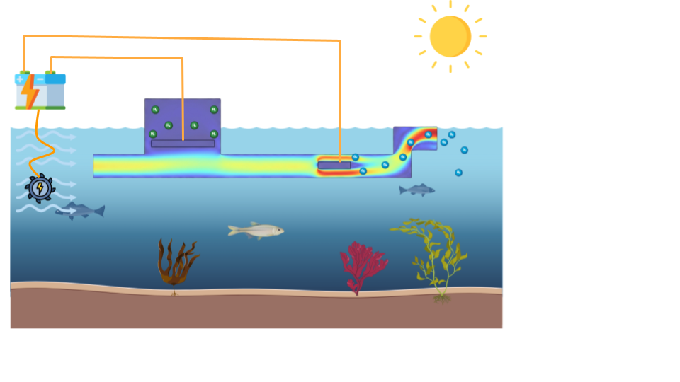
References

- Shukla, P., Singh, K., Tewari, P., & Gupta, P. (2012). Numerical simulation of flow electrolysers: Effect of obstacles. Electrochimica Acta, 79, 57–66.
- Hashemi, S. M. H., Karnakov, P., Hadikhani, P., Chinello, E., Litvinov, S., Moser, C., Koumoutsakos, P., & Psaltis, D. (2019). A versatile and membrane-less electrochemical reactor for the electrolysis of water and brine. Energy & Environmental Science, 12(5), 1592–1604.

