Ultra-robust recleanable SERS sensors
for studying the electrical double layer in nanogaps

Jeremy J Baumberg

Nanophotonics Centre, Cavendish Laboratory, University of Cambridge, Cambridge, CB3 0HE, UK
jjb12@cam.ac.uk

Sensing of trace analytes, or the detailed solvation at the molecule-metal interface which controls catalysis and battery electrochemistry, is challenging. Optical vibrational spectroscopies have huge potential, because they can be enhanced at nanostructured metal surfaces, but have been hard to control. In this keynote I will discuss a range of recent key advances that give robust, repeatable, and recleanable nanogap plasmonic sensors, as well as midIR metamaterials enabling real-time flow electrochemistry.

Over the last few years we have developed a simple colloidally-assembled nanoelectrode based on a monolayer of Au nanoparticles which have reliable robust 0.9nm gaps scaffolded by rigid cucurbituril molecules.^{1,2} The extreme light confinement generates surface-enhanced Raman scattering from trace analytes that is even visible to the eye, and is uniform and consistent allowing quantitative measurement. Crucially, as either nanofabricated or colloidally assembled SERS substrates always come with organic molecular contamination, we have developed a robust way to strip all molecules from the Au and then rescaffold the nanogaps to the same 0.9nm precision.^{2,3} This is used to preclean all samples for sensing, and can be repeated hundreds of times without sintering of the gaps, which is extremely unusual and is based on the peculiar chemistries of Au₂O₃ and AuCl.

We have explored how these can be used to directly study electrochemistry, as the precision nanogaps give highly repeatable SERS when potential is varied.^{4,5} This reveals strong forces on analytes in these geometries that can be used to separate them, and concentrate them in the gap, allowing an additional degree of analyte separation in situ. We show that unique signatures result from the potential induced reorientation and capture of analytes in their interactions with the electrical double layer. Finally we show how these advances lead to the realistic prospects for an intelligent toilet detecting hormones and neurotransmitters, and an optical nose measuring VOCs and environmental contaminants.⁶
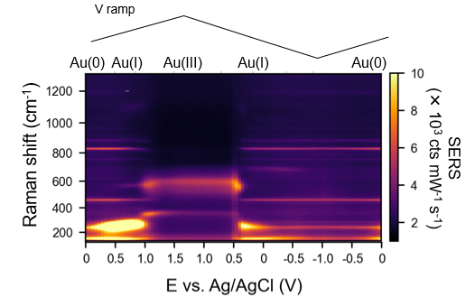

Fig 1: Spectro-electrochemical spectra as nanogaps are slowly oxidized and reduced, revealing all processes.

References:
¹ ACS Sensors (2023); Controlling atomic-scale.. cleaning…, 10.1021/acssensors.3c00967
² Nature Comm. (2024); In situ electrochemical..ultrathin SERS sensors, 10.1038/s41467-024-46097-y
³ Nature Chem (2025);Transient Au–Cl adlayers modulate…redox, 10.1038/s41557-025-01989-4
⁴ Small e07013 (2025);Tracking and controlling monolayer water …, 10.1002/smll.202507013
⁵ ACS Nano (2026); How electrochemical double layers manipulate molecule-metal interactions, in press
⁶ Science Advances 12, eaea1478 (2026);The optical nose: …, 10.1126/sciadv.aea1478

