Complete characterization of bi-functional OER/HER Co catalyst by operando WAXS and quasi-in-situ XPEEM/NEXAFS/XPS

Martha Y. Stando^{1,2}, Merel V. Rittel², Thomas Schmidt³, Mauricio Prieto³, Jakub Drnec¹, Peter Strasser²
¹European Synchrotron Radiation Facility, ID31 Beamline, 71 Av. Des Martyrs, 38000 Grenoble, France
² The Electrochemical Energy, Catalysis, and Materials Science Laboratory, Department of Chemistry, Technical University Berlin, Strasse des 17. Juni 124, 10623 Berlin, Germany
³Department of Chemical Physics, Fritz-Haber-Institute of the Max-Planck Society, Faradayweg 4-6, 14195 Berlin, Germany
martha.stando@esrf.fr

Recently, a novel Zn-H₂ system was proposed. This hybrid concept combines principles of Zn-based energy storage, analogous to Zn-air batteries, with decoupled electrolysis via OER and HER occurring on a bi-functional during charge and discharge respectively.¹ Operated in 6.9M KOH electrolyte, saturated with ZnO, gas separation is achieved by process design rather than presence of a membrane, mitigating gas crossover factors. The system is also well suited to dynamic operation required for intermittent wind and solar energy storage, unlike many conventional AEM water electrolyzers. Real-world application requires an efficient bi-functional catalyst stable over a wide potential range in highly alkaline conditions.
A Co catalyst synthesized on steel using a microwave-assisted solvothermal route (Co_{sol}) showed low OER/HER overpotentials when tested in 6.9M KOH. Furthermore, the excellent performance was retained over prolonged cycling in the presence of ZnO. To understand its superior performance relative to other Ni- and Co-based catalysts tested and the role of ZnO, operando and in situ synchrotron X-ray characterization was performed.
High energy X-rays (75 keV) at the ESRF ID31 beamline result in the ability to penetrate through cell casing and electrolyte, which in tandem with grazing-incidence geometry yields high quality information on the catalyst structure throughout operation in 6.9M KOH electrolyte with and without ZnO. Scanning through the catalyst layer height-wise with the 5 x 15 µm beam allows for evaluation of phase distribution throughout the sample. Operando wide angle X-ray scattering (WAXS) measurements (fig.1) revealed rapid oxidation of Co to Co(OH)₂ at 0.25V vs RHE, followed by further formation of CoOOH, the known Co active phase for OER in alkaline environments. Under cathodic polarization to −0.4 V vs RHE, CoOOH reduced to Co₃O₄ rather than reverting to Co or Co(OH)₂. In the presence of ZnO, Co oxidation was found to be initially reduced, yet both samples became highly oxidized throughout cycling. Furthermore, a potential reversible intercalation of Zn cations into a Fe₃O₄/CoFe₂O₄ spinel phase was noted.
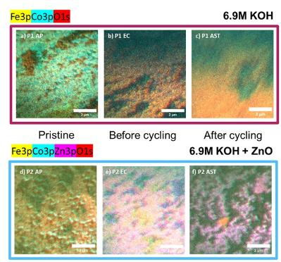
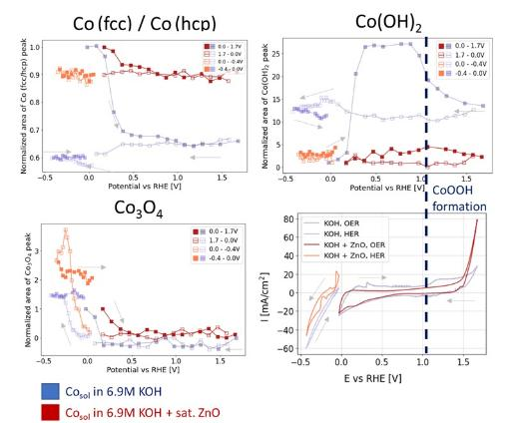
Quasi-in-situ experiments at BESSY II using the aberration corrected spectromicroscope, SMART, combined X-ray photoemission electron microscopy (XPEEM), near edge X-ray adsorption fine structure (NEXAFS), and X-ray photoelectron spectroscopy (XPS) to probe surface evolution before and after cycling without air exposure. In ZnO-containing electrolyte, Coₛₒₗ showed a uniform Zn layer extending 1 nm into the catalyst. Additionally, ZnO appeared to stabilize the surface structure, resulting in reduced morphological changes during cycling (fig.2).
Figure 2. XPEEM images of Co_{sol} acquired throughout electrochemical protocol.
Figure 1. Evolution of peak area of Co based phases as function of potential extracted from operando WAXS.

