Properties of Ce_{0.8}Hf_{0.1}Zr_{0.1}O₂ Thin Layers Prepared by Spray Pyrolysis Method
Maryam Mehdizade1 , Dimitrios Koukoulis2, Łukasz Gaweł3, Ahsanul Kabir2 ,Piotr Jasinski1, Vincenzo Esposito2, Sebastian Molin1
1 Advanced Materials Center, Faculty of Electronics, Telecommunications and Informatics, Gdansk University of Technology, 11/12 Narutowicza Street, 80-233 Gdansk, Poland
2 Department of Energy Conversion and Storage, Technical University of Denmark, Lyngby 2800 Kgs, Denmark
3 Department of Electrochemistry Corrosion and Materials Engineering, Gdansk University of Technology, 11/12 Narutowicza Street, 80-233 Gdansk, Poland
Maryam.mehdizade@pg.edu.pl

In the current research, Zr and Hf co-substituted ceria-based films with the chemical composition of Ce_{0.8}Zr_{0.1}Hf_{0.1}O₂ were produced using the spray pyrolysis method. The main goal of this work is to study the effects of Zr and Hf co-doping on the properties of the Ce-based defective oxides in the form of thin layer. For this purpose, the microstructure, phase structure, Raman spectra, oxidation state, and electromechanical and electrochemical properties of the deposited Ce_{0.8}Zr_{0.1}Hf_{0.1}O₂ layers were investigated. Prepared layers showed uniform and crack-free microstructure with grain size ≤ 40 nm. As-deposited and post-annealed samples exhibited fluorite cubic structure without any secondary phase, confirming formation of CeZrHfO solid solution. XPS results confirmed Ce has mixed 3+ and 4+ oxidation states, Zr has 4+ oxidation state, and Hf has mixed 2+ and 4+ oxidation states in Ce_{0.8}Zr_{0.1}Hf_{0.1}O₂ thin films. Ce_{0.8}Zr_{0.1}Hf_{0.1}O₂ thin film post-annealed at 800 C showed ionic conductivity value of 3.84 × 10⁻⁷ S/cm at room temperature and frequency of 100 Hz. Additionally, it illustrated electrostriction strain co-efficient of 2.8 × 10⁻¹⁷ and 3.7 × 10⁻¹⁸ at the frequencies of 10 and 100 Hz, respectively, which is higher than values reported for pure ceria pellets.
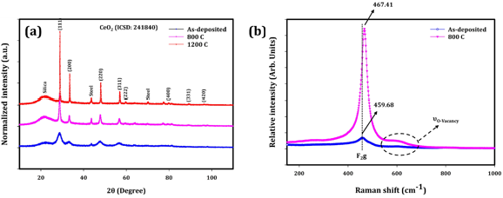
Figure 1. (a) XRD pattern and (b) Raman spectroscopy of Ce_{0.8}Zr_{0.1}Hf_{0.1}O₂ thin layers before and after post-annealing.

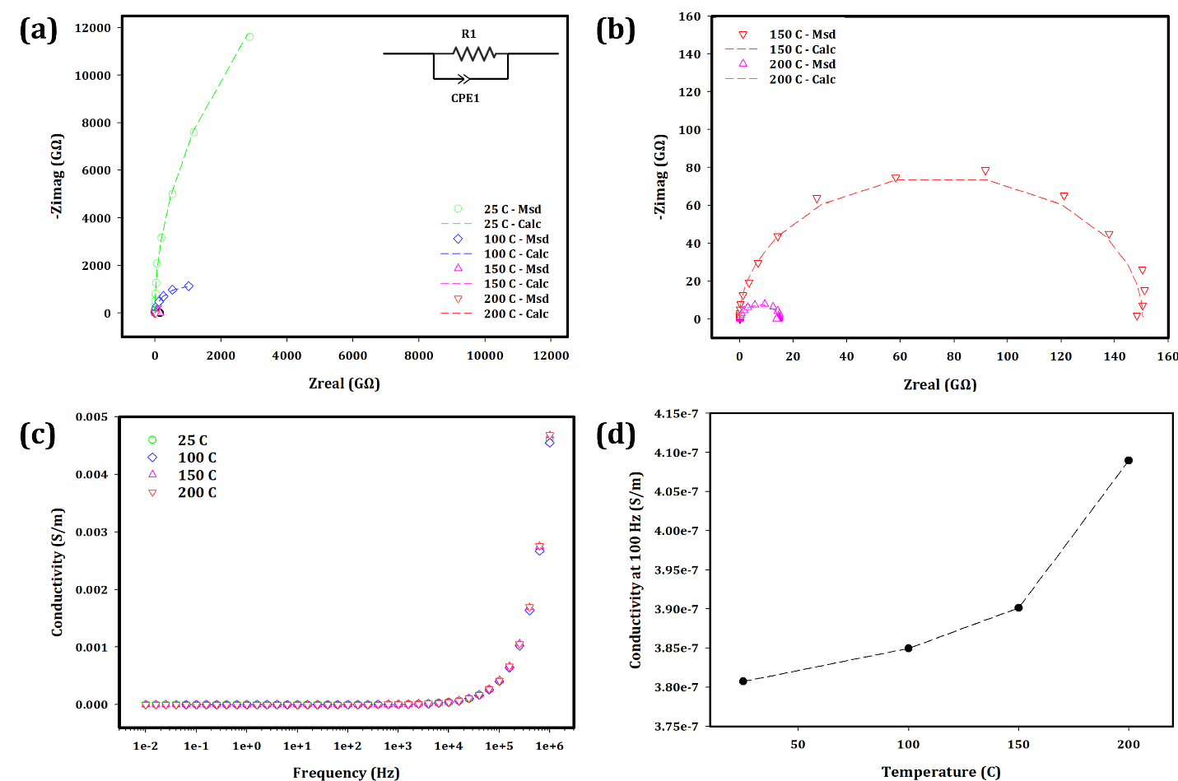
Figure 2. (a) and (b) Nyquist plots at temperature range of 25 – 200 C, (c) conductivity changes versus temperature and (d) conductivity values at frequency of 100 Hz versus temperature of Ce_{0.8}Hf_{0.1}Zr_{0.1}O₂ thin layer post-annealed at 800 C.

