New perspective of electrochemistry originating from the surface engineering through oxygen evolution reaction
Shigeto Hirai, Jeevan Kumar Padarti, Tomoya Ohno
Kitami Institute of Technology
165 Koen-cho, Kitami, Hokkaido, Japan, 090-8507
hirai@mail.kitami-it.ac.jp

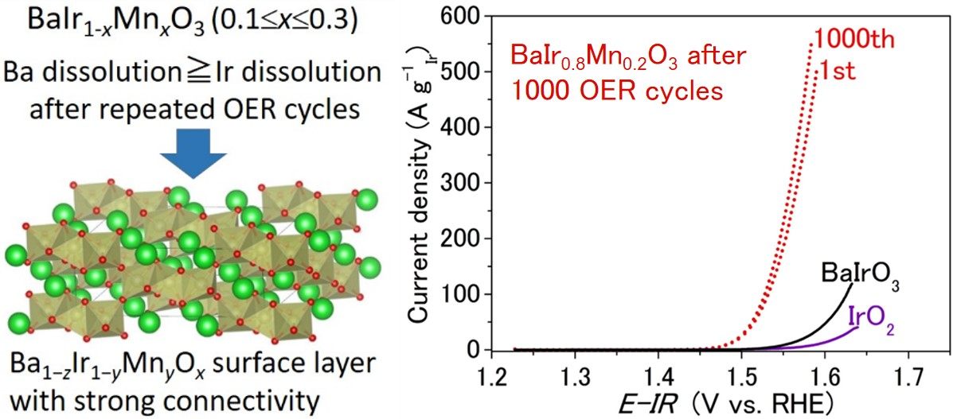
The oxygen evolution reaction (OER) is an important electrochemical reaction of the water splitting [1] and the rechargeable metal-air batteries [2]. However, the kinetics of OER are sluggish and it is difficult to lower the overpotential even with the OER catalysts, and even the acid stable IrO₂ suffers from lattice collapse and poor durability [3]. In this talk, BaIr_{1−x}Mn_{x}O₃ (0.1≤x≤0.3) and the solution plasma treated layered oxides will be introduced as excellent OER catalysts with both high activity and durability [4,5]. Firstly, BaIr_{1−x}Mn_{x}O₃ (0.1≤x≤0.3) will be introduced, which is a series of excellent OER catalysts under acidic conditions with both high activity and durability [4]. Specifically, the substitution of the Ir-site with Mn for BaIrO₃ prevents the lattice collapse after repeated OER cycling, leading to a remarkable activity enhancement by a factor of 28 and an overall improvement in durability (Fig. 1) [4]. This dual enhancement of OER performance was accomplished by the novel strategy of balancing the elemental dissolution of the electrocatalyst to obtain highly durable and active surface structure after repeated OER cycling [4], benefitting from the robust surface structure with increased electrochemical surface area (ECSA). Secondly, solution plasma treatment in combination with OER for the layered oxide will be introduced as a powerful tool for the dual enhancement of OER activity and durability [5]. Specifically, Mn-doping of the Co-site for the Ca₃Co₄O₉ in combination with solution plasma treatment enhances the OER activity by a factor of 11, along with the remarkable enhancement in durability [5]. This dual enhancement is enabled by the improved atomic order of the OER active Mn³⁺-rich catalytic surface, which is an example of the state-of-the-art surface engineering originating from the OER.

Fig. 1 Schematic representation of the surface structure in BaIr_{1−x}Mn_{x}O₃ after 1000 OER cycles, and its cycle dependence of the linear sweep voltammograms for BaIr_{0.8}Mn_{0.2}O₃.

References:
1. T. E. Mallouk, Nat. Chem. 5, 362-363 (2013).
2. Y. C. Lu et al., J. Am. Chem. Soc. 132, 12170-12171 (2010).
3. C. W. Song et al., Energy Environ. Sci. 13, 4178-4188 (2020).
4. S. Hirai et al., RSC Adv. 12, 24427-24438 (2022).
5. S. Hirai et al., Sustainable Energy Fuels 8, 789-796 (2024).

