LYNF Perovskite Zinc-Air Battery

Monika Srivastava,^{a,*} Sandra Sajeev, ª Anurag Srivastava,^{c} Wiktor Kepinski,ª Damian Kowalski^{a,b}

ª Faculty of Chemistry, University of Warsaw, Pasteura 1, 02-093 Warsaw, Poland
^{b} CNBCh, University of Warsaw, Zwirki i Wigury 101, 02-089 Warsaw, Poland
^{c} ABV-Indian Institute of Information Technology & Management, Gwalior-474015, MP, India
*m.srivastava@uw.edu.pl

The growing demand for low-cost, highly efficient non-noble-metal electrocatalysts has garnered extensive attention towards perovskite (ABO₃) type materials, which can be tuned for their electronic behavior and thus, enhance bifunctional catalytic activity for both oxygen reduction and oxygen evolution reactions through partial substitution of A and/or B sites.^{1,2} Herein, we report Y/Fe dual-substituted LaNiO₃ (LYNF) as a bifunctional electrocatalyst for the rechargeable zinc-air battery. The electrochemical analysis revealed that LYNF exhibits a relatively high discharge capacity of 10477 mAh g⁻¹, stable charge-discharge cycling over 100 cycles, demonstrating its bifunctional activity and reversibility in alkaline electrolyte.³ The in-situ Raman spectroscopy employed for understanding battery operation⁴ revealed the reversible formation of superoxide intermediates during battery cycling, suggesting that the oxygen vacancies serve as the primary active centers in the double-perovskite. The LYNF system follows an oxygen-vacancy-assisted bidentate pathway for the discharge phase and the corresponding lattice oxygen mechanism (LOM) for the charge phase, during battery operation. Furthermore, density functional theory has been employed in terms of density of states and projected density of states to demonstrate that Y/Fe substitution shifts the electronic states closer to the Fermi level and enhances metal-oxygen covalency, which facilitates charge transfer compared to pristine LaNiO₃ and thus, enhances the catalytic activity of the LYNF. This work provides insight into the development of the next-generation reversible zinc-air batteries, via comprehending the underlying mechanism during the battery operation, and opens up new opportunities to explore the perovskites for metal-air battery applications.

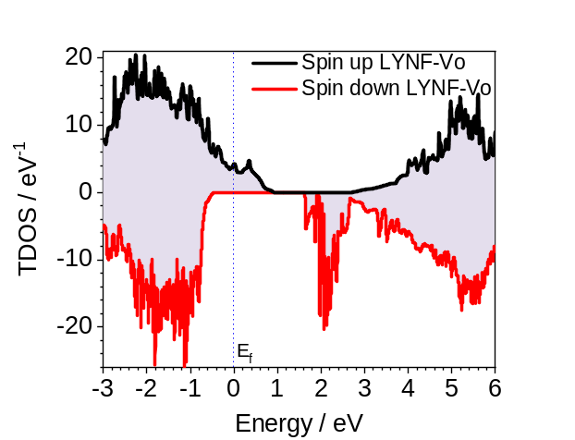 | 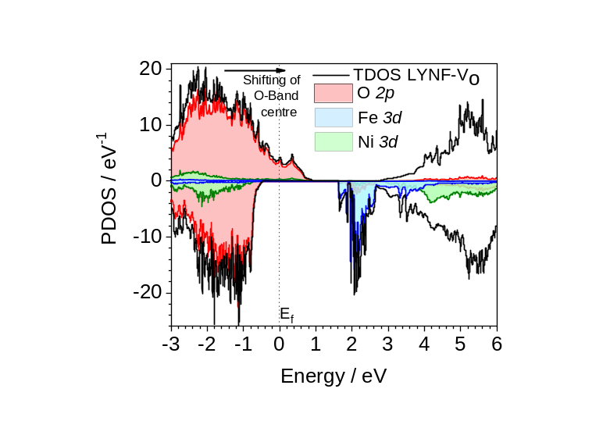
Figure. DOS, and PDOS states for LYNF-V₀, studied as air-electrode in zinc-air battery operating in
6 mol.dm⁻³ potassium hydroxide and 0.2 mol.dm⁻³ Zn(AC)₂.

References:
[1] S. Sajeev, M. Vincent, P. Garbacz, M. Strawski, C. Zhu, Y. Aoki, D. Kowalski, RSC Applied Interfaces, 2 (2025) 1051-1058.
[2] Y. Aoki, K. Takase, H. Kiuchi, D. Kowalski, Y. Sato, H. Toriumi, S. Kitano, H. Habazaki, JACS, 143 (2021) 6505-6515.
[3] M. Srivastava, S. Sajeev, A. Srivastava, W. Kepinski, D. Kowalski, Electrochim. Acta, 559 (2026) 148472.
[4] M. Vincent, D. Kowalski, ACS Applied Nano Materials, 6 (2023) 6528-6537.

