Revisiting a (G)old Riddle: Oxide Growth and Place-Exchange on Au(111) in Alkaline Electrolyte

Francesc Valls Mascaró¹*, Toni Moser¹, Lara Handle¹, Christoph Griesser¹, Andrea Auer¹, and Julia Kunze-Liebhäuser¹
¹ Institute of Physical Chemistry, University of Innsbruck, Innsbruck, 6020 (Austria)
* Francesc.Valls-Mascaro@uibk.ac.at

Understanding noble metal oxidation is essential for designing stable, high-performance electrocatalysts for direct energy conversion. Single-crystalline Au(111) is ideal for isolating fundamental surface processes that take place during the anodic oxidation, due to its high nobility and the model applicability of the processes at its electrified solid/liquid interface. While the anodic oxidation of Au(111) via the gold-oxygen place-exchange mechanism is well-documented in acidic media [1-4], its dynamics and structural consequences in alkaline environments remain poorly understood. In this work, we elucidate the oxidation and associated surface restructuring of Au(111) in 0.1 M NaOH by complementing nanoscale imaging with spectroscopic tracking. Using electrochemical scanning tunneling microscopy (EC-STM), we directly visualize the growth of a surface oxide layer across Au(111) terraces that occurs in the form of a dark appearing slowly propagating oxidation front. This observation reveals the slow, kinetically limited dynamics of the place-exchange process that results in an irreversible roughening of the surface. Crucially, this structural transformation is corroborated by electrochemical X-ray photoelectron spectroscopy (EC-XPS), where the emergence of a Au⁺ peak in the Au 4f spectra at 1.34 V vs. RHE precisely matches the observation of the oxidation front. These findings provide critical insight into the phase transitions governing noble metal oxidation and degradation, while also offering a framework to enhance the stability of Au-based materials in alkaline electrochemical applications.

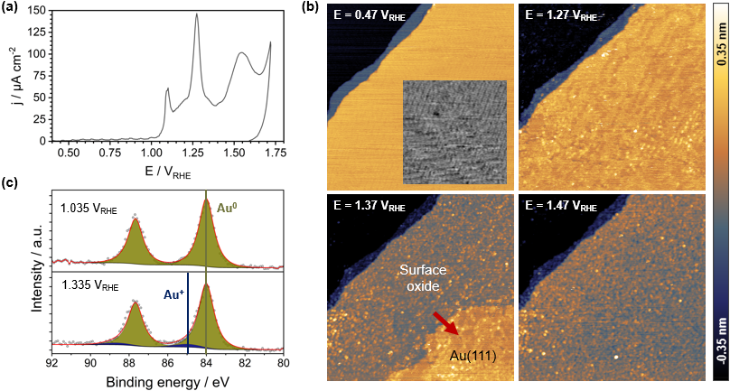

Figure 1. Electrochemical oxidation and restructuring of Au(111) in 0.1 M NaOH. (a) Cyclic voltammogram recorded at a scan rate of 50 mV/s. (b) In-situ EC-STM images of Au(111) acquired at the designated potentials, capturing the progression of the oxidation front, which grows in the direction of the red arrow. (c) High-resolution EC-XPS spectra of the Au 4f core level recorded at the corresponding potentials, showing the oxidation onset through appearance of the Au⁺ component.

References
[1] B. E. Conway, Prog. Surf. Sci. 1995, 228, 429.
[2] H. Honbo et al., Anal. Chem. 1990, 62, 2424.
[3] K. J. Hanson et al., MRS Online Proc. Library 1991, 237, 323.
[4] C. M. Vitus et al., J. Electrochem. Soc. 1994, 141, 1291.

