Electrochemical Near Ambient Pressure XPS and its connection to the absolute electrode potential

Christoph Griesser, Francesc Valls Mascaró, Sebastian Liebl, Engelbert Portenkirchner, Julia Kunze-Liebhäuser
Department of Physical Chemistry, University of Innsbruck
Innrain 52 c, Innsbruck Austria
christoph.griesser@uibk.ac.at

Since the 1980s,^{[1]} several ultrahigh-vacuum-based techniques have been adapted to investigate electrochemical processes, including X-ray photoelectron spectroscopy (XPS) where in situ operation enables to track the (redox) chemistry of the solid/liquid interface during polarization. Progress in near-ambient-pressure XPS, particularly through differential pumping and electrostatic lens systems, enabled the first electrochemical XPS (EC-XPS) experiments roughly a decade ago.^{[2]} Today, a number of EC-XPS setups, mainly located at synchrotron facilities, make it possible to probe electrified interfaces under operating conditions. However, due to challenges such as intricate cell designs and limited access to synchrotron facilities, EC-XPS is still developing.
In this work, we use lab-based EC-XPS^{[3]} to directly probe the local electrostatic potential landscape of electrified solid/liquid interfaces and relate the observed binding energy shifts to the concept of the absolute electrode potential. We show that core levels of electrolyte species that are not electronically equilibrated with the grounded working electrode are expected to shift by approximately −1 eV/V with applied potential. Experimentally, the liquid phase water (LPW) O 1s signal follows this behavior with an almost ideal unity slope. Furthermore, its binding energy correlates linearly with the standard hydrogen electrode scale across different electrode electrolyte combinations, providing an experimentally accessible energy scale linked to the solvated electron in solution. We further show that this concept is not limited to aqueous electrolytes: in non-aqueous LiPF₆/propylene carbonate electrolytes, solvent- and salt- derived core levels likewise track local electrostatic potential changes during Li plating. These results establish EC-XPS as a direct experimental approach for determining absolute or relative electrode potentials in electrochemical systems under operating conditions.
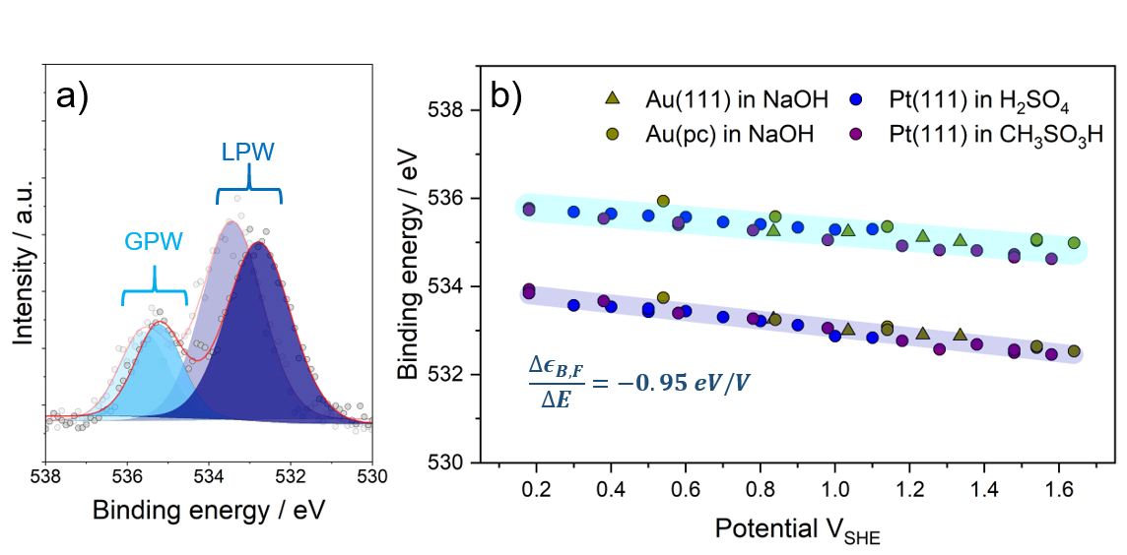
Figure 1. Binding energy shifts in EC-XPS. a) shows the dependency of the gas phase water (GPW) signal and the liquid phase water (LPW) signal on the applied potential (1.6 V_{SHE} and 0.9 V_{SHE}, respectively) shows this behavior over a wide potential range for various electrode/electrolyte combinations suggesting a connection to an absolute electrode potential.

References
[1] S. Ye, T. Kondo, N. Hoshi, J. Inukai, S. Yoshimoto, M. Osawa, K. Itaya. Electrochemistry. 77, E1 (2009),
[2] S. Axnanda, E. J. Crumlin, B. Mao, S. Rani, R. Chang, P. G. Karlsson, M. O. M. Edwards, M. Lundqvist, R. Moberg, P. Ross, Z. Hussain, Z. Liu. Scientific reports. 5, 9788 (2015).
[3] C. Griesser, D. Winkler, T. Moser, L. Haug, M. Thaler, E. Portenkirchner, B. Klötzer, S. Diaz‐Coello, E. Pastor, J. Kunze‐Liebhäuser. Electrochemical Science Adv. 4 (2024).

