Morphology Design of Doped Anodic WO₃ Layers

Sebastian Kotarba^{1,2}, Marcin Pisarek³, Karolina Syrek¹
¹ Department of Physical Chemistry and Electrochemistry, Faculty of Chemistry, Jagiellonian University, ²Doctoral School of Exact and Natural Sciences, Jagiellonian University, 30-387 Kraków, Poland; ³Laboratory of Surface Analysis, Institute of Physical Chemistry, Polish Academy of Sciences,
01-224 Warsaw, Poland
sebastian.kotarba@doctoral.uj.edu.pl; karolina.syrek@uj.edu.pl

Tungsten(VI) oxide has attracted significant attention as a promising photoanode material for converting solar energy into electrical or chemical energy, particularly for hydrogen production via direct water splitting [1]. This semiconductor exhibits a relatively narrow band gap (~2.8 eV for γ-WO₃), which allows absorption of nearly 12% of the solar spectrum at wavelengths below 440 nm. In addition, its valence band energy (approximately 3.2 eV versus the standard hydrogen electrode, SHE) is favorable for the oxygen evolution reaction, a key process in efficient photoelectrochemical systems [2]. Tailoring the electronic structure of WO₃ through metal doping, for example with iron, may further improve its performance by enhancing visible-light absorption, increasing charge carrier concentration, and promoting more efficient charge separation, ultimately leading to improved photoelectrochemical activity [3]. Furthermore, designing electrodes with controlled morphologies may also enhance charge separation and carrier mobility, further improving the efficiency of photoelectrochemical processes.
Nanostructured WO₃ layers were synthesized via electrochemical anodization according to a previously reported procedure [4]. Iron incorporation was achieved through in situ doping by introducing FeF₃ into the electrolyte, resulting in a series of electrolytes containing precursor concentrations ranging from 2 to 100 mM. In addition to conventional anodization, pulsed anodization conditions were also applied to influence oxide growth dynamics and tailor the morphology of the obtained non-doped WO₃ layers.
The fabricated materials were characterized using scanning electron microscopy (SEM, Figure 1 A, B), X-ray photoelectron spectroscopy (XPS), Mott–Schottky analysis, and photoelectrochemical measurements (Figure 1 C).

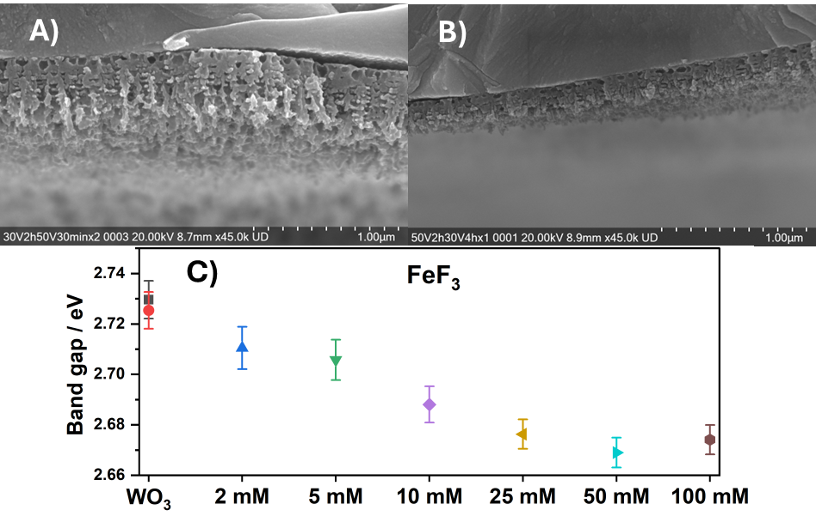
Fig. 1. SEM cross-sectional images of samples anodized under pulsed conditions: (A) two cycles consisting of anodization at 30 V for 2 h followed by 50 V for 30 min; (B) one cycle consisting of anodization at 50 V for 2 h followed by 30 V for 4 h. (C) calculated band-gap energies from incident photon-to-current efficiency (IPCE) measurements of samples with increasing content of FeF₃ in electrolyte during anodization.
The research was supported by the National Science Centre Poland (Project No. 2023/51/D/ST4/01999).

References
[1] J. Li, N. Wu, Catal. Sci. Technol., 2015, 5, 1360–1384,
[2] C. C. Mardare, A. W. Hassel, Phys. Status Solidi A, 2019, 216,
[3] Y. Wang, W. Tian, C. Chen, W. Xu, L. Li, Adv. Funct. Mater., 2019, 29,
[4] M. Zych, K. Syrek, L. Zaraska, G. D. Sulka, Molecules, 2020, 25, 2916.

