Live imaging electrochemistry using liquid phase electron microscopy: in situ Ag dissolution at open-circuit potential

A. Lucía Morales^{a,b}, A. Körner^{a,b}, K. J. J. Mayrhofer^{a,b},S. Cherevkoª, A. Hutzlerª
- Forschungszentrum Jülich GmbH, Helmholtz Institute Erlangen-Nürnberg for Renewable Energy (IET-2). Cauerstr. 1, 91058 Erlangen, Germany
- Friedrich-Alexander-Universität Erlangen-Nürnberg, Department of Chemical and Biological Engineering. Immerwahrstr. 2a, 91058 Erlangen, Germany
l.morales@fz-juelich.de, a.hutzler@fz-juelich.de

Understanding the degradation mechanisms of electrodes during operation has relied on initial and post-mortem characterizations obtained under accelerated-stress conditions. Their results raise awareness of different degradation routes associated with specific operational protocols [1]. Electrochemical liquid phase electron microscopy (EC-LP-EM) is an emerging operando technique that aims to provide new insights into the highly dynamic electrode-electrolyte interface by directly observing structural changes correlated to electrochemical footprint changes [2]. Like synchrotron experiments, it relies on exposing the sample to a high-energy irradiation source, which, depending on the irradiation dose rate, generates radiolytic products resulting from beam-electrolyte interactions [3,4]. Thus, careful handling of beam effects and data interpretation is important to isolate the events under investigation. Here, we studied the in situ electrodeposition of silver (Ag) onto platinum (Pt) electrodes, followed by its immediate dissolution at open-circuit potential (OCP). We conclude that this dissolution results from system equilibration driven by the oxygen reduction reaction at the newly formed Ag-Pt interface, accompanied by bimetallic corrosion driven by the difference in oxidation preferences of Ag over Pt under acidic conditions and low oxygen concentrations. These assumptions were validated via ex situ experiments using a scanning flow cell-inductively coupled plasma-mass spectrometry (SFC-ICP-MS) setup [5]. Furthermore, we ensured a net-neutral-beam-damage environment by applying experimental parameters previously validated [6]. The study shows how macroscopic electrochemical responses reflect nanoscale dynamics and identifies opportunities for in situ accelerated stress testing under harsh conditions [4].
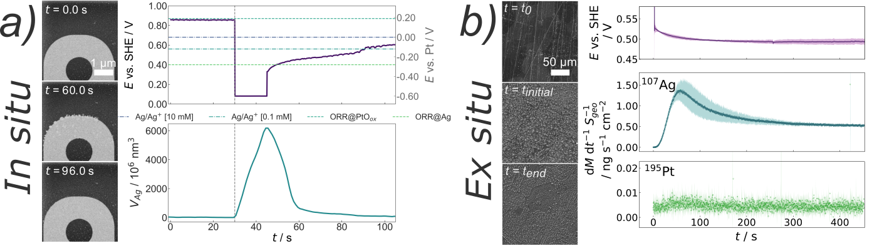
Figure 1. Electrodeposition of Ag on Pt, and its immediate dissolution at OCP driven by system equilibration: a) in situ observations using LP-EM, b) ex situ observations using SFC-ICP-MS.

References
[1] S. Finger; Fritsch, Birk, et al., Degradation phenomena in PEMWE revealed by correlative electrochemical and nanostructure analysis, Energy Environ. Sci. https://doi.org/10.1039/D5EE03712C.
[2] F.M. Ross (Ed.), Liquid Cell Electron Microscopy, Cambridge University Press, 2016.
[3] B. Fritsch; Lee, Serin, et al., The Influence of Ionizing Radiation on Quantification for In Situ and Operando Liquid-Phase Electron Microscopy, Adv Mater (2025) 2415728. https://doi.org/10.1002/adma.202415728.
[4] A.L. Morales; Körner, Andreas, et al., A snapshot review on utilizing radiolysis in electrochemical liquid phase electron microscopy for accelerated degradation analyses, MRS Advances. https://doi.org/10.1557/s43580-025-01393-7.
[5] A. Körner; Morales, A. Lucía, et al., Live Imaging of Silver Nanostructures Electrochemically Dissolving at Open-Circuit Potential, Small (Weinheim an der Bergstrasse, Germany) 22 (2026) e13338. https://doi.org/10.1002/smll.202513338.
[6] A. Körner; Fritsch, Birk, et al., Panta Rhei - tuning silver nanostructure evolution with flow and radiolysis in liquid phase STEM, Nano Today 61 (2025) 102575. https://doi.org/10.1016/j.nantod.2024.102575.

