Stretchable printed micro-supercapacitors based on nitrogen-doped graphene ink
Jan Urbánek, Ivan Dědek, Vojtěch Kupka, Michal Otyepka
Regional Centre of Advanced Technologies and Materials, Czech Advanced Technologies and Reseatch Institute (CATRIN), Palacký University Olomouc, Šlechtitelů 341/27, 779 00 Olomouc, Czech Republic
jan.urbanek@upol.cz

The increasing popularity of wearable devices calls for a more user-friendly power source than typical Li-ion coin- or pouch-cell batteries. Ideally, such power sources should be flexible and stretchable and beneficially avoiding commonly used heavy metals and lithium. In this work, we explored an alternative power source with the aim of achieving a stretchable, fully carbon-based solution for wearable energy storage. Using a direct ink writing technique, stretchable micro-supercapacitors were prototyped, utilising both commercial and in-house-developed inks for the electrodes. So far, using our nitrogen-doped graphene (GN₃) as an active material, the micro-supercapacitors achieved capacitance up to 11.1 mF (44.5 mF/cm²) at 200 µA. Such results from the first prototypes demonstrate a viable route toward wearable energy storage devices.
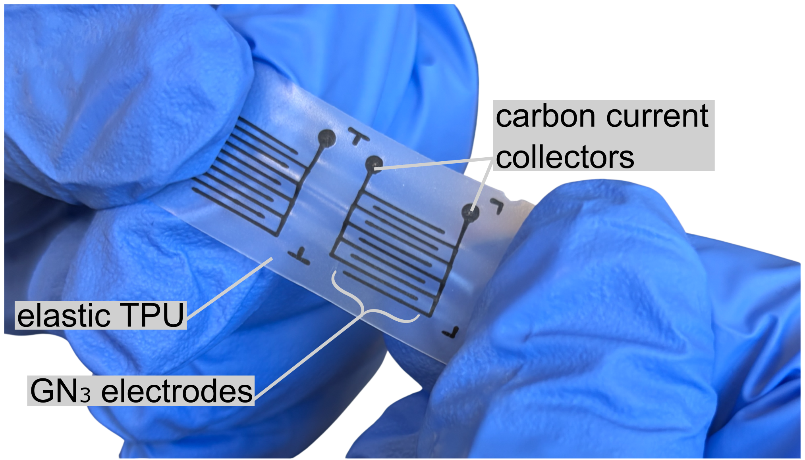
Figure 1 – Example of stretchable printed micro-super-capacitors.

